1.3.2: Develop a Working Thesis and a Research Proposal Writing for Success: "Chapter 11, Section 2: Steps in Developing a Research Proposal"

LEARNING OBJECTIVES
- Identify the steps in developing a research proposal.
- Choose a topic and formulate a research question and working thesis.
- Develop a research proposal.
Writing a good research paper takes time, thought, and effort. Although this assignment is challenging, it is manageable. Focusing on one step at a time will help you develop a thoughtful, informative, well-supported research paper.
Your first step is to choose a topic and then to develop research questions, a working thesis, and a written research proposal. Set aside adequate time for this part of the process. Fully exploring ideas will help you build a solid foundation for your paper.

Choosing a Topic
When you choose a topic for a research paper, you are making a major commitment. Your choice will help determine whether you enjoy the lengthy process of research and writing—and whether your final paper fulfills the assignment requirements. If you choose your topic hastily, you may later find it difficult to work with your topic. By taking your time and choosing carefully, you can ensure that this assignment is not only challenging but also rewarding.
Writers understand the importance of choosing a topic that fulfills the assignment requirements and fits the assignment’s purpose and audience. (For more information about purpose and audience, see Chapter 6 "Writing Paragraphs: Separating Ideas and Shaping Content".) Choosing a topic that interests you is also crucial. You instructor may provide a list of suggested topics or ask that you develop a topic on your own. In either case, try to identify topics that genuinely interest you.
After identifying potential topic ideas, you will need to evaluate your ideas and choose one topic to pursue. Will you be able to find enough information about the topic? Can you develop a paper about this topic that presents and supports your original ideas? Is the topic too broad or too narrow for the scope of the assignment? If so, can you modify it so it is more manageable? You will ask these questions during this preliminary phase of the research process.

Identifying Potential Topics
Sometimes, your instructor may provide a list of suggested topics. If so, you may benefit from identifying several possibilities before committing to one idea. It is important to know how to narrow down your ideas into a concise, manageable thesis. You may also use the list as a starting point to help you identify additional, related topics. Discussing your ideas with your instructor will help ensure that you choose a manageable topic that fits the requirements of the assignment.
In this chapter, you will follow a writer named Jorge, who is studying health care administration, as he prepares a research paper. You will also plan, research, and draft your own research paper.
Jorge was assigned to write a research paper on health and the media for an introductory course in health care. Although a general topic was selected for the students, Jorge had to decide which specific issues interested him. He brainstormed a list of possibilities.

Tip
If you are writing a research paper for a specialized course, look back through your notes and course activities. Identify reading assignments and class discussions that especially engaged you. Doing so can help you identify topics to pursue.
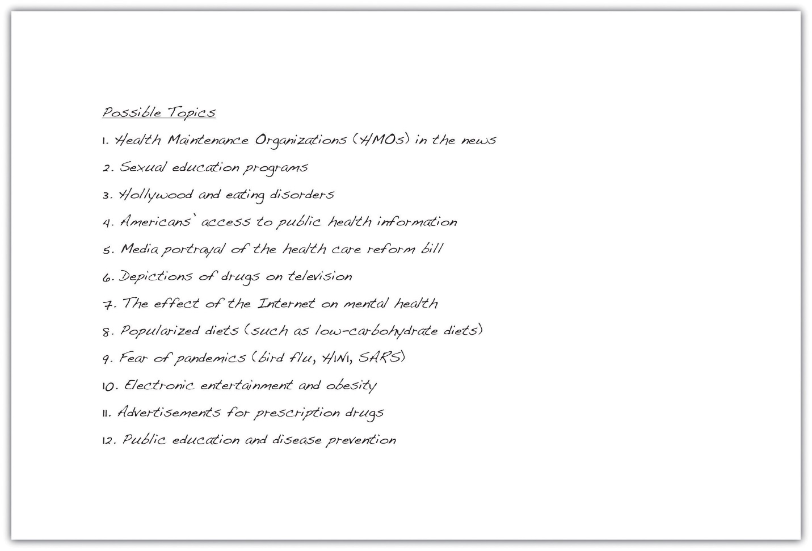

EXERCISE 1
Set a timer for five minutes. Use brainstorming or idea mapping to create a list of topics you would be interested in researching for a paper about the influence of the Internet on social networking. Do you closely follow the media coverage of a particular website, such as Twitter? Would you like to learn more about a certain industry, such as online dating? Which social networking sites do you and your friends use? List as many ideas related to this topic as you can.

Narrowing Your Topic
Once you have a list of potential topics, you will need to choose one as the focus of your essay. You will also need to narrow your topic. Most writers find that the topics they listed during brainstorming or idea mapping are broad—too broad for the scope of the assignment. Working with an overly broad topic, such as sexual education programs or popularized diets, can be frustrating and overwhelming. Each topic has so many facets that it would be impossible to cover them all in a college research paper. However, more specific choices, such as the pros and cons of sexual education in kids’ television programs or the physical effects of the South Beach diet, are specific enough to write about without being too narrow to sustain an entire research paper.
A good research paper provides focused, in-depth information and analysis. If your topic is too broad, you will find it difficult to do more than skim the surface when you research it and write about it. Narrowing your focus is essential to making your topic manageable. To narrow your focus, explore your topic in writing, conduct preliminary research, and discuss both the topic and the research with others.

Exploring Your Topic in Writing
“How am I supposed to narrow my topic when I haven’t even begun researching yet?” In fact, you may already know more than you realize. Review your list and identify your top two or three topics. Set aside some time to explore each one through freewriting. (For more information about freewriting, see Chapter 8 "The Writing Process: How Do I Begin?".) Simply taking the time to focus on your topic may yield fresh angles.
Jorge knew that he was especially interested in the topic of diet fads, but he also knew that it was much too broad for his assignment. He used freewriting to explore his thoughts so he could narrow his topic. Read Jorge’s ideas.
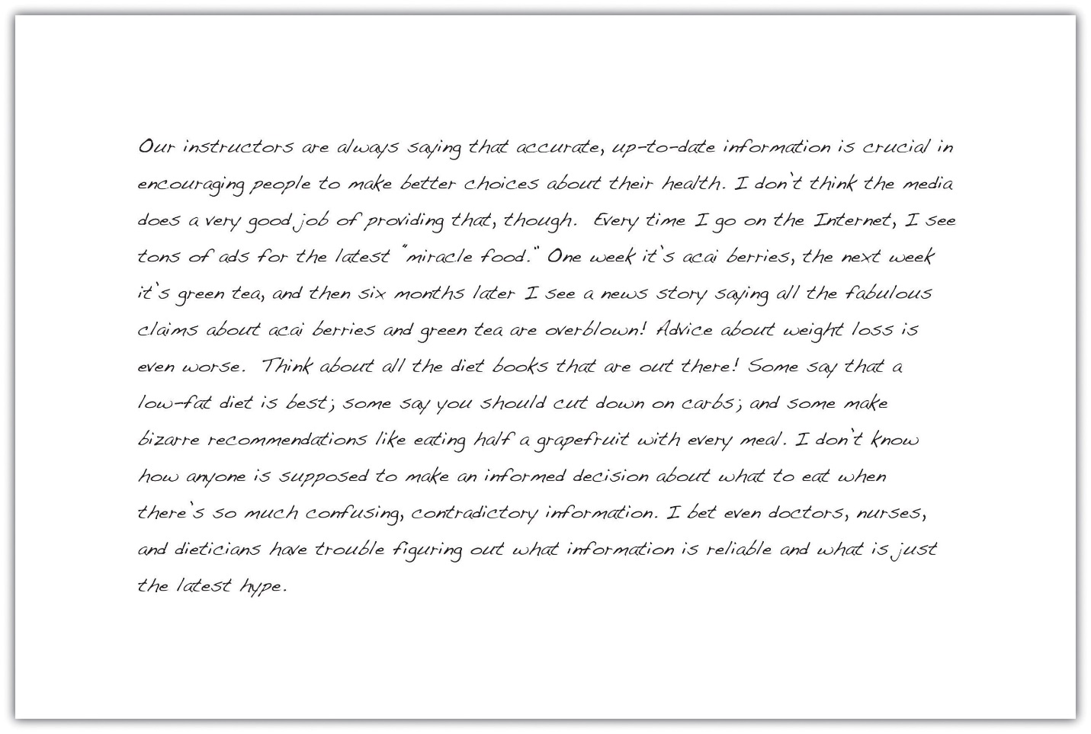

Conducting Preliminary Research
Another way writers may focus a topic is to conduct preliminary research. Like freewriting, exploratory reading can help you identify interesting angles. Surfing the web and browsing through newspaper and magazine articles are good ways to start. Find out what people are saying about your topic on blogs and online discussion groups. Discussing your topic with others can also inspire you. Talk about your ideas with your classmates, your friends, or your instructor.
Jorge’s freewriting exercise helped him realize that the assigned topic of health and the media intersected with a few of his interests—diet, nutrition, and obesity. Preliminary online research and discussions with his classmates strengthened his impression that many people are confused or misled by media coverage of these subjects.
Jorge decided to focus his paper on a topic that had garnered a great deal of media attention—low-carbohydrate diets. He wanted to find out whether low-carbohydrate diets were as effective as their proponents claimed.

Writing at Work
At work, you may need to research a topic quickly to find general information. This information can be useful in understanding trends in a given industry or generating competition. For example, a company may research a competitor’s prices and use the information when pricing their own product. You may find it useful to skim a variety of reliable sources and take notes on your findings.

Tip
The reliability of online sources varies greatly. In this exploratory phase of your research, you do not need to evaluate sources as closely as you will later. However, use common sense as you refine your paper topic. If you read a fascinating blog comment that gives you a new idea for your paper, be sure to check out other, more reliable sources as well to make sure the idea is worth pursuing.

EXERCISE 2
Review the list of topics you created in Note 11.18 "Exercise 1" and identify two or three topics you would like to explore further. For each of these topics, spend five to ten minutes writing about the topic without stopping. Then review your writing to identify possible areas of focus.
Set aside time to conduct preliminary research about your potential topics. Then choose a topic to pursue for your research paper.
Collaboration
Please share your topic list with a classmate. Select one or two topics on his or her list that you would like to learn more about and return it to him or her. Discuss why you found the topics interesting, and learn which of your topics your classmate selected and why.

A Plan for Research
Your freewriting and preliminary research have helped you choose a focused, manageable topic for your research paper. To work with your topic successfully, you will need to determine what exactly you want to learn about it—and later, what you want to say about it. Before you begin conducting in-depth research, you will further define your focus by developing a research question, a working thesis, and a research proposal.

Formulating a Research Question
In forming a research question, you are setting a goal for your research. Your main research question should be substantial enough to form the guiding principle of your paper—but focused enough to guide your research. A strong research question requires you not only to find information but also to put together different pieces of information, interpret and analyze them, and figure out what you think. As you consider potential research questions, ask yourself whether they would be too hard or too easy to answer.
To determine your research question, review the freewriting you completed earlier. Skim through books, articles, and websites and list the questions you have. (You may wish to use the 5WH strategy to help you formulate questions. See Chapter 8 "The Writing Process: How Do I Begin?" for more information about 5WH questions.) Include simple, factual questions and more complex questions that would require analysis and interpretation. Determine your main question—the primary focus of your paper—and several subquestions that you will need to research to answer your main question.
Here are the research questions Jorge will use to focus his research. Notice that his main research question has no obvious, straightforward answer. Jorge will need to research his subquestions, which address narrower topics, to answer his main question.
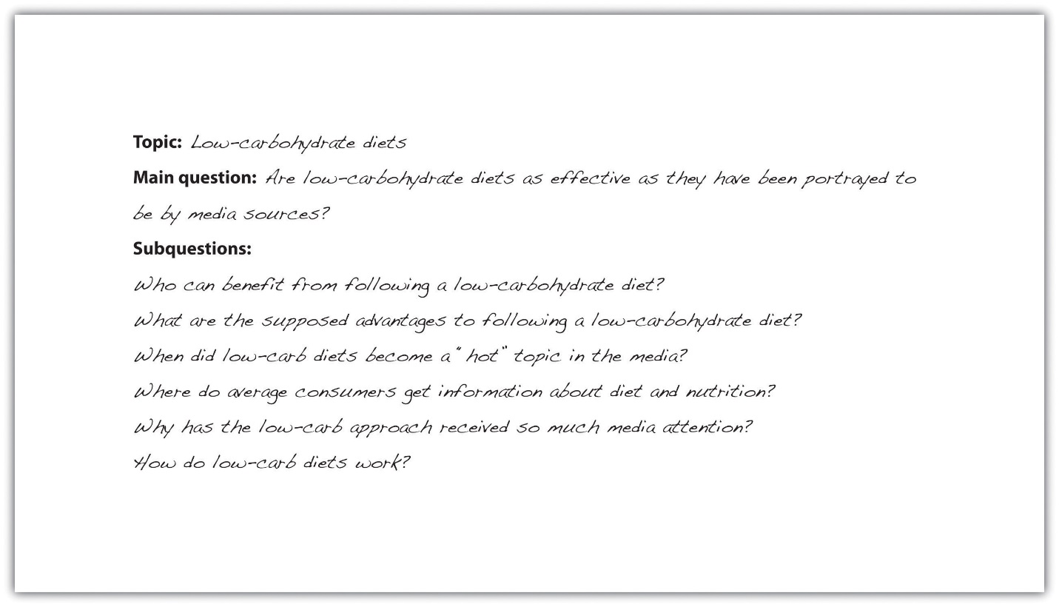

EXERCISE 3
Using the topic you selected in Note 11.24 "Exercise 2", write your main research question and at least four to five subquestions. Check that your main research question is appropriately complex for your assignment.

Constructing a Working ThesIs
A working thesis concisely states a writer’s initial answer to the main research question. It does not merely state a fact or present a subjective opinion. Instead, it expresses a debatable idea or claim that you hope to prove through additional research. Your working thesis is called a working thesis for a reason—it is subject to change. As you learn more about your topic, you may change your thinking in light of your research findings. Let your working thesis serve as a guide to your research, but do not be afraid to modify it based on what you learn.
Jorge began his research with a strong point of view based on his preliminary writing and research. Read his working thesis statement, which presents the point he will argue. Notice how it states Jorge’s tentative answer to his research question.


Tip
One way to determine your working thesis is to consider how you would complete sentences such as I believe or My opinion is. However, keep in mind that academic writing generally does not use first-person pronouns. These statements are useful starting points, but formal research papers use an objective voice.

EXERCISE 4
Write a working thesis statement that presents your preliminary answer to the research question you wrote in Note 11.27 "Exercise 3". Check that your working thesis statement presents an idea or claim that could be supported or refuted by evidence from research.

Creating a Research Proposal
A research proposal is a brief document—no more than one typed page—that summarizes the preliminary work you have completed. Your purpose in writing it is to formalize your plan for research and present it to your instructor for feedback. In your research proposal, you will present your main research question, related subquestions, and working thesis. You will also briefly discuss the value of researching this topic and indicate how you plan to gather information.
When Jorge began drafting his research proposal, he realized that he had already created most of the pieces he needed. However, he knew he also had to explain how his research would be relevant to other future health care professionals. In addition, he wanted to form a general plan for doing the research and identifying potentially useful sources. Read Jorge’s research proposal.
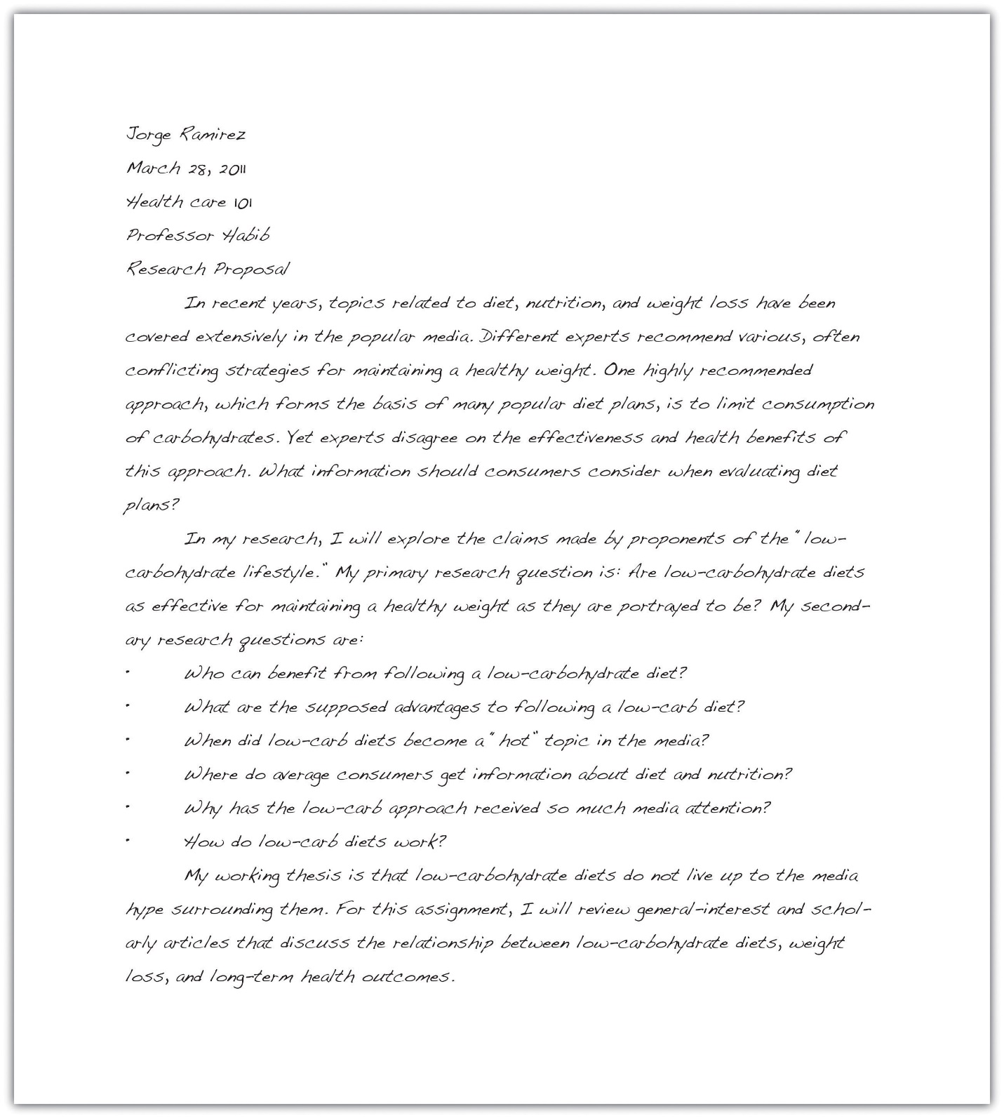

Writing at Work
Before you begin a new project at work, you may have to develop a project summary document that states the purpose of the project, explains why it would be a wise use of company resources, and briefly outlines the steps involved in completing the project. This type of document is similar to a research proposal. Both documents define and limit a project, explain its value, discuss how to proceed, and identify what resources you will use.

Writing Your Own Research Proposal
Now you may write your own research proposal, if you have not done so already. Follow the guidelines provided in this lesson.

KEY TAKEAWAYS
- Developing a research proposal involves the following preliminary steps: identifying potential ideas, choosing ideas to explore further, choosing and narrowing a topic, formulating a research question, and developing a working thesis.
- A good topic for a research paper interests the writer and fulfills the requirements of the assignment.
- Defining and narrowing a topic helps writers conduct focused, in-depth research.
- Writers conduct preliminary research to identify possible topics and research questions and to develop a working thesis.
- A good research question interests readers, is neither too broad nor too narrow, and has no obvious answer.
- A good working thesis expresses a debatable idea or claim that can be supported with evidence from research.
- Writers create a research proposal to present their topic, main research question, subquestions, and working thesis to an instructor for approval or feedback.

