OER Saylor Academy’s ENGL002: English Composition II
READER
Dean Ramser, E.dD.
Fall 2019

TABLE OF CONTENTS

x, xi Course Terms of Use

- Over of Units 1-6
- Unit 1: Research and the Writing Process (p8-86)
- Unit 2: Researching: How, What, When, Where, and Why (p87-116)
- Unit 3: Reviewing and Analyzing Your Sources (p117-144)
- Unit 4: Putting Your Source Material to Work (p143-216)
- Unit 5: Writing the Research Paper and Acknowledging Your Sources (p216-264)
- Unit 6: Polishing Your Research Paper (p266-296)

Saylor Academy’s ENGL002: English Composition II Course Terms of Use
All Saylor Academy courses are licensed under a Creative Commons Attribution 3.0 Unported License. For licensing purposes, a "course" is defined as the structure, syllabus, learning outcomes, unit descriptions, and the framing text that accompanies resources curated from third parties. That excludes the third party resources themselves, including the following resources used in this course, which contain the individual licenses listed below:
Steven D. Krause's Resources:  - Attributed to Steven D. Krause  - Licensed under CC BY-NC-SA 3.0  - Original versions may be found here: http://www.stevendkrause.com/  Writing for Success:  - Provided without attribution as requested by the work's original creator or licensor  - Licensed under CC BY-NC-SA 3.0  Cornell University Library Resources:  - Attributed to Cornell University  - Licensed under CC BY-NC-SA 3.0  - Original versions may be found here: https://olinuris.library.cornell.edu/  Pavel Zemliansky's Resources:  - Attributed to Pavel Zemliansky  - Licensed under CC BY-NC-SA 3.0  University of North Carolina at Chapel Hill Writing Center Resources:  - Attributed to the University of North Carolina at Chapel Hill  - Licensed under CC BY-NC-ND 2.5  - Original versions can be found here: http://writingcenter.unc.edu/  Texas A&M University Writing Center Resources:  - Attributed to Texas A&M University  - Licensed under CC BY-NC-ND 3.0  - Original versions can be found here: http://writingcenter.tamu.edu/  Duke University Libraries Resources:  - Attributed to Duke University  - Licensed under CC BY-NC-SA 3.0  - Original versions can be found here: http://sites.duke.edu/ |  |  | North Carolina State University Library Resources:  - Attributed to North Carolina State University  - Licensed under CC BY-NC-SA 3.0  - Original versions can be found here: http://www.lib.ncsu.edu/  California State University, Northridge Library Resources:  - Attributed to California State University, Northridge  - Licensed under CC BY 3.0  - Original versions may be found here: http://library.csun.edu/  Brock Library and Eastern Michigan University Resources:  - Attributed to Brock Library and Eastern Michigan University  - Licensed under CC BY 3.0  Joe Schall's Resources:  - Attributed to Joe Schall and Penn State University  - Licensed under CC BY-SA 3.0  - Original versions can be found here: https://www.e-education.psu.edu/  Utah State University Resources:  - Attributed to Utah State University  - Licensed under CC BY-NC-SA 2.5  Boundless Resources:  - Attributed to Boundless  - Licensed under CC BY 4.0  - Original versions may be found here: https://www.boundless.com/  Graduate Journal of Social Science Resources:  - Attributed to the Graduate Journal of Social Science  - Licensed under CC BY-ND 3.0  - Original versions may be found here: http://gjss.org/  All other resources are copyrighted, and may not be reproduced without the explicit permission from the copyright holder.  Last modified: Wednesday, July 20, 2016, 2:48 PM
Unit 1: Research and the Writing Process |  | Unit 1 Learning Outcomes:  -define the basic components of an academic research paper;  -identify and describe the various types of research papers;  -relate research techniques to academic work in various disciplines;  -practice identifying and focusing a research topic and develop research questions;  -develop a research proposal; and  -write a draft outline.
1.1.1: Academic Research Writing |  | Steven D. Krause's "The Process of Research Writing - Academic Research Writing: What Is It?"
1.1.2: Why Write a Research Paper? |  | Writing for Success: "Chapter 11, Section 1: The Purpose of Research Writing"
1.1.3: How to Manage a Research Project |  | Writing for Success: "Chapter 11, Section 3: Managing Your Research Project"
1.2.1: The Research Process: An Overview |  | Cornell University Library: "The Seven Steps of the Research Process"
1.2.2: What Is Your Research Community? |  | Dr. Pavel Zemliansky's "Analyze Your Discourse Communities"
 |  | Dr. Pavel Zemliansky's "Methods of Discovery: A Guide to Research Writing - Chapter 6: Research Writing in the Academic Disciplines"
1.2.3: Identifying and Understanding Your Audience |  | The University of North Carolina at Chapel Hill Writing Center: "Audience"
 |  | Texas A&M University Writing Center: "Audience Awareness"
1.2.4: Understanding Your Audience and Purpose |  | Dr. Pavel Zemliansky's "Methods of Discovery: A Guide to Research Writing - Chapter 1: Research Writing and Argument"
1.2.5: Purpose, Audience, Tone, and Content |  | Writing for Success: "Chapter 6, Section 1: Purpose, Audience, Tone, and Content"
1.3.1: Discovering and Choosing a Topic |  | Activity: Identify Your Research Topic
1.3.2: Develop a Working Thesis and a Research Proposal |  | Writing for Success: "Chapter 11, Section 2: Steps in Developing a Research Proposal"
 |  | Activity: Develop a Working Thesis
1.3.3: Mapping Your Topic |  | The University of North Carolina at Chapel Hill Writing Center: "Webbing"
1.4: Outlining |  | Writing for Success: "Chapter 8, Section 2: Outlining"
Unit 2: Researching: How, What, When, Where, and Why |  | Unit 2 Learning Outcomes:  -discuss the basic theory and concepts of research;  -explain how to analyze your topic and plan research, as well as demonstrate moderate expertise in topic analysis and research planning;  -practice researching in physical and online media;  -differentiate between primary and secondary sources, and understand the advantages and disadvantages of both;  -differentiate between printed and online sources, and discuss the advantages and disadvantages of both;  -explain how to use the tools and techniques associated with researching on the Internet; and  -develop practical techniques for recording, organizing, and documenting research information.
2.1.1: Note Taking Tools |  | Evernote [CIW-see Cornell Notes handout]
2.1.2: Using a Reverse Outline |  | The University of North Carolina at Chapel Hill Writing Center: "Reverse Outline"
2.2.1: How to Begin Your Research |  | Writing for Success: "Chapter 11, Section 4: Strategies for Gathering Reliable Information"
2.2.2: Investigating Scholarly vs. Non-Scholarly Sources |  | Dr. Pavel Zemliansky's "Methods of Discovery: A Guide to Research Writing - Chapter 4: Finding and Evaluating Research Sources"
 |  | Duke University Libraries: "Evaluating Sources"
 |  | North Carolina State University Library: "Anatomy of a Scholarly Article"
 |  | California State University, Northridge - Oviatt Library: "What's a Scholarly Article?"
 |  | Brock University Library: "What is a peer-reviewed article?"
 |  | Eastern Michigan University Library: "Using Google Scholar"
2.3: Reviewing and Evaluating Your Sources |  | Identifying Primary and Secondary Sources
Unit 3: Reviewing and Analyzing Your Sources |  | Unit 3 Learning Outcomes:  -evaluate sources for accuracy, authority, and currency  -explain how to use strategies for differentiating fact from opinion, propaganda, and disinformation, and apply these strategies  -practice critical reading as a research strategy  -research physical and online media  -explain how to locate and evaluate information sources on the Internet, and perform these tasks  -explain how to create an annotated bibliography, and perform this task.
3.1.1: Reading Critically as a Research Strategy |  | Dr. Pavel Zemliansky's "Methods of Discovery: A Guide to Research Writing - Chapter 3: Research and Critical Reading"
3.1.2: Analyze Your Research |  | Writing for Success: "Chapter 11, Section 5: Critical Thinking and Research Applications"
3.2: Developing an Annotated Bibliography |  | Pennsylvania State University: Joe Schall's "Annotated Bibliographies"
 |  | Cornell University Library: Michael Engle's "How to Prepare an Annotated Bibliography"
 |  | Research Activity: Annotated Bibliography
3.3: Research Assessment |  | Research Activity: Reviewing and Evaluating Your Sources
Unit 4: Putting Your Source Material to Work |  | Unit 4 Learning Outcomes:  -describe how to use persuasion and argumentation in academic papers, and perform this task;  -explain the relationships between research and persuasion;  -explain how to use research to support logical structure and various rhetorical strategies, including analysis, discussion, and comparison/contrast, as well as perform this task;  -incorporate quotations, paraphrases, and summaries into academic writing;  -identify and use tools for research and analysis;  -explain how to develop an informative abstract, and perform this task; and  -explain how to develop a detailed outline for a formal research paper and perform this task.  Read "Argument” to learn about the goals of writing an argumentative essay, developing claims, and using supporting evidence.
4.1.1: What Is an Argumentative Essay? |  | The University of North Carolina at Chapel Hill Writing Center: "Argument"
 |  | Writing for Success: "Chapter 10, Section 9: Persuasion"
 |  | Writing for Success: "Chapter 15, Section 10: Persuasive Essay"
4.1.2: Research and Argumentative Essays |  | Dr. Pavel Zemliansky's "Methods of Discovery: A Guide to Research Writing, Chapter 1: Research Writing and Argument"
4.1.3: Dividing Your Argument |  | The University of North Carolina Writing Center: "Transitions"
4.2.1: Refine Your Thesis |  | Writing for Success: "Chapter 9, Section 1: Developing a Strong, Clear Thesis Statement"
4.2.2: Develop Arguments around Your Thesis |  | Writing for Success: "Chapter 6, Section 2: Effective Means for Writing a Paragraph"
 |  | Writing for Success: "Chapter 9, Section 2: Writing Body Paragraphs"
4.2.3: Strengthen Your Claims |  | Pennsylvania State University: Joe Schall's "Blending Source Material with Your Own Work"
4.2.4: Toulmins Schema |  | Utah State University: "Intermediate Writing: Toulmin's Schema"
4.3.1: Look for Assumptions and Generalizations |  | Utah State University: "Intermediate Writing: Detecting Assumptions and Generalizations"
4.3.2: Using Direct Quotations to Support Your Arguments |  | Boundless: "Differentiating your Argument from Others"
 |  | The University of North Carolina at Chapel Hill Writing Center: "Quotations"
4.3.3: Addressing Counterargument |  | The University of North Carolina at Chapel Hill Writing Center: "Argument"
4.4.1: Write an Abstract of Your Work |  | The University of North Carolina at Chapel Hill Writing Center: "Abstracts"
4.4.2: Revising Your Outline |  | Activity: Revising Your Outline
Unit 5: Writing the Research Paper and Acknowledging Your Sources |  | Unit 5 Learning Outcomes:  -explain the importance of accurately and honestly crediting information sources;  -define plagiarism, and explain how to avoid it;  -describe the advantages of accurate and complete citation to all members of the discourse community (i.e., readers, source authors, and the writer);  -identify and use the most common standards for citing sources in academic writing; and  -develop a draft of an academic research paper.
5.1.1: Drafting Process |  | Writing for Success: "Chapter 12, Section 1: Creating a Rough Draft for a Research Paper"
5.1.2: Overcoming Writer's Block |  | The University of North Carolina at Chapel Hill Writing Center: "Writing Anxiety"
5.2.1: Writing an Introduction |  | The University of North Carolina at Chapel Hill Writing Center: "Introductions"
5.2.2: Paragraph Development |  | The University of North Carolina at Chapel Hill Writing Center: "Paragraphs"
5.2.3: Writing a Conclusion |  | Writing for Success: "Chapter 9, Section 4: Writing Introductory and Concluding Paragraphs"
5.3.1: Why You Must Acknowledge Sources |  | Dr. Pavel Zemliansky's "Methods of Discovery: A Guide to Research Writing - Chapter 5: Acknowledging Sources and Avoiding Plagiarism"
5.3.2: Acknowledging and Integrating Sources |  | Writing for Success: "Chapter 13, Section 2: Citing and Referencing Techniques"
5.3.3: Avoiding Plagiarism |  | Pennsylvania State University: Joe Schaal's "How Plagiarism Occurs"
5.3.3.1: Documenting to Avoid Plagiarism |  | Pennsylvania State University: Joe Schall's "Anatomy of a Well-Cited Paragraph"
5.3.3.2: When Sources Must Be Cited |  | Pennsylvania State University: Joe Schall's "When Sources Must Be Cited"
5.3.4: Frequently Asked Questions about Citing Sources |  | Pennsylvania State University: Joe Schall's "FAQs about Citing Sources"
5.4.1: Modern Language Association (MLA) Style |  | Writing for Success: "Chapter 13, Section 4: Using Modern Language Association (MLA) Style"
5.4.2: American Psychological Association (APA) Style |  | Writing for Success: "Chapter 13, Section 1: Formatting a Research Paper"
5.4.3: The Chicago Manual of Style |  | Graduate Journal of Social Science: "Chicago Manual of Style Citation Guide"
5.4.4: Comparing Documentation Styles |  | Activity: Comparing Documentation Styles
5.4.5: Unit 5 Activity |  | Activity: Developing a Finished Draft
Unit 6: Polishing Your Research Paper |  | Unit 6 Learning Outcomes:  -revise language and diction in a research paper;  -revise sentence-level problems in a research paper;  -revise paragraph-level problems in a research paper; and  -develop a polished final draft of an academic research paper that incorporates MLA-style citations and bibliographic information.
6.1: Review, Revise, and Finalize Research Paper |  | Writing for Success: "Chapter 8, Section 4: Revising and Editing"
6.2: Completing Your Research Paper |  | Writing for Success: "Chapter 12, Section 2: Developing a Final Draft of a Research Paper"

UNIT ONE: Research and the Writing Process
1.1.1: Academic Research Writing Steven D. Krause's "The Process of Research Writing - Academic Research Writing: What Is It?"
Writing That Isn’t “Research Writing”
Not all useful and valuable writing automatically involves research or can be called “academic research writing.”

• While poets, playwrights, and novelists frequently do research and base their writings on that research, what they produce doesn’t constitute academic research writing. The film Shakespeare in Love incorporated facts about Shakespeare’s life and work to tell a touching, entertaining, and interesting story, but it was nonetheless a work of fiction since the writers, director, and actors clearly took liberties with the facts in order to tell their story. If you were writing a research project for a literature class which focuses on Shakespeare, you would not want to use Shakespeare in Love as evidence about how Shakespeare wrote his plays.

• Essay exams are usually not a form of research writing. When an instructor gives an essay exam, she usually is asking students to write about what they learned from the class readings, discussions, and lecturers. While writing essay exams demand an understanding of the material, this isn’t research writing because instructors aren’t expecting students to do additional research on the topic.

• All sorts of other kinds of writing we read and write all the time—letters, emails, journal entries, instructions, etc.—are not research writing. Some writers include research in these and other forms of personal writing, and practicing some of these types of writing—particularly when you are trying to come up with an idea to write and research about in the first place—can be helpful in thinking through a research project. But when we set about to write a research project, most of us don’t have these sorts of personal writing genres in mind.

So, what is “research writing”?

Research writing is writing that uses evidence (from journals, books, magazines, the Internet, experts, etc.) to persuade or inform an audience about a particular point.

Research writing exists in a variety of different forms. For example, academics, journalists, or other researchers write articles for journals or magazines; academics, professional writers and almost anyone create web pages that both use research to make some sort of point and that show readers how to find more research on a particular topic. All of these types of writing projects can be done by a single writer who seeks advice from others, or by a number of writers who collaborate on the project.

Academic research writing—the specific focus of The Process of Research Writingand the sort of writing project you will probably need to write in this class—is a form of research writing. How is academic research writing different from other kinds of writing that involve research? The goal of this textbook is to answer that question, and academic research projects come in a variety of shapes and forms. (In fact, you may have noticed that The Process of Research Writingpurposefully avoids the term “research paper” since this is only one of the many ways in which it is possible to present academic research). But in brief, academic research writing projects are a bit different from other kinds of research writing projects in three significant ways:

• Thesis: Academic research projects are organized around a point or a “thesis” that members of the intended audience would not accept as “common sense.” What an audience accepts as “common sense” depends a great deal on the audience, which is one of the many reasons why what “counts” as academic research varies from field to field. But audiences want to learn something new either by being informed about something they knew nothing about before or by reading a unique interpretation on the issue or the evidence.

• Evidence: Academic research projects rely almost exclusively on evidence in order to support this point. Academic research writers use evidence in order to convince their audiences that the point they are making is right. Of course, all writing uses other means of persuasion—appeals to emotion, to logic, to the credibility of the author, and so forth. But the readers of academic research writing projects are likely to be more persuaded by good evidence than by anything else.
“Evidence,” the information you use to support your point, includes readings you find in the library (journal and magazine articles, books, newspapers, and many other kinds of documents); materials from the Internet (web pages, information from databases, other Internet-based forums); and information you might be able to gather in other ways (interviews, field research, experiments, and so forth).

• Citation: Academic research projects use a detailed citation process in order to demonstrate to their readers where the evidence that supports the writer’s point came from. Unlike most types of “non-academic” research writing, academic research writers provide their readers with a great deal of detail about where they found the evidence they are using to support their point. This processes is called citation, or “citing” of evidence. It can sometimes seem intimidating and confusing to writers new to the process of academic research writing, but it is really nothing more than explaining to your reader where your evidence came from.

Research Writing with Computers and the Internet

There are good reasons for writing with computers. To name just a few, computers help writers:

• Revise more easily, since you don’t need to retype an entire draft;
• Share their writing with others, either electronically (on disk or via email) or in “hard copy” since the writer only needs to print additional copies;
• Store and organize files, since papers that might get lost or take up a lot of room can all fit onto a computer hard drive or a floppy diskette; and
• Make correct and “nice looking” drafts with the use of features like spelling and grammar checkers, and with design features that allow you to select different fonts and layouts.

Chances are, you already know these things.

If you are not using computers or the Internet in your academic research writing process, you need to try and learn more about the possibilities. It can be intimidating and time consuming to begin effectively using a computer, but there are few things that will be as rewarding for your academic writing career.

The Process of Research Writing: A Guide to
Understanding this Book

Writing as a Process: A Brief Explanation and Map
No essay, story, or book (including this one) simply “appeared” one day from the writer’s brain; rather, all writings are made after the writer, with the help of others, works through the process of writing.

Generally speaking, the process of writing involves:
• Coming up with an idea (sometimes called brainstorming, invention or “pre-writing”);
• Writing a rough draft of that idea;
• Showing that rough draft to others to get feedback (peers, instructors, colleagues, etc.);
• Revising the draft (sometimes many times); and
• Proof-reading and editing to correct minor mistakes and errors.

An added component in the writing process of research projects is, obviously, research. Rarely does research begin before at least some initial writing (even if it is nothing more than brainstorming or pre-writing exercises), and research is usually not completed until after the entire writing project is completed. Rather, research comes in to play at all parts of the process and can have a dramatic effect on the other parts of the process. Chances are you will need to do at least some simple research to develop an idea to write about in the first place. You might do the bulk of your research as you write your rough draft, though you will almost certainly have to do more research based on the revisions that you decide to make to your project.

There are two other things to think about within this simplified version of the process of writing. First, the process of writing always takes place for somereason or purpose and within some context that potentially change the way you do these steps. The process that you will go through in writing for this class will be different from the process you go through in responding to an essay question on a Sociology midterm or from sending an email to a friend. This is true in part because your purposes for writing these different kinds of texts are simply different.

Second, the process of writing isn’t quite as linear and straight-forward as my list might suggest. Writers generally have to start by coming up with an idea, but writers often go back to their original idea and make changes in it after they write several drafts, do research, talk with others, and so on. The writing process might be more accurately represented like this:

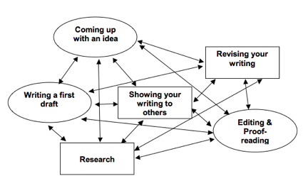
Seem complicated? It is, or at least it can be.

So, instead of thinking of the writing process as an ordered list, you should think of it more as a “web” where different points can and do connect with each other in many different ways, and a process that changes according to the demands of each writing project. While you might write an essay where you follow the steps in the writing process in order (from coming up with an idea all the way to proofreading), writers also find themselves following the writing process out of order all the time. That’s okay. The key thing to remember about the writing process is that it is a process made up of many different steps, and writers are rarely successful if they “just write.”
Last modified: Friday, October 16, 2015, 11:31 AM
1.1.2: Why Write a Research Paper? Writing for Success: "Chapter 11, Section 1: The Purpose of Research Writing"

LEARNING OBJECTIVES
- Identify reasons to research writing projects.
- Outline the steps of the research writing process.
Why was the Great Wall of China built? What have scientists learned about the possibility of life on Mars? What roles did women play in the American Revolution? How does the human brain create, store, and retrieve memories? Who invented the game of football, and how has it changed over the years?
You may know the answers to these questions off the top of your head. If you are like most people, however, you find answers to tough questions like these by searching the Internet, visiting the library, or asking others for information. To put it simply, you perform research.
Whether you are a scientist, an artist, a paralegal, or a parent, you probably perform research in your everyday life. When your boss, your instructor, or a family member asks you a question that you do not know the answer to, you locate relevant information, analyze your findings, and share your results. Locating, analyzing, and sharing information are key steps in the research process, and in this chapter, you will learn more about each step. By developing your research writing skills, you will prepare yourself to answer any question no matter how challenging.

Reasons for Research
When you perform research, you are essentially trying to solve a mystery—you want to know how something works or why something happened. In other words, you want to answer a question that you (and other people) have about the world. This is one of the most basic reasons for performing research.
But the research process does not end when you have solved your mystery. Imagine what would happen if a detective collected enough evidence to solve a criminal case, but she never shared her solution with the authorities. Presenting what you have learned from research can be just as important as performing the research. Research results can be presented in a variety of ways, but one of the most popular—and effective—presentation forms is the research paper. A research paper presents an original thesis, or purpose statement, about a topic and develops that thesis with information gathered from a variety of sources.
If you are curious about the possibility of life on Mars, for example, you might choose to research the topic. What will you do, though, when your research is complete? You will need a way to put your thoughts together in a logical, coherent manner. You may want to use the facts you have learned to create a narrative or to support an argument. And you may want to show the results of your research to your friends, your teachers, or even the editors of magazines and journals. Writing a research paper is an ideal way to organize thoughts, craft narratives or make arguments based on research, and share your newfound knowledge with the world.

EXERCISE 1
Write a paragraph about a time when you used research in your everyday life. Did you look for the cheapest way to travel from Houston to Denver? Did you search for a way to remove gum from the bottom of your shoe? In your paragraph, explain what you wanted to research, how you performed the research, and what you learned as a result.

Research Writing and the Academic Paper
No matter what field of study you are interested in, you will most likely be asked to write a research paper during your academic career. For example, a student in an art history course might write a research paper about an artist’s work. Similarly, a student in a psychology course might write a research paper about current findings in childhood development.
Having to write a research paper may feel intimidating at first. After all, researching and writing a long paper requires a lot of time, effort, and organization. However, writing a research paper can also be a great opportunity to explore a topic that is particularly interesting to you. The research process allows you to gain expertise on a topic of your choice, and the writing process helps you remember what you have learned and understand it on a deeper level.

Research Writing at Work
Knowing how to write a good research paper is a valuable skill that will serve you well throughout your career. Whether you are developing a new product, studying the best way to perform a procedure, or learning about challenges and opportunities in your field of employment, you will use research techniques to guide your exploration. You may even need to create a written report of your findings. And because effective communication is essential to any company, employers seek to hire people who can write clearly and professionally.

Writing at Work
Take a few minutes to think about each of the following careers. How might each of these professionals use researching and research writing skills on the job?
- Medical laboratory technician
- Small business owner
- Information technology professional
- Freelance magazine writer
A medical laboratory technician or information technology professional might do research to learn about the latest technological developments in either of these fields. A small business owner might conduct research to learn about the latest trends in his or her industry. A freelance magazine writer may need to research a given topic to write an informed, up-to-date article.

EXERCISE 2
Think about the job of your dreams. How might you use research writing skills to perform that job? Create a list of ways in which strong researching, organizing, writing, and critical thinking skills could help you succeed at your dream job. How might these skills help you obtain that job?

Steps of the Research Writing Process
How does a research paper grow from a folder of brainstormed notes to a polished final draft? No two projects are identical, but most projects follow a series of six basic steps.
These are the steps in the research writing process:
- Choose a topic.
- Plan and schedule time to research and write.
- Conduct research.
- Organize research and ideas.
- Draft your paper.
- Revise and edit your paper.
Each of these steps will be discussed in more detail later in this chapter. For now, though, we will take a brief look at what each step involves.

Step 1: Choosing a Topic
As you may recall from Chapter 8 "The Writing Process: How Do I Begin?", to narrow the focus of your topic, you may try freewriting exercises, such as brainstorming. You may also need to ask a specific research question—a broad, open-ended question that will guide your research—as well as propose a possible answer, or a working thesis. You may use your research question and your working thesis to create a research proposal. In a research proposal, you present your main research question, any related subquestions you plan to explore, and your working thesis.

Step 2: Planning and Scheduling
Before you start researching your topic, take time to plan your researching and writing schedule. Research projects can take days, weeks, or even months to complete. Creating a schedule is a good way to ensure that you do not end up being overwhelmed by all the work you have to do as the deadline approaches.
During this step of the process, it is also a good idea to plan the resources and organizational tools you will use to keep yourself on track throughout the project. Flowcharts, calendars, and checklists can all help you stick to your schedule. See Chapter 11 "Writing from Research: What Will I Learn?", Section 11.2 "Steps in Developing a Research Proposal" for an example of a research schedule.

Step 3: Conducting Research
When going about your research, you will likely use a variety of sources—anything from books and periodicals to video presentations and in-person interviews.
Your sources will include both primary sources and secondary sources. Primary sources provide firsthand information or raw data. For example, surveys, in-person interviews, and historical documents are primary sources. Secondary sources, such as biographies, literary reviews, or magazine articles, include some analysis or interpretation of the information presented. As you conduct research, you will take detailed, careful notes about your discoveries. You will also evaluate the reliability of each source you find.

Step 4: Organizing Research and the Writer’s Ideas
When your research is complete, you will organize your findings and decide which sources to cite in your paper. You will also have an opportunity to evaluate the evidence you have collected and determine whether it supports your thesis, or the focus of your paper. You may decide to adjust your thesis or conduct additional research to ensure that your thesis is well supported.

Tip
Remember, your working thesis is not set in stone. You can and should change your working thesis throughout the research writing process if the evidence you find does not support your original thesis. Never try to force evidence to fit your argument. For example, your working thesis is “Mars cannot support life-forms.” Yet, a week into researching your topic, you find an article in the New York Times detailing new findings of bacteria under the Martian surface. Instead of trying to argue that bacteria are not life forms, you might instead alter your thesis to “Mars cannot support complex life-forms.”

Step 5: Drafting Your Paper
Now you are ready to combine your research findings with your critical analysis of the results in a rough draft. You will incorporate source materials into your paper and discuss each source thoughtfully in relation to your thesis or purpose statement. When you cite your reference sources, it is important to pay close attention to standard conventions for citing sources in order to avoid plagiarism, or the practice of using someone else’s words without acknowledging the source. Later in this chapter, you will learn how to incorporate sources in your paper and avoid some of the most common pitfalls of attributing information.

Step 6: Revising and Editing Your Paper
In the final step of the research writing process, you will revise and polish your paper. You might reorganize your paper’s structure or revise for unity and cohesion, ensuring that each element in your paper flows into the next logically and naturally. You will also make sure that your paper uses an appropriate and consistent tone. Once you feel confident in the strength of your writing, you will edit your paper for proper spelling, grammar, punctuation, mechanics, and formatting. When you complete this final step, you will have transformed a simple idea or question into a thoroughly researched and well-written paper you can be proud of!

EXERCISE 3
Review the steps of the research writing process. Then answer the questions on your own sheet of paper.
- In which steps of the research writing process are you allowed to change your thesis?
- In step 2, which types of information should you include in your project schedule?
- What might happen if you eliminated step 4 from the research writing process?

KEY TAKEAWAYS
- People undertake research projects throughout their academic and professional careers in order to answer specific questions, share their findings with others, increase their understanding of challenging topics, and strengthen their researching, writing, and analytical skills.
- The research writing process generally comprises six steps: choosing a topic, scheduling and planning time for research and writing, conducting research, organizing research and ideas, drafting a paper, and revising and editing the paper.
1.1.3: How to Manage a Research Project

LEARNING OBJECTIVES
- Identify reasons for outlining the scope and sequence of a research project.
- Recognize the steps of the research writing process.
- Develop a plan for managing time and resources to complete the research project on time.
- Identify organizational tools and strategies to use in managing the project.
The prewriting you have completed so far has helped you begin to plan the content of your research paper—your topic, research questions, and preliminary thesis. It is equally important to plan out the process of researching and writing the paper. Although some types of writing assignments can be completed relatively quickly, developing a good research paper is a complex process that takes time. Breaking it into manageable steps is crucial. Review the steps outlined at the beginning of this chapter.
Steps to Writing a Research Paper
- Choose a topic.
- Schedule and plan time for research and writing.
- Conduct research.
- Organize research
- Draft your paper.
- Revise and edit your paper.
You have already completed step 1. In this section, you will complete step 2. The remaining steps fall under two broad categories—the research phase of the project (steps 3 and 4) and the writing phase (steps 5 and 6). Both phases present challenges. Understanding the tasks involved and allowing enough time to complete each task will help you complete your research paper on time with a minimal amount of stress.

Planning Your Project
Each step of a research project requires time and attention. Careful planning helps ensure that you will keep your project running smoothly and produce your best work. Set up a project schedulethat shows when you will complete each step. Think about how you will complete each step and what project resources you will use. Resources may include anything from library databases and word-processing software to interview subjects and writing tutors.
To develop your schedule, use a calendar and work backward from the date your final draft is due. Generally, it is wise to divide half of the available time on the research phase of the project and half on the writing phase. For example, if you have a month to work, plan for two weeks for each phase. If you have a full semester, plan to begin research early and to start writing by the middle of the term. You might think that no one really works that far ahead, but try it. You will probably be pleased with the quality of your work and with the reduction in your stress level.
As you plan, break down major steps into smaller tasks if necessary. For example, step 3, conducting research, involves locating potential sources, evaluating their usefulness and reliability, reading, and taking notes. Defining these smaller tasks makes the project more manageable by giving you concrete goals to achieve.
Jorge had six weeks to complete his research project. Working backward from a due date of May 2, he mapped out a schedule for completing his research by early April so that he would have ample time to write. Jorge chose to write his schedule in his weekly planner to help keep himself on track.
Review Jorge’s schedule. Key target dates are shaded. Note that Jorge planned times to use available resources by visiting the library and writing center and by meeting with his instructor.

EXERCISE 1
- Working backward from the date your final draft is due, create a project schedule. You may choose to write a sequential list of tasks or record tasks on a calendar.
- Check your schedule to be sure that you have broken each step into smaller tasks and assigned a target completion date to each key task.
- Review your target dates to make sure they are realistic. Always allow a little more time than you think you will actually need.

Tip
Plan your schedule realistically, and consider other commitments that may sometimes take precedence. A business trip or family visit may mean that you are unable to work on the research project for a few days. Make the most of the time you have available. Plan for unexpected interruptions, but keep in mind that a short time away from the project may help you come back to it with renewed enthusiasm. Another strategy many writers find helpful is to finish each day’s work at a point when the next task is an easy one. That makes it easier to start again.

Writing at Work
When you create a project schedule at work, you set target dates for completing certain tasks and identify the resources you plan to use on the project. It is important to build in some flexibility. Materials may not be received on time because of a shipping delay. An employee on your team may be called away to work on a higher-priority project. Essential equipment may malfunction. You should always plan for the unexpected.

Staying Organized
Although setting up a schedule is easy, sticking to one is challenging. Even if you are the rare person who never procrastinates, unforeseen events may interfere with your ability to complete tasks on time. A self-imposed deadline may slip your mind despite your best intentions. Organizational tools—calendars, checklists, note cards, software, and so forth—can help you stay on track.
Throughout your project, organize both your time and your resources systematically. Review your schedule frequently and check your progress. It helps to post your schedule in a place where you will see it every day. Both personal and workplace e-mail systems usually include a calendar feature where you can record tasks, arrange to receive daily reminders, and check off completed tasks. Electronic devices such as smartphones have similar features.
Organize project documents in a binder or electronic folder, and label project documents and folders clearly. Use note cards or an electronic document to record bibliographical information for each source you plan to use in your paper. Tracking this information throughout the research process can save you hours of time when you create your references page.

EXERCISE 2
Revisit the schedule you created in Note 11.42 "Exercise 1". Transfer it into a format that will help you stay on track from day to day. You may wish to input it into your smartphone, write it in a weekly planner, post it by your desk, or have your e-mail account send you daily reminders. Consider setting up a buddy system with a classmate that will help you both stay on track.

Tip
Some people enjoy using the most up-to-date technology to help them stay organized. Other people prefer simple methods, such as crossing off items on a checklist. The key to staying organized is finding a system you like enough to use daily. The particulars of the method are not important as long as you are consistent.

Anticipating Challenges
Do any of these scenarios sound familiar? You have identified a book that would be a great resource for your project, but it is currently checked out of the library. You planned to interview a subject matter expert on your topic, but she calls to reschedule your meeting. You have begun writing your draft, but now you realize that you will need to modify your thesis and conduct additional research. Or you have finally completed your draft when your computer crashes, and days of hard work disappear in an instant.
These troubling situations are all too common. No matter how carefully you plan your schedule, you may encounter a glitch or setback. Managing your project effectively means anticipating potential problems, taking steps to minimize them where possible, and allowing time in your schedule to handle any setbacks.
Many times a situation becomes a problem due only to lack of planning. For example, if a book is checked out of your local library, it might be available through interlibrary loan, which usually takes a few days for the library staff to process. Alternatively, you might locate another, equally useful source. If you have allowed enough time for research, a brief delay will not become a major setback.
You can manage other potential problems by staying organized and maintaining a take-charge attitude. Take a minute each day to save a backup copy of your work on a portable hard drive. Maintain detailed note cards and source cards as you conduct research—doing so will make citing sources in your draft infinitely easier. If you run into difficulties with your research or your writing, ask your instructor for help, or make an appointment with a writing tutor.

EXERCISE 3
Identify five potential problems you might encounter in the process of researching and writing your paper. Write them on a separate sheet of paper. For each problem, write at least one strategy for solving the problem or minimizing its effect on your project.

Writing at Work
In the workplace, documents prepared at the beginning of a project often include a detailed plan for risk management. When you manage a project, it makes sense to anticipate and prepare for potential setbacks. For example, to roll out a new product line, a software development company must strive to complete tasks on a schedule in order to meet the new product release date. The project manager may need to adjust the project plan if one or more tasks fall behind schedule.

KEY TAKEAWAYS
- To complete a research project successfully, a writer must carefully manage each phase of the process and break major steps into smaller tasks.
- Writers can plan a research project by setting up a schedule based on the deadline and by identifying useful project resources.
- Writers stay focused by using organizational tools that suit their needs.
- Anticipating and planning for potential setbacks can help writers avoid those setbacks or minimize their effect on the project schedule.

1.2.2: What Is Your Research Community - Dr. Pavel Zemliansky's "Methods of Discovery: A Guide to Research Writing - Chapter 6: Research Writing in the Academic Disciplines"

Introduction
Regardless of the academic discipline in which you conduct research and write, and the heart of the research and writing processes lie the same principles. These principles are critical reading and writing, active and creative interpretation of research sources and data, and writing rhetorically. At the same time, as a college writer, you probably know that research and writing assignment differ from one academic discipline to another. For example, different academic disciplines require researchers to use different research methods and techniques. Writers in different disciplines are also often required to discuss the results of their research differently. Finally, as you probably know, the finished texts look different in different disciplines. They often use different format and organizational structure and use different citation and documentation systems to acknowledge research sources.
All these differences are rhetorical in nature. Researchers and writers in different academic disciplines do what they do because they have a certain rhetorical purpose to fulfill and a certain audience to reach. In order to make their research understood and to enable others in their intellectual community to follow their ideas and theories, academic writers conform to the expectations of their readers. They follow the research methods and procedures as well as the conventions of presenting that research established by their academic community.
As a college student, you have probably noticed that your professors in different classes will give you different assignments and expect different things from you as a researcher and a writer. Researching this chapter, I looked for the types of writing and research assignments that professors of different academic disciplines assign to students at the university where I work, by browsing websites of its different departments. As I expected, there was a considerable variety of purposes, audience, and research methods. I saw assignments ranging from annual accounting reports assigned in a business class, to studies of various countries’ political systems in a political science course, to a web search for information on cystic fibrosis in a cell biology class. All these assignments had different parameters and expected writers to do different things because they reflected the peculiarities of research and writing in the disciplines in which they were assigned.
This variety of assignments, methods, and approaches is universal. A study by Daniel Melzer examined the kinds of research and writing assignments students in various colleges and universities across the nation receive in different disciplines. Melzer’s shows that students in various academic disciplines are asked to conduct research for a variety of purposes, which ranged from informing and persuading to exploration and self-expression (91). Also, according to Melzer’s study, students in different disciplines researched and wrote for a variety of audience which included not only the instructor of their class, but also their classmates and for wider audiences outside of their classes (95).
Despite this variety of goals, methods, and approaches, there are several key principles of source-based writing which span different academic disciplines and professions. These principles are:
- The purpose of academic writing is to generate and communicate new knowledge and new ideas.
- Academic writers write "from sources." This means that new ideas, conclusions, and theories are created on the basis of existing ideas and existing research
- Academic writers examine their sources carefully for their credibility and appropriateness for the writer's goals and objectives.
- Academic writers carefully acknowledge all their research sources using source citation and documentation systems accepted in their disciplines.
So, while one chapter or even a whole book cannot cover all the nuances and conventions of research and writing in every academic discipline. My purpose in this chapter is different. I would like to explore, together with you, the fundamental rhetorical and other principles and approaches that govern research writing across all academic disciplines. This chapter also offers activities and projects which, I hope, will make you more aware of the peculiar aspects of researching and writing in different academic disciplines. My ultimate goal in this chapter is to enable my readers to become active and critical investigators of the disciplinary differences in research and writing. Such an active approach will enable you to find out what I cannot cover here by reading outside of this book, by talking to your professors, and by practicing research and writing across disciplines.

Intellectual and Discourse Communities
My contention throughout this book has been that, in order to become better researchers and writers, we need to know not only the “how’s” of these two activities but also the “why’s.” In other words, it is not sufficient to acquire practical skills of research and writing. It is also necessary to understand why you do what you do as you research and what results you can expect to achieve as a results of your research. And this is where rhetorical theory comes in.
Writing and reading are interactive, social processes. Ideas presented in written texts are born as a result of long and intense dialog between authors and others interested in the same topic or issue. Gone is the image of the medieval scholar and thinker sitting alone in his turret, surrounded by his books and scientific instruments as the primary maker and advancer of knowledge. Instead, the knowledge-making process in modern society is a collaborative, effort to which many parties contribute. Knowledge is not a product of individual thinking, but of collective work, and many people contribute to its creation.
Academic and professional readers and writers function within groups known as discourse communities. The word “discourse” means the language that a group uses to talk what interests its members. For example, as a student, you belong to the community of your academic discipline. Together with other members of your academic discipline’s intellectual community, you read the same literature, discuss and write about the same subjects, and are interested in solving the same problems. The language or discourse used by you and your fellow-intellectuals in professional conversations (both oral and written) is discipline-specific. This explains, among other things, why the texts you read and write in different academic disciplines are often radically different from one another and even why they are often evaluated differently.

Writing Activity: Analyzing Intellectual and Discourse Communities
List all intellectual and discourse communities to which you belong. Examples of such communities are your academic major, any clubs or other academic or non-academic groups you belong to, your sorority or fraternity, and so on. Do not limit yourself to the groups with which you interact while in school. If you are a member of any virtual communities on the Internet, such as discussion groups, etc., include them in this list as well.
One you have listed all the intellectual and discourse communities to which you belong, consider the following questions:
- What topics of discussion, issues, problems, or concerns keep these communities together? And what constitutes new knowledge for your group? Is it created experimentally, through discussion, or through a combination of these two and other methods?
- How would you characterize the kinds of language which each of these communities use? Is it formal, informal, complex, simple, and so on? How are the community’s reasons for existence you listed in the first question reflected in their language?
- When you entered into the community, did you have to change your discourse, both oral and written, in any way, to be accepted and to participate in the discussions of the community? This might be a good time to consider all the linguistic adjustments you had to make becoming a college student or entering your academic major.
- Think of several classes you are currently taking. How do the discourses used in them differ from one another? Think about topics discussed, ways of making knowledge accepted in them, the degree of formality of the language used, and so on.
- Does your community or group produce any written documents? These may include books, professional journals, newsletters, and other documents. Don’t forget the papers that you write as a student in your classes. Those papers are also examples of your intellectual community’s discourse.
- What is the purpose of those documents, their intended audience, and the language that they use? How different are these documents from one community to the next? Compare, for example, a paper you wrote for your psychology class and one for a literature class.
- How often does a community you belong to come into contact with other intellectual and discourse groups? What kinds of conversations take place? How are conflicts and disagreements negotiated and resolved? How does each group adjust its discourse to hear the other side and be heard by it?
After completing this activity, you will begin to see knowledge making as a social process. I also hope that you will begin to notice the differences that exist in ways that different groups of people use language, reading, and writing. As persuasive and rhetorical mechanisms, reading and writing are supposed to reach between people and groups.
The term community does not necessarily mean that all members of these intellectual and discourse groups agree on everything. Nor does it mean that they have to be geographically close to one another to form such a community. Quite the opposite is often true. Debates and discussions among scientists and other academics who see things differently allows knowledge to advance. These debates in discussions are taking place in professional books, journals, and other publications, as well as at professional meetings.
Writing Activity: Rhetorical Analysis of Academic Texts
In consultation with your instructor, select two or three leading journals or other professional publications in your academic major or any other academic discipline in which you are interested. Next, conduct a rhetorical analysis of the writing which appears in them. Consider the following questions:
- What is the purpose of the articles and other materials that appear in the journals? Talk about this purpose as a whole; then select one or two articles and discuss their purpose in detail. Be sure to give concrete examples and details.
- Who are the intended audience of these publications? What specific elements in the writing which appears there can help us decide?
- Consider the structure and format of the writings in the journals. How do they connect with the purpose of the writing and the intended audience? For instance, what kinds of evidence or citation systems do their authors’ use?
- Discuss your results with your classmates and your instructor, or prepare a formal paper reporting and analyzing the results of your research.
The Making of Knowledge in Academic Disciplines
In the preceding section of this chapter, I made a claim that the making of new knowledge is a social process, undertaken by intellectual communities. In this section, we will look at one influential theory that has tried to explain how exactly this knowledge-making process happens. The theory of knowledge-making which I am talking about was proposed by Thomas Kuhn in his much-cited 1962 book The Structure of Scientific Revolutions. Although, as the book’s title suggests, Kuhn was writing about sciences, Kuhn’s theory has now been accepted as relevant and useful not only by academic disciplines outside of natural sciences.
According to Kuhn, the change in human knowledge about any subject takes place in the following steps. At first, an academic discipline or any other intellectual community works within the confines of an accepted theory or theories. The members of the community use it systematically and methodically. Kuhn calls this theory or theories the accepted paradigm, or standard of the discipline. Once the majority of an intellectual community accepts a new paradigm, the community’s members work on expanding this paradigm, but not on changing it. While working within an established paradigm, all members of an intellectual community have the same assumptions about what they study and discuss, use the same research methods and approaches, and use the same methods to present and compare the results of their investigation. Such uniformity allows them to share their work with one another easily. More importantly, though, staying within an accepted paradigm allows researchers to create a certain version of reality that is based on the paradigm that is being used and which is accepted by all members of the community. For example, if a group of scientists studies something using a common theory and common research methods, the results that such investigation yields are accepted by this group as a kind of truth or fact that had been experimentally verified.
Changes in scientific paradigms happen, according to Kuhn, when scientists begin to observe unusual phenomena or unexpected results in their research. Kuhn calls such phenomena anomalies. When anomalies happen, the current paradigm or system of research and thinking that a community employs fails to explain them. Eventually, these anomalies become so great that they are impossible to ignore. Then, a shift in paradigm becomes necessary. Gradually, then, existing paradigms are re-examined and revised, and new ones are established. When this happens, old knowledge gets discarded and substituted by new knowledge. In other words, an older version of reality is replaced by a newer version.
To illustrate his theory, Kuhn uses the paradigm shift started by the astronomer Copernicus and his theory that the Earth revolves around the Sun. I have also used this example in the chapter of this book dedicated to rhetoric to show that even scientific truths that seem constant and unshakable are subject to revision and change. To an untrained eye it may seem that all scientists and other researchers do is explain and describe reality which is unchangeable and stable. However, when an intellectual community is working within the confines of the current paradigm, such as a scientific theory or a set of research methods, their interpretations of this reality are limited by the capabilities and limitations of that paradigm. In other words, the results of their research are only as good as the system they use to obtain those results. Once the paradigm use for researching and discussing the subjects of investigation changes, the results of that investigation may change, too. This, in turn, will result in a different interpretation of reality.

Application of the Concept of Discourse Communities to Research Writing
Kuhn’s theory of knowledge making is useful for us as researchers and writers because it highlights the instability and changeability of the terms “fact” and “opinion.” As I have mentioned throughout this book, the popular perception of these two terms is that they are complete opposites. According to this view, facts can be verified by empirical, or experimental methods, while opinions are usually purely personal and cannot be verified or proven since they vary from one person to another. Facts are also objective while opinions are subjective. This ways of thinking about facts and opinions is especially popular among beginning writers and researchers. When I discuss with my students their assumptions about research writing, I often hear that research papers are supposed to be completely objective because they are based on facts, and that creative writing is subjective because it is based on opinion. Moreover, such writers say, it is impossible to argue with facts, but it is almost equally impossible to argue with opinions since every person is entitled to one and since we can’t really tell anyone that their opinions are wrong.
In college writing, such a theory of fact and opinion has very tangible consequences. It often results in writing in which the author is either too afraid to commit to a theory or points of view because he or she is afraid of being labeled subjective or biased. Consequently, such writers create little more than summaries of available sources. Other inexperienced writers may take the opposite route, writing exclusively or almost exclusively from their current understanding of their topics, or from their current opinions. Since “everyone is entitled to their own opinion,” they reason, no one can question what they have written even if that writing is completely unpersuasive. In either case, such writing fails to fulfill the main purpose of research, which is to learn.
What later becomes an accepted theory in an academic discipline begins as someone’s opinion. Enough people have to be persuaded by a theory in order for it to approach the status of accepted knowledge. All theories are subject to revision and change, and who is to say some time down the road, a better research paradigm will not be invented that would overturn what we now consider a solid fact. Thus, research and the making of knowledge are not only social processes but also rhetorical ones. Change in human understanding of difficult problems and issues takes place over time. By researching those problems and issues and by discussing what they find with others, writers advance their community’s understanding and knowledge.

Writing Activity: Investigating Histories of Academic Discussions.
The subjects of academic research, debates, and disagreements develop over time. To you as a student, it may seem that when you read textbooks and other professional literature in your major or other classes you are taking, you are taking in permanent and stable truths. Yet, as we have seen from the previous two sections of this chapter, members of academic communities decide what topics and questions are important and worth researching and discussing before these discussions make it to the textbook of the pages of an academic journal.
In this activity, you are invited to examine the history and development of an issue, problem, or question in your major or other academic discipline that interests you. In other words, you will be a historian of an academic discipline whose job will be to trace the development of a topic, question, or issue important to one academic community. How far you will take this project will depend on the time you have, the structure of your class, and the advice of your instructor. For example, you may be limited to conducting a simple series of searches and preparing an oral presentation for your classmates. Or, you may decide to make a full-length writing project out of this assignment, at the end creating an I-search paper or some other written document presenting and discussing the results of your research.
In either case, try to follow the following steps during this project. Depending on the instructions from your teacher, you may work by yourself or with others.
In order to select an important issue or question that is actively discussed in your academic or professional community, first look through the textbooks in your major or any other academic discipline you are interested in. Next, conduct a library search for journals in the field and briefly looks over what topics, issues, or questions they are concerned with. Conduct a web search for reliable sites where these professional discussions are taking place. If you are taking a class or classes in the discipline you are studying, discuss this assignment and the emerging topic of your investigation with your professor. Try to find out how this topic is explained to the general public in popular magazines and newspapers. Remembers that your goal in this project not to learn and report on the current state of this discussion (although such reporting may be a part of your project), but to investigate its historical development as an issue or a problem in the academic discipline of your interest.
Develop a general understanding of the current state of the issue or topic you are interested in. Be sure to include to the following elements:
  - What is the topic of discussion?
  - What evidence of the topic’s importance for your academic discipline have you found?
  - What is being said about the issue and by whom?
  - Are there opposing sides in the discussion and on what ground do they oppose each other?
  - What arguments do all the sides in the discussion use?
Conduct research into the origin and the history of your topic. The time range of your investigation will depend on the topic you choose. Some academic discussions go back centuries while others may have started only several years ago. Your research sources may include older textbooks, academic journals and conference procedures from years past, ever articles about your subject written for popular magazines and newspapers and designed to reach non-specialized audience. As a historian, you will need to cover the following areas:
- The first time the topic or issue gets significant attention from the professional community. Keep in mind that your job is not necessarily to pinpoint the exact date when the first publication on the topic appeared or the first discussion about it took place, although finding that out certainly will not hurt. Rather, try to find out the general time period when the discussion originated or the topic was attracting attention from academic professionals.
- What events in the academic world and society as a whole may have triggered the discussion of this topic? Since the academic world is a part of society as a whole, academic interests and discussions are usually somehow connected with what society as a whole is interested in and concerned about.
- Name a few key figures and events that contributed to the prominence of the topic or issue you are investigating.
- Identify times of paradigm shift for your subject. What event, both in the academic discipline and in society at large, may have caused significant shifts in people’s thinking about the issue?
- Try to predict the future development of the discussion. Will it remain an important issue in your discipline or will the discussion end? Why or why not? What factors, events, and people, both in the academic worlds and in society as a whole may contribute to this. How do you suppose the discussion of the topic will evolve in the future? For example, will the questions and issues at stake be revised and redefined?
- Chances are that during your research, your saw some significant developments and shifts in the ways in which your academic discipline has understood and talked about the issues and topic that interest its members.
To illustrate the process of historical investigation of an academic subject, let us look at the hot issue of cloning. What began as a scientific debate years ago has transcended the boundaries of the academic world and is not interesting to various people from various walks of life, and for various reasons. The issue of cloning is debated not only from the scientific, but also from the ethical and legal points of view, to name just a few.

Cloning: Current Perspectives and Discussions
Since I am not a scientist, my interest in the subject of cloning is triggered by an article on stem cell research that I read recently in the popular magazine Scientific American. I know that stem cell research is a controversial subject, related to the subject of human cloning. My interest in stem cell research was further provoked by the impassioned speech made by Ron Regan, the son of the late President Ronald Regan, at the Democratic Party’s National Convention in the summer of 2004. Regan was trying to make a case for more stem cell research by arguing that it could have helped hid father who had died of Alzheimer’s disease.
I conducted a quick search of my university library using the key words “human cloning.” The search turned up eighty-seven book titles that told me that the topic is fairly important for the academic community as well as for the general public. I noticed that the most recent book on cloning in my library’s collection was published this year while the oldest one appeared in 1978. There seemed to be an explosion of interest in the topic beginning in the 1990s with the majority of the titles appearing between then and 2004.
Next, I decided to search two online databases, which are also accessible from my university library’s website. I was interested in both scientific and legal aspects of cloning, so I searched the health science database PubMed (my search turns up 2549 results). Next, I search the database LexisNexis Congressional that gave me access to legislative documents related to human cloning. This search left me with over a hundred documents.
I was able to find many more articles on human cloning in popular magazines and newspapers. By reading across these publications, I would probably be able to get a decent idea about the current state of the debate on cloning.

Cloning: A Historical Investigation
Dolly the sheep was cloned in 1996 by British scientists and died in 2003. According to the website Science Museum (www.sciencemuseum.org.uk), “Dolly the sheep became a scientific sensation when her birth was announced in 1997. Her relatively early death in February 2003 fuels the debate about the ethics of cloning research and the long-term health of clones.”
I am tempted to start my search with Dolly because it was her birth that brought the issue of cloning to broad public’s attention. But then I recall the homunculus—a “test tube” human being that medieval alchemists often claimed to have created. It appears that my search into the history of cloning debate will have to go back much further than 1996 when Dolly was cloned.

Cloning: Signs of Paradigm Shifts
Living in the 21st century, I am skeptical towards alchemists’ claims about creating a homunculus out of a bad of bones, skin, and hair. Their stories may have been believable in the middle-ages, though, and may have represented the current paradigm of thinking about the possibility of creating living organisms is a lab. So, I turned to Dolly in an attempt to investigate what the paradigm of thinking about cloning was in the second half of the 1990s and how the scientific community and the general public received the news of Dolly’s birth. Therefore, I went back to my university library’s web page and searched the databases for articles on Dolly and cloning published within two years of Dolly’s birth in 1996.
After looking through several publications, both from scientific and popular periodicals, I sense excitement, surprise, skepticism, and a little concern about the future implications of our ability to close living creatures. Writing for The Sunday Times, in 1998, Steve Connor says that Dolly would undergo texts to prove that she is, indeed, the clone of her mother. In his article, Connor uses such words as “reportedly” which indicates skepticism (The Sunday Times, Feb 8, 1998, p. 9).
In a New Scientist article published in January 1998, Philip Cohen writes that in the future scientists are likely to establish human cloning techniques. Cohen is worried that human cloning would create numerous scientific, ethical, and legal problems. (New Scientist, Jan 17, 1998 v157 n2117 p. 4(2))
Let’s now fast-forward to 2003 and 2004. Surprisingly, at the top of the page of search results are the news that the British biotech company whose employees cloned Dolly. Does this mean that cloning is dead, though? Far from it! My research shows debates about legal and ethical aspects of cloning. The ability of scientists to clone living organisms is not in doubt anymore. By now, political and ideological groups have added their agendas and their voices to the cloning and stem cell research debate, and the US Congress has enacted legislation regulating stem cell research in the US. The current paradigm of discussions of human cloning and the related subject of stem cell research is not only scientific but also political, ethical, legal, and ideological in nature.
The historical study project as well as my illustration of how such an investigation could be completed should illustrate two things. Firstly, if you believe that something about human cloning or any other topic worth investigating is an undisputable fact, chances are that some years ago in was “only” someone’s opinion, or, in Kuhn’s words, an “anomaly” which the current system of beliefs and the available research methods could not explain. Secondly, academic and social attitudes towards any subject of discussion and debate are formed and changed gradually over time. Both internal, discipline specific factors, and external, social ones, contribute to this change. Such internal factors include the availability of new, more accurate research techniques or equipment. The external factors include, but are not limited to, the general cultural and political climate in the country and in the world. Academic research and academic discussions are, therefore, rhetorical phenomena which are tightly connected not only to the state of an academic discipline at any given time, but also to the state of society as a whole and to the interests, beliefs, and convictions of its members.
Research Activity: Interviewing Academic Professionals
In order to learn more about the conventions of academic discourse, interview a professor at your college. You may wish to talk to one of the teachers whose classes you are currently taking. Or, you may choose to interview a teacher whom you do not yet know personally, but who teaches a course that interests you or who works in an academic major that you are considering. In either case, the purpose of your interview will be to learn about the conventions of research and writing in your interlocutor’s academic discipline. You can design your own interview questions. To learn about designing interviews, read the appropriate section in Chapter 7 of this book. To get you started, here are three suggestions:
- Ask to describe, in general, the kinds of research and writing that professionals in that academic field conduct. Focus on research goals, methods, and ways in which research results are discussed in the field’s literature.
- Discuss how a specific text from the academic discipline, such as a book or a journal article reflects the principles and approaches covered in the first question.
- Ask for insights on learning the discourse of the discipline.

Establishing Authority in Academic Writing by Taking Control of Your Research Sources
Good writing is authoritative. It shows that the author is in control and that he or she is leading the readers along the argument by skillfully using research sources, interpreting them actively and creatively, and placing the necessary signposts to help the readers anticipate where the discussion will go next. Authoritative writing has its writing and its writer’s voice present at all times. Readers of such writing do not have to guess which parts of the paper they are reading come from an external source and which come from the author him or herself.
The task of conveying authority through writing faces any writer since it is one of the major components of the rhetorical approach to composing. However, it is especially relevant to academic writing because of the context in which we learn it and in which it is read and evaluated.
We come to academic writing as apprentices not only in the art of composing but also in the academic discipline which are studying. We face two challenges at the same time. On the one hand, we try to learn to become better writers. On the other, we study the content of our chosen academic disciplines that will become the content of our academic writing itself. Anyone entering college, either as an undergraduate or a graduate student, has to navigate the numerous discourse conventions of their academic discipline. We often have too little time for such navigation as reading, writing, and research assignments are handed to us soon after our college careers begin. In these circumstances, we may feel insecure and unsure of our previous knowledge, research, and writing expertise.
In the words of writing teacher and writer David Bartholomae, every beginning academic writer has to “invent the university.” What Bartholomae means by this is, when becoming a member of an academic community, such as a college or a university, each student has to understand what functioning in that community will mean personally for him or her and what conventions of academic reading, writing, and learning he or she will be expected to fulfill and follow. Thus, for every beginning academic writing, the process of learning its conventions is akin to inventing his or her own idea of what university intellectual life is like and how to join the university community.
Beginning research and academic writers let their sources control their writing too often. I think that the cause of this is the old idea, inherent in the traditional research paper assignment, that researched writing is supposed to be a compilation of external sources first and a means for the writer to create and advance new knowledge second, if at all. As a result, passages, and sometimes whole papers written in this way lack the writer’s presence and, as a consequence, they lack authority because all they do is re-tell the information presented in sources. Consider, for example, the following passage from a researched argument in favor of curbing video game violence. In the paper, the author is trying to make a case that a connection exists between violence on the video game screen and in real life. The passage below summarizes some of the literature
The link between violence in video games and violence in real life has been shown many times (Abrams 54). Studies show that children who play violent video games for more than two hours each day are more likely to engage in violent behavior than their counterparts who do not (Smith 3). Axelson states that some video games manufacturers have recognized the problems by reducing the violence in some of their titles and by rating their games for different age groups (157). The government has instituted a rating system for videogames similar to the one used by the movie industry in an effort to protect your children from violence on the screen (Johnson 73). Alberts and Cohen say that we will have to wait and see whether this rating system will prove to be effective in curbing violence (258).
This passage lacks authority because every sentence in it is taken from an external source. Where is the writer in this paragraph? Where are the writer’s voice and interpretations of the research data? What new insights about the possible connection between video game and real life violence do we get from this author? Is there anything in this passage that we could not have learned by reading the sources mentioned in this paper? This writer has let external sources control the writing by composing an entire paragraph (and the rest of the paper is written in the same way) out of external source segments and nowhere in this passage do we see the author’s own voice, persona, or authority.
So, how can the problem of writing without authority and without voice be solved? There are several ways, and the checklist below provides you with some suggestions.
- Always remember to use research for a rhetorical purpose—to create new knowledge and convey it to your readers. Except in rare cases, writers are not compilers of existing information. Resist the urge to limit your research to simply summarizing and quoting external sources. Therefore, your ultimate purpose is to create and express your own theories and opinions about your topic
- Talk to academics or professionals to find out what constitutes authoritative writing in their field. It could be the presence of a strong voice, or the use f particular research methods and techniques, or a certain way to present the results of your research. Later on in the chapter, you are offered an interview project designed to help you do that.
- Create annotated bibliographies to make sense of your research and make the ideas and theories you read about, your own. Try the annotated bibliography activity later on in the chapter.
- Use only reliable sources. For advice on locating such sources, see Chapter 11 of this book.

Integrating Sources into Your Own Writing
One of the most difficult tasks facing students of research writing is learning how to seamlessly integrate the information they find in the research sources into their own writing. In order to create a rhetorically effective researched text, a writer needs to work out a way of combining the research data, the voices and theories of research sources’ authors on the one hand and his or her ideas, voice, and tone on the other. The following techniques of integrating source material into your own writing are, of course, relevant not only for academic research. However, it is when faced with academic research papers that many beginning researchers face problems with the integration of sources. Therefore, I am placing the discussion of these methods into the chapter of the book dedicated to academic research.
Typically, researching writers use the following methods of integrating information from research sources into their writing:
Direct quoting
Quoting from a source directly allows you to convey not only the information contained in the research source, but also the voice, tone, and “feel” of the original text. By reading direct quotes, your readers gain first-hand access to the language and the spirit of the original source.

How Much to Quote
Students often ask me how much of their sources they should quote directly in their papers. While there is no hard and fast rule about it, I usually reply that they should quote only when they feel it necessary to put their readers in direct contact with the text of the source. Quote if you encounter a striking word, sentence, or passage, one that you would be hard pressed to convey the same information and the same emotions and voice better than the original source. Consider, for example the following passage from a paper written by a student. In the paper, the writer analyzes a 19th-century slave narrative written by a man named J. D. Green:
The most important event of Green’s early life was the sale of his mother to another owner at the young age of twelve years old. In response to this Green dropped to his knees and [shouted] at the heavens, “Oh! How dreadful it is to be black! Why was I born black? It would have been better had I not been born at all” (Green 5). It is this statement that communicates the message of Green’s story. [None of] the atrocities told in the later portions of the narrative…elicit the same level of emotion and feeling from Green. For the remainder of the story, [he] is very reserved and treats each increasingly horrendous crime as if it was of no particular importance.
The direct quote works well here because it conveys the emotion and the voice of the original better than a paraphrase or summary would. Notice also the author of the paper quotes sparingly and that the borrowed material does not take over his own ideas, voice, and tone. Out of roughly ten lines in this passage, only about two are quoted, and the rest is the author’s own interpretation of the quote or explanation for why the quote is necessary here.
If, after writing a preliminary draft of a paper, you feel that you have too many quotes and not enough of your own material, try the following simple trouble-shooting method. This activity was suggested to me by my colleague Michael Moghtader. Both my students and I have found it effective.
Take a pen or a highlighter and mark all direct quotes in your paper. Make sure that the amount of quoted material does not exceed, or even equal the amount of your own writing. A good ratio of your own writing to quoted material would be 70% to 30% or even 80% to 20%. By keeping to these numbers, you will ensure that you work is not merely a regurgitation of writing done by others, but that it makes a new and original contribution to the treatment of your topic.

Summarizing
A summary is a shortened version of the original passage, expressed in the writer’s own words. The key to creating a good and useful summary of a source is preserving all the information and arguments contained in the original while condensing original to a small size. According to Bruce Ballenger, the author of the book The Curious Researcher (2001), summarizing “…requires careful thought , since you are the one doing the distilling [of the original], especially if you are trying to capture the essence of the whole movie, article, or chapter, that’s fairly complex” (128). Purely and simply, then, a good summary manages to capture the essence of the original passage without losing any important information.
Consider the following example. The original passage comes from an article exploring manifestation of the attention deficit/hyperactivity disorder (ADHD) not only in children but also in adults
Original passage:
Perhaps the clearest picture of adult ADHD comes from studies of people originally diagnosed with ADHD in grade school and followed by researchers through adolescence and young adulthood. These studies vary widely in their estimates of ADHD prevalence, remission rates, and relationship to other psychiatric disorders. But over all, they show a high percentage -- 80% in several studies --of ADHD children growing into ADHD adolescents. Such individuals have continual trouble in school, at home, on the job, with the law in general, and with substance abuse in particular. Compared with control groups, ADHD adolescents are more likely to smoke, to drop out of school, to get fired, to have bad driving records, and to have difficulties with sexual relationships. "There's a great deal of continuity from the child to the adult form," says Russell Barkley, a researcher at the Medical University of South Carolina. "We're not seeing anything that suggests a qualitative change in the disorder. What's changing for adults is the broadening scope of impact. Adults have more things they've got to do. We're especially seeing problems with time, with self-control, and with planning for the future and being able to persist toward goals. In adults, these are major problems." Poor time management is a particularly treacherous area. As Barkley observes, "With a five-year-old, time management isn't relevant. With a 30-year-old, it's highly relevant. You can lose your job over that. You can lose a relationship over it."
Summary:
According to the authors of the article “A Lifetime of Distraction,” studies show that about 80% of children with ADHD grown into ADHD adolescents. Such people may have trouble in school, at work, and even with the law. Poor time management by adults with ADHD is of particular concern (1).
When summarizing the lengthy original passage, I looked for information struck me as new, interesting, and unusual and that might help me with my own research project. After reading the original text, I discovered that ADHD can transfer into adulthood—something I had not known before. That claim is the main focus of the passage and I tried to reflect it in my summary.

Paraphrasing
Paraphrasing means rewriting original passages in your own words and in roughly the same length. Skillful paraphrasing of your sources can go a long way in helping you achieve two goals. Firstly, when you paraphrase you are making sense of your sources, increasing your “ownership” of the ideas expressed in them. This allows you to move a little closer to creating your own viewpoint, your own theory about the subject of your research. Paraphrasing is a great alternative to direct quoting (especially excessive quoting) because it allows you to recast the ideas of the original into your own language and voice. Secondly, by carefully paraphrasing source material, you are helping yourself to avoid unintentionally plagiarizing your sources. There is more discussion on how to avoid plagiarism in Chapter 12. For now, consider this passage, taken from the article “Fighting the Images Wars”, by Steven Heller.
Original:
Such is the political power of negative imagery that, during World War II, American newspapers and magazines were prohibited from publishing scenes of excessively bloody battles, and drawings done by official "war artists" (at least those that were made public) eschewed overly graphic depictions. It wasn't easy, but U.S. military propaganda experts sanitized the war images, with little complaint from the media. While it was acceptable to show barbaric adversaries, dead enemy soldiers, and even bedraggled allies, rare were any alarming representations of our own troops in physical peril, such as the orgy of brutal violence during the D-Day landings.
Paraphrase:
In his article “Fighting the Image Wars,” writer Steven Heller argues that the US government tries to limit the power of the media to publish disturbing images of war and conflict. According to Heller, during World War II and during the Korean War, American media were not allowed to publish images of disturbing war scenes (176). Heller further states that while it was often OK to show the enemies of the US as “barbaric” by displaying images of the atrocities committed by them, media rarely showed our own killed or wounded troops (176).
While the paraphrase is slightly shorter than the original, it captures the main information presented in the original. Notice the use in the paraphrase of the so-called “signal phrases.” The paraphrase opens with the indication that what is about to come is taken from a source. The first sentence of the paraphrased passage also indicates the title of that source and the name of its author. Later on in the paragraph, the signal phrase “According to Heller” is used in order to continue to tell the reader that what he or she is reading is the author’s rendering of external source material.
How to Quote, Paraphrase, and Summarize Effectively
One of the reasons why so many of us do not like the traditional research paper assignment is because we often feel that it requires us to collect and compile information without much thought about why we do it. In such assignments, there is often not enough space for the writer to express and explore his or her own purpose, ideas, and theories. Direct quoting is supposed to help you make your case, explain or illustrate something. The quote in the passage above also works well because it is framed by the author’s own commentary and because it is clear from why the author needs it. He needs it in order to show the utter horror of J.D. Green at the sale of his mother and his anguish at being black in a slave-holding society. The quote is preceded by statement claiming that the loss of his mother was a terrible event for Green (something that the quote eloquently illustrates). After quoting from the source, the writer of the paper prepares his readers for what is to come later in the paper. Therefore, the quote in the passage above fulfills a rhetorical purpose. It illustrates a key concept that will be seen throughout the rest of the work and sets up the remaining portion of the argument.
Every direct quotation from a source should be accompanied by your own commentary. Incorporating source material into your writing effectively is similar to weaving a thread of one color into a carpet or blanket of another. In combination, the two colors can create a beautiful pattern. Try to follow this sequence:
- Introduce the source and explain why you are using it
- Quote
- Comment on the source material and set up the next use of a source
- Quote
- Continue using the steps in the same or similar order for each source.
Such variation of your own ideas, commentary, and interpretation on the one hand and source material on the other creates a smooth flow of the text and can be used not only for work with direct quotes but also with source summaries and paraphrases.
Quick Reference: Using Signal Phrases
When using external source material, whether by direct quoting, summarizing or paraphrasing, it is important to guide your readers through it in such a way that they always understand clearly where it is you, the author of the paper speaking and where you are working with external sources. To indicate this, signal phrases are used. Signal phrases introduce quoted, paraphrased, or summarized material to the reader. Here are some popular signal phrases:
“According to [author’s name or work’s title]…”
“[Author’s name] argues that…”
“[Author’s name] states that…”
“[Author’s name] writes that…”
“[Author’s name] contends that…”
There are many other variations of these. When writing your own papers, play with these phrases, modify them to suit your needs, and see how that does to your writing. Remember that your readers need to be prepared for every quote, summary, or paraphrase. They need to know what is coming and why. Using signal phrases will help you prepare them.
Writing Activity: Putting The Writer Back into Writing
If you suspect that you might have passages like the one above in your own academic writing, try to locate them. Then, make them your own by using sources for your rhetorical purpose rather than letting your sources control you. Follow the following suggestions:
- Do something with every source and every external reference. Sources, no matter how authoritative, do not speak for themselves. It is up to you as a writer to explain their significance for your paper and to comment on them. Therefore, every time you need to use an external source in your writing, explain to your readers what that source does for your argument and why you are using it.
- Establish and assert your authority over the subject of your writing and over your sources. It is your paper, and therefore it your voice, your opinions, and your theories that really count in it. External sources are useful learning and argument tools, but it is still you who does the learning and the arguing.
- If you summarize and paraphrase your sources, make sure your readers know where a reference to one source ends and a reference to the next one begins.
- Make sure your readers know whether it is your source speaking or you. If you summarize or paraphrase your sources, rather then quoting them directly, do so in such a way that your audience knows where the summary or paraphrase ends and your own commentary on it begins.
- Carefully analyze what information about your sources your readers need. For example, if most of your readers have not studied your sources in detail, provide them with enough information about the sources.
- Apply the conventions of working with sources that exist in your academic discipline.

Writing Activity: Creating an Annotated Bibliography

Purpose
Creating an annotated bibliography of your research sources can help you take control of them and put your own voice and personality back into your research writing. Unlike conventional bibliographies that simply provide information about the work’s author, title, publisher, and so on, each entry of an annotated bibliography briefly summarizes an entry and then evaluates its possible application to research and writing.
According to Owen Williams, a librarian at the library of the University of Minnesota, annotated bibliographies are created with the following purposes:
- To review literature on a particular subject.
- To illustrate the quality of research that you have done
- To provide examples of the types of sources available
- To describe other items on the topic that might be of interest to the reader.
Williams then provides an example of an entry from an annotated bibliography:
“Sewell, W. (1989). Weaving a program: Literate programming in WEB. New York: Van Nostrand Reinhold.
Sewell explains the code language within these pages including certain lines of code as examples. One useful idea that Sewell uses is to explain characters and how they work in the programming of a Web Page. He also goes through and describes how to make lists and a title section. This will be very useful because all Web Pages have a title section. This author also introduces Pascal which I am not sure if I will include in my manual but after I read more about it I can decide whether this will be helpful to future users. This book will not be the basis of my manual but will add some key points, which are described above.”
Note that the author of this entry not only summarizes the content of a source, but also evaluates the usefulness of this source a specific research project. Annotated bibliographies are not just exercises in the rules of citation. Instead, they help writers to begin the transition from reading sources into writing about them. By combining evaluation with description, annotated bibliographies help writers approach their research actively by beginning to make sense of their sources early on in the research process.
Process
Begin a research project by collecting and annotating possible sources. Remember that not all the sources which your annotated bibliography will include may end up in your final paper. This is normal since researchers cast their nets much wider in the beginning of a project than the range of sources which they eventually include in their writing. The purpose of creating an annotated bibliography is to learn about the available resources on your subject and to get an idea how these resources might be useful for your particular writing project. As you collect your sources, write short summaries of each of them. Also try to apply the content of these sources to the project you are working on Don’t worry about fitting each source exactly into what you think your project will be like. Remember that, in the process of research, you are learning about your subject, and that you never really know where this learning process takes you.
Conclusions
As a college student, you are probably taking four, five, or even six classes simultaneously. In many, if not all of those classes you are probably required to conduct research and produce research-based writing. So far in this chapter, we have discussed some general principles of academic research and writing which, I hope, will help you improve as an academic researcher and writer regardless of your major or academic discipline in which you work. In this segment of the chapter, I would like to offer a practical checklist of approaches, strategies, and methods that you can use for academic research and writing.
- Approach each research writing assignment rhetorically. Learn to recognize its purpose, intended audience, the context in which you are writing and the limitations that this context will impose on you as a writer. Also treat the format and structural requirements, such as the requirement to cite external sources, as rhetorical devices which will help you to make a bigger impact on your readers.
- Try to understand each research and writing assignment as best as you can. If you receive a written description of the assignment, read it several times and discuss it with your classmates and your instructor. If in doubt about some aspect of the assignment, ask your instructor.
- Develop and use a strong and authoritative voice. Make your sources work for you, not control you. When you write, it is your theories and your voice that counts. Research helps you form and express those opinions.
- Becoming a good academic researcher and writer takes time, practice, and rhetorical sensitivity. It takes talking to professionals in academic fields, such as your college professors, reading a lot of professional literature, and learning to understand the research and writing conventions of each academic discipline. To learn to function as a researcher and writer in your chosen academic discipline or profession, it is necessary to understand that research and writing are governed by discourse and community conventions and not by rigid and artificial rules.

Sources
Kuhn, Thomas. 1962. The Structure of Scientific Revolutions. University of Chicago Press, Chicago, Illinois.
Melzer, Dan. 2003. “Assignments Across the Curriculum: A Survey of College Writing.” Language and Learning Across the Disciplines. (6.1): 86-110.
Last modified: Monday, October 19, 2015, 11:45 AM
1.2.2: What Is Your Research Community? Dr. Pavel Zemliansky's "Analyze Your Discourse Communities"
According to Dr. Zemliansky, a discourse community is a group of people that share common interests and who discuss topics important to the group. Before you begin any research project, it is important to understand your discourse community, because this will lead you to the most appropriate places to conduct your research and will help you speak to your audience in a language they understand and relate to. Complete this activity, adapted from Dr. Zemliansky’s “Chapter 6.” Use any academic resources that you can find on the Internet, in your home, or in any library with which you are affiliated. Thousands of references are available online, either in full or in part. If you need help getting started, try the sources listed in the "Online Resources for Professional and Academic Research Papers" worksheet.
List all intellectual and discourse communities to which you belong. Then, consider the following questions:
- What topics of discussion, issues, problems, or concerns keep these communities together? And what constitutes new knowledge for your group? Is it created experimentally, through discussion, or through a combination of these two and other methods?
- How would you characterize the kinds of language which each of these communities use? Is it formal, informal, complex, simple, and so on? How are the community’s reasons for existence you listed in the first question reflected in their language?
- When you entered into the community, did you have to change your discourse, both oral and written, in any way, to be accepted and to participate in the discussions of the community?
- Does your community or group produce any written documents? These may include books, professional journals, newsletters, and other documents. What is the purpose of those documents, their intended audience, and the language that they use? How different are these documents from one community to the next?
- How often does a community you belong to come into contact with other intellectual and discourse groups? What kinds of conversations take place? How are conflicts and disagreements negotiated and resolved? How does each group adjust its discourse to hear the other side and be heard by it?
Last modified: Monday, October 19, 2015, 11:42 AM

1.2.3: Identifying and Understanding Your Audience - Texas A&M University Writing Center: "Audience Awareness"
Knowing your audience—whether readers or listeners—will help you determine what information to include in a document or presentation, as well as how to convey it most effectively. You should consider your audience when choosing your tone, content, and language—or else your message may seem unfocused or inappropriate.
In the classroom, your audience is often your professor. However, some assignments are designed so that you are addressing a secondary audience such as an expert in the field or the general public. Even when your audience is your instructor, tailor your communication to meet expectations. For example, your professor may expect you to demonstrate critical thinking or to employ an academic style.

Audience Awareness in the Composing Process
You should consider your audience early in the course of writing documents or speeches, but not necessarily as the first step. Worrying too much about accommodating an audience can inhibit early stages of composition. Do some research and prewriting first. Once you’re knowledgeable about the topic and confident you have something to say about it, consider how to make it interesting and significant for specific readers or listeners.
Here are some questions to ask when analyzing your audience:
- How much does the audience know about the subject? The level and type of knowledge your audience already has determines how much background you need to provide, which terms will need definition or explanation, and whether you’ll use an academic or familiar tone.
- How does the audience feel about your topic? You may need to convince a skeptical audience that your views have merit. If the audience is biased against your stance, you’ll have to find ways to bring them around to your viewpoint. In that case, finding common ground might be a good place to start.
- What new information can you provide? Consider why your topic is important to your audience and what they can gain by giving you their attention. Can you motivate them to think more about your issue? To take action?
- What is your relationship to the audience? Are you giving orders, suggestions, or advice? Your tone may be more personal with a peer. If you’re an authority, you need to sound sure of yourself; if you’re a subordinate, you need to show respect.

The Effect of Audience on Style
Your style is determined in part by your audience. Together, the following elements constitute style; adjust them to reach your intended audience:
- Message. What does the audience care about, or what are they likely to act upon? What do they need to know from you?
- Argument/Content. What sort of evidence would convince them? What would they need to hear to agree with your argument? Would they appreciate a story or find it distracting?
- Word choice. Should you use jargon and slang? Formal or informal words? Contractions?
- Sentence type and length. Should you use long, complex sentences or short, simple ones? Can you use fragments?
- Tone. Should it be personal or distanced, humorous or serious, formal or informal?

Reaching Out to the Audience in the Introduction
The introduction helps the audience decide if a text is worth reading or a speech is worth their attention. Consider the choices the author makes in the following introduction:
Ex.1 Natalie, 11, is a timid kid, and her parents, though possessing the best of intentions, aren’t making it any easier for her. The Portland, Maine, sixth grader says, “I hate it when Mom and Dad get all supercheery and say, ‘Don’t be shy. See how your sister Tracy does it? Just go up to that kid and say hi.’ But I’m not Tracy. It’s really hard for me. I feel like everyone is watching me and waiting for me to mess up.”
The above is from a Good Housekeeping article, “10 Smart Ways to Help a Shy Child” by Beth Johns (March 2001, page 89). The intended audience is middle-class American women with at least a high school education. The readers have children and know ways to deal with them, but are looking for something new. The writer presents herself as a peer and draws interest immediately by using a human interest story about a particular child to introduce the topic. Her tone is informal and her language is casual: “kid” instead of “child,” a contraction for “are not,” and slang (“supercheery”). She uses active voice and short sentences.
Compare Johns’ introduction with “An Ambulatory Physiological Monitor for Animal Welfare Studies” in the scholarly journal Computers and Electronics in Agriculture (2001, Volume 32, pages 181-194):
Ex.2 A fundamental problem in recording continuous and rapidly varying physiological signals such as the electrocardiogram (ECG), electromyogram (EMG), or electroencephalogram (EEG) from freely-moving subjects over extended periods of time is the large volume of data that must be collected. This problem is further exacerbated when a number of signals and/or subjects are monitored simultaneously. In animal welfare studies, researchers often wish to record multiple signals from multiple animals while the animals are subjected to various stressors over periods of several weeks (Krantz and Falconer, 1995; Rollin, 1997).
Phillip J. Harris, Peter N. Schaare, Christian J. Cook, and Jon D. Henderson, the research team who wrote this, are clearly addressing fellow researchers who want to gain detailed knowledge on a topic they’re familiar with. Because these readers expect that the authors have read the most current literature on the topic, careful documentation is provided within parentheses. The authors use formal language, passive voice (“data must be collected”), jargon (“stressors”), and acronyms (“ECG”). Sentences tend to be long and use many modifiers. For example, the opening sentence has 26 words separating the subject from the predicate.

Addressing a Diverse Audience
An additional but important factor to consider when writing a document or preparing a speech is the differences that exist in our diverse society. Your goal should be to not only address your audience accurately and clearly, but also in a socially acceptable and professional manner. The following are suggestions to help you adapt your document or speech to meet this goal:
- Recognize your cultural filter. Cultures are not monolithic, but are formed from many factors such as class, gender, generation, religion, or education. Your cultural filter shapes how you view the world and can at times prevent understanding different backgrounds.
- Avoid ethnocentrism. Assuming that your culture’s values, customs, or beliefs are superior to another’s is ethnocentrism. It’s an attitude that can alienate your audience. Be careful not to assume that all cultural practices are shared. Suspend any judgments or cultural stereotypes. An example of an ethnocentric attitude is assuming that everyone in your audience believes capitalism is the best economic system just because that’s the system you live under.
- Be aware of gestures when speaking. In many cultures, different gestures have different meanings. For example, in North America, eye contact is a sign of respect. However, in Japan and Korea, the same eye contact is considered intimidating. Some gestures (sitting cross-legged, folding your arms) might be acceptable in one culture, but may appear rude or defensive in another. When giving a speech, consider whether your audiences might misconstrue any gestures you’re likely to make.
- Distinguish between people and their abilities. When referring to an individual with a disability, always use people-first language. For example, instead of “the blind woman,” write “the woman who is blind.” This will ensure the person is the focus of your message and not the disability. Also, avoid outdated terms (“handicapped,” “crippled”) and never identify someone solely by that person’s disability (“a quadriplegic,” “an epileptic.”).
- Adopt bias-free language. Biased language privileges one group or leaves out other groups or individuals and often makes unwarranted assumptions. For example, using the term “flesh-colored” assumes that every reader will have the same skin color—or that one color of skin is better than another. Don’t write “the male lawyer” when it is unnecessary to signify the lawyer’s gender. Avoid mentioning a person’s sex, gender, ethnic background, religion, disability, or physical characteristics without a sufficient reason for doing so.
- Avoid sexist language and gender-specific terms. Sexist language creates stereotypes that assume one gender is the norm. Nonsexist language refrains from addressing sex at all when it’s irrelevant. Gender-specific words (policeman) stress one sex, excluding the other. Consider substituting gender-neutral words (police officer).
- Acknowledge issues of oppression. Similar to ethnocentrism, the language we write or speak might convey a negative bias towards individuals or groups. If your message stereotypes a group, even unconsciously, you risk offending your audience. Examples of discriminating language to avoid include:
  - Racism– Your audience will be diverse. By recognizing that there are many cultural frames of reference, you’ll reach each reader or listener effectively. Unless it is necessary, avoid references to ethnicity.
  - Heterosexism – If your essay or speech depicts a relationship, don’t assume that each member of your audience is heterosexual.
  - Ageism – Many pervasive stereotypes exist with regard to the age of individuals. If you write or speak about an elderly person, challenge discriminating ideas such as “old people are feeble” or “teenagers lack wisdom.”
  - Sexism – While sexist language assumes one term for both genders, sexism suggests one sex or gender is inferior to the other. To suggest that females are emotional and men are logical privileges one sex over the other, while stereotyping that all of one sex have the same traits or characteristics.

References
Axtell, Roger E. Gestures: The Do’s and Taboos of Body Language Around the World. New York: John Wiley & Sons, Inc., 1998.
Lucas, Stephen E. The Art of Public Speaking: Ninth Edition. New York: McGraw-Hill, 2007.
Maggio, Rosalie. Talking About People: A Guide to Fair and Accurate Language. Westport, CT: Oryx Press, 1997.
Last modified: Tuesday, October 20, 2015, 11:15 AM

1.2.3: Identifying and Understanding Your Audience Texas A&M University Writing Center: "Audience Awareness"
Knowing your audience—whether readers or listeners—will help you determine what information to include in a document or presentation, as well as how to convey it most effectively. You should consider your audience when choosing your tone, content, and language—or else your message may seem unfocused or inappropriate.
In the classroom, your audience is often your professor. However, some assignments are designed so that you are addressing a secondary audience such as an expert in the field or the general public. Even when your audience is your instructor, tailor your communication to meet expectations. For example, your professor may expect you to demonstrate critical thinking or to employ an academic style.

Audience Awareness in the Composing Process
You should consider your audience early in the course of writing documents or speeches, but not necessarily as the first step. Worrying too much about accommodating an audience can inhibit early stages of composition. Do some research and prewriting first. Once you’re knowledgeable about the topic and confident you have something to say about it, consider how to make it interesting and significant for specific readers or listeners.
Here are some questions to ask when analyzing your audience:
- How much does the audience know about the subject? The level and type of knowledge your audience already has determines how much background you need to provide, which terms will need definition or explanation, and whether you’ll use an academic or familiar tone.
- How does the audience feel about your topic? You may need to convince a skeptical audience that your views have merit. If the audience is biased against your stance, you’ll have to find ways to bring them around to your viewpoint. In that case, finding common ground might be a good place to start.
- What new information can you provide? Consider why your topic is important to your audience and what they can gain by giving you their attention. Can you motivate them to think more about your issue? To take action?
- What is your relationship to the audience? Are you giving orders, suggestions, or advice? Your tone may be more personal with a peer. If you’re an authority, you need to sound sure of yourself; if you’re a subordinate, you need to show respect.

The Effect of Audience on Style
Your style is determined in part by your audience. Together, the following elements constitute style; adjust them to reach your intended audience:
- Message. What does the audience care about, or what are they likely to act upon? What do they need to know from you?
- Argument/Content. What sort of evidence would convince them? What would they need to hear to agree with your argument? Would they appreciate a story or find it distracting?
- Word choice. Should you use jargon and slang? Formal or informal words? Contractions?
- Sentence type and length. Should you use long, complex sentences or short, simple ones? Can you use fragments?
- Tone. Should it be personal or distanced, humorous or serious, formal or informal?

Reaching Out to the Audience in the Introduction
The introduction helps the audience decide if a text is worth reading or a speech is worth their attention. Consider the choices the author makes in the following introduction:
Ex.1 Natalie, 11, is a timid kid, and her parents, though possessing the best of intentions, aren’t making it any easier for her. The Portland, Maine, sixth grader says, “I hate it when Mom and Dad get all supercheery and say, ‘Don’t be shy. See how your sister Tracy does it? Just go up to that kid and say hi.’ But I’m not Tracy. It’s really hard for me. I feel like everyone is watching me and waiting for me to mess up.”
The above is from a Good Housekeeping article, “10 Smart Ways to Help a Shy Child” by Beth Johns (March 2001, page 89). The intended audience is middle-class American women with at least a high school education. The readers have children and know ways to deal with them, but are looking for something new. The writer presents herself as a peer and draws interest immediately by using a human interest story about a particular child to introduce the topic. Her tone is informal and her language is casual: “kid” instead of “child,” a contraction for “are not,” and slang (“supercheery”). She uses active voice and short sentences.
Compare Johns’ introduction with “An Ambulatory Physiological Monitor for Animal Welfare Studies” in the scholarly journal Computers and Electronics in Agriculture (2001, Volume 32, pages 181-194):
Ex.2 A fundamental problem in recording continuous and rapidly varying physiological signals such as the electrocardiogram (ECG), electromyogram (EMG), or electroencephalogram (EEG) from freely-moving subjects over extended periods of time is the large volume of data that must be collected. This problem is further exacerbated when a number of signals and/or subjects are monitored simultaneously. In animal welfare studies, researchers often wish to record multiple signals from multiple animals while the animals are subjected to various stressors over periods of several weeks (Krantz and Falconer, 1995; Rollin, 1997).
Phillip J. Harris, Peter N. Schaare, Christian J. Cook, and Jon D. Henderson, the research team who wrote this, are clearly addressing fellow researchers who want to gain detailed knowledge on a topic they’re familiar with. Because these readers expect that the authors have read the most current literature on the topic, careful documentation is provided within parentheses. The authors use formal language, passive voice (“data must be collected”), jargon (“stressors”), and acronyms (“ECG”). Sentences tend to be long and use many modifiers. For example, the opening sentence has 26 words separating the subject from the predicate.

Addressing a Diverse Audience
An additional but important factor to consider when writing a document or preparing a speech is the differences that exist in our diverse society. Your goal should be to not only address your audience accurately and clearly, but also in a socially acceptable and professional manner. The following are suggestions to help you adapt your document or speech to meet this goal:
- Recognize your cultural filter. Cultures are not monolithic, but are formed from many factors such as class, gender, generation, religion, or education. Your cultural filter shapes how you view the world and can at times prevent understanding different backgrounds.
- Avoid ethnocentrism. Assuming that your culture’s values, customs, or beliefs are superior to another’s is ethnocentrism. It’s an attitude that can alienate your audience. Be careful not to assume that all cultural practices are shared. Suspend any judgments or cultural stereotypes. An example of an ethnocentric attitude is assuming that everyone in your audience believes capitalism is the best economic system just because that’s the system you live under.
- Be aware of gestures when speaking. In many cultures, different gestures have different meanings. For example, in North America, eye contact is a sign of respect. However, in Japan and Korea, the same eye contact is considered intimidating. Some gestures (sitting cross-legged, folding your arms) might be acceptable in one culture, but may appear rude or defensive in another. When giving a speech, consider whether your audiences might misconstrue any gestures you’re likely to make.
- Distinguish between people and their abilities. When referring to an individual with a disability, always use people-first language. For example, instead of “the blind woman,” write “the woman who is blind.” This will ensure the person is the focus of your message and not the disability. Also, avoid outdated terms (“handicapped,” “crippled”) and never identify someone solely by that person’s disability (“a quadriplegic,” “an epileptic.”).
- Adopt bias-free language. Biased language privileges one group or leaves out other groups or individuals and often makes unwarranted assumptions. For example, using the term “flesh-colored” assumes that every reader will have the same skin color—or that one color of skin is better than another. Don’t write “the male lawyer” when it is unnecessary to signify the lawyer’s gender. Avoid mentioning a person’s sex, gender, ethnic background, religion, disability, or physical characteristics without a sufficient reason for doing so.
- Avoid sexist language and gender-specific terms. Sexist language creates stereotypes that assume one gender is the norm. Nonsexist language refrains from addressing sex at all when it’s irrelevant. Gender-specific words (policeman) stress one sex, excluding the other. Consider substituting gender-neutral words (police officer).
- Acknowledge issues of oppression. Similar to ethnocentrism, the language we write or speak might convey a negative bias towards individuals or groups. If your message stereotypes a group, even unconsciously, you risk offending your audience. Examples of discriminating language to avoid include:
  - Racism– Your audience will be diverse. By recognizing that there are many cultural frames of reference, you’ll reach each reader or listener effectively. Unless it is necessary, avoid references to ethnicity.
  - Heterosexism – If your essay or speech depicts a relationship, don’t assume that each member of your audience is heterosexual.
  - Ageism – Many pervasive stereotypes exist with regard to the age of individuals. If you write or speak about an elderly person, challenge discriminating ideas such as “old people are feeble” or “teenagers lack wisdom.”
  - Sexism – While sexist language assumes one term for both genders, sexism suggests one sex or gender is inferior to the other. To suggest that females are emotional and men are logical privileges one sex over the other, while stereotyping that all of one sex have the same traits or characteristics.

References
Axtell, Roger E. Gestures: The Do’s and Taboos of Body Language Around the World. New York: John Wiley & Sons, Inc., 1998.
Lucas, Stephen E. The Art of Public Speaking: Ninth Edition. New York: McGraw-Hill, 2007.
Maggio, Rosalie. Talking About People: A Guide to Fair and Accurate Language. Westport, CT: Oryx Press, 1997.
Last modified: Tuesday, October 20, 2015, 11:15 AM

1.2.3: Identifying and Understanding Your Audience The University of North Carolina at Chapel Hill Writing Center: "Audience"

WHAT THIS HANDOUT IS ABOUT
This handout will help you understand and write for the appropriate audience when you write an academic essay.

AUDIENCE MATTERS
When you’re in the process of writing a paper, it’s easy to forget that you are actually writing to someone. Whether you’ve thought about it consciously or not, you always write to an audience: sometimes your audience is a very generalized group of readers, sometimes you know the individuals who compose the audience, and sometimes you write for yourself. Keeping your audience in mind while you write can help you make good decisions about what material to include, how to organize your ideas, and how best to support your argument.
To illustrate the impact of audience, imagine you’re writing a letter to your grandmother to tell her about your first month of college. What details and stories might you include? What might you leave out? Now imagine that you’re writing on the same topic but your audience is your best friend. Unless you have an extremely cool grandma to whom you’re very close, it’s likely that your two letters would look quite different in terms of content, structure, and even tone.

ISN’T MY INSTRUCTOR MY AUDIENCE?
Yes, your instructor or TA is probably the actual audience for your paper. Your instructors read and grade your essays, and you want to keep their needs and perspectives in mind when you write. However, when you write an essay with only your instructor in mind, you might not say as much as you should or say it as clearly as you should, because you assume that the person grading it knows more than you do and will fill in the gaps. This leaves it up to the instructor to decide what you are really saying, and she might decide differently than you expect. For example, she might decide that those gaps show that you don’t know and understand the material. Remember that time when you said to yourself, “I don’t have to explain communism; my instructor knows more about that than I do” and got back a paper that said something like “Shows no understanding of communism”? That’s an example of what can go awry when you think of your instructor as your only audience.
Thinking about your audience differently can improve your writing, especially in terms of how clearly you express your argument. The clearer your points are, the more likely you are to have a strong essay. Your instructor will say, “He really understands communism—he’s able to explain it simply and clearly!” By treating your instructor as an intelligent but uninformed audience, you end up addressing her more effectively.

HOW DO I IDENTIFY MY AUDIENCE AND WHAT THEY WANT FROM ME?
Before you even begin the process of writing, take some time to consider who your audience is and what they want from you. Use the following questions to help you identify your audience and what you can do to address their wants and needs.
- Who is your audience?
- Might you have more than one audience? If so, how many audiences do you have? List them.
- Does your assignment itself give any clues about your audience?
- What does your audience need? What do they want? What do they value?
- What is most important to them?
- What are they least likely to care about?
- What kind of organization would best help your audience understand and appreciate your argument?
- What do you have to say (or what are you doing in your research) that might surprise your audience?
- What do you want your audience to think, learn, or assume about you? What impression do you want your writing or your research to convey?

HOW MUCH SHOULD I EXPLAIN?
This is the hard part. As we said earlier, you want to show your instructor that you know the material. But different assignments call for varying degrees of information. Different fields also have different expectations. For more about what each field tends to expect from an essay, see the Writing Center handouts on writing in specific fields of study. The best place to start figuring out how much you should say about each part of your paper is in a careful reading of the assignment. We give you some tips for reading assignments and figuring them out in our handout on how to read an assignment. The assignment may specify an audience for your paper; sometimes the instructor will ask you to imagine that you are writing to your congressperson, for a professional journal, to a group of specialists in a particular field, or for a group of your peers. If the assignment doesn’t specify an audience, you may find it most useful to imagine your classmates reading the paper, rather than your instructor.
Now, knowing your imaginary audience, what other clues can you get from the assignment? If the assignment asks you to summarize something that you have read, then your reader wants you to include more examples from the text than if the assignment asks you to interpret the passage. Most assignments in college focus on argument rather than the repetition of learned information, so your reader probably doesn’t want a lengthy, detailed, point-by-point summary of your reading (book reports in some classes and argument reconstructions in philosophy classes are big exceptions to this rule). If your assignment asks you to interpret or analyze the text (or an event or idea), then you want to make sure that your explanation of the material is focused and not so detailed that you end up spending more time on examples than on your analysis. If you are not sure about the difference between explaining something and analyzing it, see our handouts on reading the assignmentand argument.
Once you have a draft, try your level of explanation out on a friend, a classmate, or a Writing Center tutor. Get the person to read your rough draft, and then ask her to talk to you about what she did and didn’t understand. (Now is not the time to talk about proofreading stuff, so make sure she ignores those issues for the time being). You will likely get one of the following responses or a combination of them:
- If your listener/reader has tons of questions about what you are saying, then you probably need to explain more. Let’s say you are writing a paper on piranhas, and your reader says, “What’s a piranha? Why do I need to know about them? How would I identify one?” Those are vital questions that you clearly need to answer in your paper. You need more detail and elaboration.
- If your reader seems confused, you probably need to explain more clearly. So if he says, “Are there piranhas in the lakes around here?” you may not need to give more examples, but rather focus on making sure your examples and points are clear.
- If your reader looks bored and can repeat back to you more details than she needs to know to get your point, you probably explained too much. Excessive detail can also be confusing, because it can bog the reader down and keep her from focusing on your main points. You want your reader to say, “So it seems like your paper is saying that piranhas are misunderstood creatures that are essential to South American ecosystems,” not, “Uh…piranhas are important?” or, “Well, I know you said piranhas don’t usually attack people, and they’re usually around 10 inches long, and some people keep them in aquariums as pets, and dolphins are one of their predators, and…a bunch of other stuff, I guess?”
Sometimes it’s not the amount of explanation that matters, but the word choice and tone you adopt. Your word choice and tone need to match your audience’s expectations. For example, imagine you are researching piranhas; you find an article in National Geographic and another one in an academic journal for scientists. How would you expect the two articles to sound? National Geographic is written for a popular audience; you might expect it to have sentences like “The piranha generally lives in shallow rivers and streams in South America.” The scientific journal, on the other hand, might use much more technical language, because it’s written for an audience of specialists. A sentence like “Serrasalmus piraya lives in fresh and brackish intercoastal and proto-arboreal sub-tropical regions between the 45th and 38th parallels” might not be out of place in the journal.
Generally, you want your reader to know enough material to understand the points you are making. It’s like the old forest/trees metaphor. If you give the reader nothing but trees, she won’t see the forest (your thesis, the reason for your paper). If you give her a big forest and no trees, she won’t know how you got to the forest (she might say, “Your point is fine, but you haven’t proven it to me”). You want the reader to say, “Nice forest, and those trees really help me to see it.” Our handout on paragraph development can help you find a good balance of examples and explanation.

READING YOUR OWN DRAFTS
Writers tend to read over their own papers pretty quickly, with the knowledge of what they are trying to argue already in their minds. Reading in this way can cause you to skip over gaps in your written argument because the gap-filler is in your head. A problem occurs when your reader falls into these gaps. Your reader wants you to make the necessary connections from one thought or sentence to the next. When you don’t, the reader can become confused or frustrated. Think about when you read something and you struggle to find the most important points or what the writer is trying to say. Isn’t that annoying? Doesn’t it make you want to quit reading and surf the web or call a friend?

PUTTING YOURSELF IN THE READER’S POSITION
Instead of reading your draft as if you wrote it and know what you meant, try reading it as if you have no previous knowledge of the material. Have you explained enough? Are the connections clear? This can be hard to do at first. Consider using one of the following strategies:
- Take a break from your work—go work out, take a nap, take a day off. This is why the Writing Center and your instructors encourage you to start writing more than a day before the paper is due. If you write the paper the night before it’s due, you make it almost impossible to read the paper with a fresh eye.
- Try outlining after writing—after you have a draft, look at each paragraph separately. Write down the main point for each paragraph on a separate sheet of paper, in the order you have put them. Then look at your “outline”—does it reflect what you meant to say, in a logical order? Are some paragraphs hard to reduce to one point? Why? This technique will help you find places where you may have confused your reader by straying from your original plan for the paper.
- Read the paper aloud—we do this all the time at the Writing Center, and once you get used to it, you’ll see that it helps you slow down and really consider how your reader experiences your text. It will also help you catch a lot of sentence-level errors, such as misspellings and missing words, which can make it difficult for your reader to focus on your argument.
These techniques can help you read your paper in the same way your reader will and make revisions that help your reader understand your argument. Then, when your instructor finally reads your finished draft, he or she won’t have to fill in any gaps. The more work you do, the less work your audience will have to do—and the more likely it is that your instructor will follow and understand your argument. Last modified: Tuesday, October 20, 2015, 11:10 AM

1.2.4: Understanding Your Audience and Purpose Dr. Pavel Zemliansky's "Methods of Discovery: A Guide to Research Writing - Chapter 1: Research Writing and Argument"
All Writing is Argumentative
This chapter is about rhetoric—the art of persuasion. Every time we write, we engage in argument. Through writing, we try to persuade and influence our readers, either directly or indirectly. We work to get them to change their minds, to do something, or to begin thinking in new ways. Therefore, every writer needs to know and be able to use principles of rhetoric. The first step towards such knowledge is learning to see the argumentative nature of all writing.
I have two goals in this chapter: to explain the term rhetoric and to give you some historical perspective on its origins and development; and to demonstrate the importance of seeing research writing as a rhetorical, persuasive activity.
As consumers of written texts, we are often tempted to divide writing into two categories: argumentative and non-argumentative. According to this view, in order to be argumentative, writing must have the following qualities. It has to defend a position in a debate between two or more opposing sides; it must be on a controversial topic; and the goal of such writing must be to prove the correctness of one point of view over another.
On the other hand, this view goes, non-argumentative texts include narratives, descriptions, technical reports, news stories, and so on. When deciding to which category a given piece of writing belongs, we sometimes look for familiar traits of argument, such as the presence of a thesis statement, of “factual” evidence, and so on.
Research writing is often categorized as “non-argumentative.” This happens because of the way in which we learn about research writing. Most of us do that through the traditional research report, the kind which focuses too much on information-gathering and note cards and not enough on constructing engaging and interesting points of view for real audiences. It is the gathering and compiling of information, and not doing something productive and interesting with this information, that become the primary goals of this writing exercise. Generic research papers are also often evaluated on the quantity and accuracy of external information that they gather, rather on the persuasive impact they make and the interest they generate among readers.
Having written countless research reports, we begin to suspect that all research-based writing is non-argumentative. Even when explicitly asked to construct a thesis statement and support it through researched evidence, beginning writers are likely to pay more attention to such mechanics of research as finding the assigned number and kind of sources and documenting them correctly, than to constructing an argument capable of making an impact on the reader.
Arguments Aren't Verbal Fights
We often have narrow concept of the word “argument.” In everyday life, argument often implies a confrontation, a clash of opinions and personalities, or just a plain verbal fight. It implies a winner and a loser, a right side and a wrong one. Because of this understanding of the word "argument," the only kind of writing seen as argumentative is the debate-like "position" paper, in which the author defends his or her point of view against other, usually opposing points of view.
Such an understanding of argument is narrow because arguments come in all shapes and sizes. I invite you to look at the term “argument” in a new way. What if we think of "argument" as an opportunity for conversation, for sharing with others our point of view on something, for showing others our perspective of the world? What if we see it as the opportunity to tell our stories, including our life stories? What if we think of "argument" as an opportunity to connect with the points of view of others rather than defeating those points of view?
Some years ago, I heard a conference speaker define argument as the opposite of “beating your audience into rhetorical submission.” I still like that definition because it implies gradual and even gentle explanation and persuasion instead of coercion. It implies effective use of details, and stories, including emotional ones. It implies the understanding of argument as an explanation of one’s world view.
Arguments then, can be explicit and implicit, or implied. Explicit arguments contain noticeable and definable thesis statements and lots of specific proofs. Implicit arguments, on the other hand, work by weaving together facts and narratives, logic and emotion, personal experiences and statistics. Unlike explicit arguments, implicit ones do not have a one-sentence thesis statement. Instead, authors of implicit arguments use evidence of many different kinds in effective and creative ways to build and convey their point of view to their audience. Research is essential for creative effective arguments of both kinds.
To consider the many types and facets of written argumentation, consider the following exploration activity.
Writing Activity: Analyzing Writing Situations
- Working individually or in small groups, consider the following writing situations. Are these situations opportunities for argumentative writing? If so, what elements of argument do you see? Use your experience as a reader and imagine the kinds of published texts that might result from these writing situations. Apply the ideas about argument mentioned so far in this chapter, including the “explicit” and “implicit” arguments.
- A group of scientists develops a hypothesis and conducts a series of experiments to test it. After obtaining the results from those experiments, they decide to publish their findings in a scientific journal. However, the data can be interpreted in two ways. The authors can use a long-standing theory with which most of his colleagues agree. But they can also use a newer and more ambitious theory on which there is no consensus in the field, but which our authors believe to be more comprehensive and up-to-date. Using different theories will produce different interpretations of the data and different pieces of writing. Are both resulting texts arguments? Why or why not?
- An author wants to write a memoir. She is particularly interested in her relationship with her parents as a teenager. In order to focus on that period of her life, she decides to omit other events and time periods from the memoir. The finished text is a combination of stories, reflections, and facts. This text does not have a clear thesis statement or proofs. Could this “selective” memory” writing be called an argument? What are the reasons for your decision?
- A travel writer who is worried about global warming goes to Antarctica and observes the melting of the ice there. Using her observations, interviews with scientists, and secondary research, she then prepares an article about her trip for The National Geographic magazine or a similar publication. Her piece does not contain a one-sentence thesis statement or a direct call to fight global warming. At the same time, her evidence suggests that ice in the Arctic melts faster than it used to. Does this writer engage in argument? Why or why not? What factors influenced your decision?
- A novelist writes a book based on the events of the American Civil War. He recreates historical characters from archival research, but adds details, descriptions, and other characters to his book that are not necessarily historic. The resulting novel is in the genre known as “historical fiction.” Like all works of fiction, the book does not have a thesis statement or explicit proofs. It does, however, promote a certain view of history, some of which is based on the author’s research and some—on his imagination and creative license. Is this a representation of history, an argument, or a combination of both? Why or why not?
You can probably think of many more examples when argument in writing is expressed through means other than the traditional thesis statement and proofs. As you work through this book, continue to think about the nature of argument in writing and discuss it with your classmates and your instructor.
Definitions of Rhetoric and the Rhetorical Situation
The art of creating effective arguments is explained and systematized by a discipline called rhetoric. Writing is about making choices, and knowing the principles of rhetoric allows a writer to make informed choices about various aspects of the writing process. Every act of writing takes places in a specific rhetorical situation. The three most basic and important components of a rhetorical situations are:
- Purpose of writing
- Intended audience,
- Occasion, or context in which the text will be written and read
These factors help writers select their topics, arrange their material, and make other important decisions about their work.
Before looking closely at different definitions and components of rhetoric, let us try to understand what rhetoric is not. In recent years, the word “rhetoric” has developed a bad reputation in American popular culture. In the popular mind, the term "rhetoric" has come to mean something negative and deceptive. Open a newspaper or turn on the television, and you are likely to hear politicians accusing each other of "too much rhetoric and not enough substance." According to this distorted view, rhetoric is verbal fluff, used to disguise empty or even deceitful arguments.
Examples of this misuse abound. Here are some examples.
A 2003 CNN news article “North Korea Talks On Despite Rhetoric” describes the decision by the international community to continue the talks with North Korea about its nuclear arms program despite what the author sees as North Koreans’ “rhetorical blast” at a US official taking part in the talks. The implication here is that that, by verbally attacking the US official, the North Koreans attempted to hide the lack of substance in their argument. The word “rhetoric” in this context implies a strategy to deceive or distract.
Another example is the title of the now-defunct political website “Spinsanity: Countering Rhetoric with Reason.” The website's authors state that "engaged citizenry, active press and strong network of
fact-checking websites and blogs can help turn the tide of deception
that we now see." (http://www.spinsanity.org). What this statement implies, of course, is that rhetoric is "spin" and that it is the opposite of truth.
Here, perhaps, is the most interesting example. The author of the video below, posted on Youtube, is clearly dissatisfied with the abundance of "rhetoric" in Barack Obama's 2008 campaign for the White House.
What is interesting about this clip is that its author does not seem to realize that she is engaging in rhetoric as she is criticizing the term. She has a purpose, which is to question Obama's credentials; she is addressing an audience which consists of people who are perhaps considering voting for Obama; finally, she is creating her video in a very real context of the heated battle between Senators Obama and Clinton for the Presidential nomination of the Democratic Party.
Rhetoric is not a dirty trick used by politicians to conceal and obscure, but an art, which, for many centuries, has had many definitions. Perhaps the most popular and overreaching definition comes to us from the Ancient Greek thinker Aristotle. Aristotle defined rhetoric as “the faculty of observing in any given case
the available means of persuasion" (Ch.2). Aristotle saw primarily as a practical tool, indispensable for civic discourse.
Elements of the Rhetorical Situation
When composing, every writer must take into account the conditions under which the writing is produced and will be read. It is customary to represent the three key elements of the rhetorical situation as a triangle of writer, reader, and text, or, as they are represented on this image, as "communicator," "audience," and "message."
The three elements of the rhetorical situation are in a constant and dynamic interrelation. All three are also necessary for communication through writing to take place. For example, if the writer is taken out of this equation, the text will not be created. Similarly, eliminating the text itself will leave us with the reader and writer, but without any means of conveying ideas between them, and so on.
Moreover, changing on or more characteristics of any of the elements depicted in the figure above will change the other elements as well. For example, with the change in the beliefs and values of the audience, the message will also likely change to accommodate those new beliefs, and so on.
In his discussion of rhetoric, Aristotle states that writing’s primary purpose is persuasion. Other ancient rhetoricians’ theories expand the scope of rhetoric by adding new definitions, purposes, and methods. For example, another Greek philosopher and rhetorician Plato saw rhetoric as a means of discovering the truth, including personal truth, through dialog and discussion. According to Plato, rhetoric can be directed outward (at readers or listeners), or inward (at the writer him or herself). In the latter case, the purpose of rhetoric is to help the author discover something important about his or her own experience and life.
The third major rhetorical school of Ancient Greece whose views have profoundly influenced our understanding of rhetoric were the Sophists. The Sophists were teachers of rhetoric for hire. The primary goal of their activities was to teach skills and strategies for effective speaking and writing. Many Sophists claimed that they could make anyone into an effective rhetorician. In their most extreme variety, Sophistic rhetoric claims that virtually anything could be proven if the rhetorician has the right skills. The legacy of Sophistic rhetoric is controversial. Some scholars, including Plato himself, have accused the Sophists of bending ethical standards in order to achieve their goals, while others have praised them for promoting democracy and civic participation through argumentative discourse.
What do these various definitions of rhetoric have to do with research writing? Everything! If you have ever had trouble with a writing assignment, chances are it was because you could not figure out the assignment’s purpose. Or, perhaps you did not understand very well whom your writing was supposed to appeal to. It is hard
to commit to purposeless writing done for no one in particular.
Research is not a very useful activity if it is done for its own sake. If you think of a situation in your own life where you had to do any kind of research, you probably
had a purpose that the research helped you to accomplish. You could, for example, have been considering buying a car and wanted to know which make and model would suite you best. Or, you could have been looking for an apartment to rent and wanted to get the best deal for your money. Or, perhaps your family was planning a vacation and researched the best deals on hotels, airfares, and rental cars. Even in these simple examples of research that are far simpler than research
most writers conduct, you as a researcher were guided by some overriding purpose. You researched because you had a purpose to accomplish.
How to Approach Writing Tasks Rhetorically
The three main elements of rhetorical theory are purpose, audience, and ocassion. We will look at these elements primarily through the lens of Classical Rhetoric, the rhetoric of Ancient Greece and Rome. Principles of classical rhetoric (albeit some of them modified) are widely accepted across the modern Western civilization. Classical rhetoric provides a solid framework for analysis and production of effective texts in a variety of situations.
Purpose
Good writing always serves a purpose. Texts are created to persuade, entertain, inform, instruct, and so on. In a real writing situation, these discrete purposes are often combined

Writing Activity: Analyzing Purpose
Recall any text you wrote, in or outside of school. Think not only of school papers, but also of letters to relatives and friends, e-mails, shopping lists, online postings, and so on. Consider the following questions.
- Was the purpose of the writing well defined for you in the assignment, or did you have to define it yourself?
- What did you have to do in order to understand or create your purpose?
- Did you have trouble articulating and fulfilling your writing purpose?
Be sure to record your answers and share them with your classmates and/or instructor.
Audience
The second key element of the rhetorical approach to writing is audience-awareness. As you saw from the rhetorical triangle earlier in this chapter, readers are an indispensable part of the rhetorical equation, and it is essential for every writer to understand their audience and tailor his or her message to the audience’s needs.
The key principles that every writer needs to follow in order to reach and affect his or her audience are as follows:
- Have a clear idea about who your readers will be.
- Understand your readers’ previous experiences, knowledge, biases, and expectations and how these factors can influence their reception of your argument.
- When writing, keep in mind not only those readers who are physically present or whom you know (your classmates and instructor), but all readers who would benefit from or be influenced by your argument.
- Choose a style, tone, and medium of presentation appropriate for your intended audience.

Writing Activity: Analyzing Audience
Every writer needs to consider his or her audience carefully when writing. Otherwise, you writing will be directed at no one in particular. As a result, your purpose will become unclear and your work will lose its effectiveness.
Consider any recent writing task that you faced. As with all the exploration activities included in this chapter, do not limit yourself to school writing assignments. Include letters, e-mails, notes, and any other kinds of writing you may do.
- Did you have a clearly defined audience?
- If not, what measures did you take to define and understand your audience?
- How did you know who your readers were?
- Did your writing purpose fit what your intended audience needed or wanted to hear?
- What were the best ways to appeal to your audience (both logical and emotional)?
- How did your decision to use or not to use external research influence the reception of your argument by your audience?
Occasion
Occasion is an important part of the rhetorical situation. It is a part of the writing context that was mentioned earlier in the chapter. Writers do not work in a vacuum. Instead, the content, form and reception of their work by readers are heavily influenced by the conditions in society as well as by personal situations of their readers. These conditions in which texts are created and read affect every aspect of writing and every stage of the writing process, from topic selection, to decisions about what kinds of arguments used and their arrangement, to the writing style, voice, and persona which the writer wishes to project in his or her writing. All elements of the rhetorical situation work together in a dynamic relationship. Therefore, awareness of rhetorical occasion and other elements of the context of your writing will also help you refine your purpose and understand your audience better. Similarly having a clear purpose in mind when writing and knowing your audience will help you understand the context in which you are writing and in which your work will be read better.
One aspect of writing where you can immediately benefit from understanding occasion and using it to your rhetorical advantage is the selection of topics for your compositions. Any topic can be good or bad, and a key factor in deciding on whether it fits the occasion. In order to understand whether a particular topic is suitable for a composition, it is useful to analyze whether the composition would address an issue, or a rhetorical exigency when created. The writing activity below can help you select topics and issues for written arguments.

Writing Activity: Analyzing Rhetorical Exigency
- If you are considering a topic for a paper, think whether the paper would address a specific problem or issue. In other words, will it address a real exigency, something that needs to be solved or discussed?
- Who are the people with interests and stakes in the problem?
- What are your limitations? Can you hope to solve the problem once and for all, or should your goals be more modest? Why or why not?
Share your results with your classmates and instructor.
To understand how writers can study and use occasion in order to make effective arguments, let us examine another ancient rhetorical concept. Kairos is one of the most fascinating terms from Classical rhetoric. It signifies the right, or opportune moment for an argument to be made. It is such a moment or time when the subject of the argument is particularly urgent or important and when audiences are more likely to be persuaded by it. Ancient rhetoricians believed that if the moment for the argument is right, for instance if there are conditions in society which would make the audience more receptive to the argument, the rhetorician would have more success persuading such an audience.
Figure 1.2. Kairos. Source: Ancient Greek Cities (www.sikyon.com)
For example, as I write this text, a heated debate about the war on terrorism and about the goals and methods of this war is going on in the US. It is also the year of the Presidential Election, and political candidates try to use the war on terrorism to their advantage when they debate each other. These are topics of high public interested, with print media, television, radio, and the Internet constantly discussing them. Because there is an enormous public interest in the topic of terrorism, well-written articles and reports on the subject will not fall on deaf ears. Simply put, the moment, or occasion, for the debate is right, and it will continue until public interest in the subject weakens or disappears.
Rhetorical Appeals
In order to persuade their readers, writers must use three types of proofs or rhetorical appeals. They are logos, or logical appeal; pathos, or emotional appeal; and ethos, or ethical appeal, or appeal based on the character and credibility of the author. It is easy to notice that modern words “logical,” “pathetic,” and “ethical” are derived from those Greek words. In his work Rhetoric, Aristotle writes that the three appeals must be used together in every piece of persuasive discourse. An argument based on the appeal to logic, or emotions alone will not be an effective one.
Understanding how logos, pathos, and ethos should work together is very important for writers wh use research. Often, research writing assignment are written in a way that seems to emphasize logical proofs over emotional or ethical ones. Such logical proofs in research papers typically consist of factual information, statistics, examples, and other similar evidence. According to this view, writers of academic papers need to be unbiased and objective, and using logical proofs will help them to be that way.
Because of this emphasis on logical proofs, you may be less familiar with the kinds of pathetic and ethical proofs available to you. Pathetic appeals, or appeals to emotions of the audience were considered by ancient rhetoricians as important as logical proofs. Yet, writers are sometimes not easily convinced to use pathetic appeals in their writing. As modern rhetoricians and authors of the influential book Classical Rhetoric for the Modern Student (1998), Edward P.J. Corbett and Robert Connors said, “People are rather sheepish about acknowledging that their opinions can be affected by their emotions” (86). According to Corbett, many of us think that there may be something wrong about using emotions in argument. But, I agree with Corbett and Connors, pathetic proofs are not only admissible in argument, but necessary (86-89). The most basic way of evoking appropriate emotional responses in your audience, according to Corbett, is the use of vivid descriptions (94).
Using ethical appeals, or appeals based on the character of the writer, involves establishing and maintaining your credibility in the eyes of your readers. In other words, when writing, think about how you are presenting yourself to your audience. Do you give your readers enough reasons to trust you and your argument, or do you give them reasons to doubt your authority and your credibility? Consider all the times when your decision about the merits of a given argument was affected by the person or people making the argument. For example, when watching television news, are you predisposed against certain cable networks and more inclined towards others because you trust them more?
So, how can a writer establish a credible persona for his or her audience? One way to do that is through external research. Conducting research and using it well in your writing help with you with the factual proofs (logos), but it also shows your readers that you, as the author, have done your homework and know what you are talking about. This knowledge, the sense of your authority that this creates among your readers, will help you be a more effective writer.
The logical, pathetic, and ethical appeals work in a dynamic combination with one another. It is sometimes hard to separate one kind of proof from another and the methods by which the writer achieved the desired rhetorical effect. If your research contains data which is likely to cause your readers to be emotional, it data can enhance the pathetic aspect of your argument. The key to using the three appeals, is to use them in combination with each other, and in moderation. It is impossible to construct a successful argument by relying too much on one or two appeals while neglecting the others.
Consider two recent examples of fairly ineffective use of the three appeals. In the beginning of April 2008, two candidates for the Democratic Party's presidential nomination, Senators Hillary Clinton and Barack Obama began airing campaign television ads in Pennsylvania ahead of their party's primary presidential election in that state.
Clinton's ad is called "Scranton" and it is very heavy of pathos, or emotional appeal. It invokes very warm childhood memories which, the ad's creators hoped, would show Senator Clinton's "softer side" thus persuading more people to vote for her. The purpose of the ad is to stir emotion, and it does it rather well. The problem with this approach is, however, that it does not tell voters much about the concrete steps and activities Senator Clinton would undertake if elected. The ad is rather thin on the logical appeal, and this, in turn, affects Clinton's ethos or credibility.
Barack Obama's ad is called "One Voice," and is calling on his supporters to "change the world."
While this is certainly a worthy cause, it is not clear from this ad how exactly Senator Obama intends to change the world should he be elected. The reason for this lack of clarity is the heavy emphasis on the pathetic appeal at the expense of logos. If you followed the presidential campaign of 2008, you would know that the call for change which is so clear in this ad was Obama's main slogan, a statement than became a large part of his ethos, or persona as a politician and as a rhetorician. This ad succeeds in highlighting that part of Obama's political persona once again while, probably intentionally, under-emphasizing logos.
Research Writing as Conversation
Writing is a social process. Texts are created to be read by others, and in creating those texts, writers should be aware of not only their personal assumptions, biases, and tastes, but also those of their readers. Writing, therefore, is an interactive process. It is a conversation, a meeting of minds, during which ideas are exchanged, debates and discussions take place and, sometimes, but not always, consensus is reached. You may be familiar with the famous quote by the 20th century rhetorician Kenneth Burke who compared writing to a conversation at a social event. In his 1974 bookThe Philosophy of Literary Form Burke writes,
Imagine that you enter a parlor. You come late. When you arrive, others have long preceded you, and they are engaged in a heated discussion, a discussion too heated for them to pause and tell you exactly what it is about. In fact, the discussion had already begun long before any of them got there, so that no one present is qualified to retrace for you all the steps that had gone before. You listen for a while, until you decide that you have caught the tenor of the argument; then you put in your oar. Someone answers; you answer him, another comes to your defense; another aligns himself against you, to either the embarrassment of gratification of your opponent, depending upon the quality of your ally's assistance. However, the discussion is interminable. The hour grows late, you must depart. And you do depart, with the discussion still vigorously in progress (110-111).
This passage by Burke is extremely popular among writers because it captures the interactive nature of writing so precisely. Reading Burke’s words carefully, we will notice that the interaction between readers and writers is continuous. A writer always enters a conversation in progress. In order to participate in the discussion, just like in real life, you need to know what your interlocutors have been talking about. So you listen (read). Once you feel you have got the drift of the conversation, you say (write) something. Your text is read by others who respond to your ideas, stories, and arguments with their own. This interaction never ends!
To write well, it is important to listen carefully and understand the conversations that are going on around you. Writers who are able to listen to these conversations and pick up important topics, themes, and arguments are generally more effective at reaching and impressing their audiences. It is also important to treat research, writing, and every occasion for these activities as opportunities to participate in the on-going conversation of people interested in the same topics and questions which interest you.
Our knowledge about our world is shaped by the best and most up-to-date theories available to them. Sometimes these theories can be experimentally tested and proven, and sometimes, when obtaining such proof is impossible, they are based on consensus reached as a result of conversation and debate. Even the theories and knowledge that can be experimentally tested (for example in sciences) do not become accepted knowledge until most members of the scientific community accept them. Other members of this community will help them test their theories and hypotheses, give them feedback on their writing, and keep them searching for the best answers to their questions. As Burke says in his famous passage, the interaction between the members of intellectual communities never ends. No piece of writing, no argument, no theory or discover is ever final. Instead, they all are subject to discussion, questioning, and improvement.
A simple but useful example of this process is the evolution of humankind’s understanding of their planet Earth and its place in the Universe. As you know, in Medieval Europe, the prevailing theory was that the Earth was the center of the Universe and that all other planets and the Sun rotated around it. This theory was the result of the church’s teachings, and thinkers who disagreed with it were pronounced heretics and often burned. In 1543, astronomer Nikolaus Kopernikus argued that the Sun was at the center of the solar system and that all planets of the system rotate around the Sun. Later, Galieo experimentally proved Kopernikus’ theory with the help of a telescope. Of course, the Earch did not begin to rotate around the Sun with this discovery. Yet, Kopernikus’ and Galileo’s theories of the Universe went against the Catholic Church’s teachings which dominated the social discourse of Medieval Europe. The Inquisition did not engage in debate with the two scientists. Instead, Kopernikus was executed for his views and Galileo was sentenced to house arrest for his views.
Although in the modern world, dissenting thinkers are unlikely to suffer such harsh punishment, the examples of Kopernikus and Galileo teach us two valuable lessons about the social nature of knowledge. Firstly, Both Kopernikus and Galileo tried to improve on an existing theory of the Universe that placed our planet at the center. They did not work from nothing but used beliefs that already existed in their society and tried to modify and disprove those beliefs. Time and later scientific research proved that they were right. Secondly, even after Galileo was able to prove the structure of the Solar system experimentally, his theory did not become widely accepted until the majority of people in society assimilated it. Therefore, new findings do not become accepted knowledge until they penetrate the fabric of social discourse and until enough people accept them as true.
Writing Activity: Finding the Origins of Knowledge
- Seeing writing as an exchange of ideas means seeing all new theories, ideas, and beliefs as grounded in pre-existing knowledge. Therefore, when beginning a new writing project, writers never work “from scratch.” Instead, they tap into the resources of their community for ideas, inspiration, and research leads. Keeping these statements in mind, answer the following questions. Apply your answers to one of the research projects described in this book. Be sure to record your answers.
- Consider a possible research project topic. What do you know about your topic before you begin to write?
- Where did this knowledge come from? Be sure to include both secondary sources (books, websites, etc.) and primary ones (people, events, personal memories). Is this knowledge socially created? What communities or groups or people created it, how, and why?
- What parts of your current knowledge about your subject could be called “fact” and what parts could be called “opinion?”
- How can your current knowledge about the topic help you in planning and conducting the research for the project?
Share your thoughts with your classmates and instructor.
Conclusions
In this chapter, we have learned the definition of rhetoric and the basic differences between several important rhetorical schools. We have also discussed how to key elements of the rhetorical situation: purpose, audience, and context. As you work on the research writing projects presented throughout this book, be sure to revisit this chapter often. Everything that you have read about here and every activity you have completed as you worked through this chapter is applicable to all research writing projects in this book and beyond. Most school writing assignments give you direct instructions about your purpose, intended audience, and rhetorical occasion. Truly proficient and independent writers, however, learn to define their purpose, audiences, and contexts of their writing, on their own. The material in this chapter is designed to enable to become better at those tasks.
When you receive a writing assignment, it is very tempting to see it as just another hoop to jump through and not as a genuine rhetorical situation, an opportunity to influence others with your writing. It is certainly tempting to see yourself writing only for the teacher, without a real purpose and oblivious of the context of your writing.
The material of this chapter as well as the writing projects presented throughout this book are designed to help you think of writing as a persuasive, rhetorical activity. Conducting research and incorporating its results into your paper is a part of this rhetorical process.
Sources
Aristotle. "Rhetoric." Aristotle's Rhetoric. June 21, 2004. http://www.public.iastate.edu/~honeyl/Rhetoric/. April 21, 2008.
Burke, Kenneth. The Philosophy of Literary Form. Berkeley: University of California Press, 1941.
Clinton, Hillary. "Scranton." Youtube. April 7, 2008. http://youtube.com/watch?v=uCQBYsoo_mc. April 21, 2008.
CNN. "N. Korea Talks On Despite Rhetoric." CNN.com. August 3, 2003. http://www.cnn.com/2003/WORLD/asiapcf/east/08/03/nkorea.talks/index.html.... April 21, 2008.
Corbett, Edward, P.J and Connors, Robert. Classical Rhetoric for the Modern Student. Oxford University Press, USA; 4 edition, 1998.
Fritz, Ben et al. "About Spinsanity." Spinsanity. 2001-2005. http://www.spinsanity.org. April 21, 2008.
Obama, Barack. "One Voice." Youtube. April 8, 2008. http://youtube.com/watch?v=AO_TfQ6hiXk. April 21, 2008.
Papakyriakou/Anagnostou, Ellen. Kairos. Ancient Greek Cities. 1998. http://www.sikyon.com/sicyon/Lysippos/lysip_kairos.jpg. April 21, 2008.
Rouzie, Albert. "The Rhetorical Triangle." Rhetoric Resources. 1998. http://www-as.phy.ohiou.edu/~rouzie/fall151/rhetriang.gif. April 21, 2008.
wafer157. "Obama Rhetoric." Youtube. February 27, 2008. http://www.youtube.com/watch?v=O6hdQtVGV_A. April 21, 2008.
Last modified: Tuesday, October 20, 2015, 11:20 AM

1.2.4: Understanding Your Audience and Purpose Dr. Pavel Zemliansky's "Methods of Discovery: A Guide to Research Writing - Chapter 1: Research Writing and Argument"
All Writing is Argumentative
This chapter is about rhetoric—the art of persuasion. Every time we write, we engage in argument. Through writing, we try to persuade and influence our readers, either directly or indirectly. We work to get them to change their minds, to do something, or to begin thinking in new ways. Therefore, every writer needs to know and be able to use principles of rhetoric. The first step towards such knowledge is learning to see the argumentative nature of all writing.
I have two goals in this chapter: to explain the term rhetoric and to give you some historical perspective on its origins and development; and to demonstrate the importance of seeing research writing as a rhetorical, persuasive activity.
As consumers of written texts, we are often tempted to divide writing into two categories: argumentative and non-argumentative. According to this view, in order to be argumentative, writing must have the following qualities. It has to defend a position in a debate between two or more opposing sides; it must be on a controversial topic; and the goal of such writing must be to prove the correctness of one point of view over another.
On the other hand, this view goes, non-argumentative texts include narratives, descriptions, technical reports, news stories, and so on. When deciding to which category a given piece of writing belongs, we sometimes look for familiar traits of argument, such as the presence of a thesis statement, of “factual” evidence, and so on.
Research writing is often categorized as “non-argumentative.” This happens because of the way in which we learn about research writing. Most of us do that through the traditional research report, the kind which focuses too much on information-gathering and note cards and not enough on constructing engaging and interesting points of view for real audiences. It is the gathering and compiling of information, and not doing something productive and interesting with this information, that become the primary goals of this writing exercise. Generic research papers are also often evaluated on the quantity and accuracy of external information that they gather, rather on the persuasive impact they make and the interest they generate among readers.
Having written countless research reports, we begin to suspect that all research-based writing is non-argumentative. Even when explicitly asked to construct a thesis statement and support it through researched evidence, beginning writers are likely to pay more attention to such mechanics of research as finding the assigned number and kind of sources and documenting them correctly, than to constructing an argument capable of making an impact on the reader.
Arguments Aren't Verbal Fights
We often have narrow concept of the word “argument.” In everyday life, argument often implies a confrontation, a clash of opinions and personalities, or just a plain verbal fight. It implies a winner and a loser, a right side and a wrong one. Because of this understanding of the word "argument," the only kind of writing seen as argumentative is the debate-like "position" paper, in which the author defends his or her point of view against other, usually opposing points of view.
Such an understanding of argument is narrow because arguments come in all shapes and sizes. I invite you to look at the term “argument” in a new way. What if we think of "argument" as an opportunity for conversation, for sharing with others our point of view on something, for showing others our perspective of the world? What if we see it as the opportunity to tell our stories, including our life stories? What if we think of "argument" as an opportunity to connect with the points of view of others rather than defeating those points of view?
Some years ago, I heard a conference speaker define argument as the opposite of “beating your audience into rhetorical submission.” I still like that definition because it implies gradual and even gentle explanation and persuasion instead of coercion. It implies effective use of details, and stories, including emotional ones. It implies the understanding of argument as an explanation of one’s world view.
Arguments then, can be explicit and implicit, or implied. Explicit arguments contain noticeable and definable thesis statements and lots of specific proofs. Implicit arguments, on the other hand, work by weaving together facts and narratives, logic and emotion, personal experiences and statistics. Unlike explicit arguments, implicit ones do not have a one-sentence thesis statement. Instead, authors of implicit arguments use evidence of many different kinds in effective and creative ways to build and convey their point of view to their audience. Research is essential for creative effective arguments of both kinds.
To consider the many types and facets of written argumentation, consider the following exploration activity.
Writing Activity: Analyzing Writing Situations
- Working individually or in small groups, consider the following writing situations. Are these situations opportunities for argumentative writing? If so, what elements of argument do you see? Use your experience as a reader and imagine the kinds of published texts that might result from these writing situations. Apply the ideas about argument mentioned so far in this chapter, including the “explicit” and “implicit” arguments.
- A group of scientists develops a hypothesis and conducts a series of experiments to test it. After obtaining the results from those experiments, they decide to publish their findings in a scientific journal. However, the data can be interpreted in two ways. The authors can use a long-standing theory with which most of his colleagues agree. But they can also use a newer and more ambitious theory on which there is no consensus in the field, but which our authors believe to be more comprehensive and up-to-date. Using different theories will produce different interpretations of the data and different pieces of writing. Are both resulting texts arguments? Why or why not?
- An author wants to write a memoir. She is particularly interested in her relationship with her parents as a teenager. In order to focus on that period of her life, she decides to omit other events and time periods from the memoir. The finished text is a combination of stories, reflections, and facts. This text does not have a clear thesis statement or proofs. Could this “selective” memory” writing be called an argument? What are the reasons for your decision?
- A travel writer who is worried about global warming goes to Antarctica and observes the melting of the ice there. Using her observations, interviews with scientists, and secondary research, she then prepares an article about her trip for The National Geographic magazine or a similar publication. Her piece does not contain a one-sentence thesis statement or a direct call to fight global warming. At the same time, her evidence suggests that ice in the Arctic melts faster than it used to. Does this writer engage in argument? Why or why not? What factors influenced your decision?
- A novelist writes a book based on the events of the American Civil War. He recreates historical characters from archival research, but adds details, descriptions, and other characters to his book that are not necessarily historic. The resulting novel is in the genre known as “historical fiction.” Like all works of fiction, the book does not have a thesis statement or explicit proofs. It does, however, promote a certain view of history, some of which is based on the author’s research and some—on his imagination and creative license. Is this a representation of history, an argument, or a combination of both? Why or why not?
You can probably think of many more examples when argument in writing is expressed through means other than the traditional thesis statement and proofs. As you work through this book, continue to think about the nature of argument in writing and discuss it with your classmates and your instructor.
Definitions of Rhetoric and the Rhetorical Situation
The art of creating effective arguments is explained and systematized by a discipline called rhetoric. Writing is about making choices, and knowing the principles of rhetoric allows a writer to make informed choices about various aspects of the writing process. Every act of writing takes places in a specific rhetorical situation. The three most basic and important components of a rhetorical situations are:
- Purpose of writing
- Intended audience,
- Occasion, or context in which the text will be written and read
These factors help writers select their topics, arrange their material, and make other important decisions about their work.
Before looking closely at different definitions and components of rhetoric, let us try to understand what rhetoric is not. In recent years, the word “rhetoric” has developed a bad reputation in American popular culture. In the popular mind, the term "rhetoric" has come to mean something negative and deceptive. Open a newspaper or turn on the television, and you are likely to hear politicians accusing each other of "too much rhetoric and not enough substance." According to this distorted view, rhetoric is verbal fluff, used to disguise empty or even deceitful arguments.
Examples of this misuse abound. Here are some examples.
A 2003 CNN news article “North Korea Talks On Despite Rhetoric” describes the decision by the international community to continue the talks with North Korea about its nuclear arms program despite what the author sees as North Koreans’ “rhetorical blast” at a US official taking part in the talks. The implication here is that that, by verbally attacking the US official, the North Koreans attempted to hide the lack of substance in their argument. The word “rhetoric” in this context implies a strategy to deceive or distract.
Another example is the title of the now-defunct political website “Spinsanity: Countering Rhetoric with Reason.” The website's authors state that "engaged citizenry, active press and strong network of
fact-checking websites and blogs can help turn the tide of deception
that we now see." (http://www.spinsanity.org). What this statement implies, of course, is that rhetoric is "spin" and that it is the opposite of truth.
Here, perhaps, is the most interesting example. The author of the video below, posted on Youtube, is clearly dissatisfied with the abundance of "rhetoric" in Barack Obama's 2008 campaign for the White House.
What is interesting about this clip is that its author does not seem to realize that she is engaging in rhetoric as she is criticizing the term. She has a purpose, which is to question Obama's credentials; she is addressing an audience which consists of people who are perhaps considering voting for Obama; finally, she is creating her video in a very real context of the heated battle between Senators Obama and Clinton for the Presidential nomination of the Democratic Party.
Rhetoric is not a dirty trick used by politicians to conceal and obscure, but an art, which, for many centuries, has had many definitions. Perhaps the most popular and overreaching definition comes to us from the Ancient Greek thinker Aristotle. Aristotle defined rhetoric as “the faculty of observing in any given case
the available means of persuasion" (Ch.2). Aristotle saw primarily as a practical tool, indispensable for civic discourse.
Elements of the Rhetorical Situation
When composing, every writer must take into account the conditions under which the writing is produced and will be read. It is customary to represent the three key elements of the rhetorical situation as a triangle of writer, reader, and text, or, as they are represented on this image, as "communicator," "audience," and "message."
The three elements of the rhetorical situation are in a constant and dynamic interrelation. All three are also necessary for communication through writing to take place. For example, if the writer is taken out of this equation, the text will not be created. Similarly, eliminating the text itself will leave us with the reader and writer, but without any means of conveying ideas between them, and so on.
Moreover, changing on or more characteristics of any of the elements depicted in the figure above will change the other elements as well. For example, with the change in the beliefs and values of the audience, the message will also likely change to accommodate those new beliefs, and so on.
In his discussion of rhetoric, Aristotle states that writing’s primary purpose is persuasion. Other ancient rhetoricians’ theories expand the scope of rhetoric by adding new definitions, purposes, and methods. For example, another Greek philosopher and rhetorician Plato saw rhetoric as a means of discovering the truth, including personal truth, through dialog and discussion. According to Plato, rhetoric can be directed outward (at readers or listeners), or inward (at the writer him or herself). In the latter case, the purpose of rhetoric is to help the author discover something important about his or her own experience and life.
The third major rhetorical school of Ancient Greece whose views have profoundly influenced our understanding of rhetoric were the Sophists. The Sophists were teachers of rhetoric for hire. The primary goal of their activities was to teach skills and strategies for effective speaking and writing. Many Sophists claimed that they could make anyone into an effective rhetorician. In their most extreme variety, Sophistic rhetoric claims that virtually anything could be proven if the rhetorician has the right skills. The legacy of Sophistic rhetoric is controversial. Some scholars, including Plato himself, have accused the Sophists of bending ethical standards in order to achieve their goals, while others have praised them for promoting democracy and civic participation through argumentative discourse.
What do these various definitions of rhetoric have to do with research writing? Everything! If you have ever had trouble with a writing assignment, chances are it was because you could not figure out the assignment’s purpose. Or, perhaps you did not understand very well whom your writing was supposed to appeal to. It is hard
to commit to purposeless writing done for no one in particular.
Research is not a very useful activity if it is done for its own sake. If you think of a situation in your own life where you had to do any kind of research, you probably
had a purpose that the research helped you to accomplish. You could, for example, have been considering buying a car and wanted to know which make and model would suite you best. Or, you could have been looking for an apartment to rent and wanted to get the best deal for your money. Or, perhaps your family was planning a vacation and researched the best deals on hotels, airfares, and rental cars. Even in these simple examples of research that are far simpler than research
most writers conduct, you as a researcher were guided by some overriding purpose. You researched because you had a purpose to accomplish.
How to Approach Writing Tasks Rhetorically
The three main elements of rhetorical theory are purpose, audience, and ocassion. We will look at these elements primarily through the lens of Classical Rhetoric, the rhetoric of Ancient Greece and Rome. Principles of classical rhetoric (albeit some of them modified) are widely accepted across the modern Western civilization. Classical rhetoric provides a solid framework for analysis and production of effective texts in a variety of situations.
Purpose
Good writing always serves a purpose. Texts are created to persuade, entertain, inform, instruct, and so on. In a real writing situation, these discrete purposes are often combined

Writing Activity: Analyzing Purpose
Recall any text you wrote, in or outside of school. Think not only of school papers, but also of letters to relatives and friends, e-mails, shopping lists, online postings, and so on. Consider the following questions.
- Was the purpose of the writing well defined for you in the assignment, or did you have to define it yourself?
- What did you have to do in order to understand or create your purpose?
- Did you have trouble articulating and fulfilling your writing purpose?
Be sure to record your answers and share them with your classmates and/or instructor.
Audience
The second key element of the rhetorical approach to writing is audience-awareness. As you saw from the rhetorical triangle earlier in this chapter, readers are an indispensable part of the rhetorical equation, and it is essential for every writer to understand their audience and tailor his or her message to the audience’s needs.
The key principles that every writer needs to follow in order to reach and affect his or her audience are as follows:
- Have a clear idea about who your readers will be.
- Understand your readers’ previous experiences, knowledge, biases, and expectations and how these factors can influence their reception of your argument.
- When writing, keep in mind not only those readers who are physically present or whom you know (your classmates and instructor), but all readers who would benefit from or be influenced by your argument.
- Choose a style, tone, and medium of presentation appropriate for your intended audience.

Writing Activity: Analyzing Audience
Every writer needs to consider his or her audience carefully when writing. Otherwise, you writing will be directed at no one in particular. As a result, your purpose will become unclear and your work will lose its effectiveness.
Consider any recent writing task that you faced. As with all the exploration activities included in this chapter, do not limit yourself to school writing assignments. Include letters, e-mails, notes, and any other kinds of writing you may do.
- Did you have a clearly defined audience?
- If not, what measures did you take to define and understand your audience?
- How did you know who your readers were?
- Did your writing purpose fit what your intended audience needed or wanted to hear?
- What were the best ways to appeal to your audience (both logical and emotional)?
- How did your decision to use or not to use external research influence the reception of your argument by your audience?
Occasion
Occasion is an important part of the rhetorical situation. It is a part of the writing context that was mentioned earlier in the chapter. Writers do not work in a vacuum. Instead, the content, form and reception of their work by readers are heavily influenced by the conditions in society as well as by personal situations of their readers. These conditions in which texts are created and read affect every aspect of writing and every stage of the writing process, from topic selection, to decisions about what kinds of arguments used and their arrangement, to the writing style, voice, and persona which the writer wishes to project in his or her writing. All elements of the rhetorical situation work together in a dynamic relationship. Therefore, awareness of rhetorical occasion and other elements of the context of your writing will also help you refine your purpose and understand your audience better. Similarly having a clear purpose in mind when writing and knowing your audience will help you understand the context in which you are writing and in which your work will be read better.
One aspect of writing where you can immediately benefit from understanding occasion and using it to your rhetorical advantage is the selection of topics for your compositions. Any topic can be good or bad, and a key factor in deciding on whether it fits the occasion. In order to understand whether a particular topic is suitable for a composition, it is useful to analyze whether the composition would address an issue, or a rhetorical exigency when created. The writing activity below can help you select topics and issues for written arguments.

Writing Activity: Analyzing Rhetorical Exigency
- If you are considering a topic for a paper, think whether the paper would address a specific problem or issue. In other words, will it address a real exigency, something that needs to be solved or discussed?
- Who are the people with interests and stakes in the problem?
- What are your limitations? Can you hope to solve the problem once and for all, or should your goals be more modest? Why or why not?
Share your results with your classmates and instructor.
To understand how writers can study and use occasion in order to make effective arguments, let us examine another ancient rhetorical concept. Kairos is one of the most fascinating terms from Classical rhetoric. It signifies the right, or opportune moment for an argument to be made. It is such a moment or time when the subject of the argument is particularly urgent or important and when audiences are more likely to be persuaded by it. Ancient rhetoricians believed that if the moment for the argument is right, for instance if there are conditions in society which would make the audience more receptive to the argument, the rhetorician would have more success persuading such an audience.

Figure 1.2. Kairos. Source: Ancient Greek Cities (www.sikyon.com)
For example, as I write this text, a heated debate about the war on terrorism and about the goals and methods of this war is going on in the US. It is also the year of the Presidential Election, and political candidates try to use the war on terrorism to their advantage when they debate each other. These are topics of high public interested, with print media, television, radio, and the Internet constantly discussing them. Because there is an enormous public interest in the topic of terrorism, well-written articles and reports on the subject will not fall on deaf ears. Simply put, the moment, or occasion, for the debate is right, and it will continue until public interest in the subject weakens or disappears.
Rhetorical Appeals
In order to persuade their readers, writers must use three types of proofs or rhetorical appeals. They are logos, or logical appeal; pathos, or emotional appeal; and ethos, or ethical appeal, or appeal based on the character and credibility of the author. It is easy to notice that modern words “logical,” “pathetic,” and “ethical” are derived from those Greek words. In his work Rhetoric, Aristotle writes that the three appeals must be used together in every piece of persuasive discourse. An argument based on the appeal to logic, or emotions alone will not be an effective one.
Understanding how logos, pathos, and ethos should work together is very important for writers wh use research. Often, research writing assignment are written in a way that seems to emphasize logical proofs over emotional or ethical ones. Such logical proofs in research papers typically consist of factual information, statistics, examples, and other similar evidence. According to this view, writers of academic papers need to be unbiased and objective, and using logical proofs will help them to be that way.
Because of this emphasis on logical proofs, you may be less familiar with the kinds of pathetic and ethical proofs available to you. Pathetic appeals, or appeals to emotions of the audience were considered by ancient rhetoricians as important as logical proofs. Yet, writers are sometimes not easily convinced to use pathetic appeals in their writing. As modern rhetoricians and authors of the influential book Classical Rhetoric for the Modern Student (1998), Edward P.J. Corbett and Robert Connors said, “People are rather sheepish about acknowledging that their opinions can be affected by their emotions” (86). According to Corbett, many of us think that there may be something wrong about using emotions in argument. But, I agree with Corbett and Connors, pathetic proofs are not only admissible in argument, but necessary (86-89). The most basic way of evoking appropriate emotional responses in your audience, according to Corbett, is the use of vivid descriptions (94).
Using ethical appeals, or appeals based on the character of the writer, involves establishing and maintaining your credibility in the eyes of your readers. In other words, when writing, think about how you are presenting yourself to your audience. Do you give your readers enough reasons to trust you and your argument, or do you give them reasons to doubt your authority and your credibility? Consider all the times when your decision about the merits of a given argument was affected by the person or people making the argument. For example, when watching television news, are you predisposed against certain cable networks and more inclined towards others because you trust them more?
So, how can a writer establish a credible persona for his or her audience? One way to do that is through external research. Conducting research and using it well in your writing help with you with the factual proofs (logos), but it also shows your readers that you, as the author, have done your homework and know what you are talking about. This knowledge, the sense of your authority that this creates among your readers, will help you be a more effective writer.
The logical, pathetic, and ethical appeals work in a dynamic combination with one another. It is sometimes hard to separate one kind of proof from another and the methods by which the writer achieved the desired rhetorical effect. If your research contains data which is likely to cause your readers to be emotional, it data can enhance the pathetic aspect of your argument. The key to using the three appeals, is to use them in combination with each other, and in moderation. It is impossible to construct a successful argument by relying too much on one or two appeals while neglecting the others.
Consider two recent examples of fairly ineffective use of the three appeals. In the beginning of April 2008, two candidates for the Democratic Party's presidential nomination, Senators Hillary Clinton and Barack Obama began airing campaign television ads in Pennsylvania ahead of their party's primary presidential election in that state.
Clinton's ad is called "Scranton" and it is very heavy of pathos, or emotional appeal. It invokes very warm childhood memories which, the ad's creators hoped, would show Senator Clinton's "softer side" thus persuading more people to vote for her. The purpose of the ad is to stir emotion, and it does it rather well. The problem with this approach is, however, that it does not tell voters much about the concrete steps and activities Senator Clinton would undertake if elected. The ad is rather thin on the logical appeal, and this, in turn, affects Clinton's ethos or credibility.
Barack Obama's ad is called "One Voice," and is calling on his supporters to "change the world."
While this is certainly a worthy cause, it is not clear from this ad how exactly Senator Obama intends to change the world should he be elected. The reason for this lack of clarity is the heavy emphasis on the pathetic appeal at the expense of logos. If you followed the presidential campaign of 2008, you would know that the call for change which is so clear in this ad was Obama's main slogan, a statement than became a large part of his ethos, or persona as a politician and as a rhetorician. This ad succeeds in highlighting that part of Obama's political persona once again while, probably intentionally, under-emphasizing logos.
Research Writing as Conversation
Writing is a social process. Texts are created to be read by others, and in creating those texts, writers should be aware of not only their personal assumptions, biases, and tastes, but also those of their readers. Writing, therefore, is an interactive process. It is a conversation, a meeting of minds, during which ideas are exchanged, debates and discussions take place and, sometimes, but not always, consensus is reached. You may be familiar with the famous quote by the 20th century rhetorician Kenneth Burke who compared writing to a conversation at a social event. In his 1974 bookThe Philosophy of Literary Form Burke writes,
Imagine that you enter a parlor. You come late. When you arrive, others have long preceded you, and they are engaged in a heated discussion, a discussion too heated for them to pause and tell you exactly what it is about. In fact, the discussion had already begun long before any of them got there, so that no one present is qualified to retrace for you all the steps that had gone before. You listen for a while, until you decide that you have caught the tenor of the argument; then you put in your oar. Someone answers; you answer him, another comes to your defense; another aligns himself against you, to either the embarrassment of gratification of your opponent, depending upon the quality of your ally's assistance. However, the discussion is interminable. The hour grows late, you must depart. And you do depart, with the discussion still vigorously in progress (110-111).
This passage by Burke is extremely popular among writers because it captures the interactive nature of writing so precisely. Reading Burke’s words carefully, we will notice that the interaction between readers and writers is continuous. A writer always enters a conversation in progress. In order to participate in the discussion, just like in real life, you need to know what your interlocutors have been talking about. So you listen (read). Once you feel you have got the drift of the conversation, you say (write) something. Your text is read by others who respond to your ideas, stories, and arguments with their own. This interaction never ends!
To write well, it is important to listen carefully and understand the conversations that are going on around you. Writers who are able to listen to these conversations and pick up important topics, themes, and arguments are generally more effective at reaching and impressing their audiences. It is also important to treat research, writing, and every occasion for these activities as opportunities to participate in the on-going conversation of people interested in the same topics and questions which interest you.
Our knowledge about our world is shaped by the best and most up-to-date theories available to them. Sometimes these theories can be experimentally tested and proven, and sometimes, when obtaining such proof is impossible, they are based on consensus reached as a result of conversation and debate. Even the theories and knowledge that can be experimentally tested (for example in sciences) do not become accepted knowledge until most members of the scientific community accept them. Other members of this community will help them test their theories and hypotheses, give them feedback on their writing, and keep them searching for the best answers to their questions. As Burke says in his famous passage, the interaction between the members of intellectual communities never ends. No piece of writing, no argument, no theory or discover is ever final. Instead, they all are subject to discussion, questioning, and improvement.
A simple but useful example of this process is the evolution of humankind’s understanding of their planet Earth and its place in the Universe. As you know, in Medieval Europe, the prevailing theory was that the Earth was the center of the Universe and that all other planets and the Sun rotated around it. This theory was the result of the church’s teachings, and thinkers who disagreed with it were pronounced heretics and often burned. In 1543, astronomer Nikolaus Kopernikus argued that the Sun was at the center of the solar system and that all planets of the system rotate around the Sun. Later, Galieo experimentally proved Kopernikus’ theory with the help of a telescope. Of course, the Earch did not begin to rotate around the Sun with this discovery. Yet, Kopernikus’ and Galileo’s theories of the Universe went against the Catholic Church’s teachings which dominated the social discourse of Medieval Europe. The Inquisition did not engage in debate with the two scientists. Instead, Kopernikus was executed for his views and Galileo was sentenced to house arrest for his views.
Although in the modern world, dissenting thinkers are unlikely to suffer such harsh punishment, the examples of Kopernikus and Galileo teach us two valuable lessons about the social nature of knowledge. Firstly, Both Kopernikus and Galileo tried to improve on an existing theory of the Universe that placed our planet at the center. They did not work from nothing but used beliefs that already existed in their society and tried to modify and disprove those beliefs. Time and later scientific research proved that they were right. Secondly, even after Galileo was able to prove the structure of the Solar system experimentally, his theory did not become widely accepted until the majority of people in society assimilated it. Therefore, new findings do not become accepted knowledge until they penetrate the fabric of social discourse and until enough people accept them as true.
Writing Activity: Finding the Origins of Knowledge
- Seeing writing as an exchange of ideas means seeing all new theories, ideas, and beliefs as grounded in pre-existing knowledge. Therefore, when beginning a new writing project, writers never work “from scratch.” Instead, they tap into the resources of their community for ideas, inspiration, and research leads. Keeping these statements in mind, answer the following questions. Apply your answers to one of the research projects described in this book. Be sure to record your answers.
- Consider a possible research project topic. What do you know about your topic before you begin to write?
- Where did this knowledge come from? Be sure to include both secondary sources (books, websites, etc.) and primary ones (people, events, personal memories). Is this knowledge socially created? What communities or groups or people created it, how, and why?
- What parts of your current knowledge about your subject could be called “fact” and what parts could be called “opinion?”
- How can your current knowledge about the topic help you in planning and conducting the research for the project?
Share your thoughts with your classmates and instructor.
Conclusions
In this chapter, we have learned the definition of rhetoric and the basic differences between several important rhetorical schools. We have also discussed how to key elements of the rhetorical situation: purpose, audience, and context. As you work on the research writing projects presented throughout this book, be sure to revisit this chapter often. Everything that you have read about here and every activity you have completed as you worked through this chapter is applicable to all research writing projects in this book and beyond. Most school writing assignments give you direct instructions about your purpose, intended audience, and rhetorical occasion. Truly proficient and independent writers, however, learn to define their purpose, audiences, and contexts of their writing, on their own. The material in this chapter is designed to enable to become better at those tasks.
When you receive a writing assignment, it is very tempting to see it as just another hoop to jump through and not as a genuine rhetorical situation, an opportunity to influence others with your writing. It is certainly tempting to see yourself writing only for the teacher, without a real purpose and oblivious of the context of your writing.
The material of this chapter as well as the writing projects presented throughout this book are designed to help you think of writing as a persuasive, rhetorical activity. Conducting research and incorporating its results into your paper is a part of this rhetorical process.
Sources
Aristotle. "Rhetoric." Aristotle's Rhetoric. June 21, 2004. http://www.public.iastate.edu/~honeyl/Rhetoric/. April 21, 2008.
Burke, Kenneth. The Philosophy of Literary Form. Berkeley: University of California Press, 1941.
Clinton, Hillary. "Scranton." Youtube. April 7, 2008. http://youtube.com/watch?v=uCQBYsoo_mc. April 21, 2008.
CNN. "N. Korea Talks On Despite Rhetoric." CNN.com. August 3, 2003. http://www.cnn.com/2003/WORLD/asiapcf/east/08/03/nkorea.talks/index.html.... April 21, 2008.
Corbett, Edward, P.J and Connors, Robert. Classical Rhetoric for the Modern Student. Oxford University Press, USA; 4 edition, 1998.
Fritz, Ben et al. "About Spinsanity." Spinsanity. 2001-2005. http://www.spinsanity.org. April 21, 2008.
Obama, Barack. "One Voice." Youtube. April 8, 2008. http://youtube.com/watch?v=AO_TfQ6hiXk. April 21, 2008.
Papakyriakou/Anagnostou, Ellen. Kairos. Ancient Greek Cities. 1998. http://www.sikyon.com/sicyon/Lysippos/lysip_kairos.jpg. April 21, 2008.
Rouzie, Albert. "The Rhetorical Triangle." Rhetoric Resources. 1998. http://www-as.phy.ohiou.edu/~rouzie/fall151/rhetriang.gif. April 21, 2008.
wafer157. "Obama Rhetoric." Youtube. February 27, 2008. http://www.youtube.com/watch?v=O6hdQtVGV_A. April 21, 2008.
Last modified: Tuesday, October 20, 2015, 11:20 AM

1.2.5: Purpose, Audience, Tone, and Content- Writing for Success: "Chapter 6, Section 1: Purpose, Audience, Tone, and Content"

LEARNING OBJECTIVES
- Identify the four common academic purposes.
- Identify audience, tone, and content.
- Apply purpose, audience, tone, and content to a specific assignment.
Imagine reading one long block of text, with each idea blurring into the next. Even if you are reading a thrilling novel or an interesting news article, you will likely lose interest in what the author has to say very quickly. During the writing process, it is helpful to position yourself as a reader. Ask yourself whether you can focus easily on each point you make. One technique that effective writers use is to begin a fresh paragraph for each new idea they introduce.
Paragraphs separate ideas into logical, manageable chunks. One paragraph focuses on only one main idea and presents coherent sentences to support that one point. Because all the sentences in one paragraph support the same point, a paragraph may stand on its own. To create longer assignments and to discuss more than one point, writers group together paragraphs.
Three elements shape the content of each paragraph:
- Purpose. The reason the writer composes the paragraph.
- Tone. The attitude the writer conveys about the paragraph’s subject.
- Audience. The individual or group whom the writer intends to address.

Figure 6.1 Purpose, Audience, Tone, and Content Triangle
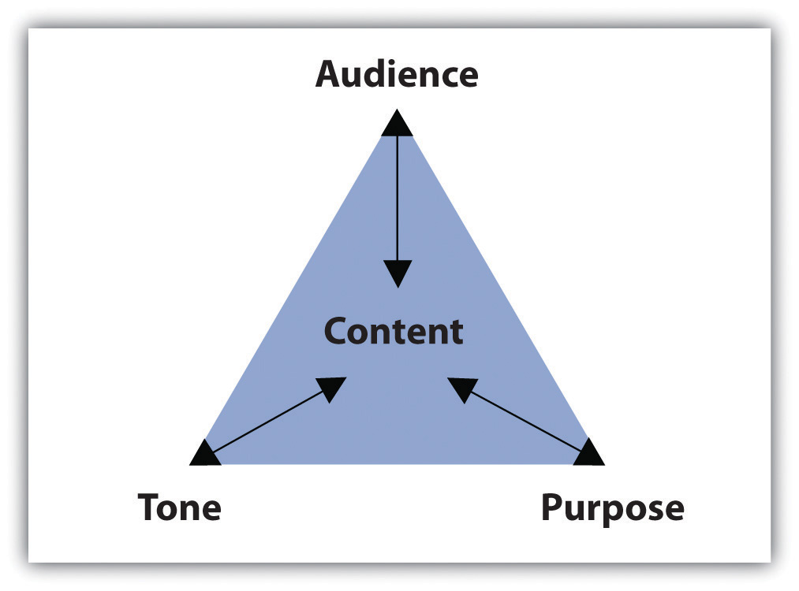
The assignment’s purpose, audience, and tone dictate what the paragraph covers and how it will support one main point. This section covers how purpose, audience, and tone affect reading and writing paragraphs.

Identifying Common Academic Purposes
The purpose for a piece of writing identifies the reason you write a particular document. Basically, the purpose of a piece of writing answers the question “Why?” For example, why write a play? To entertain a packed theater. Why write instructions to the babysitter? To inform him or her of your schedule and rules. Why write a letter to your congressman? To persuade him to address your community’s needs.
In academic settings, the reasons for writing fulfill four main purposes: to summarize, to analyze, to synthesize, and to evaluate. You will encounter these four purposes not only as you read for your classes but also as you read for work or pleasure. Because reading and writing work together, your writing skills will improve as you read. To learn more about reading in the writing process, see Chapter 8 "The Writing Process: How Do I Begin?".
Eventually, your instructors will ask you to complete assignments specifically designed to meet one of the four purposes. As you will see, the purpose for writing will guide you through each part of the paper, helping you make decisions about content and style. For now, identifying these purposes by reading paragraphs will prepare you to write individual paragraphs and to build longer assignments.

Summary Paragraphs
A summary shrinks a large amount of information into only the essentials. You probably summarize events, books, and movies daily. Think about the last blockbuster movie you saw or the last novel you read. Chances are, at some point in a casual conversation with a friend, coworker, or classmate, you compressed all the action in a two-hour film or in a two-hundred-page book into a brief description of the major plot movements. While in conversation, you probably described the major highlights, or the main points in just a few sentences, using your own vocabulary and manner of speaking.
Similarly, a summary paragraph condenses a long piece of writing into a smaller paragraph by extracting only the vital information. A summary uses only the writer’s own words. Like the summary’s purpose in daily conversation, the purpose of an academic summary paragraph is to maintain all the essential information from a longer document. Although shorter than the original piece of writing, a summary should still communicate all the key points and key support. In other words, summary paragraphs should be succinct and to the point.
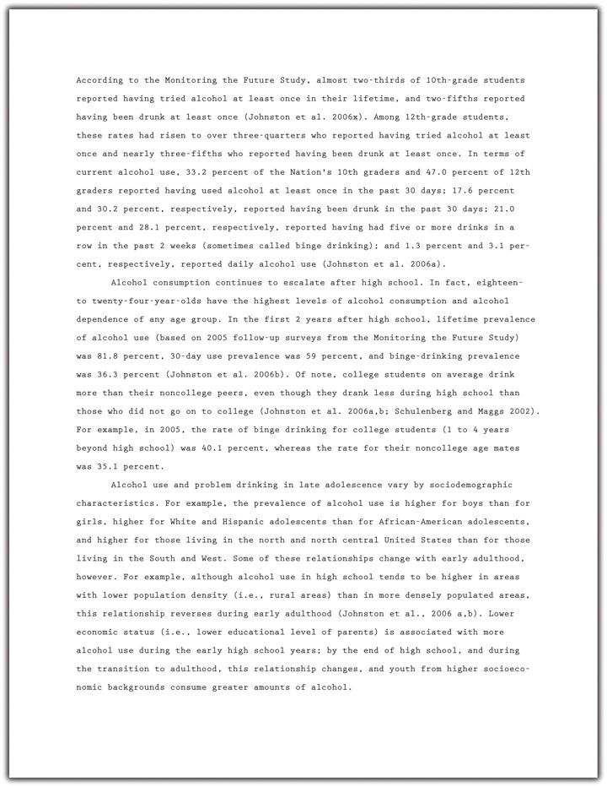
A summary of the report should present all the main points and supporting details in brief. Read the following summary of the report written by a student:
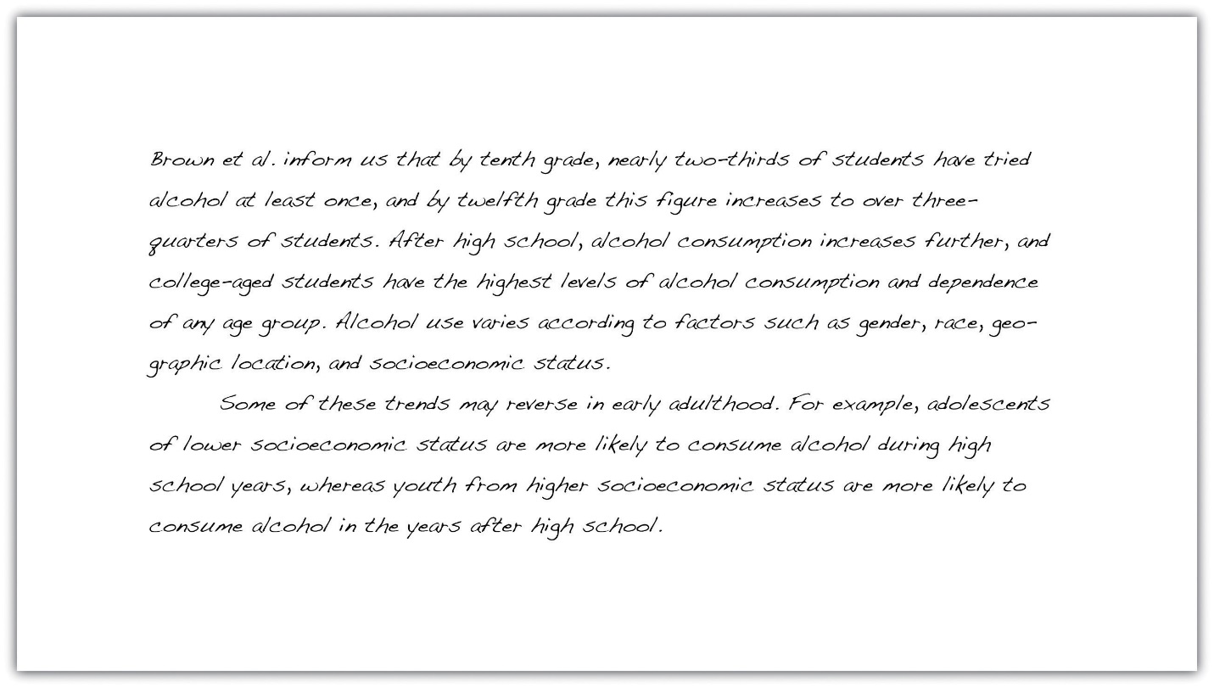
Notice how the summary retains the key points made by the writers of the original report but omits most of the statistical data. Summaries need not contain all the specific facts and figures in the original document; they provide only an overview of the essential information.

Analysis Paragraphs
An analysis separates complex materials in their different parts and studies how the parts relate to one another. The analysis of simple table salt, for example, would require a deconstruction of its parts—the elements sodium (Na) and chloride (Cl). Then, scientists would study how the two elements interact to create the compound NaCl, or sodium chloride, which is also called simple table salt.
Analysis is not limited to the sciences, of course. An analysis paragraph in academic writing fulfills the same purpose. Instead of deconstructing compounds, academic analysis paragraphs typically deconstruct documents. An analysis takes apart a primary source (an essay, a book, an article, etc.) point by point. It communicates the main points of the document by examining individual points and identifying how the points relate to one another.

Take a look at a student’s analysis of the journal report.
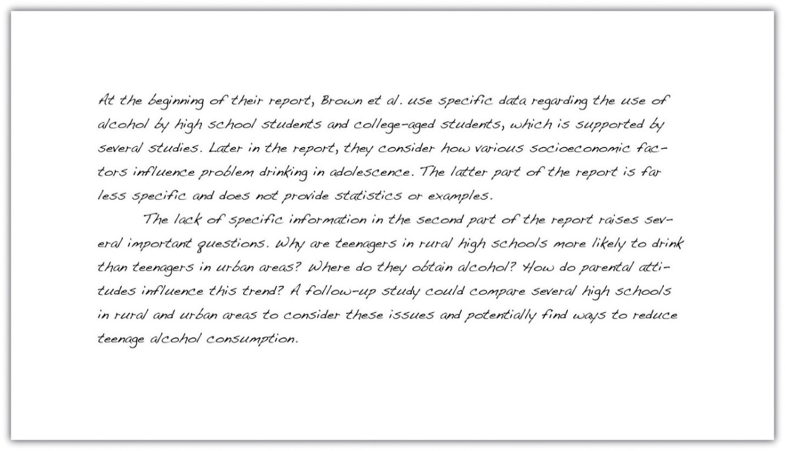
Notice how the analysis does not simply repeat information from the original report, but considers how the points within the report relate to one another. By doing this, the student uncovers a discrepancy between the points that are backed up by statistics and those that require additional information. Analyzing a document involves a close examination of each of the individual parts and how they work together.

Synthesis Paragraphs
A synthesis combines two or more items to create an entirely new item. Consider the electronic musical instrument aptly named the synthesizer. It looks like a simple keyboard but displays a dashboard of switches, buttons, and levers. With the flip of a few switches, a musician may combine the distinct sounds of a piano, a flute, or a guitar—or any other combination of instruments—to create a new sound. The purpose of the synthesizer is to blend together the notes from individual instruments to form new, unique notes.
The purpose of an academic synthesis is to blend individual documents into a new document. An academic synthesis paragraph considers the main points from one or more pieces of writing and links the main points together to create a new point, one not replicated in either document.

Take a look at a student’s synthesis of several sources about underage drinking.
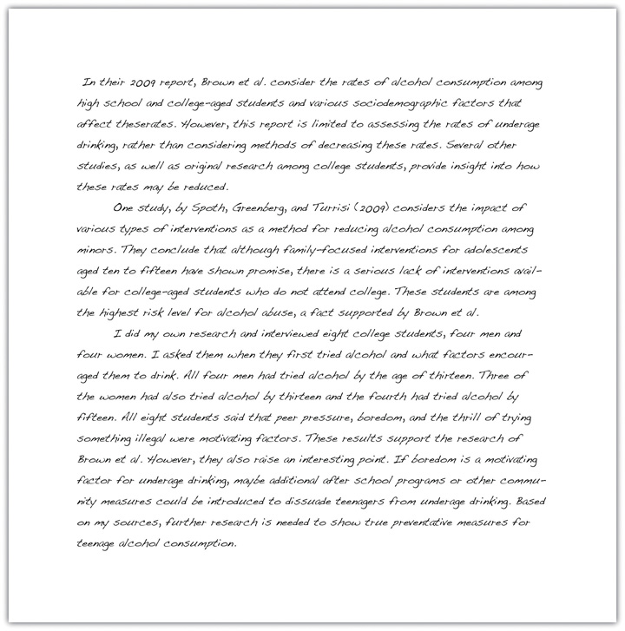
Notice how the synthesis paragraphs consider each source and use information from each to create a new thesis. A good synthesis does not repeat information; the writer uses a variety of sources to create a new idea.

Evaluation Paragraphs
An evaluation judges the value of something and determines its worth. Evaluations in everyday experiences are often not only dictated by set standards but also influenced by opinion and prior knowledge. For example, at work, a supervisor may complete an employee evaluation by judging his subordinate’s performance based on the company’s goals. If the company focuses on improving communication, the supervisor will rate the employee’s customer service according to a standard scale. However, the evaluation still depends on the supervisor’s opinion and prior experience with the employee. The purpose of the evaluation is to determine how well the employee performs at his or her job.
An academic evaluation communicates your opinion, and its justifications, about a document or a topic of discussion. Evaluations are influenced by your reading of the document, your prior knowledge, and your prior experience with the topic or issue. Because an evaluation incorporates your point of view and reasons for your point of view, it typically requires more critical thinking and a combination of summary, analysis, and synthesis skills. Thus evaluation paragraphs often follow summary, analysis, and synthesis paragraphs. Read a student’s evaluation paragraph.
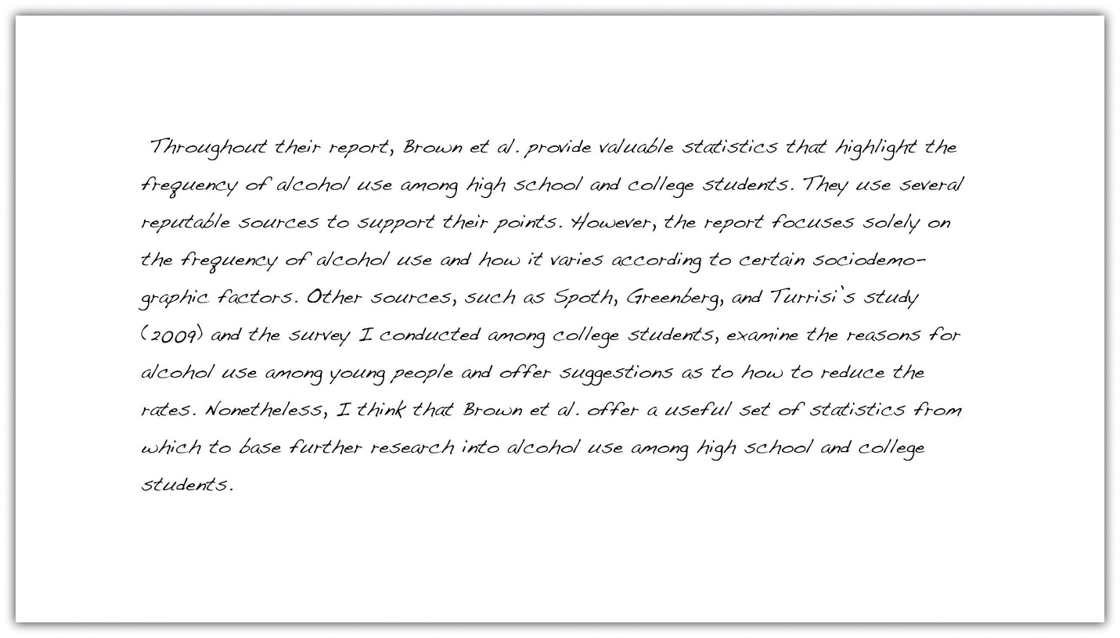
Notice how the paragraph incorporates the student’s personal judgment within the evaluation. Evaluating a document requires prior knowledge that is often based on additional research.

Tip
When reviewing directions for assignments, look for the verbs summarize, analyze, synthesize, or evaluate. Instructors often use these words to clearly indicate the assignment’s purpose. These words will cue you on how to complete the assignment because you will know its exact purpose.

EXERCISE 1
Read the following paragraphs about four films and then identify the purpose of each paragraph.
- This film could easily have been cut down to less than two hours. By the final scene, I noticed that most of my fellow moviegoers were snoozing in their seats and were barely paying attention to what was happening on screen. Although the director sticks diligently to the book, he tries too hard to cram in all the action, which is just too ambitious for such a detail-oriented story. If you want my advice, read the book and give the movie a miss.
- During the opening scene, we learn that the character Laura is adopted and that she has spent the past three years desperately trying to track down her real parents. Having exhausted all the usual options—adoption agencies, online searches, family trees, and so on—she is on the verge of giving up when she meets a stranger on a bus. The chance encounter leads to a complicated chain of events that ultimately result in Laura getting her lifelong wish. But is it really what she wants? Throughout the rest of the film, Laura discovers that sometimes the past is best left where it belongs.
- To create the feeling of being gripped in a vice, the director, May Lee, uses a variety of elements to gradually increase the tension. The creepy, haunting melody that subtly enhances the earlier scenes becomes ever more insistent, rising to a disturbing crescendo toward the end of the movie. The desperation of the actors, combined with the claustrophobic atmosphere and tight camera angles create a realistic firestorm, from which there is little hope of escape. Walking out of the theater at the end feels like staggering out of a Roman dungeon.
- The scene in which Campbell and his fellow prisoners assist the guards in shutting down the riot immediately strikes the viewer as unrealistic. Based on the recent reports on prison riots in both Detroit and California, it seems highly unlikely that a posse of hardened criminals will intentionally help their captors at the risk of inciting future revenge from other inmates. Instead, both news reports and psychological studies indicate that prisoners who do not actively participate in a riot will go back to their cells and avoid conflict altogether. Examples of this lack of attention to detail occur throughout the film, making it almost unbearable to watch.
Collaboration
Share with a classmate and compare your answers.

Writing at Work
Thinking about the purpose of writing a report in the workplace can help focus and structure the document. A summary should provide colleagues with a factual overview of your findings without going into too much specific detail. In contrast, an evaluation should include your personal opinion, along with supporting evidence, research, or examples to back it up. Listen for words such as summarize, analyze, synthesize, or evaluate when your boss asks you to complete a report to help determine a purpose for writing.

EXERCISE 2
Consider the essay most recently assigned to you. Identify the most effective academic purpose for the assignment.
My assignment: ____________________________________________
My purpose: ____________________________________________

Identifying the Audience
Imagine you must give a presentation to a group of executives in an office. Weeks before the big day, you spend time creating and rehearsing the presentation. You must make important, careful decisions not only about the content but also about your delivery. Will the presentation require technology to project figures and charts? Should the presentation define important words, or will the executives already know the terms? Should you wear your suit and dress shirt? The answers to these questions will help you develop an appropriate relationship with your audience, making them more receptive to your message.
Now imagine you must explain the same business concepts from your presentation to a group of high school students. Those important questions you previously answered may now require different answers. The figures and charts may be too sophisticated, and the terms will certainly require definitions. You may even reconsider your outfit and sport a more casual look. Because the audience has shifted, your presentation and delivery will shift as well to create a new relationship with the new audience.
In these two situations, the audience—the individuals who will watch and listen to the presentation—plays a role in the development of presentation. As you prepare the presentation, you visualize the audience to anticipate their expectations and reactions. What you imagine affects the information you choose to present and how you will present it. Then, during the presentation, you meet the audience in person and discover immediately how well you perform.
Although the audience for writing assignments—your readers—may not appear in person, they play an equally vital role. Even in everyday writing activities, you identify your readers’ characteristics, interests, and expectations before making decisions about what you write. In fact, thinking about audience has become so common that you may not even detect the audience-driven decisions.
For example, you update your status on a social networking site with the awareness of who will digitally follow the post. If you want to brag about a good grade, you may write the post to please family members. If you want to describe a funny moment, you may write with your friends’ senses of humor in mind. Even at work, you send e-mails with an awareness of an unintended receiver who could intercept the message.
In other words, being aware of “invisible” readers is a skill you most likely already possess and one you rely on every day. Consider the following paragraphs. Which one would the author send to her parents? Which one would she send to her best friend?
Example A
Last Saturday, I volunteered at a local hospital. The visit was fun and rewarding. I even learned how to do cardiopulmonary resuscitation, or CPR. Unfortunately, I think caught a cold from one of the patients. This week, I will rest in bed and drink plenty of clear fluids. I hope I am well by next Saturday to volunteer again.
Example B
OMG! You won’t believe this! My advisor forced me to do my community service hours at this hospital all weekend! We learned CPR but we did it on dummies, not even real peeps. And some kid sneezed on me and got me sick! I was so bored and sniffling all weekend; I hope I don’t have to go back next week. I def do NOT want to miss the basketball tournament!
Most likely, you matched each paragraph to its intended audience with little hesitation. Because each paragraph reveals the author’s relationship with her intended readers, you can identify the audience fairly quickly. When writing your own paragraphs, you must engage with your audience to build an appropriate relationship given your subject. Imagining your readers during each stage of the writing process will help you make decisions about your writing. Ultimately, the people you visualize will affect what and how you write.

Tip
While giving a speech, you may articulate an inspiring or critical message, but if you left your hair a mess and laced up mismatched shoes, your audience would not take you seriously. They may be too distracted by your appearance to listen to your words.
Similarly, grammar and sentence structure serve as the appearance of a piece of writing. Polishing your work using correct grammar will impress your readers and allow them to focus on what you have to say.
Because focusing on audience will enhance your writing, your process, and your finished product, you must consider the specific traits of your audience members. Use your imagination to anticipate the readers’ demographics, education, prior knowledge, and expectations.
- Demographics. These measure important data about a group of people, such as their age range, their ethnicity, their religious beliefs, or their gender. Certain topics and assignments will require these kinds of considerations about your audience. For other topics and assignments, these measurements may not influence your writing in the end. Regardless, it is important to consider demographics when you begin to think about your purpose for writing.
- Education. Education considers the audience’s level of schooling. If audience members have earned a doctorate degree, for example, you may need to elevate your style and use more formal language. Or, if audience members are still in college, you could write in a more relaxed style. An audience member’s major or emphasis may also dictate your writing.
- Prior knowledge. This refers to what the audience already knows about your topic. If your readers have studied certain topics, they may already know some terms and concepts related to the topic. You may decide whether to define terms and explain concepts based on your audience’s prior knowledge. Although you cannot peer inside the brains of your readers to discover their knowledge, you can make reasonable assumptions. For instance, a nursing major would presumably know more about health-related topics than a business major would.
- Expectations. These indicate what readers will look for while reading your assignment. Readers may expect consistencies in the assignment’s appearance, such as correct grammar and traditional formatting like double-spaced lines and legible font. Readers may also have content-based expectations given the assignment’s purpose and organization. In an essay titled “The Economics of Enlightenment: The Effects of Rising Tuition,” for example, audience members may expect to read about the economic repercussions of college tuition costs.

EXERCISE 3
On your own sheet of paper, generate a list of characteristics under each category for each audience. This list will help you later when you read about tone and content.
- Your classmates
  - Demographics ____________________________________________
  - Education ____________________________________________
  - Prior knowledge ____________________________________________
  - Expectations ____________________________________________
- Your instructor
  - Demographics ____________________________________________
  - Education ____________________________________________
  - Prior knowledge ____________________________________________
  - Expectations ____________________________________________
- The head of your academic department
  - Demographics ____________________________________________
  - Education ____________________________________________
  - Prior knowledge ____________________________________________
  - Expectations ____________________________________________
- Now think about your next writing assignment. Identify the purpose (you may use the same purpose listed in Note 6.12 "Exercise 2"), and then identify the audience. Create a list of characteristics under each category.
My assignment: ____________________________________________
My purpose: ____________________________________________
My audience: ____________________________________________
  - Demographics ____________________________________________
  - Education ____________________________________________
  - Prior knowledge ____________________________________________
  - Expectations ____________________________________________
Collaboration
Please share with a classmate and compare your answers.
Keep in mind that as your topic shifts in the writing process, your audience may also shift. For more information about the writing process, see Chapter 8 "The Writing Process: How Do I Begin?".
Also, remember that decisions about style depend on audience, purpose, and content. Identifying your audience’s demographics, education, prior knowledge, and expectations will affect how you write, but purpose and content play an equally important role. The next subsection covers how to select an appropriate tone to match the audience and purpose.

Selecting an Appropriate Tone
Tone identifies a speaker’s attitude toward a subject or another person. You may pick up a person’s tone of voice fairly easily in conversation. A friend who tells you about her weekend may speak excitedly about a fun skiing trip. An instructor who means business may speak in a low, slow voice to emphasize her serious mood. Or, a coworker who needs to let off some steam after a long meeting may crack a sarcastic joke.
Just as speakers transmit emotion through voice, writers can transmit through writing a range of attitudes, from excited and humorous to somber and critical. These emotions create connections among the audience, the author, and the subject, ultimately building a relationship between the audience and the text. To stimulate these connections, writers intimate their attitudes and feelings with useful devices, such as sentence structure, word choice, punctuation, and formal or informal language. Keep in mind that the writer’s attitude should always appropriately match the audience and the purpose.
Read the following paragraph and consider the writer’s tone. How would you describe the writer’s attitude toward wildlife conservation?
Many species of plants and animals are disappearing right before our eyes. If we don’t act fast, it might be too late to save them. Human activities, including pollution, deforestation, hunting, and overpopulation, are devastating the natural environment. Without our help, many species will not survive long enough for our children to see them in the wild. Take the tiger, for example. Today, tigers occupy just 7 percent of their historical range, and many local populations are already extinct. Hunted for their beautiful pelt and other body parts, the tiger population has plummeted from one hundred thousand in 1920 to just a few thousand. Contact your local wildlife conservation society today to find out how you can stop this terrible destruction.

EXERCISE 4
Think about the assignment and purpose you selected in Note 6.12 "Exercise 2", and the audience you selected in Note 6.16 "Exercise 3". Now, identify the tone you would use in the assignment.
My assignment: ____________________________________________
My purpose: ____________________________________________
My audience: ____________________________________________
My tone: ____________________________________________

Choosing Appropriate, Interesting Content
Content refers to all the written substance in a document. After selecting an audience and a purpose, you must choose what information will make it to the page. Content may consist of examples, statistics, facts, anecdotes, testimonies, and observations, but no matter the type, the information must be appropriate and interesting for the audience and purpose. An essay written for third graders that summarizes the legislative process, for example, would have to contain succinct and simple content.
Content is also shaped by tone. When the tone matches the content, the audience will be more engaged, and you will build a stronger relationship with your readers. Consider that audience of third graders. You would choose simple content that the audience will easily understand, and you would express that content through an enthusiastic tone. The same considerations apply to all audiences and purposes.

EXERCISE 5
Match the content in the box to the appropriate audience and purpose. On your own sheet of paper, write the correct letter next to the number.
- Whereas economist Holmes contends that the financial crisis is far from over, the presidential advisor Jones points out that it is vital to catch the first wave of opportunity to increase market share. We can use elements of both experts’ visions. Let me explain how.
- In 2000, foreign money flowed into the United States, contributing to easy credit conditions. People bought larger houses than they could afford, eventually defaulting on their loans as interest rates rose.
- The Emergency Economic Stabilization Act, known by most of us as the humungous government bailout, caused mixed reactions. Although supported by many political leaders, the statute provoked outrage among grassroots groups. In their opinion, the government was actually rewarding banks for their appalling behavior.
- Audience: An instructor
Purpose: To analyze the reasons behind the 2007 financial crisis
Content: ____________________________________________
- Audience: Classmates
Purpose: To summarize the effects of the $700 billion government bailout
Content: ____________________________________________
- Audience: An employer
Purpose: To synthesize two articles on preparing businesses for economic recovery
Content: ____________________________________________
Collaboration
Please share with a classmate and compare your answers.

EXERCISE 6
Using the assignment, purpose, audience, and tone from Note 6.18 "Exercise 4", generate a list of content ideas. Remember that content consists of examples, statistics, facts, anecdotes, testimonies, and observations.
My assignment: ____________________________________________
My purpose: ____________________________________________
My audience: ____________________________________________
My tone: ____________________________________________
My content ideas: ____________________________________________

KEY TAKEAWAYS
- Paragraphs separate ideas into logical, manageable chunks of information.
- The content of each paragraph and document is shaped by purpose, audience, and tone.
- The four common academic purposes are to summarize, to analyze, to synthesize, and to evaluate.
- Identifying the audience’s demographics, education, prior knowledge, and expectations will affect how and what you write.
- Devices such as sentence structure, word choice, punctuation, and formal or informal language communicate tone and create a relationship between the writer and his or her audience.
- Content may consist of examples, statistics, facts, anecdotes, testimonies, and observations. All content must be appropriate and interesting for the audience, purpose and tone.

1.3.2: Develop a Working Thesis and a Research Proposal Writing for Success: "Chapter 11, Section 2: Steps in Developing a Research Proposal"

LEARNING OBJECTIVES
- Identify the steps in developing a research proposal.
- Choose a topic and formulate a research question and working thesis.
- Develop a research proposal.
Writing a good research paper takes time, thought, and effort. Although this assignment is challenging, it is manageable. Focusing on one step at a time will help you develop a thoughtful, informative, well-supported research paper.
Your first step is to choose a topic and then to develop research questions, a working thesis, and a written research proposal. Set aside adequate time for this part of the process. Fully exploring ideas will help you build a solid foundation for your paper.

Choosing a Topic
When you choose a topic for a research paper, you are making a major commitment. Your choice will help determine whether you enjoy the lengthy process of research and writing—and whether your final paper fulfills the assignment requirements. If you choose your topic hastily, you may later find it difficult to work with your topic. By taking your time and choosing carefully, you can ensure that this assignment is not only challenging but also rewarding.
Writers understand the importance of choosing a topic that fulfills the assignment requirements and fits the assignment’s purpose and audience. (For more information about purpose and audience, see Chapter 6 "Writing Paragraphs: Separating Ideas and Shaping Content".) Choosing a topic that interests you is also crucial. You instructor may provide a list of suggested topics or ask that you develop a topic on your own. In either case, try to identify topics that genuinely interest you.
After identifying potential topic ideas, you will need to evaluate your ideas and choose one topic to pursue. Will you be able to find enough information about the topic? Can you develop a paper about this topic that presents and supports your original ideas? Is the topic too broad or too narrow for the scope of the assignment? If so, can you modify it so it is more manageable? You will ask these questions during this preliminary phase of the research process.

Identifying Potential Topics
Sometimes, your instructor may provide a list of suggested topics. If so, you may benefit from identifying several possibilities before committing to one idea. It is important to know how to narrow down your ideas into a concise, manageable thesis. You may also use the list as a starting point to help you identify additional, related topics. Discussing your ideas with your instructor will help ensure that you choose a manageable topic that fits the requirements of the assignment.
In this chapter, you will follow a writer named Jorge, who is studying health care administration, as he prepares a research paper. You will also plan, research, and draft your own research paper.
Jorge was assigned to write a research paper on health and the media for an introductory course in health care. Although a general topic was selected for the students, Jorge had to decide which specific issues interested him. He brainstormed a list of possibilities.

Tip
If you are writing a research paper for a specialized course, look back through your notes and course activities. Identify reading assignments and class discussions that especially engaged you. Doing so can help you identify topics to pursue.
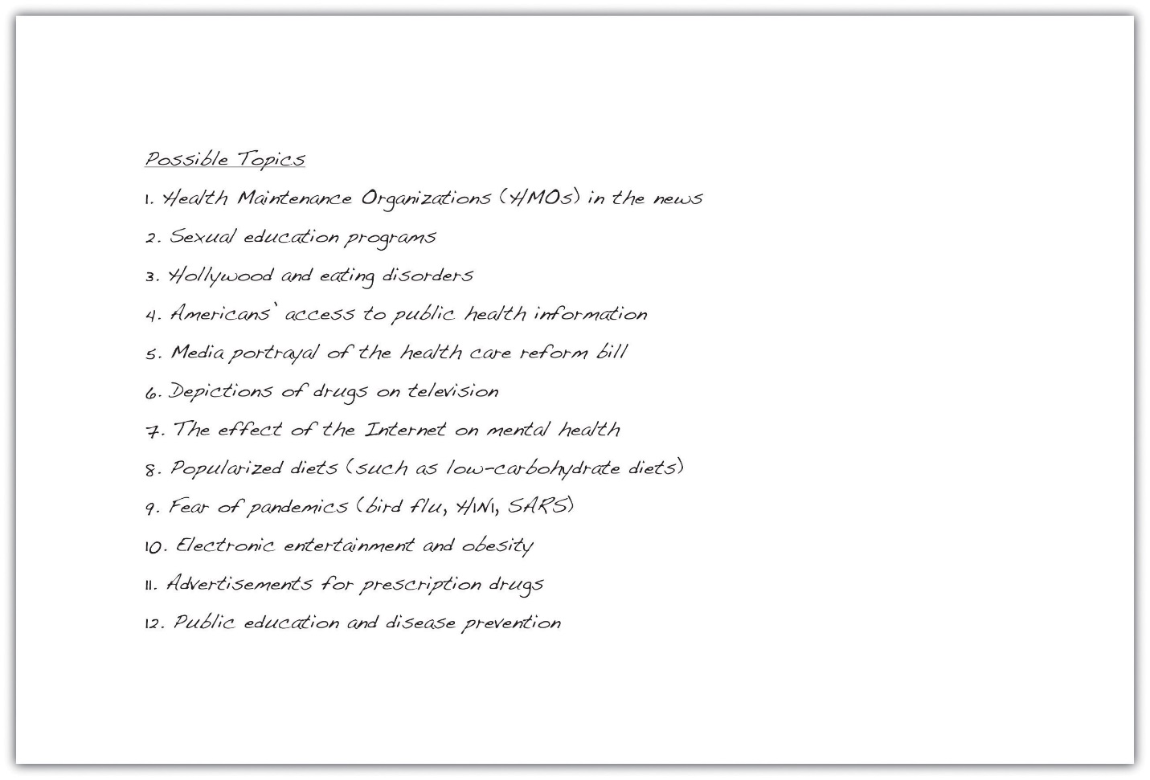

EXERCISE 1
Set a timer for five minutes. Use brainstorming or idea mapping to create a list of topics you would be interested in researching for a paper about the influence of the Internet on social networking. Do you closely follow the media coverage of a particular website, such as Twitter? Would you like to learn more about a certain industry, such as online dating? Which social networking sites do you and your friends use? List as many ideas related to this topic as you can.

Narrowing Your Topic
Once you have a list of potential topics, you will need to choose one as the focus of your essay. You will also need to narrow your topic. Most writers find that the topics they listed during brainstorming or idea mapping are broad—too broad for the scope of the assignment. Working with an overly broad topic, such as sexual education programs or popularized diets, can be frustrating and overwhelming. Each topic has so many facets that it would be impossible to cover them all in a college research paper. However, more specific choices, such as the pros and cons of sexual education in kids’ television programs or the physical effects of the South Beach diet, are specific enough to write about without being too narrow to sustain an entire research paper.
A good research paper provides focused, in-depth information and analysis. If your topic is too broad, you will find it difficult to do more than skim the surface when you research it and write about it. Narrowing your focus is essential to making your topic manageable. To narrow your focus, explore your topic in writing, conduct preliminary research, and discuss both the topic and the research with others.

Exploring Your Topic in Writing
“How am I supposed to narrow my topic when I haven’t even begun researching yet?” In fact, you may already know more than you realize. Review your list and identify your top two or three topics. Set aside some time to explore each one through freewriting. (For more information about freewriting, see Chapter 8 "The Writing Process: How Do I Begin?".) Simply taking the time to focus on your topic may yield fresh angles.
Jorge knew that he was especially interested in the topic of diet fads, but he also knew that it was much too broad for his assignment. He used freewriting to explore his thoughts so he could narrow his topic. Read Jorge’s ideas.
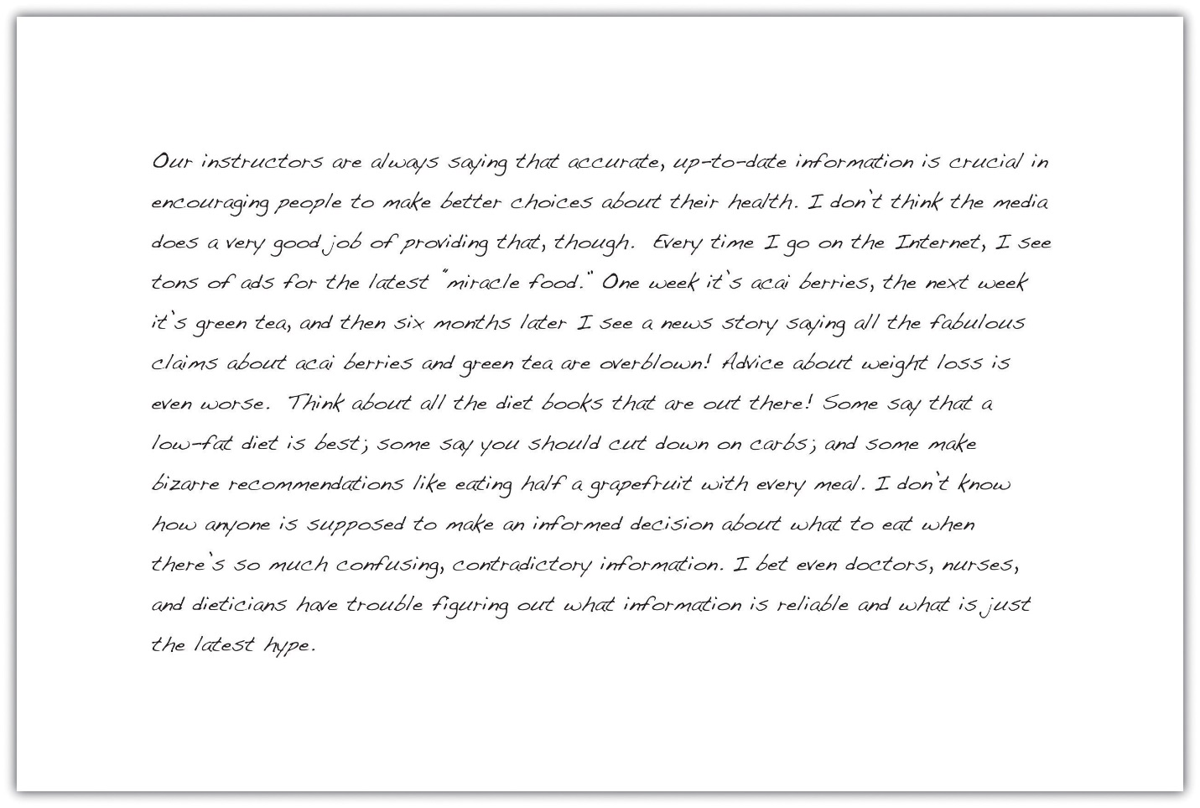

Conducting Preliminary Research
Another way writers may focus a topic is to conduct preliminary research. Like freewriting, exploratory reading can help you identify interesting angles. Surfing the web and browsing through newspaper and magazine articles are good ways to start. Find out what people are saying about your topic on blogs and online discussion groups. Discussing your topic with others can also inspire you. Talk about your ideas with your classmates, your friends, or your instructor.
Jorge’s freewriting exercise helped him realize that the assigned topic of health and the media intersected with a few of his interests—diet, nutrition, and obesity. Preliminary online research and discussions with his classmates strengthened his impression that many people are confused or misled by media coverage of these subjects.
Jorge decided to focus his paper on a topic that had garnered a great deal of media attention—low-carbohydrate diets. He wanted to find out whether low-carbohydrate diets were as effective as their proponents claimed.

Writing at Work
At work, you may need to research a topic quickly to find general information. This information can be useful in understanding trends in a given industry or generating competition. For example, a company may research a competitor’s prices and use the information when pricing their own product. You may find it useful to skim a variety of reliable sources and take notes on your findings.

Tip
The reliability of online sources varies greatly. In this exploratory phase of your research, you do not need to evaluate sources as closely as you will later. However, use common sense as you refine your paper topic. If you read a fascinating blog comment that gives you a new idea for your paper, be sure to check out other, more reliable sources as well to make sure the idea is worth pursuing.

EXERCISE 2
Review the list of topics you created in Note 11.18 "Exercise 1" and identify two or three topics you would like to explore further. For each of these topics, spend five to ten minutes writing about the topic without stopping. Then review your writing to identify possible areas of focus.
Set aside time to conduct preliminary research about your potential topics. Then choose a topic to pursue for your research paper.
Collaboration
Please share your topic list with a classmate. Select one or two topics on his or her list that you would like to learn more about and return it to him or her. Discuss why you found the topics interesting, and learn which of your topics your classmate selected and why.

A Plan for Research
Your freewriting and preliminary research have helped you choose a focused, manageable topic for your research paper. To work with your topic successfully, you will need to determine what exactly you want to learn about it—and later, what you want to say about it. Before you begin conducting in-depth research, you will further define your focus by developing a research question, a working thesis, and a research proposal.

Formulating a Research Question
In forming a research question, you are setting a goal for your research. Your main research question should be substantial enough to form the guiding principle of your paper—but focused enough to guide your research. A strong research question requires you not only to find information but also to put together different pieces of information, interpret and analyze them, and figure out what you think. As you consider potential research questions, ask yourself whether they would be too hard or too easy to answer.
To determine your research question, review the freewriting you completed earlier. Skim through books, articles, and websites and list the questions you have. (You may wish to use the 5WH strategy to help you formulate questions. See Chapter 8 "The Writing Process: How Do I Begin?" for more information about 5WH questions.) Include simple, factual questions and more complex questions that would require analysis and interpretation. Determine your main question—the primary focus of your paper—and several subquestions that you will need to research to answer your main question.
Here are the research questions Jorge will use to focus his research. Notice that his main research question has no obvious, straightforward answer. Jorge will need to research his subquestions, which address narrower topics, to answer his main question.
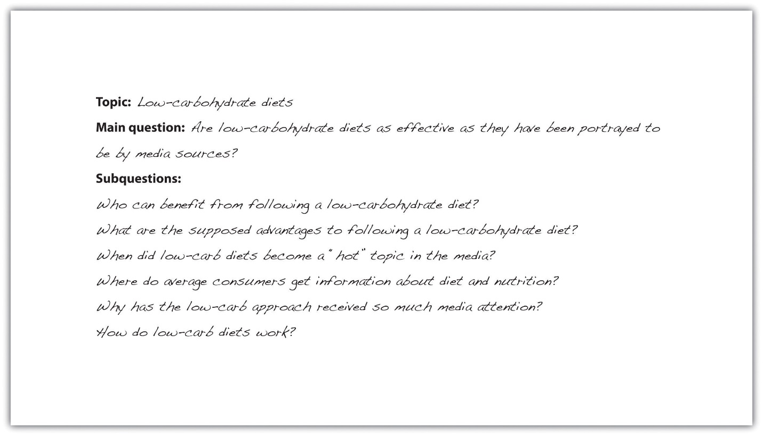

EXERCISE 3
Using the topic you selected in Note 11.24 "Exercise 2", write your main research question and at least four to five subquestions. Check that your main research question is appropriately complex for your assignment.

Constructing a Working ThesIs
A working thesis concisely states a writer’s initial answer to the main research question. It does not merely state a fact or present a subjective opinion. Instead, it expresses a debatable idea or claim that you hope to prove through additional research. Your working thesis is called a working thesis for a reason—it is subject to change. As you learn more about your topic, you may change your thinking in light of your research findings. Let your working thesis serve as a guide to your research, but do not be afraid to modify it based on what you learn.
Jorge began his research with a strong point of view based on his preliminary writing and research. Read his working thesis statement, which presents the point he will argue. Notice how it states Jorge’s tentative answer to his research question.
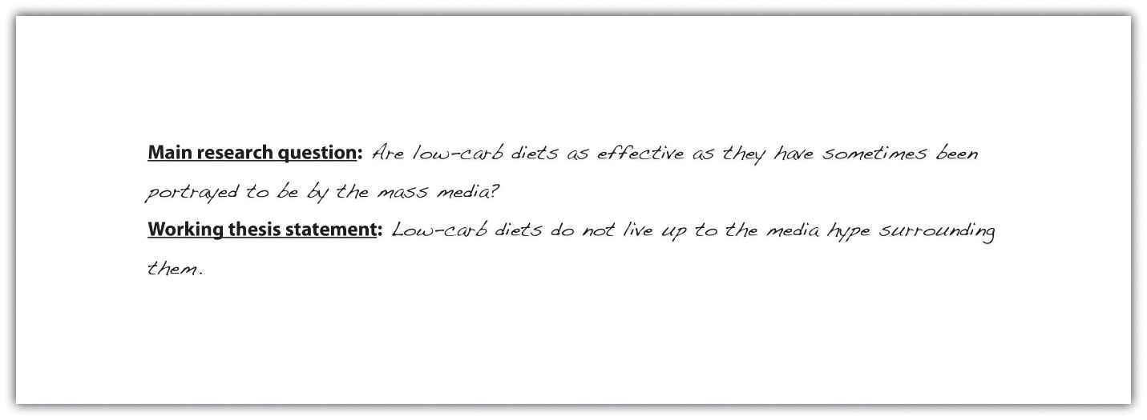

Tip
One way to determine your working thesis is to consider how you would complete sentences such as I believe or My opinion is. However, keep in mind that academic writing generally does not use first-person pronouns. These statements are useful starting points, but formal research papers use an objective voice.

EXERCISE 4
Write a working thesis statement that presents your preliminary answer to the research question you wrote in Note 11.27 "Exercise 3". Check that your working thesis statement presents an idea or claim that could be supported or refuted by evidence from research.

Creating a Research Proposal
A research proposal is a brief document—no more than one typed page—that summarizes the preliminary work you have completed. Your purpose in writing it is to formalize your plan for research and present it to your instructor for feedback. In your research proposal, you will present your main research question, related subquestions, and working thesis. You will also briefly discuss the value of researching this topic and indicate how you plan to gather information.
When Jorge began drafting his research proposal, he realized that he had already created most of the pieces he needed. However, he knew he also had to explain how his research would be relevant to other future health care professionals. In addition, he wanted to form a general plan for doing the research and identifying potentially useful sources. Read Jorge’s research proposal.
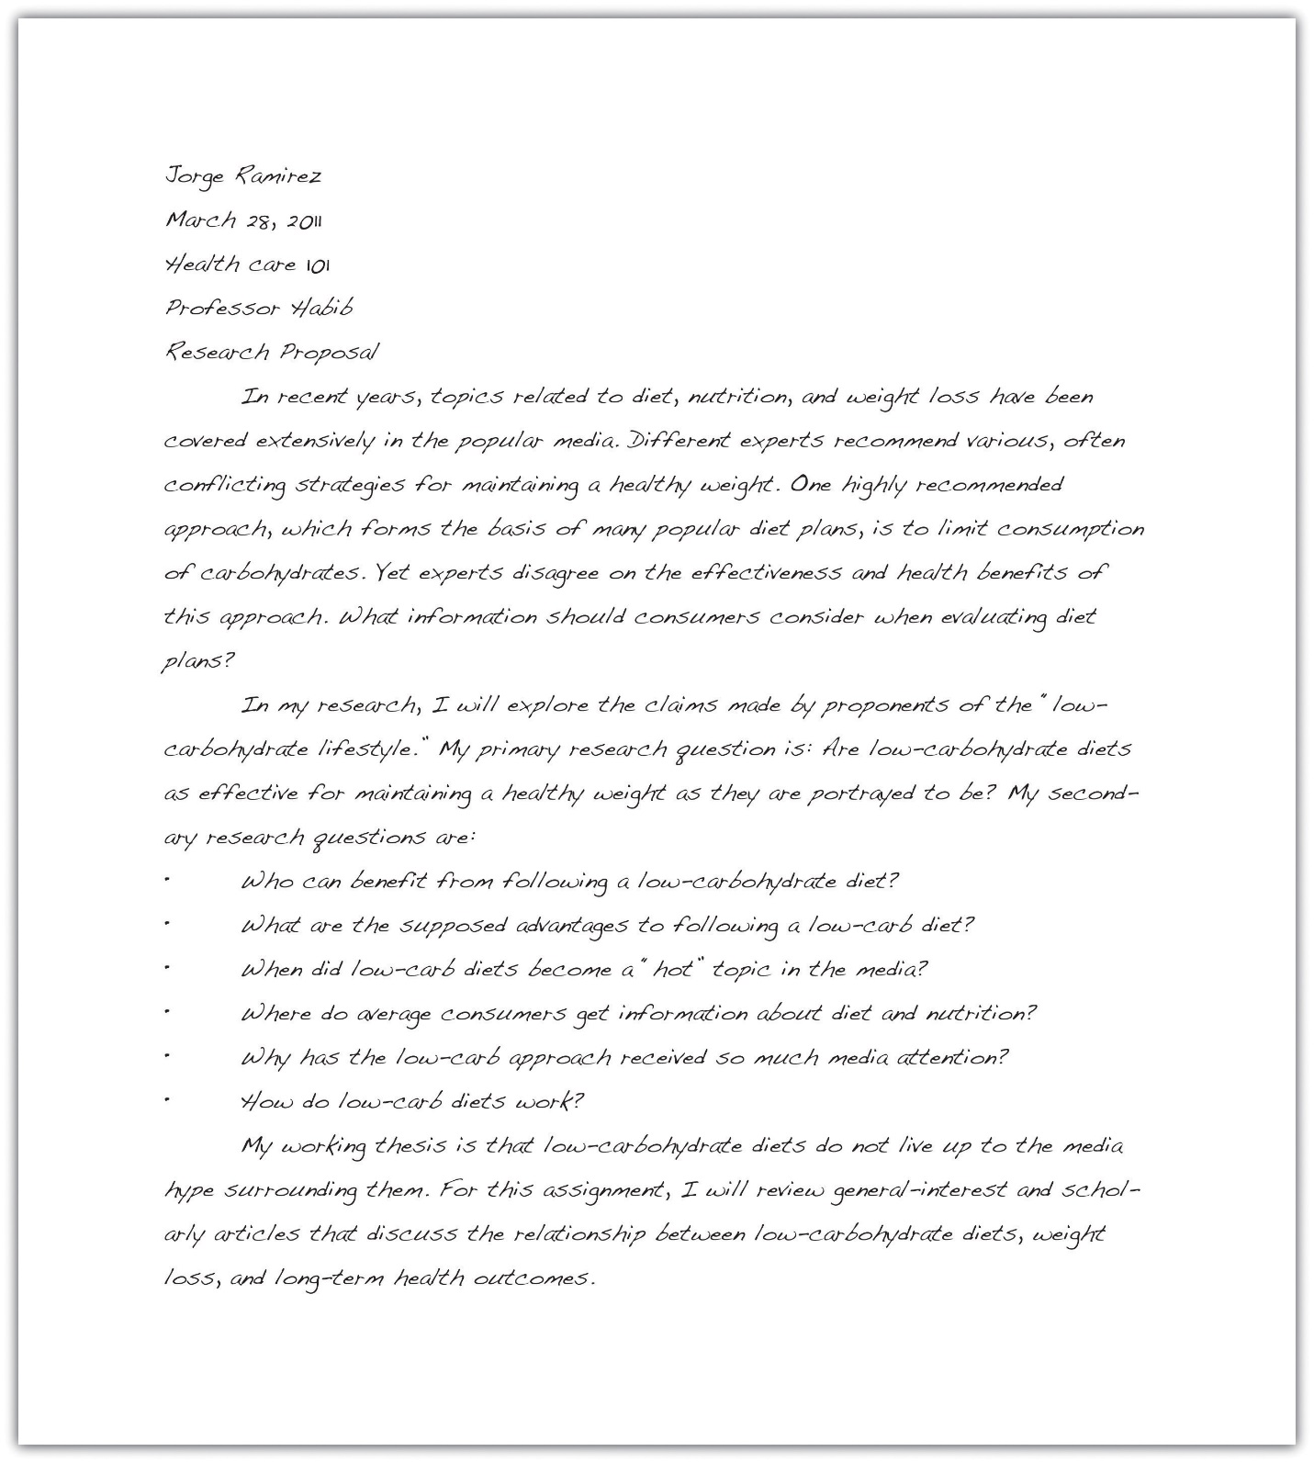

Writing at Work
Before you begin a new project at work, you may have to develop a project summary document that states the purpose of the project, explains why it would be a wise use of company resources, and briefly outlines the steps involved in completing the project. This type of document is similar to a research proposal. Both documents define and limit a project, explain its value, discuss how to proceed, and identify what resources you will use.

Writing Your Own Research Proposal
Now you may write your own research proposal, if you have not done so already. Follow the guidelines provided in this lesson.

KEY TAKEAWAYS
- Developing a research proposal involves the following preliminary steps: identifying potential ideas, choosing ideas to explore further, choosing and narrowing a topic, formulating a research question, and developing a working thesis.
- A good topic for a research paper interests the writer and fulfills the requirements of the assignment.
- Defining and narrowing a topic helps writers conduct focused, in-depth research.
- Writers conduct preliminary research to identify possible topics and research questions and to develop a working thesis.
- A good research question interests readers, is neither too broad nor too narrow, and has no obvious answer.
- A good working thesis expresses a debatable idea or claim that can be supported with evidence from research.
- Writers create a research proposal to present their topic, main research question, subquestions, and working thesis to an instructor for approval or feedback.
1.3.3 Mapping Your Topic Concept Map:
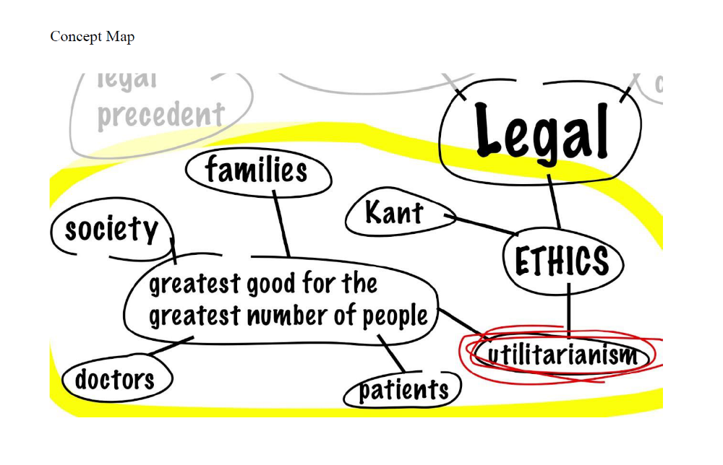

1.3.3 Mapping Your Topic The University of North Carolina at Chapel Hill Writing Center Webbing:
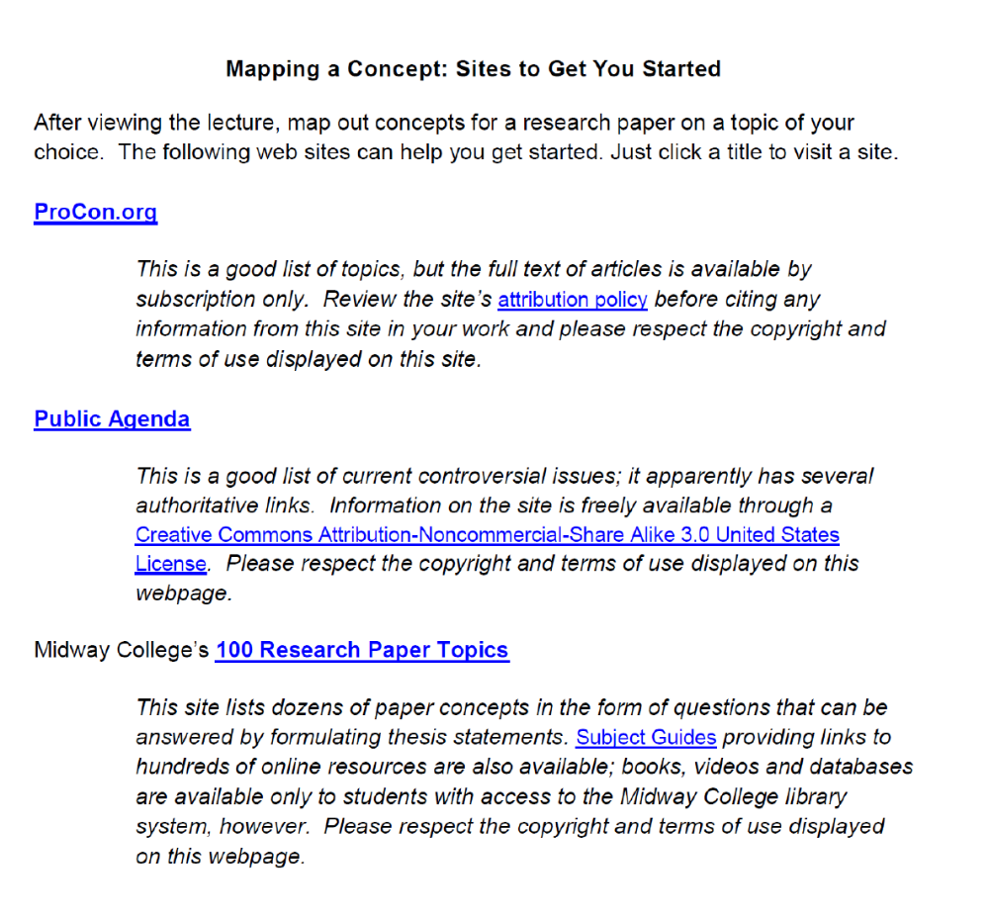

UNIT TWO: Researching: How, What, When, Where, and Why
2.1.1 Note Taking Tools Cornell Note-Taking System
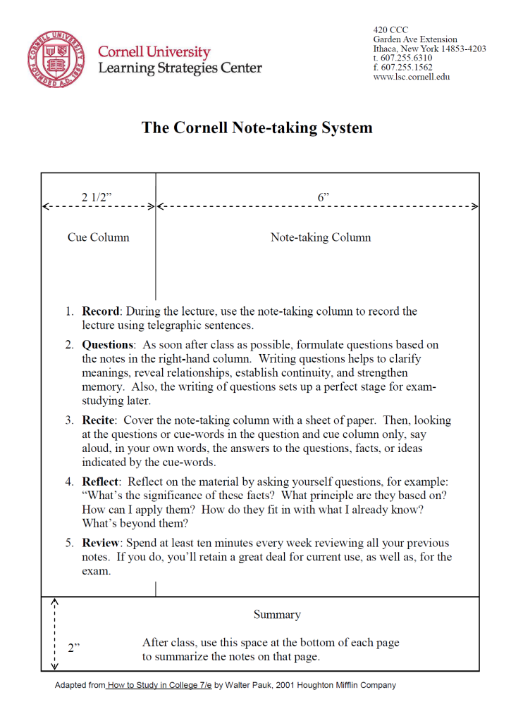
2.2.1: How to Begin Your Research Writing for Success: "Chapter 11, Section 4: Strategies for Gathering Reliable Information"

LEARNING OBJECTIVES
- Distinguish between primary and secondary sources.
- Identify strategies for locating relevant print and electronic resources efficiently.
- Identify instances when it is appropriate to use human sources, such as interviews or eyewitness testimony.
- Identify criteria for evaluating research resources.
- Understand why many electronic resources are not reliable.
Now that you have planned your research project, you are ready to begin the research. This phase can be both exciting and challenging. As you read this section, you will learn ways to locate sources efficiently, so you have enough time to read the sources, take notes, and think about how to use the information.
Of course, the technological advances of the past few decades—particularly the rise of online media—mean that, as a twenty-first-century student, you have countless sources of information available at your fingertips. But how can you tell whether a source is reliable? This section will discuss strategies for evaluating sources critically so that you can be a media-savvy researcher.
In this section, you will locate and evaluate resources for your paper and begin taking notes. As you read, begin gathering print and electronic resources, identify at least eight to ten sources by the time you finish the chapter, and begin taking notes on your research findings.

Locating Useful Resources
When you chose a paper topic and determined your research questions, you conducted preliminary research to stimulate your thinking. Your research proposal included some general ideas for how to go about your research—for instance, interviewing an expert in the field or analyzing the content of popular magazines. You may even have identified a few potential sources. Now it is time to conduct a more focused, systematic search for informative primary and secondary sources.

Using Primary and Secondary Sources
Writers classify research resources in two categories: primary sources and secondary sources. Primary sources are direct, firsthand sources of information or data. For example, if you were writing a paper about the First Amendment right to freedom of speech, the text of the First Amendment in the Bill of Rights would be a primary source.
Other primary sources include the following:
- Research articles
- Literary texts
- Historical documents such as diaries or letters
- Autobiographies or other personal accounts
Secondary sources discuss, interpret, analyze, consolidate, or otherwise rework information from primary sources. In researching a paper about the First Amendment, you might read articles about legal cases that involved First Amendment rights, or editorials expressing commentary on the First Amendment. These sources would be considered secondary sources because they are one step removed from the primary source of information.
The following are examples of secondary sources:
- Magazine articles
- Biographical books
- Literary and scientific reviews
- Television documentaries
Your topic and purpose determine whether you must cite both primary and secondary sources in your paper. Ask yourself which sources are most likely to provide the information that will answer your research questions. If you are writing a research paper about reality television shows, you will need to use some reality shows as a primary source, but secondary sources, such as a reviewer’s critique, are also important. If you are writing about the health effects of nicotine, you will probably want to read the published results of scientific studies, but secondary sources, such as magazine articles discussing the outcome of a recent study, may also be helpful.
Once you have thought about what kinds of sources are most likely to help you answer your research questions, you may begin your search for print and electronic resources. The challenge here is to conduct your search efficiently. Writers use strategies to help them find the sources that are most relevant and reliable while steering clear of sources that will not be useful.

Finding Print Resources
Print resources include a vast array of documents and publications. Regardless of your topic, you will consult some print resources as part of your research. (You will use electronic sources as well, but it is not wise to limit yourself to electronic sources only, because some potentially useful sources may be available only in print form.) Table 11.1 "Library Print Resources" lists different types of print resources available at public and university libraries.
Table 11.1 Library Print Resources
Resource Type | Description | Example(s)
Reference works | Reference works provide a summary of information about a particular topic. Almanacs, encyclopedias, atlases, medical reference books, and scientific abstracts are examples of reference works. In some cases, reference books may not be checked out of a library.  Note that reference works are many steps removed from original primary sources and are often brief, so these should be used only as a starting point when you gather information. | - The World Almanac and Book of Facts 2010  - Diagnostic and Statistical Manualpublished by the American Psychiatric Association
Nonfiction books | Nonfiction books provide in-depth coverage of a topic. Trade books, biographies, and how-to guides are usually written for a general audience. Scholarly books and scientific studies are usually written for an audience that has specialized knowledge of a topic. | - The Low-Carb Solution: A Slimmer You in 30 Days  - Carbohydrates, Fats and Proteins: Exploring the Relationship Between Macronutrient Ratios and Health Outcomes
Periodicals and news sources | These sources are published at regular intervals—daily, weekly, monthly, or quarterly. Newspapers, magazines, and academic journals are examples. Some periodicals provide articles on subjects of general interest, while others are more specialized. | - New York Times  - PC Magazine  - JAMA, The Journal of the American Medical Association
Government publications | Federal, state, and local government agencies publish information on a variety of topics. Government publications include reports, legislation, court documents, public records, statistics, studies, guides, programs, and forms. | - The Census 2000 Profile  - The Business Relocation Package published by the Philadelphia Chamber of Commerce
Business and nonprofit publications | Businesses and nonprofit organizations produce publications designed to market a product, provide background about the organization, provide information on topics connected to the organization, or promote a cause. These publications include reports, newsletters, advertisements, manuals, brochures, and other print documents. | - A company’s instruction manual explaining how to use a specific software program  - A news release published by the Sierra Club
Some of these resources are also widely available in electronic format. In addition to the resources noted in the table, library holdings may include primary texts such as historical documents, letters, and diaries.

Writing at Work
Businesses, government organizations, and nonprofit organizations produce published materials that range from brief advertisements and brochures to lengthy, detailed reports. In many cases, producing these publications requires research. A corporation’s annual report may include research about economic or industry trends. A charitable organization may use information from research in materials sent to potential donors.
Regardless of the industry you work in, you may be asked to assist in developing materials for publication. Often, incorporating research in these documents can make them more effective in informing or persuading readers.

Tip
As you gather information, strive for a balance of accessible, easy-to-read sources and more specialized, challenging sources. Relying solely on lightweight books and articles written for a general audience will drastically limit the range of useful, substantial information. On the other hand, restricting oneself to dense, scholarly works could make the process of researching extremely time-consuming and frustrating.

EXERCISE 1
Make a list of five types of print resources you could use to find information about your research topic. Include at least one primary source. Be as specific as possible—if you have a particular resource or type of resource in mind, describe it.
To find print resources efficiently, first identify the major concepts and terms you will use to conduct your search—that is, your keywords. These, along with the research questions you identified in Chapter 11 "Writing from Research: What Will I Learn?", Section 11.2 "Steps in Developing a Research Proposal", will help you find sources using any of the following methods:
- Using the library’s online catalog or card catalog
- Using periodicals indexes and databases
- Consulting a reference librarian
You probably already have some keywords in mind based on your preliminary research and writing. Another way to identify useful keywords is to visit the Library of Congress’s website at http://id.loc.gov/authorities. This site allows you to search for a topic and see the related subject headings used by the Library of Congress, including broader terms, narrower terms, and related terms. Other libraries use these terms to classify materials. Knowing the most-used terms will help you speed up your keyword search.
Jorge used the Library of Congress site to identify general terms he could use to find resources about low-carb dieting. His search helped him identify potentially useful keywords and related topics, such as carbohydrates in human nutrition, glycemic index, and carbohydrates—metabolism. These terms helped Jorge refine his search.

Tip
Knowing the right keywords can sometimes make all the difference in conducting a successful search. If you have trouble finding sources on a topic, consult a librarian to see whether you need to modify your search terms.

EXERCISE 2
Visit the Library of Congress’s website at http://id.loc.gov/authorities and conduct searches on a few terms related to your topic.
- Review your search results and identify six to eight additional terms you might use when you conduct your research.
- Print out the search results or save the results to your research folder on your computer or portable storage device.

Using Periodicals, Indexes, and Databases
Library catalogs can help you locate book-length sources, as well as some types of nonprint holdings, such as CDs, DVDs, and audio books. To locate shorter sources, such as magazine and journal articles, you will need to use a periodical index or an online periodical database. These tools index the articles that appear in newspapers, magazines, and journals. Like catalogs, they provide publication information about an article and often allow users to access a summary or even the full text of the article.
Print indexes may be available in the periodicals section of your library. Increasingly, libraries use online databases that users can access through the library website. A single library may provide access to multiple periodical databases. These can range from general news databases to specialized databases. Table 11.2 "Commonly Used Indexes and Databases" describes some commonly used indexes and databases.
Table 11.2 Commonly Used Indexes and Databases
Resource | Format | Contents
New York Times Index | Print | Guide to articles published in the New York Times
ProQuest | Online | Database that archives content from newspapers, magazines, and dissertations
Psychlit, PsycINFO | Online | Databases that archive content from journals in psychology and psychiatry
Business Source Complete | Online | Database that archives business-related content from magazines and journals
MEDLINE, PubMed | Online | Databases that archive articles in medicine and health
EBSCOhost | Online | General database that provides access to articles on a wide variety of topics

Reading Popular and Scholarly Periodicals
When you search for periodicals, be sure to distinguish among different types. Mass-market publications, such as newspapers and popular magazines, differ from scholarly publications in their accessibility, audience, and purpose.
Newspapers and magazines are written for a broader audience than scholarly journals. Their content is usually quite accessible and easy to read. Trade magazines that target readers within a particular industry may presume the reader has background knowledge, but these publications are still reader-friendly for a broader audience. Their purpose is to inform and, often, to entertain or persuade readers as well.
Scholarly or academic journals are written for a much smaller and more expert audience. The creators of these publications assume that most of their readers are already familiar with the main topic of the journal. The target audience is also highly educated. Informing is the primary purpose of a scholarly journal. While a journal article may advance an agenda or advocate a position, the content will still be presented in an objective style and formal tone. Entertaining readers with breezy comments and splashy graphics is not a priority.
Because of these differences, scholarly journals are more challenging to read. That doesn’t mean you should avoid them. On the contrary, they can provide in-depth information unavailable elsewhere. Because knowledgeable professionals carefully review the content before publication, scholarly journals are far more reliable than much of the information available in popular media. Seek out academic journals along with other resources. Just be prepared to spend a little more time processing the information.

Writing at Work
Periodicals databases are not just for students writing research papers. They also provide a valuable service to workers in various fields. The owner of a small business might use a database such as Business Source Premiere to find articles on management, finance, or trends within a particular industry. Health care professionals might consult databases such as MedLine to research a particular disease or medication. Regardless of what career path you plan to pursue, periodicals databases can be a useful tool for researching specific topics and identifying periodicals that will help you keep up with the latest news in your industry.

Consulting a Reference Librarian
Sifting through library stacks and database search results to find the information you need can be like trying to find a needle in a haystack. If you are not sure how you should begin your search, or if it is yielding too many or too few results, you are not alone. Many students find this process challenging, although it does get easier with experience. One way to learn better search strategies is to consult a reference librarian.
Reference librarians are intimately familiar with the systems libraries use to organize and classify information. They can help you locate a particular book in the library stacks, steer you toward useful reference works, and provide tips on how to use databases and other electronic research tools. Take the time to see what resources you can find on your own, but if you encounter difficulties, ask for help. Many university librarians hold virtual office hours and are available for online chatting.

EXERCISE 3
Visit your library’s website or consult with a reference librarian to determine what periodicals indexes or databases would be useful for your research. Depending on your topic, you may rely on a general news index, a specialized index for a particular subject area, or both. Search the catalog for your topic and related keywords. Print out or bookmark your search results.
- Identify at least one to two relevant periodicals, indexes, or databases.
- Conduct a keyword search to find potentially relevant articles on your topic.
- Save your search results. If the index you are using provides article summaries, read these to determine how useful the articles are likely to be.
- Identify at least three to five articles to review more closely. If the full article is available online, set aside time to read it. If not, plan to visit our library within the next few days to locate the articles you need.

Tip
One way to refine your keyword search is to use Boolean operators. These operators allow you to combine keywords, find variations on a word, and otherwise expand or limit your results. Here are some of the ways you can use Boolean operators:
- Combine keywords with and or + to limit results to citations that include both keywords—for example, diet + nutrition.
- Combine keywords with not or - to search for the first word without the second. This can help you eliminate irrelevant results based on words that are similar to your search term. For example, searching for obesity not childhood locates materials on obesity but excludes materials on childhood obesity.
- Enclose a phrase in quotation marks to search for an exact phrase, such as “morbid obesity.”
- Use parentheses to direct the order of operations in a search string. For example, since Type II diabetes is also known as adult-onset diabetes, you could search (Type II or adult-onset) and diabetes to limit your search results to articles on this form of the disease.
- Use a wildcard symbol such as #, ?, or $ after a word to search for variations on a term. For instance, you might type diabet# to search for information on diabetes and diabetics. The specific symbol used varies with different databases.

Finding and Using Electronic Resources
With the expansion of technology and media over the past few decades, a wealth of information is available to you in electronic format. Some types of resources, such as a television documentary, may only be available electronically. Other resources—for instance, many newspapers and magazines—may be available in both print and electronic form. The following are some of the electronic sources you might consult:
- Online databases
- CD-ROMs
- Popular web search engines
- Websites maintained by businesses, universities, nonprofit organizations, or government agencies
- Newspapers, magazines, and journals published on the web
- E-books
- Audio books
- Industry blogs
- Radio and television programs and other audio and video recordings
- Online discussion groups
The techniques you use to locate print resources can also help you find electronic resources efficiently. Libraries usually include CD-ROMs, audio books, and audio and video recordings among their holdings. You can locate these materials in the catalog using a keyword search. The same Boolean operators used to refine database searches can help you filter your results in popular search engines.

Using Internet Search Engines Efficiently
When faced with the challenge of writing a research paper, some students rely on popular search engines as their first source of information. Typing a keyword or phrase into a search engine instantly pulls up links to dozens, hundreds, or even thousands of related websites—what could be easier? Unfortunately, despite its apparent convenience, this research strategy has the following drawbacks to consider:
- Results do not always appear in order of reliability. The first few hits that appear in search results may include sites whose content is not always reliable, such as online encyclopedias that can be edited by any user. Because websites are created by third parties, the search engine cannot tell you which sites have accurate information.
- Results may be too numerous for you to use. The amount of information available on the web is far greater than the amount of information housed within a particular library or database. Realistically, if your web search pulls up thousands of hits, you will not be able to visit every site—and the most useful sites may be buried deep within your search results.
- Search engines are not connected to the results of the search. Search engines find websites that people visit often and list the results in order of popularity. The search engine, then, is not connected to any of the results. When you cite a source found through a search engine, you do not need to cite the search engine. Only cite the source.
A general web search can provide a helpful overview of a topic and may pull up genuinely useful resources. To get the most out of a search engine, however, use strategies to make your search more efficient. Use multiple keywords and Boolean operators to limit your results. Click on the Advanced Search link on the homepage to find additional options for streamlining your search. Depending on the specific search engine you use, the following options may be available:
- Limit results to websites that have been updated within a particular time frame.
- Limit results by language or country.
- Limit results to scholarly works available online.
- Limit results by file type.
- Limit results to a particular domain type, such as .edu (school and university sites) or .gov (government sites). This is a quick way to filter out commercial sites, which can often lead to more objective results.
Use the Bookmarks or Favorites feature of your web browser to save and organize sites that look promising.

Using Other Information Sources: Interviews
With so many print and electronic media readily available, it is easy to overlook another valuable information resource: other people. Consider whether you could use a person or group as a primary source. For instance, you might interview a professor who has expertise in a particular subject, a worker within a particular industry, or a representative from a political organization. Interviews can be a great way to get firsthand information.
To get the most out of an interview, you will need to plan ahead. Contact your subject early in the research process and explain your purpose for requesting an interview. Prepare detailed questions. Open-ended questions, rather than questions with simple yes-or-no answers, are more likely to lead to an in-depth discussion. Schedule a time to meet, and be sure to obtain your subject’s permission to record the interview. Take careful notes and be ready to ask follow-up questions based on what you learn.

Tip
If scheduling an in-person meeting is difficult, consider arranging a telephone interview or asking your subject to respond to your questions via e-mail. Recognize that any of these formats takes time and effort. Be prompt and courteous, avoid going over the allotted interview time, and be flexible if your subject needs to reschedule.

Evaluating Research Resources
As you gather sources, you will need to examine them with a critical eye. Smart researchers continually ask themselves two questions: “Is this source relevant to my purpose?” and “Is this source reliable?” The first question will help you avoid wasting valuable time reading sources that stray too far from your specific topic and research questions. The second question will help you find accurate, trustworthy sources.

Determining Whether a Source Is Relevant
At this point in your research process, you may have identified dozens of potential sources. It is easy for writers to get so caught up in checking out books and printing out articles that they forget to ask themselves how they will use these resources in their research. Now is a good time to get a little ruthless. Reading and taking notes takes time and energy, so you will want to focus on the most relevant sources.
To weed through your stack of books and articles, skim their contents. Read quickly with your research questions and subtopics in mind. Table 11.3 "Tips for Skimming Books and Articles" explains how to skim to get a quick sense of what topics are covered. If a book or article is not especially relevant, put it aside. You can always come back to it later if you need to.
Table 11.3 Tips for Skimming Books and Articles
Tips for Skimming Books | Tips for Skimming Articles
- Read the dust jacket and table of contents for a broad overview of the topics covered.  - Use the index to locate more specific topics and see how thoroughly they are covered.  - Flip through the book and look for subtitles or key terms that correspond to your research. | - Skim the introduction and conclusion for summary material.  - Skim through subheadings and text features such as sidebars.  - Look for keywords related to your topic.  - Journal articles often begin with an abstract or summary of the contents. Read it to determine the article’s relevance to your research.

Determining Whether a Source Is Reliable
All information sources are not created equal. Sources can vary greatly in terms of how carefully they are researched, written, edited, and reviewed for accuracy. Common sense will help you identify obviously questionable sources, such as tabloids that feature tales of alien abductions, or personal websites with glaring typos. Sometimes, however, a source’s reliability—or lack of it—is not so obvious. For more information about source reliability, see Chapter 12 "Writing a Research Paper".
To evaluate your research sources, you will use critical thinking skills consciously and deliberately. You will consider criteria such as the type of source, its intended purpose and audience, the author’s (or authors’) qualifications, the publication’s reputation, any indications of bias or hidden agendas, how current the source is, and the overall quality of the writing, thinking, and design.

Evaluating Types of Sources
The different types of sources you will consult are written for distinct purposes and with different audiences in mind. This accounts for other differences, such as the following:
- How thoroughly the writers cover a given topic
- How carefully the writers research and document facts
- How editors review the work
- What biases or agendas affect the content
A journal article written for an academic audience for the purpose of expanding scholarship in a given field will take an approach quite different from a magazine feature written to inform a general audience. Textbooks, hard news articles, and websites approach a subject from different angles as well. To some extent, the type of source provides clues about its overall depth and reliability. Table 11.4 "Source Rankings" ranks different source types.
Table 11.4 Source Rankings
High-Quality Sources
These sources provide the most in-depth information. They are researched and written by subject matter experts and are carefully reviewed. | - Scholarly books and articles in scholarly journals  - Trade books and magazines geared toward an educated general audience, such as Smithsonian Magazine or Nature  - Government documents, such as books, reports, and web pages  - Documents posted online by reputable organizations, such as universities and research institutes  - Textbooks and reference books, which are usually reliable but may not cover a topic in great depth
Varied-Quality Sources
These sources are often useful. However, they do not cover subjects in as much depth as high-quality sources, and they are not always rigorously researched and reviewed. Some, such as popular magazine articles or company brochures, may be written to market a product or a cause. Use them with caution. | - News stories and feature articles (print or online) from reputable newspapers, magazines, or organizations, such as Newsweek or the Public Broadcasting Service  - Popular magazine articles, which may or may not be carefully researched and fact checked  - Documents published by businesses and nonprofit organizations
Questionable Sources
These sources should be avoided. They are often written primarily to attract a large readership or present the author’s opinions and are not subject to careful review. | - Loosely regulated or unregulated media content, such as Internet discussion boards, blogs, free online encyclopedias, talk radio shows, television news shows with obvious political biases, personal websites, and chat rooms

Tip
Free online encyclopedias and wikis may seem like a great source of information. They usually appear among the first few results of a web search. They cover thousands of topics, and many articles use an informal, straightforward writing style. Unfortunately, these sites have no control system for researching, writing, and reviewing articles. Instead, they rely on a community of users to police themselves. At best, these sites can be a starting point for finding other, more trustworthy sources. Never use them as final sources.

Evaluating Credibility and Reputability
Even when you are using a type of source that is generally reliable, you will still need to evaluate the author’s credibility and the publication itself on an individual basis. To examine the author’s credibility—that is, how much you can believe of what the author has to say—examine his or her credentials. What career experience or academic study shows that the author has the expertise to write about this topic?
Keep in mind that expertise in one field is no guarantee of expertise in another, unrelated area. For instance, an author may have an advanced degree in physiology, but this credential is not a valid qualification for writing about psychology. Check credentials carefully.
Just as important as the author’s credibility is the publication’s overall reputability. Reputabilityrefers to a source’s standing and reputation as a respectable, reliable source of information. An established and well-known newspaper, such as the New York Times or the Wall Street Journal, is more reputable than a college newspaper put out by comparatively inexperienced students. A website that is maintained by a well-known, respected organization and regularly updated is more reputable than one created by an unknown author or group.
If you are using articles from scholarly journals, you can check databases that keep count of how many times each article has been cited in other articles. This can be a rough indication of the article’s quality or, at the very least, of its influence and reputation among other scholars.

Checking for Biases and Hidden Agendas
Whenever you consult a source, always think carefully about the author’s or authors’ purpose in presenting the information. Few sources present facts completely objectively. In some cases, the source’s content and tone are significantly influenced by biases or hidden agendas.
Bias refers to favoritism or prejudice toward a particular person or group. For instance, an author may be biased against a certain political party and present information in a way that subtly—or not so subtly—makes that organization look bad. Bias can lead an author to present facts selectively, edit quotations to misrepresent someone’s words, and distort information.
Hidden agendas are goals that are not immediately obvious but influence how an author presents the facts. For instance, an article about the role of beef in a healthy diet would be questionable if it were written by a representative of the beef industry—or by the president of an animal-rights organization. In both cases, the author would likely have a hidden agenda.
As Jorge conducted his research, he read several research studies in which scientists found significant benefits to following a low-carbohydrate diet. He also noticed that many studies were sponsored by a foundation associated with the author of a popular series of low-carbohydrate diet books. Jorge read these studies with a critical eye, knowing that a hidden agenda might be shaping the researchers’ conclusions.

Using Current Sources
Be sure to seek out sources that are current, or up to date. Depending on the topic, sources may become outdated relatively soon after publication, or they may remain useful for years. For instance, online social networking sites have evolved rapidly over the past few years. An article published in 2002 about this topic will not provide current information. On the other hand, a research paper on elementary education practices might refer to studies published decades ago by influential child psychologists.
When using websites for research, check to see when the site was last updated. Many sites publish this information on the homepage, and some, such as news sites, are updated daily or weekly. Many nonfunctioning links are a sign that a website is not regularly updated. Do not be afraid to ask your professor for suggestions if you find that many of your most relevant sources are not especially reliable—or that the most reliable sources are not relevant.

Evaluating Overall Quality by Asking Questions
When you evaluate a source, you will consider the criteria previously discussed as well as your overall impressions of its quality. Read carefully, and notice how well the author presents and supports his or her statements. Stay actively engaged—do not simply accept an author’s words as truth. Ask questions to determine each source’s value. Checklist 11.1 lists ten questions to ask yourself as a critical reader.

Checklist 11.1
Source Evaluation
- Is the type of source appropriate for my purpose? Is it a high-quality source or one that needs to be looked at more critically?
- Can I establish that the author is credible and the publication is reputable?
- Does the author support ideas with specific facts and details that are carefully documented? Is the source of the author’s information clear? (When you use secondary sources, look for sources that are not too removed from primary research.)
- Does the source include any factual errors or instances of faulty logic?
- Does the author leave out any information that I would expect to see in a discussion of this topic?
- Do the author’s conclusions logically follow from the evidence that is presented? Can I see how the author got from one point to another?
- Is the writing clear and organized, and is it free from errors, clichés, and empty buzzwords? Is the tone objective, balanced, and reasonable? (Be on the lookout for extreme, emotionally charged language.)
- Are there any obvious biases or agendas? Based on what I know about the author, are there likely to be any hidden agendas?
- Are graphics informative, useful, and easy to understand? Are websites organized, easy to navigate, and free of clutter like flashing ads and unnecessary sound effects?
- Is the source contradicted by information found in other sources? (If so, it is possible that your sources are presenting similar information but taking different perspectives, which requires you to think carefully about which sources you find more convincing and why. Be suspicious, however, of any source that presents facts that you cannot confirm elsewhere.)

Writing at Work
The critical thinking skills you use to evaluate research sources as a student are equally valuable when you conduct research on the job. If you follow certain periodicals or websites, you have probably identified publications that consistently provide reliable information. Reading blogs and online discussion groups is a great way to identify new trends and hot topics in a particular field, but these sources should not be used for substantial research.

EXERCISE 4
Use a search engine to conduct a web search on your topic. Refer to the tips provided earlier to help you streamline your search. Evaluate your search results critically based on the criteria you have learned. Identify and bookmark one or more websites that are reliable, reputable, and likely to be useful in your research.

Managing Source Information
As you determine which sources you will rely on most, it is important to establish a system for keeping track of your sources and taking notes. There are several ways to go about it, and no one system is necessarily superior. What matters is that you keep materials in order; record bibliographical information you will need later; and take detailed, organized notes.

Keeping Track of Your Sources
Think ahead to a moment a few weeks from now, when you’ve written your research paper and are almost ready to submit it for a grade. There is just one task left—writing your list of sources.
As you begin typing your list, you realize you need to include the publication information for a book you cited frequently. Unfortunately, you already returned it to the library several days ago. You do not remember the URLs for some of the websites you used or the dates you accessed them—information that also must be included in your bibliography. With a sinking feeling, you realize that finding this information and preparing your bibliography will require hours of work.
This stressful scenario can be avoided. Taking time to organize source information now will ensure that you are not scrambling to find it at the last minute. Throughout your research, record bibliographical information for each source as soon as you begin using it. You may use pen-and-paper methods, such as a notebook or note cards, or maintain an electronic list. (If you prefer the latter option, many office software packages include separate programs for recording bibliographic information.)
Table 11.5 "Details for Commonly Used Source Types" shows the specific details you should record for commonly used source types. Use these details to develop a working bibliography—a preliminary list of sources that you will later use to develop the references section of your paper. You may wish to record information using the formatting system of the American Psychological Association (APA) or the Modern Language Association (MLA), which will save a step later on. (For more information on APA and MLA formatting, see Chapter 13 "APA and MLA Documentation and Formatting".)
Table 11.5 Details for Commonly Used Source Types
Source Type | Necessary Information
Book | Author(s), title and subtitle, publisher, city of publication, year of publication
Essay or article published in a book | Include all the information you would for any other book. Additionally, record the essay’s or article’s title, author(s), the pages on which it appears, and the name of the book’s editor(s).
Periodical | Author(s), article title, publication title, date of publication, volume and issue number, and page numbers
Online source | Author(s) (if available), article or document title, organization that sponsors the site, database name (if applicable), date of publication, date you accessed the site, and URL
Interview | Name of person interviewed, method of communication, date of interview
Your research may involve less common types of sources not listed in Table 11.5 "Details for Commonly Used Source Types". For additional information on citing different sources, see Chapter 13 "APA and MLA Documentation and Formatting".

EXERCISE 5
Create a working bibliography using the format that is most convenient for you. List at least five sources you plan to use. Continue to add sources to your working bibliography throughout the research process.

Tip
To make your working bibliography even more complete, you may wish to record additional details, such as a book’s call number or contact information for a person you interviewed. That way, if you need to locate a source again, you have all the information you need right at your fingertips. You may also wish to assign each source a code number to use when taking notes (1, 2, 3, or a similar system).

Taking Notes Efficiently
Good researchers stay focused and organized as they gather information from sources. Before you begin taking notes, take a moment to step back and think about your goal as a researcher—to find information that will help you answer your research question. When you write your paper, you will present your conclusions about the topic supported by research. That goal will determine what information you record and how you organize it.
Writers sometimes get caught up in taking extensive notes, so much so that they lose sight of how their notes relate to the questions and ideas they started out with. Remember that you do not need to write down every detail from your reading. Focus on finding and recording details that will help you answer your research questions. The following strategies will help you take notes efficiently.

Use Headings to Organize Ideas
Whether you use old-fashioned index cards or organize your notes using word-processing software, record just one major point from each source at a time, and use a heading to summarize the information covered. Keep all your notes in one file, digital or otherwise. Doing so will help you identify connections among different pieces of information. It will also help you make connections between your notes and the research questions and subtopics you identified earlier.

Know When to Summarize, Paraphrase, or Directly Quote a Source
Your notes will fall under three categories—summary notes, paraphrased information, and direct quotations from your sources. Effective researchers make choices about which type of notes is most appropriate for their purpose.
- Summary notes sum up the main ideas in a source in a few sentences or a short paragraph. A summary is considerably shorter than the original text and captures only the major ideas. Use summary notes when you do not need to record specific details but you intend to refer to broad concepts the author discusses.
- Paraphrased notes restate a fact or idea from a source using your own words and sentence structure.
- Direct quotations use the exact wording used by the original source and enclose the quoted material in quotation marks. It is a good strategy to copy direct quotations when an author expresses an idea in an especially lively or memorable way. However, do not rely exclusively on direct quotations in your note taking.
Most of your notes should be paraphrased from the original source. Paraphrasing as you take notes is usually a better strategy than copying direct quotations, because it forces you to think through the information in your source and understand it well enough to restate it. In short, it helps you stay engaged with the material instead of simply copying and pasting. Synthesizing will help you later when you begin planning and drafting your paper. (For detailed guidelines on summarizing, paraphrasing, and quoting, see Chapter 11 "Writing from Research: What Will I Learn?", Section 11.6 "Writing from Research: End-of-Chapter Exercises".)

Maintain Complete, Accurate Notes
Regardless of the format used, any notes you take should include enough information to help you organize ideas and locate them instantly in the original text if you need to review them. Make sure your notes include the following elements:
- Heading summing up the main topic covered
- Author’s name, a source code, or an abbreviated source title
- Page number
- Full URL of any pages buried deep in a website
Throughout the process of taking notes, be scrupulous about making sure you have correctly attributed each idea to its source. Always include source information so you know exactly which ideas came from which sources. Use quotation marks to set off any words for phrases taken directly from the original text. If you add your own responses and ideas, make sure they are distinct from ideas you quoted or paraphrased.
Finally, make sure your notes accurately reflect the content of the original text. Make sure quoted material is copied verbatim. If you omit words from a quotation, use ellipses to show the omission and make sure the omission does not change the author’s meaning. Paraphrase ideas carefully, and check your paraphrased notes against the original text to make sure that you have restated the author’s ideas accurately in your own words.

Use a System That Works for You
There are several formats you can use to take notes. No technique is necessarily better than the others—it is more important to choose a format you are comfortable using. Choosing the format that works best for you will ensure your notes are organized, complete, and accurate. Consider implementing one of these formats when you begin taking notes:
- Use index cards. This traditional format involves writing each note on a separate index card. It takes more time than copying and pasting into an electronic document, which encourages you to be selective in choosing which ideas to record. Recording notes on separate cards makes it easy to later organize your notes according to major topics. Some writers color-code their cards to make them still more organized.
- Use note-taking software. Word-processing and office software packages often include different types of note-taking software. Although you may need to set aside some time to learn the software, this method combines the speed of typing with the same degree of organization associated with handwritten note cards.
- Maintain a research notebook. Instead of using index cards or electronic note cards, you may wish to keep a notebook or electronic folder, allotting a few pages (or one file) for each of your sources. This method makes it easy to create a separate column or section of the document where you add your responses to the information you encounter in your research.
- Annotate your sources. This method involves making handwritten notes in the margins of sources that you have printed or photocopied. If using electronic sources, you can make comments within the source document. For example, you might add comment boxes to a PDF version of an article. This method works best for experienced researchers who have already thought a great deal about the topic because it can be difficult to organize your notes later when starting your draft.
Choose one of the methods from the list to use for taking notes. Continue gathering sources and taking notes. In the next section, you will learn strategies for organizing and synthesizing the information you have found.

KEY TAKEAWAYS
- A writer’s use of primary and secondary sources is determined by the topic and purpose of the research. Sources used may include print sources, such as books and journals; electronic sources, such as websites and articles retrieved from databases; and human sources of information, such as interviews.
- Strategies that help writers locate sources efficiently include conducting effective keyword searches, understanding how to use online catalogs and databases, using strategies to narrow web search results, and consulting reference librarians.
- Writers evaluate sources based on how relevant they are to the research question and how reliable their content is.
- Skimming sources can help writers determine their relevance efficiently.
- Writers evaluate a source’s reliability by asking questions about the type of source (including its audience and purpose); the author’s credibility, the publication’s reputability, the source’s currency, and the overall quality of the writing, research, logic, and design in the source.
- In their notes, effective writers record organized, complete, accurate information. This includes bibliographic information about each source as well as summarized, paraphrased, or quoted information from the source.
2.2.2: Investigating Scholarly vs. Non-Scholarly Sources Dr. Pavel Zemliansky's "Methods of Discovery: A Guide to Research Writing - Chapter 4: Finding and Evaluating Research Sources"

Introduction
In order to create rhetorically effective and engaging pieces, research writers must be able to find appropriate and diverse sources and to evaluate those sources for usefulness and credibility. This chapter discusses how to locate such sources and how to evaluate them. On the one hand, this is a chapter about the nuts and bolts of research. If you have written research papers before, searching for sources and citing them in your paper may, at times, have appeared to you as purely mechanical processes, chores necessary to produce a paper. On the other hand, when writers work with research sources, first finding and then evaluating them, they do rhetorical work. Finding good sources and using them effectively helps you to create a message and a persona which your readers are more likely to accept, believe, and be interested in than if unsuitable and unreliable sources are used. This chapter covers the various kinds of research sources available to writers. It discusses how to find, evaluate, and use primary and secondary sources, printed and online ones.
Types of Research Sources
It is a well-known cliché: we live in an information age. Information has become a tangible commodity capable of creating and destroying wealth, influencing public opinion and government policies and effecting social change. As writers and citizens, we have unprecedented access to different kinds of information from different sources. Writers who hope to influence their audiences needs to know what research sources are available, where to find them, and how to use them.
Primary and Secondary Sources

Definition of Primary Sources
Let us begin with the definition of primary and secondary sources. A primary research sources is one that allows you to learn about your subject “first-hand.” Primary sources provide direct evidence about the topic under investigation. They offer us “direct access” to the events or phenomena we are studying. For example, if you are researching the history of World War II and decide to study soldiers’ letters home or maps of battlefields, you are working with primary sources. Similarly, if you are studying the history of your home town in a local archive that contains documents pertaining to that history, you are engaging in primary research. Among other primary sources and methods are interviews, surveys, polls, observations, and other similar “first-hand” investigative techniques.
The fact that primary sources allow us “direct access” to the topic does not mean that they offer an objective and unbiased view of it. It is therefore important to consider primary sources critically and, if possible, gather multiple perspectives on the same event, time period, or questions, from multiple primary sources.
Definition of Secondary Sources
Secondary sources describe, discuss, and analyze research obtained from primary sources or from other secondary sources. Using the previous example about World War II, if you read other historians’ accounts of it, government documents, maps and other written documents, you are engaging in secondary research. Some types of secondary sources with which you are likely to work include books, academic journals, popular magazines and newspapers, websites and other electronic sources.
The same source can be both primary and secondary, depending on the nature and purpose of the project. For example, if you study a culture or group of people by examining texts they produce, you are engaging in primary research. On the other hand, if that same group published a text analyzing some external event, person, or issue and if your focus is not on the text’s authors but on their analysis, you would be doing secondary research.
Secondary sources often contain descriptions and analyses of primary sources. Therefore, accounts, descriptions, and interpretations of research subjects found in secondary sources are at least one step further removed from what can be found in primary sources about the same subject. And while primary sources do not give us a completely objective view of reality, secondary sources, inevitably add an extra layer of opinion and interpretation to the views and ideas found in primary sources. As we have mentioned many times throughout this book, all texts are rhetorical creations, and writers make choices about what to include and what to omit. As researchers, we need to understand that and not to rely on either primary or secondary sources blindly.
Writing Activity: Examining the Same Topic through Primary and Secondary Sources
Primary and secondary sources can offer writers different views of the same topic. This activity invites you to explore the different perspectives that you may get after investigating the same subject through primary and secondary sources. It should help us see how our views of different topics depend on the kinds of sources we use.
Find several primary sources on a topic that interests you. Include archival documents, first-hand accounts, lab experiment results, interviews, surveys, and so on. Depending on how much time you have for this project, you may or may not be able to consult all of the above source types. In either case, try to consult sources of three or four different kinds.
Next, write a summary of what you learned about your subject as a result of your primary source investigation. Mention facts, dates, important people, opinions, theories, and anything that seems important or interesting.
Now, conduct a brief secondary source search on the same subject. Use books, journals, popular magazines and newspapers, Internet sites, and so on. Write a summary of your findings.
Finally, compare the two summaries. What differences do you see? What new ideas, perspectives, ideas, or opinions did your secondary source search yield? As a result of these two searches, have you obtained different accounts of the same research subject? Pay special attention to the differences in descriptions, accounts, or interpretations of the same subject. Notice what secondary sources add to the treatment of the subject and what they take away, compared to the primary sources.

Print and Electronic Sources
Researcher have at their disposal both printed and electronic sources. Before the advent of the Internet, most research papers were written based with the use of printed sources only. Until fairly recently, one of the main stated goals of research writing instruction was to give students practice in the use of the library. Libraries are venerable institutions, and therefore printed sources have traditionally been seen (with good reason, usually) as more solid and reliable than those found on the Internet.
With the growing popularity of the Internet and other computerized means of storing and communicating information, traditional libraries faced serious competition for clients. It has become impractical if not impossible for researchers to ignore the massive amount of information available to them on the Internet or from other online sources. As a result, it is not uncommon for many writers beginning a research project to begin searching online rather than at a library or a local archive. For example, several times in the process of writing this book, when I found myself in need of information, fast, I opened my web browser and researched online. With the popularity of the Internet ever increasing, it has become common practice for many student writers to limit themselves to online research and to ignore the library. While there are some cases when a modified version of such an approach to searching may be justifiable (more about that later), it is clear that by using only online research sources, a writer severely limits his or her options.
This section of the chapter covers three areas. First, we will discuss the various types of printed and online sources as well the main similarities and differences between them. Next, I’d like to offer some suggestions on using your library effectively and creatively. Finally, we will the topic of conducting online searches, including methods of evaluating information found on the Internet.

Know your Library
It is likely that your college or university library consists of two parts. One is the brick and mortar building, often at a central location on campus, where you can go to look for books, magazines, newspapers, and other publications. The other part is online. Most good libraries keep a collection of online research databases which are supported, at least in part, by your tuition and fees, and to which only people who are affiliated with the college or the university that subscribes to these databases have access.
Let us begin with the brick and mortar library. If you have not yet been to your campus library, visit it soon. Larger colleges and universities usually have several libraries that may specialize in different academic disciplines. As you enter the, you are likely to find a circulation desk (place where you can check out materials) and a reference desk. Behind a reference desk, work reference librarians. Instead of wandering around the library alone, hoping to hit the research sources that you need for your project, it is a good idea to talk to a reference librarian at the beginning of every research project, especially if you are at a loss for a topic or research materials.
Your brick and mortar campus library is likely to house the following types of materials:
- Books (these include encyclopedias, dictionaries, indexes, and so on)
- Academic Journals
- Popular magazines
- Newspapers
- Government documents
- A music and film collection (on CDs, VHS tapes, and DVDs)
- A CD-Rom collection
- A microfilm and microfiche collection
- Special collections, such as ancient manuscripts or documents related to local history and culture.
According to librarian Linda M. Miller, researchers need to “gather relevant information about a topic or research question thoroughly and efficiently. To be thorough, it helps to be familiar with the kinds of resources that the library holds, and the services it provides to enable access to the holdings of other libraries.” (2001, 61). Miller’s idea is a simple one, yet it is amazing how many inexperienced writers prefer to use the first book or journal they come across in the library in their writing and do not take the time to learn what the library has to offer.
Here are some practical steps that will help you to learn about your library:
- Take a tour of the library with your class or other groups if such tours are available. While such group tours are generally less effective that conducting your own searches or a topic that interests you, they will give you a good introduction to the library and, perhaps, give you a chance to talk to a librarian.
- Check your library’s website to see if online “virtual” tours are available. At James Madison University where I work, the librarians have developed a series of interactive online activities and quizzes which anyone wishing to learn about the JMU libraries can take in their spare time.
- Talk to reference librarians! They are, truly, your best source of information. They will not get mad at you if you ask them too many questions. Not only are they paid to answer your questions, but most librarians love what they do and are eager to share their expertise with others.
- Go from floor to floor and browse the shelves. Learn where different kinds of materials are located and what they look like.
- Pay attention to the particulars of your campus library’s architecture. I am an experienced library user, but it look me some time, after I arrived at my university for the first time, to figure out that our library building has an annex and that to get to that annex I had to take a different elevator from that which would lead me to the main floors.
- Use the library not only as a source of knowledge, but also as a source of entertainment and diversion. I like going to the library to browse through new fiction acquisitions. Many campus libraries also have excellent film and music collections.
The items on the list above will help you to acquire a general understanding of your campus library. However, the only way to gain an in-depth and meaningful knowledge of your library is to use is for specific research and writing projects. No matter how attentive you are during a library tour or, on your own, going from floor to floor and learning about all the different resources your library ha to offer, it is during searchers that you conduct for your research projects, that you will become most interested and involved in what you are doing. Here, therefore, is an activity which combines a practical purpose of finding research sources for a research project with a somewhat more far-reaching purpose of learning as much as you can about your campus library.

Activity: Conducting a Library Search for a Writing Project.
If you have a research and writing topic in mind for your next project, head for your brick-and-mortar campus library. As soon as you enter the building, go straight to the reference desk and talk to a reference librarian. Be aware that some of the people behind the reference desk may be student assistants working there. As a former librarian assistant myself and as a current library user, I know that most student assistants know their job rather well, but sometimes they need help from the professionals. So, don’t be surprised if the first person behind reference desk that you speak to will ask someone else to help him or her help you.
Describe your research interests to the librarian. Be pro-active. The worst disservice you can do yourself at this point is to be, sound, and look disinterested. Remember that the librarian can help you if you, yourself, are passionate about the subject of your research and if, and this is very important, the paper you are writing is not due the next day. So, before you go to the library, try to formulate some concrete research questions. For example, instead of saying that you are interested in, say, dolphins, you may be able to ask a questions about the attempts by people to train dolphins as rescue animals or some other similar topic.
If the librarian senses that you have a rather vague idea about what to research and writing about, he or she may point you to general reference sources such as indexes, encyclopedias, and research guides. While those may prove to be excellent thought-triggering publications, use them sparingly and do not succumb to the temptation to choose the first research topic just because your library has a lot of resources on it. After all, your research and writing will be successfully only when you are deeply interested in and passionate about the subject of your investigation.
If you have a more concrete idea about what you would like to research and write about, the reference librarian will be likely to point you to the library’s online catalog. I have often seen, in campus libraries across the country, librarians doing searches together with the students, helping them to come up with or refine a writing topic.
Find several different types of materials pertaining to your topic. Include books and academic articles. Don’t forget popular magazines and newspapers. Popular press covers just about any subject, event, or phenomenon, but does it differently from academic publications. Also, don’t neglect to look in the government documents section to see if there has been any legislation or government regulation relevant to your research subject. Remember that at this stage of the research process, your goal is to learn as much as you can about your topic by casting your research next as far and wide as you can. So, do not limit yourself to the first few sources you will find. Keep looking.
Remember that your goal is to find the best information available. Therefore, you have to look in a variety of sources, If time is a concern, however, you may not be able to study the books dedicated to your topic in detail. In this case, you may decide to focus your research entirely on shorter texts, such as journal and magazine articles, websites, government documents, and so on. It is, however, a good idea to at least browse through the books on your topic to see whether they contain any information or leads worth investigating further.

Cyber-library
Besides the brick and mortar buildings, virtually all college and university libraries have a web space which is a gateway to more documents, resources, and information than any library building can house. From that website, you can not only to conduct a search of your library collection, but also access millions of articles, electronic books, and other resources available on the Internet. I hasten to add that, usually, when trying to access most of those materials, it is a good idea to conduct a search from your campus library page rather than from your favorite search engine. There are three reasons for that. Firstly, most of the materials which you will find through your library site are accessible to paying subscribers only, and cannot be found via any search engine. Secondly, online library searches return organized and categorized results, complete with the date of publication and source—something that cannot be said about popular search engines. Finally, by searching online databases, we can be reasonably sure that the information we retrieve is reliable.
So, what might you expect to find on your library’s website? The site of the library at James Madison University where I work offers several links. In addition to the link to the library catalog, there is a “Quick Reference” link, a link called “Research Databases,” a “Periodical Locator,” “Research Guides,” and “Internet Search.” There are also links to special collections and to the featured or new electronic databases to which the library has recently subscribed. While your school library probably uses other names for these links, the kinds of resources they offer are rather similar to what JMU’s library has to offer.
Figure 1: A Screenshot of James Madison University's Carrier Library website
The titles of most of these links are self-explanatory. Obviously, the link to the library catalog allows you to search your brick and mortar library’s collection. A periodical locator search will tell you what academic journals, popular magazines, and newspapers are available at your library. The Internet search option will allow you to search the World Wide Web, except that your library’s Internet searching function will probably allow you to conduct metasearches, that is searches of many search engines simultaneously. However, where a link like “Research Databases” or “Research Guides” will take you, is a little less obvious. Therefore, I will cover these two types of library resources in some detail.
Let us start with the research databases. An average-size college or university subscribes to hundreds, if not thousands of online databases on just about every subject. These databases contain, at a minimum, information about titles, authors, and sources of relevant newspaper and journal articles, government documents, online archive materials, and other research sources. Most databases provide readers with abstracts (short summaries) of those materials, and a growing number of online databases offer full texts of articles. From the research database homepage, it is possible to search for a specific database or according to subject.
Research guide websites are similar to the database homepages, except that, in addition to database links, they often offer direct connections to academic journals and other relevant online resources on the research subject.
Searching online is a skill that can only be learned through frequent practice and critical reflection. Therefore, in order to become a proficient user of your library’s electronic resources, you will need to visit the library’s website often and conduct many searches. Although the web sites of most libraries are organized according to similar principles and offer similar types of resources, it will be up to you as a researcher and learner to find out what your school library has to offer and to learn to use those resources. I hope that the following activities will help you in that process.

Activity: Learning your Cyber-library
- Go to your school library’s website and explore the kinds of resources it has to offer.
- Conduct searches on a subject you are currently investigating, or interested in investigating in the future, using the a periodical locator resource (if you library maintains a separate periodical locator resource). Then, conduct similar searches of electronic databases and research guides.
- Summarize, whether in an oral presentation or in writing, the kind of sources you have found and your search process. Pay attention to both successes and failures that occurred as you searched.

Online Database Searching: A Case Study.
To illustrate the key principles of working with online databases, we will conduct a search of Research Navigator, an electronic resource published by the textbook publisher Allyn/Bacon Longman. Research Navigator can be found at http://www.researchnavigator.com. Please note that in order to use Research Navigator, you must have an access code that is provided by the publisher of the site.
Figure 4.1 below shows the main search screen of Research Navigator. It allows users to search four sources: EBSCO Content Select, The New York Times on the Web, Link electronic library, and The Financial Times. Note that Content Select and Link allow the searching of multiple databases which users can select from the dropdown menus under the title of each resource.
Figure 4.1: Research Navigator
For the purpose of this case study, let us select “religion” from the Content Select dropdown menu and search for the phrase “stem cell research.” Please see both variables selected on Figure 4.1 By selecting “religion” from the menu, we limit the search to those works that have to do both with stem cell issues and religion. It is possible to search for the same phrase in other areas of knowledge by changing the selection in the dropdown menu.
Figure 4.2 shows the first page of the results of the search. Six hundred and thirty results on sixty-three pages were returned. Note that many of the results have links to full texts of the articles, available either as pdf files or as web pages. The entries without links to full texts of article lead to abstracts and further information on where to find complete text of the articles.
Figure 4.2: Search Results
Over six hundred results is probably too many to sift through. The number of results is high because we used a fairly general search phrase “stem cell research.” What will happen if we narrowed the search down to “stem cell research and the Catholic Church?” The number of results returned is only five. That is a much more manageable number.

Print Sources or Electronic?
In the early years of the Internet, there was a wide-spread mistrust of the World Wide Web and the information it had to offer. While some of this mistrust is still present, including among writing teachers and students, the undeniable fact is that the authority of the Internet as a legitimate and reliable source of information has increased considerably in recent years. For example, academic journals in almost every discipline compliment their printed volumes with web versions, and some have gone completely online. These online journals employ the same rigorous submission review processes as their printed counterparts. Complete texts of academic and other books are sometimes available on the Internet. Respected specialized databases and government document collections are published entirely and exclusively online.
Print and electronic sources are not created equal, and, although online and other electronic texts are gaining ground rather quickly as legitimate research resources, there is still a wide-spread, and often justified, opinion among academics and other writers that printed materials make better research sources. Some materials that are available in some libraries simply cannot be found online and vice versa. For example, if you are a Shakespeare scholar wishing to examine manuscripts from the Elizabethan times, you will not find them online. To get to them, you will have to visit the Folger Shakespeare Library in Washington, DC, or a similar repository of scholarship on Shakespeare. On the other hand, if you are researching the Creative Commons movement which is a community dedicated to reforming copyright laws in this country, then your best bet is to begin your search on the Internet at http://www.creativecommons.org/. Surely, after reading the website, you will need to augment your research by reading other related materials, both online and in print, but in this case, starting online rather than in the library is a reasonable idea.
As a researching writer, you should realize that, inherently, printed and electronic sources are not bad or good. Both kinds can be reliable and unreliable, although with printed materials, publishers and libraries take care of not letting utterly unreliable works through to readers. Both kinds can be appropriate and inappropriate for a specific research project. It is up to researchers and writers to learn how to select both print and electronic sources judiciously and how to evaluate them for their reliability and appropriateness for these writers’ research and writing purposes.

Determining the Suitability and Reliability of Research Sources
Much of the discussion about the relative value of printed and electronic, especially Internet, sources revolves around the issue of reliability. When it comes to libraries, the issue is more or less clear. Libraries keep books, journals, ands other publications that usually undergo a rigorous pre and post-publication review process. It is a fairly sage bet that your campus library contains very few or no materials which are blatantly unreliable or false, unless those materials are kept there precisely to demonstrate their unreliability and falsehood. As a faculty member, I am sometimes asked by my university librarians to recommend titles in my academic field which, I feel, our university library should have. Of course, my opinion, as well as the opinions of my colleagues, do not provide a one-hundred-percent guarantee against errors and inaccurate facts, we use our experience and knowledge in the field to recommend certain titles and omit certain others. These faculty recommendations are the last stage in the long process before a publication gets to a campus library. Before that, every book, journal article, or other material undergoes a stringent review from the publisher’s editors and other readers.
And while researchers still need to use sound judgment in deciding which library sources to use in their project, the issue is usually one of relevance and suitability for a specific research project and specific research questions rather than one of whether the information presented in the source is truthful or not.
The same is true of some electronic sources. Databases and other research sources published on CD-ROMs, as well as various online research websites which accompany many of contemporary writing textbooks, for example, are subject to the same strict review process as their printed counterparts. Information contained in specialized academic and professional databases is also screened for reliability and correctness.
If, as we have established, most of the materials which you are likely to come across in your campus library are generally trustworthy, then your task as a researcher is to determine the appropriateness of the information which these books, journals, and other materials contain, for your particular research project. It is a simple question, really: will my research sources help me answer the research questions that I am posing in my project? Will they help me learn as much as I can about my topic and create a rhetorically effective and interesting text for my readers?
Consider the following example. Recently, the topic of the connection between certain anti-depressant drugs and suicidal tendencies among teenagers that take those drugs has received a lot of coverage in the media. Suppose that you are interested in researching this topic further. Suppose also that you want not only to give statistical information about the problem in your paper, but also to study first-hand accounts of the people, who have been negatively affected by the anti-depressants. When you come to your campus library, you have no trouble locating the latest reports and studies that give you a general overview of your topic, including rates of suicidal behavior in teenagers who took the drugs, tabulated data on the exact relationships between the dosage of the drugs and the changes in the patients’ moods, and so on. All this may be useful information, and there is a good chance that, as a writer, you will still find a way to use it in your paper. You could, for example, provide the summary of the statistics in order to introduce the topic to your readers.
However, this information does not fulfill your research purpose completely. You set out to find out, first-hand, what it is like to be a teenager whose body and mind are affected by the anti-depressants, yet the printed materials that you have found so far offer no such insight. They fulfill your goal only partially. To find such first-hand accounts, then, you will either have to keep looking in the library or to conduct interviews with the people who have affected by these drugs, if you can locate such people.
The library website of the University of California at Berkeley offers a comprehensive list of criteria for critical evaluation of all research sources which I find very useful. The expanded list of criteria and examples can be found at http://www.lib.berkeley.edu/TeachingLib/Guides/Evaluation.html.

Suitability of Sources
Determine how suitable a particular source is for your current research project. To do this, consider the following factors:
- Scope: What topics and subtopics does the source cover? Is it a general overview of your subject or it is a specialized resource?
- Audience: Who is the intended audience for the text? If the text itself is too basic or too specialized, it may not match the expectations and needs of your own target audience.
- Timeliness: When was the source published? Does it represent the latest information, theories, and views on the subject? Bear in mind, though, that if you are conducting a historical investigation, you will probably need to consult older materials, too.

Authority
What the credentials of the author or authors of the sources? This may be particularly important when you use Internet sources since a lot of materials by various authors are posted online. As a part of your evaluation of the source’s authority, you should also pay attention to the kinds of external sources that were used during its creation. Look through the bibliography or list of works cited attached to the text. Not only will it help you determine how reliable and suitable the source is, but it may also provide you with further leads for your own research. Try asking the above questions of any source you are using for a research project you are currently conducting.

Reliability of Internet Sources
Charles Lowe, the author of the essay “The Internet Can be a Wonderful Place, But…,” offers the following opinion of the importance of the Internet as a research source for contemporary researchers:
“To a generation raised in the electronic media culture, the Internet is an environment where you feel more comfortable, more at home than the antiquated libraries and research arenas of the pre-electronic, print culture. To you, instructors just don’t get it when they advise against using the Internet for research or require the bulk of the sources for a research paper to come from the library” (129-130).
Indeed, the Internet has become the main source of information not only for college students, but also for a lot of people outside of the academe. And while I do not advise you to stay away from the Internet when researching and I generally do not require my own students to use primarily printed sources, I do know that working with Internet sources places additional demands on the researcher and the writer.
Because much of the Internet is a democratic, open space, and because anyone with a computer can post materials online, evaluating online sources is not always easy. A surprisingly large number of people believe much of the information on the Internet, even if this information is blatantly misleading or if its authors have a self-serving agenda. In the chapter of this book dedicated to research and writing in academic disciplines, we discussed how authority of a text can influence its reception by the readers. I think many students uncritically accept information they find on the internet because some of the sites on which this information appears look and sound very authoritative. Used to believing the published word, inexperienced writers often fall for such information as legitimate research data.
So, what are some of strategies you can use to determine that reliability? The key to successful evaluation of Internet research sources, as any other research sources, is application of your critical reading and thinking skills. In order to determine the reliability of every source, including online sources, it is generally useful to conduct a basic rhetorical analysis of that source. When deciding whether to use a particular website as a research source, every writer should ask and answer the following questions:
- Who is the author (or, authors) of the website and the materials presented on it?
- What is known about the site’s author or authors and its publishers and their agendas and goals?
- What is the purpose of the website?
- Who is the target audience of the website
- How do the writing style and the design of the website contribute to (or detract from) its meaning?

Website Authors and Publishers
Just like with a printed source, first, we need to consider the author and the publisher of a website. Lowe whom I mentioned earlier suggest that first we need to look at the tag in the website’s URL. Whether it is a “.com,” a “.org,” a “.net, ”or a “.edu” site can offer useful clues about the types of materials located on the site and about their credibility.
In addition to the three most common URL tags which are listed above, websites of military organizations use the extension “.mil” while websites hosted in other countries have other tags which are usually abbreviations of those countries’ names. Sites of government agencies end in “.gov.” For example, most sites hosted in Great Britain have the tag “uk” which stands for “United Kingdom.” Websites out of Italy usually have the tag “it,” and so on.
Typically, a “.com” site is set up to sell or promote a product or service. Therefore, if you are researching Nike shoes, you will probably not want to rely on http://www.nike.com/ if you want to get a more or less unbiased review of the product. While Nike’s website may provide some useful information about the products it sells, the site’s main purpose is to sell Nike’s goods, playing up the advantages of their products their competitors’.
Keep in mind that not all “.com” websites try to sell something. Sometimes, academics and other professionals obtain “.com” addresses because they are easy to obtain. For example, the professional website Charles Lowe whose work I mentioned earlier is located at http://www.cyberdash.com/. Political candidates running for office also often choose “.com” addresses for their campaign websites. In every case, you need to apply your critical reading skills and your judgment when evaluating a website.
The “.org” sites usually belong to organizations, including political groups. These sites can present some specific challenges to researchers trying to evaluate their credibility and usefulness for their research. To understand these challenges, let us consider the “.org” sites of two political research organizations, also known as “think tanks.” One is the conservative Heritage Foundation (http://www.heritage.org), and the is the traditionally liberal Center for National Policy (http://www.cnponline.org).
Both sites have “About” pages intended to explain to their readers the goals and purposes of the organizations they represent. The Heritage Foundation’s site, contains the following information:
…The Heritage Foundation is a research and educational institute - a think tank - whose mission is to formulate and promote conservative public policies based on the principles of free enterprise, limited government, individual freedom, traditional American values, and a strong national defense. (http://www.heritage.org/about)
This statement can tell a researcher a lot about the research articles and other materials contained in the site. It tells us that the authors of the site are not neutral, nor do they pretend to be. Instead, they are advancing a particular political agenda, and so, when used as research sources, the writings on the site should not be seen as unbiased “truths”, but as arguments.
The same is true of the Center for National Policy’s website, although its authors choose a different rhetorical strategy explaining their political leanings to the readers. They write:
The Center for National Policy (CNP) is a non-profit, non-partisan public policy organization located in Washington, DC. Founded in 1981, the Center’s mission is to engage national leaders with new policy options and innovative programs designed to advance progressive ideas in the interest of all Americans (http://www.cnponline.org/people_and_programs.html).
It takes further study of the Center’s website, as well as a certain knowledge of the American political scene to realize that the organization is leaning towards the left of the political spectrum. The websites of both organizations contain an impressive amount of research, commentaries, and other materials designed to advance the groups’ causes.
When evaluating “.org” sites, it is important to realize that they belong to organizations, and each organization has a purpose or a cause. Therefore, each organizational website will try to advance that cause and fulfill that purpose by publishing appropriate materials. Even if the research and arguments presented on those sites are solid (and they often are), there is no such thing as an unbiased and disinterested source. This is especially true of political and social organizations whose sole purpose is to promote anendas.
The Internet addresses ending in “.edu” are rather self-explanatory—they belong to universities and other educational institutions. On these sites, we can expect academic articles and other writings, as well as, often, papers and other works created by students. These websites are also useful resources if you are looking for information on a specific college or university. Be aware, though, that typically any college faculty member or student can obtain web space from their institution and publish materials of their own choosing on that space. Thus, some of the texts that appear on “.edu” sites may be personal rather than academic.
In recent years, some political research organizations have begun to use web addresses with the “edu” tag. One of these organizations is The Brookings Institution, whose address ishttp://www.brookings.edu.
Government websites which end in “.gov” can be useful sources of information on the latest legislation and other regulatory documents. The website with a “dot net” extension can belong to commercial organizations or online forums.

Website Content
Now that we have established principles for evaluating the authors and publishers of web materials, let us look at the content of the writing. As I have stated above, like all writing, web writing is argumentative, therefore it is important to recognize that authors of web texts work to promote their agendas or highlight the events, organizations, and opinions that they consider right, important, and worthy of public attention. Different writers work from different assumption and try to reach different audiences. Websites of political organizations are prime examples of that.
Activity: Evaluating the Content of Websites
Go to one of the following websites:
The Heritage Foundation (http://www.heritage.org)
The Center for National Policy (http://www.cnponline.org)
The Brookings Institution (http://www.brookings.edu)
The American Enterprise Institute (http://www.aei.org)
Or choose another website suggested by your instructor.
Browse through the content of the site have to offer and consider the following questions:
- What is the purpose of the site?
- What is its intended audience? How do we know?
- What are the main subjects discussed on the sites?
- What assumptions and biases do the authors of the publications on the site seem to have? How do we know?
- What research methods and sources do the authors of these materials use?
- How does research help the writers of the site state their case?
Apply the same analysis to any online sources you are using for one of your research projects.

Website Design and Style
The style and layout of any text is a part of that text’s message, and online research sources are no exception. Well-designed and written websites add to the ethos (credibility) of their authors while badly designed and poorly written ones detract from it. Sometimes, however, a website with a good-looking design can turn out to be an unreliable or unsuitable research source.
In Place of a Conclusion: Do not Accept A Source Just because it Sounds or Looks Authoritative
Good writers try to create authoritative texts. Having authority in their writing helps them advance their arguments and influence their audiences. To establish such authority, writers use a variety of methods. As has been discussed throughout this chapter, it is important for any researcher to recognize authoritative and credible research sources. On the other hand, it is also important not to accept authoritative sources without questioning them. After all, the purpose of every researcher piece of writing is to create new views and new theories on the subject, not to repeat the old ones, however good and well presented those old theories may be. Therefore, when working with reliable and suitable research sources, consider them solid foundations which will help you to achieve a new understanding of your subject, which will be your own. Applying the critical source evaluation techniques laid out in this chapter will help you to accomplish this goal. Last modified: Tuesday, October 20, 2015, 12:09 PM
2.2.2 Investigating Scholarly vs. Non-Scholarly Sources Duke University Libraries Evaluating Sources [CIW – see handout]

2.2.2: Investigating Scholarly vs. Non-Scholarly Sources North Carolina State University Library: "Anatomy of a Scholarly Article":
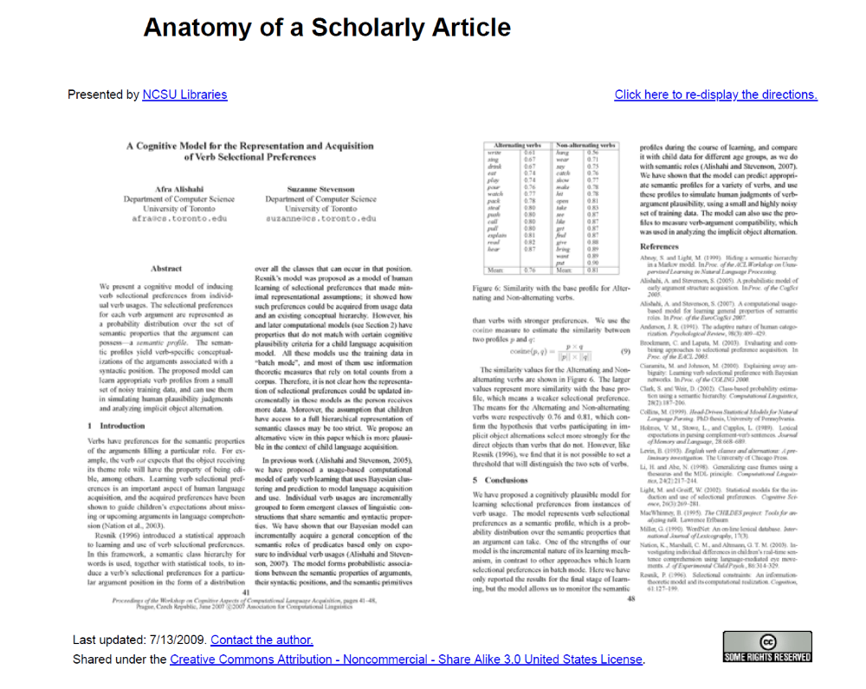

UNIT THREE: Reviewing and Analyzing Your Sources

3.1.1: Reading Critically as a Research Strategy Dr. Pavel Zemliansky's "Methods of Discovery: A Guide to Research Writing - Chapter 3: Research and Critical Reading"
Introduction
Good researchers and writers examine their sources critically and actively. They do not just compile and summarize these research sources in their writing, but use them to create their own ideas, theories, and, ultimately, their own, new understanding of the topic they are researching. Such an approach means not taking the information and opinions that the sources contain at face value and for granted, but to investigate, test, and even doubt every claim, every example, every story, and every conclusion. It means not to sit back and let your sources control you, but to engage in active conversation with them and their authors. In order to be a good researcher and writer, one needs to be a critical and active reader.
This chapter is about the importance of critical and active reading. It is also about the connection between critical reading and active, strong writing. Much of the discussion you will find in this chapter in fundamental to research and writing, no matter what writing genre, medium, or academic discipline you read and write in. Every other approach to research writing, every other research method and assignment offered elsewhere in this book is, in some way, based upon the principles discussed in this chapter.
Reading is at the heart of the research process. No matter what kinds of research sources and, methods you use, you are always reading and interpreting text. Most of us are used to hearing the word “reading” in relation to secondary sources, such as books, journals, magazines, websites, and so on. But even if you are using other research methods and sources, such as interviewing someone or surveying a group of people, you are reading. You are reading their subjects’ ideas and views on the topic you are investigating. Even if you are studying photographs, cultural artifacts, and other non-verbal research sources, you are reading them, too by trying to connect them to their cultural and social contexts and to understand their meaning. Principles of critical reading which we are about to discuss in this chapter apply to those research situations as well.
I like to think about reading and writing as not two separate activities but as two tightly connected parts of the same whole. That whole is the process of learning and making of new meaning. It may seem that reading and writing are complete opposite of one another. According to the popular view, when we read, we “consume” texts, and when we write, we “produce” texts. But this view of reading and writing is true only if you see reading as a passive process of taking in information from the text and not as an active and energetic process of making new meaning and new knowledge. Similarly, good writing does not come from nowhere but is usually based upon, or at least influenced by ideas, theories, and stories that come from reading. So, if, as a college student, you have ever wondered why your writing teachers have asked you to read books and articles and write responses to them, it is because writers who do not read and do not actively engage with their reading, have little to say to others.
We will begin this chapter with the definition of the term “critical reading.” We will consider its main characteristics and briefly touch upon ways to become an active and critical reader. Next, we will discuss the importance of critical reading for research and how reading critically can help you become a better researcher and make the research process more enjoyable. Also in this chapter, a student-writer offers us an insight into his critical reading and writing processes. This chapter also shows how critical reading can and should be used for critical and strong writing. And, as all other chapters, this one offers you activities and projects designed to help you implement the advice presented here into practice.
What Kind of Reader Are You?
You read a lot, probably more that you think. You read school textbooks, lecture notes, your classmates’ papers, and class websites. When school ends, you probably read some fiction, magazines. But you also read other texts. These may include CD liner notes, product reviews, grocery lists, maps, driving directions, road signs, and the list can go on and on. And you don’t read all these texts in the same way. You read them with different purposes and using different reading strategies and techniques. The first step towards becoming a critical and active reader is examining your reading process and your reading preferences. Therefore, you are invited to complete the following exploration activity.

Writing Activity: Analyzing your Reading Habits
List all the reading you have done in the last week. Include both “school” and “out-of school” reading. Try to list as many texts as you can think of, no matter how short and unimportant they might seem. Now, answer the following questions.
- What was your purpose in reading each of those texts? Did you read for information, to pass a test, for enjoyment, to decide on a product you wanted to buy, and so on? Or, did you read to figure out some complex problem that keeps you awake at night?
- You have probably come up with a list of different purposes. How did each of those purposes influence your reading strategies? Did you take notes or try to memorize what you read? How long did it take you to read different texts? Did you begin at the beginning and read till you reached the end, or did you browse some texts? Consider the time of day you were reading. Consider even whether some texts tired you out or whether you thought they were “boring.” Why?
- What did you do with the results of your reading? Did you use them for some practical purpose, such as buying a new product or finding directions, or did you use them for a less practical purpose, such as understanding some topic better r learning something about yourself and others?
When you finish, share your results with the rest of the class and with your instructor.
Having answered the questions above, you have probably noticed that your reading strategies differed depending on the reading task you were facing and on what you planned to do with the results of the reading. If, for example, you read lecture notes in order to pass a test, chances are you “read for information,” or “for the main” point, trying to remember as much material as possible and anticipating possible test questions. If, on the other hand, you read a good novel, you probably just focused on following the story. Finally, if you were reading something that you hoped would help you answer some personal question or solve some personal problem, it is likely that you kept comparing and contrasting the information that you read your own life and your own experiences.
You may have spent more time on some reading tasks than others. For example, when we are interested in one particular piece of information or fact from a text, we usually put that text aside once we have located the information we were looking for. In other cases, you may have been reading for hours on end taking careful notes and asking questions.
If you share the results of your investigation into your reading habits with your classmates, you may also notice that some of their reading habits and strategies were different from yours. Like writing strategies, approaches to reading may vary from person to person depending on our previous experiences with different topics and types of reading materials, expectations we have of different texts, and, of course, the purpose with which we are reading.
Life presents us with a variety of reading situations which demand different reading strategies and techniques. Sometimes, it is important to be as efficient as possible and read purely for information or “the main point.” At other times, it is important to just “let go” and turn the pages following a good story, although this means not thinking about the story you are reading. At the heart of writing and research, however, lies the kind of reading known as critical reading. Critical examination of sources is what makes their use in research possible and what allows writers to create rhetorically effective and engaging texts.
Key Features of Critical Reading
Critical readers are able to interact with the texts they read through carefully listening, writing, conversation, and questioning. They do not sit back and wait for the meaning of a text to come to them, but work hard in order to create such meaning. Critical readers are not made overnight. Becoming a critical reader will take a lot of practice and patience. Depending on your current reading philosophy and experiences with reading, becoming a critical reader may require a significant change in your whole understanding of the reading process. The trade-off is worth it, however. By becoming a more critical and active reader, you will also become a better researcher and a better writer. Last but not least, you will enjoy reading and writing a whole lot more because you will become actively engaged in both.
One of my favorite passages describing the substance of critical and active reading comes from the introduction to their book Ways of Reading whose authors David Bartholomae and Anthony Petrosky write:
“Reading involves a fair measure of push and shove. You make your mark on the book and it makes its mark on you. Reading is not simply a matter of hanging back and waiting for a piece, or its author, to tell you what the writing has to say. In fact, one of the difficult things about reading is that the pages before you will begin to speak only when the authors are silent and you begin to speak in their place, sometimes for them—doing their work, continuing their projects—and sometimes for yourself, following your own agenda” (1).
Notice that Bartholomae and Petrosky describe reading process in pro-active terms. Meaning of every text is “made,” not received. Readers need to “push and shove” in order to create their own, unique content of every text they read. It is up the you as a reader to make the pages in front of you “speak” by talking with and against the text, by questioning and expanding it.
Critical reading, then, is a two-way process. As reader, you are not a consumer of words, waiting patiently for ideas from the printed page or a web-site to fill your head and make you smarter. Instead, as a critical reader, you need to interact with what you read, asking questions of the author, testing every assertion, fact, or idea, and extending the text by adding your own understanding of the subject and your own personal experiences to your reading.
The following are key features of the critical approach to reading:
- No text, however well written and authoritative, contains its own, pre-determined meaning.
- Readers must work hard to create meaning from every text.
- Critical readers interact with the texts they read by questioning them, responding to them, and expanding them, usually in writing.
- To create meaning, critical readers use a variety of approaches, strategies, and techniques which include applying their personal experiences and existing knowledge to the reading process.
- Critical readers seek actively out other texts, related to the topic of their investigation.
The following section is an examination of these claims about critical reading in more detail.
Texts Present Ideas, Not Absolute Truths
In order to understand the mechanisms and intellectual challenges of critical reading, we need to examine some of our deepest and long-lasting assumptions about reading. Perhaps the two most significant challenges facing anyone who wants to become a more active and analytical reader is understanding that printed texts doe not contain inarguable truths and learning to questions and talk back to those texts. Students in my writing classes often tell me that the biggest challenge they face in trying to become critical readers is getting away from the idea that they have to believe everything they read on a printed page. Years of schooling have taught many of us to believe that published texts present inarguable, almost absolute truths. The printed page has authority because, before publishing his or her work, every writer goes through a lengthy process of approval, review, revision, fact-checking, and so on. Consequently, this theory goes, what gets published must be true. And if it is true, it must be taken at face value, not questioned, challenged, or extended in any way.
Perhaps, the ultimate authority among the readings materials encountered by college belongs to the textbook. As students, we all have had to read and almost memorize textbook chapters in order to pass an exam. We read textbooks “for information,” summarizing their chapters, trying to find “the main points” and then reproducing these main points during exams. I have nothing against textbook as such, in fact, I am writing one right now. And it is certainly possible to read textbooks critically and actively. But, as I think about the challenges which many college students face trying to become active and critical readers, I come to the conclusion that the habit to read every text as if they were preparing for an exam on it, as if it was a source of unquestionable truth and knowledge prevents many from becoming active readers.
Treating texts as if they were sources of ultimate and unquestionable knowledge and truth represents the view of reading as consumption. According to this view, writers produce ideas and knowledge, and we, readers, consume them. Of course, sometimes we have to assume this stance and read for information or the “main point” of a text. But it is critical reading that allows us to create new ideas from what we read and to become independent and creative learners.
Critical reading is a collaboration between the reader and the writer. It offers readers the ability to be active participants in the construction of meaning of every text they read and to use that meaning for their own learning and self-fulfillment. Not even the best researched and written text is absolutely complete and finished. Granted, most fields of knowledge have texts which are called “definitive.” Such texts usually represent our best current knowledge on their subjects. However, even the definitive works get revised over time and they are always open to questioning and different interpretations.
Reading is a Rhetorical Tool
To understand how the claim that every reader makes his or her meaning from texts works, it is necessary to examine what is know as the rhetorical theory of reading. The work that best describes and justifies the rhetorical reading theory is Douglas Brent’s 1992 book Reading as Rhetorical Invention: Knowledge, Persuasion, and the Teaching of Research-Based Writing. I like to apply Brent’s ideas to my discussions of critical reading because I think that they do a good job demystifying critical reading’s main claims. Brent’s theory of reading is a rhetorical device puts significant substance behind the somewhat abstract ideas of active and critical reading, explaining how the mechanisms of active interaction between readers and texts actually work.
Briefly explained, Brent treats reading not only as a vehicle for transmitting information and knowledge, but also as a means of persuasion. In fact, according to Brent, knowledge equals persuasion because, in his words, “Knowledge is not simply what one has been told. Knowledge is what one believes, what one accepts as being at least provisionally true.” (xi). This short passage contains two assertions which are key to the understanding of mechanisms of critical reading. Firstly, notice that simply reading “for the main point” will not necessarily make you “believe” what you read. Surely, such reading can fill our heads with information, but will that information become our knowledge in a true sense, will we be persuaded by it, or will we simply memorize it to pass the test and forget it as soon as we pass it? Of course not! All of us can probably recall many instances in which we read a lot to pass a test only to forget, with relief, what we read as soon as we left the classroom where that test was held. The purpose of reading and research, then, is not to get as much as information out of a text as possible but to change and update one’s system of beliefs on a given subject (Brent 55-57).
Brent further states:
“The way we believe or disbelieve certain texts clearly varies from one individual to the next. If you present a text that is remotely controversial to a group of people, some will be convinced by it and some not, and those who are convinced will be convinced in different degrees. The task of a rhetoric of reading is to explain systematically how these differences arise—how people are persuaded differently by texts” (18).
Critical and active readers not only accept the possibility that the same texts will have different meanings for different people, but welcome this possibility as an inherent and indispensable feature of strong, engaged, and enjoyable reading process. To answer his own questions about what factors contribute to different readers’ different interpretations of the same texts, Brent offers us the following principles that I have summarized from his book:
- Readers are guided by personal beliefs, assumptions, and pre-existing knowledge when interpreting texts. You can read more on the role of the reader’s pre-existing knowledge in the construction of meaning later on in this chapter.
- Readers react differently to the logical proofs presented by the writers of texts.
- Readers react differently to emotional and ethical proofs presented by writers. For example, an emotional story told by a writer may resonate with one person more than with another because the first person lived through a similar experience and the second one did not, and so on.
The idea behind the rhetorical theory of reading is that when we read, we not only take in ideas, information, and facts, but instead we “update our view of the world.” You cannot force someone to update their worldview, and therefore, the purpose of writing is persuasion and the purpose of reading is being persuaded. Persuasion is possible only when the reader is actively engaged with the text and understands that much more than simple retrieval of information is at stake when reading.
One of the primary factors that influence our decision to accept or not to accept an argument is what Douglas Brent calls our “repertoire of experience, much of [which] is gained through prior interaction with texts” (56). What this means is that when we read a new text, we do not begin with a clean slate, an empty mind. However unfamiliar the topic of this new reading may seem to us, we approach it with a large baggage of previous knowledge, experiences, points of view, and so on. When an argument “comes in” into our minds from a text, this text, by itself, cannot change our view on the subject. Our prior opinions and knowledge about the topic of the text we are reading will necessarily “filter out” what is incompatible with those views (Brent 56-57). This, of course, does not mean that, as readers, we should persist in keeping our old ideas about everything and actively resist learning new things. Rather, it suggests that the reading process is an interaction between the ideas in the text in front of us and our own ideas and pre-conceptions about the subject of our reading. We do not always consciously measure what we read according to our existing systems of knowledge and beliefs, but we measure it nevertheless. Reading, according to Brent, is judgment, and, like in life where we do not always consciously examine and analyze the reasons for which we make various decisions, evaluating a text often happens automatically or subconsciously (59).
Applied to research writing, Brent’s theory or reading means the following:
- The purpose of research is not simply to retrieve data, but to participate in a conversation about it. Simple summaries of sources is not research, and writers should be aiming for active interpretation of sources instead
- There is no such thing as an unbiased source. Writers make claims for personal reasons that critical readers need to learn to understand and evaluate.
- Feelings can be a source of shareable good reason for belief. Readers and writers need to use, judiciously, ethical and pathetic proofs in interpreting texts and in creating their own.
- Research is recursive. Critical readers and researchers never stop asking questions about their topic and never consider their research finished.

Active Readers Look for Connections Between Texts
Earlier on, I mentioned that one of the traits of active readers is their willingness to seek out other texts and people who may be able to help them in their research and learning. I find that for many beginning researchers and writers, the inability to seek out such connections often turns into a roadblock on their research route. Here is what I am talking about.
Recently, I asked my writing students to investigate some problem on campus and to propose a solution to it. I asked them to use both primary (interviews, surveys, etc.) and secondary (library, Internet, etc.) research. Conducting secondary research allows a writer to connect a local problem he or she is investigating and a local solution he or she is proposing with a national and even global context, and to see whether the local situation is typical or a-typical.
One group of students decided to investigate the issue of racial and ethnic diversity on our campus. The lack of diversity is a “hot” issue on our campus, and recently an institutional task force was created to investigate possible ways of making our university more diverse.
The students had no trouble designing research questions and finding people to interview and survey. Their subjects included students and faculty as well as the university vice-president who was changed with overseeing the work of the diversity task force. Overall, these authors have little trouble conducting and interpreting primary research that led them to conclude that, indeed, our campus is not diverse enough and that most students would like to see the situation change.
The next step these writers took was to look at the websites of some other schools similar in size and nature to ours, to see how our university compared on the issue of campus diversity with others. They were able to find some statistics on the numbers of minorities at other colleges and universities that allowed them to create a certain backdrop for their primary research that they had conducted earlier.
But good writing goes beyond the local situation. Good writing tries to connect the local and the national and the global. It tries to look beyond the surface of the problem, beyond simply comparing numbers and other statistics. It seeks to understand the roots of a problem and propose a solution based on a local and well as a global situation and research. The primary and secondary research conducted by these students was not allowing them to make that step from analyzing local data to understanding their problem in context. They needed some other type of research sources.
At that point, however, those writers hit an obstacle. How and where, they reasoned, would we find other secondary sources, such as books, journals, and websites, about the lack of diversity on our campus? The answer to that question was that, at this stage in their research and writing, they did not need to look for more sources about our local problem with the lack of diversity. They needed to look at diversity and ways to increase it as a national and global issue. They needed to generalize the problem and, instead of looking at a local example, to consider its implications for the issue they were studying overall. Such research would not only have allowed these writers to examine the problem as a whole but also to see how it was being solved in other places. This, in turn, might have helped them to propose a local solution.
Critical readers and researchers understand that it is not enough to look at the research question locally or narrowly. After conducting research and understanding their problem locally, or as it applies specifically to them, active researchers contextualize their investigation by seeking out texts and other sources which would allow them to see the big picture.
Sometimes, it is hard to understand how external texts which do not seem to talk directly about you can help you research and write about questions, problems, and issues in your own life. In her 2004 essay, “Developing ‘Interesting Thoughts’: Reading for Research,” writing teacher my former colleague Janette Martin tells a story of a student who was writing a paper about what it is like to be a collegiate athlete. The emerging theme in that paper was that of discipline and sacrifice required of student athletes. Simultaneously, that student was reading a chapter from the book by the French philosopher Michel Foucault called Discipline and Punish. Foucault’s work is a study of the western penitentiary system, which, of course cannot be directly compared to experiences of a student athlete. At the same time, one of the leading themes in Foucault’s work is discipline. Martin states that the student was able to see some connection between Foucault and her own life and use the reading for her research and writing (6). In addition to showing how related texts can be used to explore various aspects of the writer’s own life, this example highlights the need to read texts critically and interpret them creatively. Such reading and research goes beyond simply comparing of facts and numbers and towards relating ideas and concepts with one another.
From Reading to Writing
Reading and writing are the two essential tools of learning. Critical reading is not a process of passive consumption, but one of interaction and engagement between the reader and the text. Therefore, when reading critically and actively, it is important not only to take in the words on the page, but also to interpret and to reflect upon what you read through writing and discussing it with others.

Critical Readers Understand the Difference Between Reacting and Responding to A Text
As stated earlier in this chapter, actively responding to difficult texts, posing questions, and analyzing ideas presented in them is the key to successful reading. The goal of an active reader is to engage in a conversation with the text he or she is reading. In order to fulfill this goal, it is important to understand the difference between reacting to the text and responding to it.
Reacting to a text is often done on an emotional, rather than on an intellectual level. It is quick and shallow. For example, if we encounter a text that advances arguments with which we strongly disagree, it is natural to dismiss those ideas out of hand as not wrong and not worthy of our attention. Doing so would be reacting to the text based only on emotions and on our pre-set opinions about its arguments. It is easy to see that reacting in this way does not take the reader any closer to understanding the text. A wall of disagreement that existed between the reader and the text before the reading continues to exist after the reading.
Responding to a text, on the other hand, requires a careful study of the ideas presented and arguments advanced in it. Critical readers who possess this skill are not willing to simply reject or accept the arguments presented in the text after the first reading right away. To continue with our example from the preceding paragraph, a reader who responds to a controversial text rather than reacting to it might apply several of the following strategies before forming and expressing an opinion about that text.
- Read the text several times, taking notes, asking questions, and underlining key places.
- Study why the author of the text advances ideas, arguments, and convictions, so different from the reader’s own. For example, is the text’s author advancing an agenda of some social, political, religious, or economic group of which he or she is a member?
- Study the purpose and the intended audience of the text.
- Study the history of the argument presented in the text as much as possible. For example, modern texts on highly controversial issues such as the death penalty, abortion, or euthanasia often use past events, court cases, and other evidence to advance their claims. Knowing the history of the problem will help you to construct meaning of a difficult text.
- Study the social, political, and intellectual context in which the text was written. Good writers use social conditions to advance controversial ideas. Compare the context in which the text was written to the one in which it is read. For example, have social conditions changed, thus invalidating the argument or making it stronger?
- Consider the author’s (and your own) previous knowledge of the issue at the center of the text and your experiences with it. How might such knowledge or experience have influenced your reception of the argument?
Taking all these steps will help you to move away from simply reacting to a text and towards constructing informed and critical response to it.
To better understand the key differences between reacting and responding and between binary and nuanced reading, consider the table below.
Critical Readers Resist Oversimplified Binary Responses
Critical readers learn to avoid simple “agree-disagree” responses to complex texts. Such way of thinking and arguing is often called “binary” because is allows only two answers to every statement and every questions. But the world of ideas is complex and, a much more nuanced approach is needed when dealing with complex arguments.
When you are asked to “critique” a text, which readers are often asked to do, it does not mean that you have to “criticize” it and reject its argument out of hand. What you are being asked to do instead is to carefully evaluate and analyze the text’s ideas, to understand how and why they are constructed and presented, and only then develop a response to that text. Not every text asks for an outright agreement or disagreement. Sometimes, we as readers are not in a position to either simply support an argument or reject it. What we can do in such cases, though, is to learn more about the text’s arguments by carefully considering all of their aspects and to construct a nuanced, sophisticated response to them. After you have done all that, it will still be possible to disagree with the arguments presented in the reading, but your opinion about the text will be much more informed and nuanced than if you have taken the binary approach from the start.

Two Sample Student Responses
To illustrate the principles laid out in this section, consider the following two reading responses. Both texts respond to a very well known piece, “A Letter from Birmingham Jail,” by Martin Luther King, Jr. In the letter, King responds to criticism from other clergymen who had called his methods of civil rights struggle “unwise and untimely.” Both student writers were given the same response prompt:
“After reading King’s piece several times and with a pen or pencil in hand, consider what shapes King’s letter. Specifically, what rhetorical strategies is he using to achieve a persuasive effect on his readers? In making your decisions, consider such factors as background information that he gives, ways in which he addresses his immediate audience, and others. Remember that your goal is to explore King’s text, thus enabling you to understand his rhetorical strategies better.”
Student “A”
Martin Luther King Jr’s “Letter from Birmingham Jail” is a very powerful text. At the time when minorities in America were silenced and persecuted, King had the courage to lead his people in the struggle for equality. After being jailed in Birmingham, Alabama, King wrote a letter to his “fellow clergymen” describing his struggle for civil rights. In the letter, King recounts a brief history of that struggle and rejects the accusation that it is “unwise and untimely.” Overall, I think that King’s letter is a very rhetorically effective text, one that greatly helped Americans to understand the civil rights movement.
Student “B”
King begins his “Letter from Birmingham Jail” by addressing it to his “fellow clergymen.” Thus, he immediately sets the tone of inclusion rather than exclusion. By using the word “fellow” in the address, I think he is trying to do two things. First of all, he presents himself as a colleague and a spiritual brother of his audience. That, in effect, says “you can trust me,” “I am one of your kind.” Secondly, by addressing his readers in that way, King suggests that everyone, even those Americans who are not directly involved in the struggle for civil rights, should be concerned with it. Hence the word “fellow.” King’s opening almost invokes the phrase “My fellow Americans” or “My fellow citizens” used so often by American Presidents when they address the nation.
King then proceeds to give a brief background of his actions as a civil rights leader. As I read this part of the letter, I was wondering whether his readers would really have not known what he had accomplished as a civil rights leader. Then I realized that perhaps he gives all that background information as a rhetorical move. His immediate goal is to keep reminding his readers about his activities. His ultimate goal is to show to his audience that his actions were non-violent but peaceful. In reading this passage by King, I remembered once again that it is important not to assume that your audience knows anything about the subject of the writing. I will try to use this strategy more in my own papers.
In the middle of the letter, King states: “The purpose of our direct-action program is to create a situation so crisis-packed that it will inevitably open the door to negotiation.” This sentence looks like a thesis statement and I wonder why he did not place it towards the beginning of the text, to get his point across right away. After thinking about this for a few minutes and re-reading several pages from our class textbook, I think he leaves his “thesis” till later in his piece because he is facing a not-so-friendly (if not hostile) audience. Delaying the thesis and laying out some background information and evidence first helps a writer to prepare his or her audience for the coming argument. That is another strategy I should probably use more often in my own writing, depending on the audience I am facing.

Reflecting on the Responses
To be sure, much more can be said about King’s letter than either of these writers have said. However, these two responses allow us to see two dramatically different approaches to reading. After studying both responses, consider the questions below.
- Which response fulfills the goals set in the prompt better and why?
- Which responses shows a deeper understanding of the texts by the reader and why?
- Which writer does a better job at avoiding binary thinking and creating a sophisticated reading of King’s text and why?
- Which writer is more likely to use the results of the reading in his or her own writing in the future and why?
- Which writer leaves room for response to his text by others and why?

Critical Readers Do not Read Alone and in Silence
One of the key principles of critical reading is that active readers do not read silently and by themselves. By this I mean that they take notes and write about what they read. They also discuss the texts they are working with, with others and compare their own interpretations of those texts with the interpretations constructed by their colleagues.
As a college student, you are probably used to taking notes of what you read. When I was in college, my favorite way of preparing for a test was reading a chapter or two from my textbook, then closing the book, then trying to summarize what I have read on a piece of paper. I tried to get the main points of the chapters down and the explanations and proofs that the textbooks’ authors used. Sometimes, I wrote a summary of every chapter in the textbook and then studied for the test from those summaries rather than from the textbook itself. I am sure you have favorite methods of note taking and studying from your notes, too.
But now it strikes me that what I did with those notes was not critical reading. I simply summarized my textbooks in a more concise, manageable form and then tried to memorize those summaries before the test. I did not take my reading of the textbooks any further than what was already on their pages. Reading for information and trying to extract the main points, I did not talk back to the texts, did not question them, and did not try to extend the knowledge which they offered in any way. I also did not try to connect my reading with my personal experiences or pre-existing knowledge in any way. I also read in silence, without exchanging ideas with other readers of the same texts. Of course, my reading strategies and techniques were dictated by my goal, which was to pass the test.
Critical reading has other goals, one of which is entering an on-going intellectual exchange. Therefore it demands different reading strategies, approaches, and techniques. One of these new approaches is not reading in silence and alone. Instead, critical readers read with a pen or pencil in hand. They also discuss what they read with others.

Strategies for Connecting Reading and Writing
If you want to become a critical reader, you need to get into a habit of writing as you read. You also need to understand that complex texts cannot be read just once. Instead, they require multiple readings, the first of which may be a more general one during which you get acquainted with the ideas presented in the text, its structure and style. During the second and any subsequent readings, however, you will need to write, and write a lot. The following are some critical reading and writing techniques which active readers employ as they work to create meanings from texts they read.

Underline Interesting and Important Places in the Text
Underline words, sentences, and passages that stand out, for whatever reason. Underline the key arguments that you believe the author of the text is making as well as any evidence, examples, and stories that seem interesting or important. Don’t be afraid to “get it wrong.” There is no right or wrong here. The places in the text that you underline may be the same or different from those noticed by your classmates, and this difference of interpretation is the essence of critical reading.

Take Notes
Take notes on the margins. If you do not want to write on your book or journal, attach post-it notes with your comments to the text. Do not be afraid to write too much. This is the stage of the reading process during which you are actively making meaning. Writing about what you read is the best way to make sense of it, especially, if the text is difficult.
Do not be afraid to write too much. This is the stage of the reading process during which you are actively making meaning. Writing about what you read will help you not only to remember the argument which the author of the text is trying to advance (less important for critical reading), but to create your own interpretations of the text you are reading (more important).
Here are some things you can do in your comments
• Ask questions.
• Agree or disagree with the author.
• Question the evidence presented in the text
• Offer counter-evidence
• Offer additional evidence, examples, stories, and so on that support the author’s argument
• Mention other texts which advance the same or similar arguments
• Mention personal experiences that enhance your reading of the text

Write Exploratory Responses
Write extended responses to readings. Writing students are often asked to write one or two page exploratory responses to readings, but they are not always clear on the purpose of these responses and on how to approach writing them. By writing reading responses, you are continuing the important work of critical reading which you began when you underlined interesting passages and took notes on the margins. You are extending the meaning of the text by creating your own commentary to it and perhaps even branching off into creating your own argument inspired by your reading. Your teacher may give you a writing prompt, or ask you to come up with your own topic for a response. In either case, realize that reading responses are supposed to be exploratory, designed to help you delve deeper into the text you are reading than note-taking or underlining will allow.
When writing extended responses to the readings, it is important to keep one thing in mind, and that is their purpose. The purpose of these exploratory responses, which are often rather informal, is not to produce a complete argument, with an introduction, thesis, body, and conclusion. It is not to impress your classmates and your teacher with “big” words and complex sentences. On the contrary, it is to help you understand the text you are working with at a deeper level. The verb “explore” means to investigate something by looking at it more closely. Investigators get leads, some of which are fruitful and useful and some of which are dead-ends. As you investigate and create the meaning of the text you are working with, do not be afraid to take different directions with your reading response. In fact, it is important resist the urge to make conclusions or think that you have found out everything about your reading. When it comes to exploratory reading responses, lack of closure and presence of more leads at the end of the piece is usually a good thing. Of course, you should always check with your teacher for standards and format of reading responses.
Try the following guidelines to write a successful response to a reading:
Remember your goal—exploration. The purpose of writing a response is to construct the meaning of a difficult text. It is not to get the job done as quickly as possible and in as few words as possible.
As you write, “talk back to the text.” Make comments, ask questions, and elaborate on complex thoughts. This part of the writing becomes much easier if, prior to writing your response, you had read the assignment with a pen in hand and marked important places in the reading.
If your teacher provides a response prompt, make sure you understand it. Then try to answer the questions in the prompt to the best of your ability. While you are doing that, do not be afraid of bringing in related texts, examples, or experiences. Active reading is about making connections, and your readers will appreciate your work because it will help them understand the text better.
While your primary goal is exploration and questioning, make sure that others can understand your response. While it is OK to be informal in your response, make every effort to write in a clear, error-free language.
Involve your audience in the discussion of the reading by asking questions, expressing opinions, and connecting to responses made by others.

Use Reading for Invention
Use reading and your responses to start your own formal writing projects. Reading is a powerful invention tool. While preparing to start a new writing project, go back to the readings you have completed and your responses to those readings in search for possible topics and ideas. Also look through responses your classmates gave to your ideas about the text. Another excellent way to start your own writing projects and to begin research for them is to look through the list of references and sources at the end of the reading that you are working with. They can provide excellent topic-generating and research leads.

Keep a Double-Entry Journal
Many writers like double-entry journals because they allow us to make that leap from summary of a source to interpretation and persuasion. To start a double-entry journal, divide a page into two columns. As you read, in the left column write down interesting and important words, sentences, quotations, and passages from the text. In the right column, right your reaction and responses to them. Be as formal or informal as you want. Record words, passages, and ideas from the text that you find useful for your paper, interesting, or, in any, way striking or unusual. Quote or summarize in full, accurately, and fairly. In the right-hand side column, ask the kinds of questions and provide the kinds of responses that will later enable you to create an original reading of the text you are working with and use that reading to create your own paper.

Don’t Give Up
If the text you are reading seems too complicated or “boring,” that might mean that you have not attacked it aggressively and critically enough. Complex texts are the ones worth pursuing and investigating because they present the most interesting ideas. Critical reading is a liberating practice because you do not have to worry about “getting it right.” As long as you make an effort to engage with the text and as long as you are willing to work hard on creating a meaning out of what you read, the interpretation of the text you are working with will be valid.
IMPORTANT: So far, we have established that no pre-existing meaning is possible in written texts and that critical and active readers work hard to create such meaning. We have also established that interpretations differ from reader to reader and that there is no “right” or “wrong” during the critical reading process. So, you may ask, does this mean that any reading of a text that I create will be a valid and persuasive one? With the exception of the most outlandish and purposely-irrelevant readings that have nothing to do with the sources text, the answer is “yes.” However, remember that reading and interpreting texts, as well as sharing your interpretations with others are rhetorical acts. First of all, in order to learn something from your critical reading experience, you, the reader, need to be persuaded by your own reading of the text. Secondly, for your reading to be accepted by others, they need to be persuaded by it, too. It does not mean, however, that in order to make your reading of a text persuasive, you simply have to find “proof” in the text for your point of view. Doing that would mean reverting to reading “for the main point,” reading as consumption. Critical reading, on the other hand, requires a different approach. One of the components of this approach is the use of personal experiences, examples, stories, and knowledge for interpretive and persuasive purposes. This is the subject of the next section of this chapter.
One Critical Reader’s Path to Creating a Meaning: A Case Study
Earlier on in this chapter, we discussed the importance of using your existing knowledge and prior experience to create new meaning out of unfamiliar and difficult texts. In this section, I’d like to offer you one student writer’s account of his meaning-making process. Before I do that, however, it is important for me to tell you a little about the class and the kinds of reading and writing assignments that its members worked on.
All the writing projects offered to the members of the class were promoted by readings, and students were expected to actively develop their own ideas and provide their own readings of assigned texts in their essays. The main text for the class was the anthology Ways of Reading edited by David Bartholomae and Anthony Petrosky that contains challenging and complex texts. Like for most of his classmates, this approach to reading and writing was new to Alex who had told me earlier that he was used to reading “for information” or “for the main point”.
In preparation for the first writing project, the class read Adrienne Rich’s essay “When We Dead Awaken: Writing as Revision.” In her essay, Rich offers a moving account of her journey to becoming a writer. She makes the case for constantly “revising” one’s life in the light of all new events and experiences. Rich blends voices and genres throughout the essay, using personal narrative, academic argument, and even poetry. As a result, Rich creates the kind of personal-public argument which, on the one hand, highlights her own life, and on the other, illustrates that her Rich’s life is typical for her time and her environment and that her readers can also learn from her experiences.
To many beginning readers and writers, who are used to a neat separation of “personal” and “academic” argument, such a blend of genres and styles may seem odd. In fact, on of the challenges that many of the students in the class faced was understanding why Rich chooses to blend personal writing with academic and what rhetorical effects she achieves by doing so. To After writing informal responses to the essay and discussing it in class, the students were offered the following writing assignment:
Although Rich tells a story of her own, she does so to provide an illustration of an even larger story—one about what it means to be a woman and a writer. Tell a story of your own about the ways you might be said to have been named or shaped or positioned by an established or powerful culture. Like Rich (and perhaps with similar hesitation), use your own experience as an illustration of both your own situation and the situation of people like you. You should imagine that the assignment is a way for you to use (and put to the test) some of Rich’s terms, words like “re-vision,” “renaming,” and “structure.” (Bartholomae and Petrosky 648).
Notice that this assignment does not ask students to simply analyze Rich’s essay, to dissect its argument or “main points.” Instead, writers are asked to work with their own experiences and events of their own lives in order to provide a reading of Rich which is affected and informed by the writers’ own lives and own knowledge of life. This is critical reading in action when a reader creates his or her one’s own meaning of a complex text by reflecting on the relationship between the content of that text and one’s own life.
In response to the assignment, one of the class members, Alex Cimino-Hurt, wrote a paper that re-examined and re-evaluated his upbringing and how those factors have influenced his political and social views. In particular, Alex was trying to reconcile his own and his parents’ anti-war views with the fact than a close relative of his was fighting in the war in Iraq as he worked on the paper. Alex used such terms as “revision” and “hesitation” to develop his piece.
Like most other writers in the class, initially Alex seemed a little puzzled, even confused by the requirement to read someone else’s text through the prism of his own life and his own experiences. However, as he drafted, revised, and discussed his writing with his classmates and his instructor, the new approach to reading and writing became clearer to him. After finishing the paper, Alex commented on his reading strategies and techniques and on what he learned about critical reading during the project:

On Previous Reading Habits and Techniques
Previously when working on any project whether it be for a History, English, or any other class that involved reading and research, there was a certain amount of minimalism. As a student I tried to balance the least amount of effort with the best grade. I distinctly remember that before, being taught to skim over writing and reading so that I found “main” points and highlighted them. The value of thoroughly reading a piece was not taught because all that was needed was a shallow interpretation of whatever information that was provided followed by a regurgitation. [Critical reading] provided a dramatic difference in perspective and helped me learn to not only dissect the meaning of a piece, but also to see why the writer is using certain techniques or how the reading applies to my life.

On Developing Critical Reading Strategies
When reading critically I found that the most important thing for me was to set aside a block of time in which I wouldn’t have to hurry my reading or skip parts to “Get the gist of it”. Developing an eye for…detail came in two ways. The first method is to read the text several times, and the second is to discuss it with my classmates and my teacher. It quickly became clear to me that the more I read a certain piece, the more I got from it as I became more comfortable with the prose and writing style. With respect to the second way, there is always something that you can miss and there is always a different perspective that can be brought to the table by either the teacher or a classmate.

On Reading Rich’s Essay
In reading Adrienne Rich’s essay, the problem for me wasn’t necessarily relating to her work but instead just finding the right perspective from which to read it. I was raised in a very open family so being able to relate to others was learned early in my life. Once I was able to parallel my perspective to hers, it was just a matter of composing my own story. Mine was my liberalism in conservative environments—the fact that frustrates me sometimes. I felt that her struggle frustrated her, too. By using quotations from her work, I was able to show my own situation to my readers.

On Writing the Paper
The process that I went through to write an essay consisted of three stages. During the first stage, I wrote down every coherent idea I had for the essay as well as a few incoherent ones. This helped me create a lot of material to work with. While this initial material doesn’t always have direction it provides a foundation for writing. The second stage involved rereading Rich’s essay and deciding which parts of it might be relevant to my own story. Looking at my own life and at Rich’s work together helped me consolidate my paper. The third and final stage involved taking what is left and refining the style of the paper and taking care of the mechanics.

Advice for Critical Readers
The first key to being a critical and active reader is to find something in the piece that interests, bothers, encourages, or just confuses you. Use this to drive your analysis. Remember there is no such thing as a boring essay, only a boring reader.
- Reading something once is never enough so reading it quickly before class just won’t cut it. Read it once to get your brain comfortable with the work, then read it again and actually try to understand what’s going on in it. You can’t read it too many times.
- Ask questions. It seems like a simple suggestion but if you never ask questions you’ll never get any answers. So, while you’re reading, think of questions and just write them down on a piece of paper lest you forget them after about a line and a half of reading.
Conclusion
Reading and writing are rhetorical processes, and one does not exist without the other. The goal of a good writer is to engage his or her readers into a dialog presented in the piece of writing. Similarly, the goal of a critical and active reader is to participate in that dialog and to have something to say back to the writer and to others. Writing leads to reading and reading leads to writing. We write because we have something to say and we read because we are interested in ideas of others.
Reading what others have to say and responding to them help us make that all-important transition from simply having opinions about something to having ideas. Opinions are often over-simplified and fixed. They are not very useful because, if different people have different opinions that they are not willing to change or adjust, such people cannot work or think together. Ideas, on the other hand, are ever evolving, fluid, and flexible. Our ideas are informed and shaped by our interactions with others, both in person and through written texts. In a world where thought and action count, it is not enough to simply “agree to disagree.” Reading and writing, used together, allow us to discuss complex and difficult issues with others, to persuade and be persuaded, and, most importantly, to act.
Reading and writing are inextricably connected, and I hope that this chapter has shown you ways to use reading to inform and enrich you writing and your learning in general. The key to becoming an active, critical, and interested reader is the development of varied and effective reading techniques and strategies. I’d like to close this chapter with the words from the writer Alex Cimino-Hurt: “Being able to read critically is important no matter what you plan on doing with your career or life because it allows you to understand the world around you.”
Sources
Bartholomae, David and Anthony Petrosky, Eds. Introduction. Ways of Reading. 8th Ed. New York: Bedford/St. Martin's, 2008.
Brent, Douglas. 1992. Reading as Rhetorical Invention. NCTE, Urbana, Illinois.
Cimino-Hurt, Alex. Personal Interview. 2003.
Martin, Janette. 2004. “Developing ‘Interesting Thoughts:’ Reading for Research.” In Research Writing Revisited: A Sourcebook for Teachers, eds. Pavel Zemliansky and Wendy Bishop, Heinemann, Portsmouth, NH. (3-13).
Rich, Adrienne. 2002. “When We Dead Awaken: Writing as Re-vision.” In Ways of Reading, 6th ed. Eds. Bartholomae, David and Anthony Petrosky. Bedford/St. Martin’s Boston, (627-645).
Last modified: Tuesday, October 20, 2015, 12:41 PM

3.1.2: Analyze Your Research Writing for Success: "Chapter 11, Section 5: Critical Thinking and Research Applications"

LEARNING OBJECTIVES
- Analyze source materials to determine how they support or refute the working thesis.
- Identify connections between source materials and eliminate redundant or irrelevant source materials.
- Identify instances when it is appropriate to use human sources, such as interviews or eyewitness testimony.
- Select information from sources to begin answering the research questions.
- Determine an appropriate organizational structure for the research paper that uses critical analysis to connect the writer’s ideas and information taken from sources.
At this point in your project, you are preparing to move from the research phase to the writing phase. You have gathered much of the information you will use, and soon you will be ready to begin writing your draft. This section helps you transition smoothly from one phase to the next.
Beginning writers sometimes attempt to transform a pile of note cards into a formal research paper without any intermediary step. This approach presents problems. The writer’s original question and thesis may be buried in a flood of disconnected details taken from research sources. The first draft may present redundant or contradictory information. Worst of all, the writer’s ideas and voice may be lost.
An effective research paper focuses on the writer’s ideas—from the question that sparked the research process to how the writer answers that question based on the research findings. Before beginning a draft, or even an outline, good writers pause and reflect. They ask themselves questions such as the following:
- How has my thinking changed based on my research? What have I learned?
- Was my working thesis on target? Do I need to rework my thesis based on what I have learned?
- How does the information in my sources mesh with my research questions and help me answer those questions? Have any additional important questions or subtopics come up that I will need to address in my paper?
- How do my sources complement each other? What ideas or facts recur in multiple sources?
- Where do my sources disagree with each other, and why?
In this section, you will reflect on your research and review the information you have gathered. You will determine what you now think about your topic. You will synthesize, or put together, different pieces of information that help you answer your research questions. Finally, you will determine the organizational structure that works best for your paper and begin planning your outline.

EXERCISE 1
Review the research questions and working thesis you developed in Chapter 11 "Writing from Research: What Will I Learn?", Section 11.2 "Steps in Developing a Research Proposal". Set a timer for ten minutes and write about your topic, using your questions and thesis to guide your writing. Complete this exercise without looking over your notes or sources. Base your writing on the overall impressions and concepts you have absorbed while conducting research. If additional, related questions come to mind, jot them down.

Selecting Useful Information
At this point in the research process, you have gathered information from a wide variety of sources. Now it is time to think about how you will use this information as a writer.
When you conduct research, you keep an open mind and seek out many promising sources. You take notes on any information that looks like it might help you answer your research questions. Often, new ideas and terms come up in your reading, and these, too, find their way into your notes. You may record facts or quotations that catch your attention even if they did not seem immediately relevant to your research question. By now, you have probably amassed an impressively detailed collection of notes.
You will not use all of your notes in your paper.
Good researchers are thorough. They look at multiple perspectives, facts, and ideas related to their topic, and they gather a great deal of information. Effective writers, however, are selective. They determine which information is most relevant and appropriate for their purpose. They include details that develop or explain their ideas—and they leave out details that do not. The writer, not the pile of notes, is the controlling force. The writer shapes the content of the research paper.
While working through Chapter 11 "Writing from Research: What Will I Learn?", Section 11.4 "Strategies for Gathering Reliable Information", you used strategies to filter out unreliable or irrelevant sources and details. Now you will apply your critical-thinking skills to the information you recorded—analyzing how it is relevant, determining how it meshes with your ideas, and finding how it forms connections and patterns.

Writing at Work
When you create workplace documents based on research, selectivity remains important. A project team may spend months conducting market surveys to prepare for rolling out a new product, but few managers have time to read the research in its entirety. Most employees want the research distilled into a few well-supported points. Focused, concise writing is highly valued in the workplace.

Identify Information That Supports Your Thesis
In Note 11.81 "Exercise 1", you revisited your research questions and working thesis. The process of writing informally helped you see how you might begin to pull together what you have learned from your research. Do not feel anxious, however, if you still have trouble seeing the big picture. Systematically looking through your notes will help you.
Begin by identifying the notes that clearly support your thesis. Mark or group these, either physically or using the cut-and-paste function in your word-processing program. As you identify the crucial details that support your thesis, make sure you analyze them critically. Ask the following questions to focus your thinking:
- Is this detail from a reliable, high-quality source? Is it appropriate for me to cite this source in an academic paper? The bulk of the support for your thesis should come from reliable, reputable sources. If most of the details that support your thesis are from less-reliable sources, you may need to do additional research or modify your thesis.
- Is the link between this information and my thesis obvious—or will I need to explain it to my readers? Remember, you have spent more time thinking and reading about this topic than your audience. Some connections might be obvious to both you and your readers. More often, however, you will need to provide the analysis or explanation that shows how the information supports your thesis. As you read through your notes, jot down ideas you have for making those connections clear.
- What personal biases or experiences might affect the way I interpret this information? No researcher is 100 percent objective. We all have personal opinions and experiences that influence our reactions to what we read and learn. Good researchers are aware of this human tendency. They keep an open mind when they read opinions or facts that contradict their beliefs.

Tip
It can be tempting to ignore information that does not support your thesis or that contradicts it outright. However, such information is important. At the very least, it gives you a sense of what has been written about the issue. More importantly, it can help you question and refine your own thinking so that writing your research paper is a true learning process.

Find Connections between Your Sources
As you find connections between your ideas and information in your sources, also look for information that connects your sources. Do most sources seem to agree on a particular idea? Are some facts mentioned repeatedly in many different sources? What key terms or major concepts come up in most of your sources regardless of whether the sources agree on the finer points? Identifying these connections will help you identify important ideas to discuss in your paper.
Look for subtler ways your sources complement one another, too. Does one author refer to another’s book or article? How do sources that are more recent build upon the ideas developed in earlier sources?
Be aware of any redundancies in your sources. If you have amassed solid support from a reputable source, such as a scholarly journal, there is no need to cite the same facts from an online encyclopedia article that is many steps removed from any primary research. If a given source adds nothing new to your discussion and you can cite a stronger source for the same information, use the stronger source.
Determine how you will address any contradictions found among different sources. For instance, if one source cites a startling fact that you cannot confirm anywhere else, it is safe to dismiss the information as unreliable. However, if you find significant disagreements among reliable sources, you will need to review them and evaluate each source. Which source presents a sounder argument or more solid evidence? It is up to you to determine which source is the most credible and why.
Finally, do not ignore any information simply because it does not support your thesis. Carefully consider how that information fits into the big picture of your research. You may decide that the source is unreliable or the information is not relevant, or you may decide that it is an important point you need to bring up. What matters is that you give it careful consideration.
As Jorge reviewed his research, he realized that some of the information was not especially useful for his purpose. His notes included several statements about the relationship between soft drinks that are high in sugar and childhood obesity—a subtopic that was too far outside of the main focus of the paper. Jorge decided to cut this material.

Reevaluate Your Working Thesis
A careful analysis of your notes will help you reevaluate your working thesis and determine whether you need to revise it. Remember that your working thesis was the starting point—not necessarily the end point—of your research. You should revise your working thesis if your ideas changed based on what you read. Even if your sources generally confirmed your preliminary thinking on the topic, it is still a good idea to tweak the wording of your thesis to incorporate the specific details you learned from research.
Jorge realized that his working thesis oversimplified the issues. He still believed that the media was exaggerating the benefits of low-carb diets. However, his research led him to conclude that these diets did have some advantages. Read Jorge’s revised thesis.
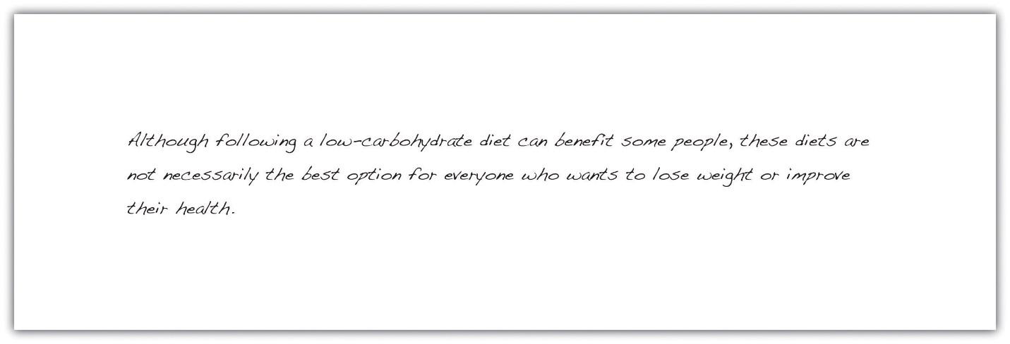

Synthesizing and Organizing Information
By now your thinking on your topic is taking shape. You have a sense of what major ideas to address in your paper, what points you can easily support, and what questions or subtopics might need a little more thought. In short, you have begun the process of synthesizing information—that is, of putting the pieces together into a coherent whole.
It is normal to find this part of the process a little difficult. Some questions or concepts may still be unclear to you. You may not yet know how you will tie all of your research together. Synthesizing information is a complex, demanding mental task, and even experienced researchers struggle with it at times. A little uncertainty is often a good sign! It means you are challenging yourself to work thoughtfully with your topic instead of simply restating the same information.

Use Your Research Questions to Synthesize Information
You have already considered how your notes fit with your working thesis. Now, take your synthesis a step further. Analyze how your notes relate to your major research question and the subquestions you identified in Chapter 11 "Writing from Research: What Will I Learn?", Section 11.2 "Steps in Developing a Research Proposal". Organize your notes with headings that correspond to those questions. As you proceed, you might identify some important subtopics that were not part of your original plan, or you might decide that some questions are not relevant to your paper.
Categorize information carefully and continue to think critically about the material. Ask yourself whether the sources are reliable and whether the connections between ideas are clear.
Remember, your ideas and conclusions will shape the paper. They are the glue that holds the rest of the content together. As you work, begin jotting down the big ideas you will use to connect the dots for your reader. (If you are not sure where to begin, try answering your major research question and subquestions. Add and answer new questions as appropriate.) You might record these big ideas on sticky notes or type and highlight them within an electronic document.
Jorge looked back on the list of research questions that he had written down earlier. He changed a few to match his new thesis, and he began a rough outline for his paper.
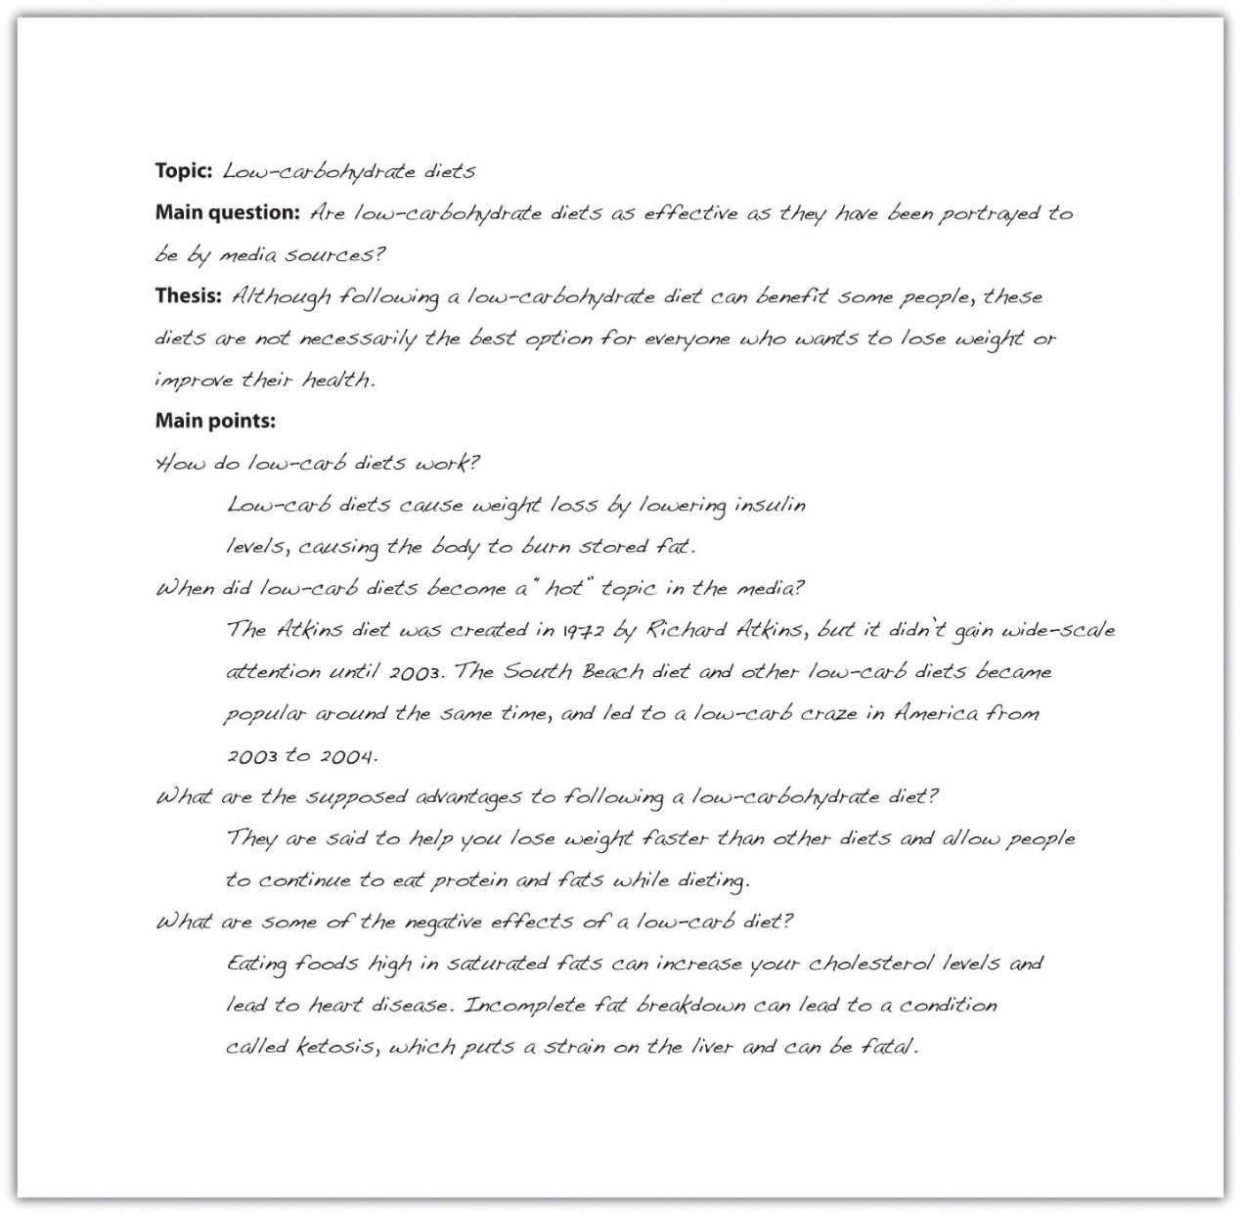

EXERCISE 2
Review your research questions and working thesis again. This time, keep them nearby as you review your research notes.
- Identify information that supports your working thesis.
- Identify details that call your thesis into question. Determine whether you need to modify your thesis.
- Use your research questions to identify key ideas in your paper. Begin categorizing your notes according to which topics are addressed. (You may find yourself adding important topics or deleting unimportant ones as you proceed.)
- Write out your revised thesis and at least two or three big ideas.
You may be wondering how your ideas are supposed to shape the paper, especially since you are writing a research paper based on your research. Integrating your ideas and your information from research is a complex process, and sometimes it can be difficult to separate the two.
Some paragraphs in your paper will consist mostly of details from your research. That is fine, as long as you explain what those details mean or how they are linked. You should also include sentences and transitions that show the relationship between different facts from your research by grouping related ideas or pointing out connections or contrasts. The result is that you are not simply presenting information; you are synthesizing, analyzing, and interpreting it.

Plan How to Organize Your Paper
The final step to complete before beginning your draft is to choose an organizational structure. For some assignments, this may be determined by the instructor’s requirements. For instance, if you are asked to explore the impact of a new communications device, a cause-and-effect structure is obviously appropriate. In other cases, you will need to determine the structure based on what suits your topic and purpose. For more information about the structures used in writing, see Chapter 10 "Rhetorical Modes".
The purpose of Jorge’s paper was primarily to persuade. With that in mind, he planned the following outline.
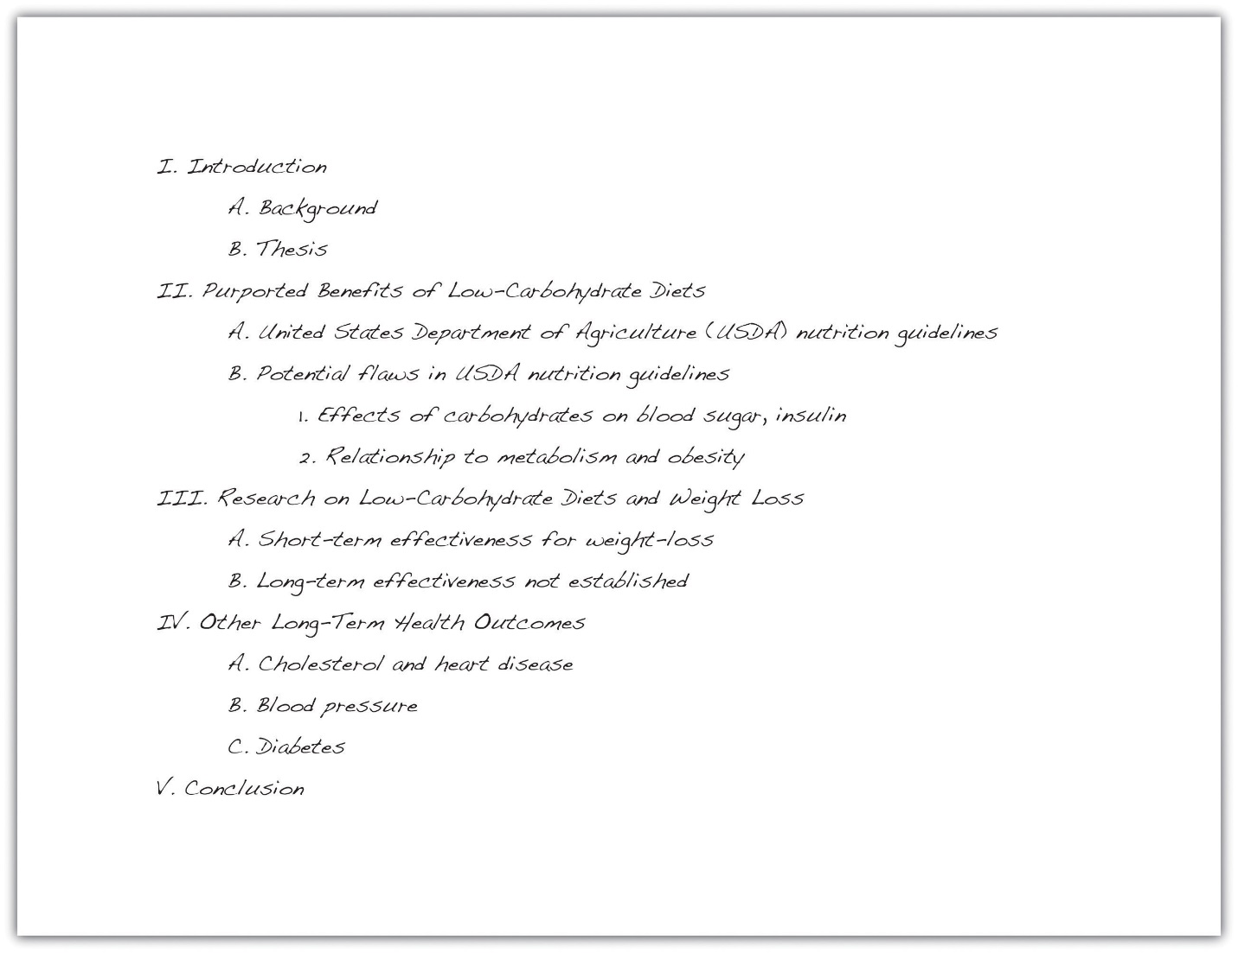

EXERCISE 3
Review the organizational structures discussed in this section and Chapter 10 "Rhetorical Modes". Working with the notes you organized earlier, follow these steps to begin planning how to organize your paper.
- Create an outline that includes your thesis, major subtopics, and supporting points.
- The major headings in your outline will become sections or paragraphs in your paper. Remember that your ideas should form the backbone of the paper. For each major section of your outline, write out a topic sentence stating the main point you will make in that section.
- As you complete step 2, you may find that some points are too complex to explain in a sentence. Consider whether any major sections of your outline need to be broken up and jot down additional topic sentences as needed.
- Review your notes and determine how the different pieces of information fit into your outline as supporting points.
Collaboration
Please share the outline you created with a classmate. Examine your classmate’s outline and see if any questions come to mind or if you see any area that would benefit from an additional point or clarification. Return the outlines to each other and compare observations.

Writing at Work
The structures described in this section and Chapter 10 "Rhetorical Modes" can also help you organize information in different types of workplace documents. For instance, medical incident reports and police reports follow a chronological structure. If the company must choose between two vendors to provide a service, you might write an e-mail to your supervisor comparing and contrasting the choices. Understanding when and how to use each organizational structure can help you write workplace documents efficiently and effectively.

KEY TAKEAWAYS
- An effective research paper focuses on presenting the writer’s ideas using information from research as support.
- Effective writers spend time reviewing, synthesizing, and organizing their research notes before they begin drafting a research paper.
- It is important for writers to revisit their research questions and working thesis as they transition from the research phase to the writing phrase of a project. Usually, the working thesis will need at least minor adjustments.
- To organize a research paper, writers choose a structure that is appropriate for the topic and purpose. Longer papers may make use of more than one structure.
UNIT FOUR: Putting Your Source Material to Work

4.1.1: What Is an Argumentative Essay? The University of North Carolina at Chapel Hill Writing Center: "Argument"

WHAT THIS HANDOUT IS ABOUT
This handout will define what an argument is and explain why you need one in most of your academic essays.

ARGUMENTS ARE EVERYWHERE
You may be surprised to hear that the word “argument” does not have to be written anywhere in your assignment for it to be an important part of your task. In fact, making an argument—expressing a point of view on a subject and supporting it with evidence—is often the aim of academic writing. Your instructors may assume that you know this and thus may not explain the importance of arguments in class.
Most material you learn in college is or has been debated by someone, somewhere, at some time. Even when the material you read or hear is presented as simple “fact,” it may actually be one person’s interpretation of a set of information. Instructors may call on you to examine that interpretation and defend it, refute it, or offer some new view of your own. In writing assignments, you will almost always need to do more than just summarize information that you have gathered or regurgitate facts that have been discussed in class. You will need to develop a point of view on or interpretation of that material and provide evidence for your position.
If you think that “fact,” not argument, rules intelligent thinking, consider an example. For nearly 2000 years, educated people in many Western cultures believed that bloodletting—deliberately causing a sick person to lose blood—was the most effective treatment for a variety of illnesses. The “fact” that bloodletting is beneficial to human health was not widely questioned until the 1800’s, and some physicians continued to recommend bloodletting as late as the 1920’s. We have come to accept a different set of “facts” now because some people began to doubt the effectiveness of bloodletting; these people argued against it and provided convincing evidence. Human knowledge grows out of such differences of opinion, and scholars like your instructors spend their lives engaged in debate over what may be counted as “true,” “real,” or “right” in their fields. In their courses, they want you to engage in similar kinds of critical thinking and debate.
Argumentation is not just what your instructors do. We all use argumentation on a daily basis, and you probably already have some skill at crafting an argument. The more you improve your skills in this area, the better you will be at thinking critically, reasoning, making choices, and weighing evidence.

MAKING A CLAIM
What is an argument? In academic writing, an argument is usually a main idea, often called a “claim” or “thesis statement,” backed up with evidence that supports the idea. In the majority of college papers, you will need to make some sort of claim and use evidence to support it, and your ability to do this well will separate your papers from those of students who see assignments as mere accumulations of fact and detail. In other words, gone are the happy days of being given a “topic” about which you can write anything. It is time to stake out a position and prove why it is a good position for a thinking person to hold. See our handout on thesis statements.
Claims can be as simple as “Protons are positively charged and electrons are negatively charged,” with evidence such as, “In this experiment, protons and electrons acted in such and such a way.” Claims can also be as complex as “The end of the South African system of apartheid was inevitable,” using reasoning and evidence such as, “Every successful revolution in the modern era has come about after the government in power has given and then removed small concessions to the uprising group.” In either case, the rest of your paper will detail the reasoning and evidence that have led you to believe that your position is best.
When beginning to write a paper, ask yourself, “What is my point?” For example, the point of this handout is to help you become a better writer, and we are arguing that an important step in the process of writing effective arguments is understanding the concept of argumentation. If your papers do not have a main point, they cannot be arguing for anything. Asking yourself what your point is can help you avoid a mere “information dump.” Consider this: your instructors probably know a lot more than you do about your subject matter. Why, then, would you want to provide them with material they already know? Instructors are usually looking for two things:
- Proof that you understand the material, AND
- A demonstration of your ability to use or apply the material in ways that go beyond what you have read or heard.
This second part can be done in many ways: you can critique the material, apply it to something else, or even just explain it in a different way. In order to succeed at this second step, though, you must have a particular point to argue.
Arguments in academic writing are usually complex and take time to develop. Your argument will need to be more than a simple or obvious statement such as “Frank Lloyd Wright was a great architect.” Such a statement might capture your initial impressions of Wright as you have studied him in class; however, you need to look deeper and express specifically what caused that “greatness.” Your instructor will probably expect something more complicated, such as “Frank Lloyd Wright’s architecture combines elements of European modernism, Asian aesthetic form, and locally found materials to create a unique new style,” or “There are many strong similarities between Wright’s building designs and those of his mother, which suggests that he may have borrowed some of her ideas.” To develop your argument, you would then define your terms and prove your claim with evidence from Wright’s drawings and buildings and those of the other architects you mentioned.

EVIDENCE
Do not stop with having a point. You have to back up your point with evidence. The strength of your evidence, and your use of it, can make or break your argument. See our handout on evidence. You already have the natural inclination for this type of thinking, if not in an academic setting. Think about how you talked your parents into letting you borrow the family car. Did you present them with lots of instances of your past trustworthiness? Did you make them feel guilty because your friends’ parents all let them drive? Did you whine until they just wanted you to shut up? Did you look up statistics on teen driving and use them to show how you didn’t fit the dangerous-driver profile? These are all types of argumentation, and they exist in academia in similar forms.
Every field has slightly different requirements for acceptable evidence, so familiarize yourself with some arguments from within that field instead of just applying whatever evidence you like best. Pay attention to your textbooks and your instructor’s lectures. What types of argument and evidence are they using? The type of evidence that sways an English instructor may not work to convince a sociology instructor. Find out what counts as proof that something is true in that field. Is it statistics, a logical development of points, something from the object being discussed (art work, text, culture, or atom), the way something works, or some combination of more than one of these things?
Be consistent with your evidence. Unlike negotiating for the use of your parents’ car, a college paper is not the place for an all-out blitz of every type of argument. You can often use more than one type of evidence within a paper, but make sure that within each section you are providing the reader with evidence appropriate to each claim. So, if you start a paragraph or section with a statement like “Putting the student seating area closer to the basketball court will raise player performance,” do not follow with your evidence on how much more money the university could raise by letting more students go to games for free. Information about how fan support raises player morale, which then results in better play, would be a better follow-up. Your next section could offer clear reasons why undergraduates have as much or more right to attend an undergraduate event as wealthy alumni—but this information would not go in the same section as the fan support stuff. You cannot convince a confused person, so keep things tidy and ordered.

COUNTERARGUMENT
One way to strengthen your argument and show that you have a deep understanding of the issue you are discussing is to anticipate and address counterarguments or objections. By considering what someone who disagrees with your position might have to say about your argument, you show that you have thought things through, and you dispose of some of the reasons your audience might have for not accepting your argument. Recall our discussion of student seating in the Dean Dome. To make the most effective argument possible, you should consider not only what students would say about seating but also what alumni who have paid a lot to get good seats might say.
You can generate counterarguments by asking yourself how someone who disagrees with you might respond to each of the points you’ve made or your position as a whole. If you can’t immediately imagine another position, here are some strategies to try:
- Do some research. It may seem to you that no one could possibly disagree with the position you are arguing, but someone probably has. For example, some people argue that the American Civil War never ended. If you are making an argument concerning, for example, the outcomes of the Civil War, you might wish to see what some of these people have to say.
- Talk with a friend or with your teacher. Another person may be able to imagine counterarguments that haven’t occurred to you.
- Consider your conclusion or claim and the premises of your argument and imagine someone who denies each of them. For example, if you argued, “Cats make the best pets. This is because they are clean and independent,” you might imagine someone saying, “Cats do not make the best pets. They are dirty and needy.”
Once you have thought up some counterarguments, consider how you will respond to them—will you concede that your opponent has a point but explain why your audience should nonetheless accept your argument? Will you reject the counterargument and explain why it is mistaken? Either way, you will want to leave your reader with a sense that your argument is stronger than opposing arguments.
When you are summarizing opposing arguments, be charitable. Present each argument fairly and objectively, rather than trying to make it look foolish. You want to show that you have seriously considered the many sides of the issue and that you are not simply attacking or caricaturing your opponents.
It is usually better to consider one or two serious counterarguments in some depth, rather than to give a long but superficial list of many different counterarguments and replies.
Be sure that your reply is consistent with your original argument. If considering a counterargument changes your position, you will need to go back and revise your original argument accordingly.

AUDIENCE
Audience is a very important consideration in argument. Take a look at our handout on audience. A lifetime of dealing with your family members has helped you figure out which arguments work best to persuade each of them. Maybe whining works with one parent, but the other will only accept cold, hard statistics. Your kid brother may listen only to the sound of money in his palm. It’s usually wise to think of your audience in an academic setting as someone who is perfectly smart but who doesn’t necessarily agree with you. You are not just expressing your opinion in an argument (“It’s true because I said so”), and in most cases your audience will know something about the subject at hand—so you will need sturdy proof. At the same time, do not think of your audience as clairvoyant. You have to come out and state both your claim and your evidence clearly. Do not assume that because the instructor knows the material, he or she understands what part of it you are using, what you think about it, and why you have taken the position you’ve chosen.

CRITICAL READING
Critical reading is a big part of understanding argument. Although some of the material you read will be very persuasive, do not fall under the spell of the printed word as authority. Very few of your instructors think of the texts they assign as the last word on the subject. Remember that the author of every text has an agenda, something that he or she wants you to believe. This is OK—everything is written from someone’s perspective—but it’s a good thing to be aware of. For more information on objectivity and bias and on reading sources carefully, read our handouts on evaluating print sources and reading to write.
Take notes either in the margins of your source (if you are using a photocopy or your own book) or on a separate sheet as you read. Put away that highlighter! Simply highlighting a text is good for memorizing the main ideas in that text—it does not encourage critical reading. Part of your goal as a reader should be to put the author’s ideas in your own words. Then you can stop thinking of these ideas as facts and start thinking of them as arguments.
When you read, ask yourself questions like “What is the author trying to prove?” and “What is the author assuming I will agree with?” Do you agree with the author? Does the author adequately defend her argument? What kind of proof does she use? Is there something she leaves out that you would put in? Does putting it in hurt her argument? As you get used to reading critically, you will start to see the sometimes hidden agendas of other writers, and you can use this skill to improve your own ability to craft effective arguments.

WORKS CONSULTED
We consulted these works while writing the original version of this handout. This is not a comprehensive list of resources on the handout’s topic, and we encourage you to do your own research to find the latest publications on this topic. Please do not use this list as a model for the format of your own reference list, as it may not match the citation style you are using. For guidance on formatting citations, please see the UNC Libraries citation tutorial.
Anson, Chris M., and Robert A. Schwegler. The Longman Handbook for Writers and Readers. 6th ed. New York: Longman, 2010.
Booth, Wayne C., Gregory G. Colomb, and Joseph M. Williams. The Craft of Research. 3rd ed. Chicago: University of Chicago Press, 2008.
Ede, Lisa. Work in Progress. New York: St. Martin’s Press, 1989.
Gage, John T. The Shape of Reason: Argumentative Writing in College. 4th ed. New York: Longman, 2005.
Lunsford, Andrea, and John Ruszkiewicz. Everything’s an Argument. 6th ed. Boston: Bedford/St. Martin’s, 2012.
Rosen, Leonard J., and Laurence Behrens. The Allyn & Bacon Handbook. 5th ed. New York: Longman, 2003.
Last modified: Wednesday, October 21, 2015, 10:10 AM

4.1.1: What Is an Argumentative Essay? Writing for Success: "Chapter 10, Section 9: Persuasion"

LEARNING OBJECTIVES
- Determine the purpose and structure of persuasion in writing.
- Identify bias in writing.
- Assess various rhetorical devices.
- Distinguish between fact and opinion.
- Understand the importance of visuals to strengthen arguments.
- Write a persuasive essay.

The Purpose of Persuasive Writing
The purpose of persuasion in writing is to convince, motivate, or move readers toward a certain point of view, or opinion. The act of trying to persuade automatically implies more than one opinion on the subject can be argued.
The idea of an argument often conjures up images of two people yelling and screaming in anger. In writing, however, an argument is very different. An argument is a reasoned opinion supported and explained by evidence. To argue in writing is to advance knowledge and ideas in a positive way. Written arguments often fail when they employ ranting rather than reasoning.

Tip
Most of us feel inclined to try to win the arguments we engage in. On some level, we all want to be right, and we want others to see the error of their ways. More times than not, however, arguments in which both sides try to win end up producing losers all around. The more productive approach is to persuade your audience to consider your opinion as a valid one, not simply the right one.

The Structure of a Persuasive Essay
The following five features make up the structure of a persuasive essay:
- Introduction and thesis
- Opposing and qualifying ideas
- Strong evidence in support of claim
- Style and tone of language
- A compelling conclusion

Creating an Introduction and Thesis
The persuasive essay begins with an engaging introduction that presents the general topic. The thesis typically appears somewhere in the introduction and states the writer’s point of view.

Tip
Avoid forming a thesis based on a negative claim. For example, “The hourly minimum wage is not high enough for the average worker to live on.” This is probably a true statement, but persuasive arguments should make a positive case. That is, the thesis statement should focus on how the hourly minimum wage is low or insufficient.

Acknowledging Opposing Ideas and Limits to Your Argument
Because an argument implies differing points of view on the subject, you must be sure to acknowledge those opposing ideas. Avoiding ideas that conflict with your own gives the reader the impression that you may be uncertain, fearful, or unaware of opposing ideas. Thus it is essential that you not only address counterarguments but also do so respectfully.
Try to address opposing arguments earlier rather than later in your essay. Rhetorically speaking, ordering your positive arguments last allows you to better address ideas that conflict with your own, so you can spend the rest of the essay countering those arguments. This way, you leave your reader thinking about your argument rather than someone else’s. You have the last word.
Acknowledging points of view different from your own also has the effect of fostering more credibility between you and the audience. They know from the outset that you are aware of opposing ideas and that you are not afraid to give them space.
It is also helpful to establish the limits of your argument and what you are trying to accomplish. In effect, you are conceding early on that your argument is not the ultimate authority on a given topic. Such humility can go a long way toward earning credibility and trust with an audience. Audience members will know from the beginning that you are a reasonable writer, and audience members will trust your argument as a result. For example, in the following concessionary statement, the writer advocates for stricter gun control laws, but she admits it will not solve all of our problems with crime:
Although tougher gun control laws are a powerful first step in decreasing violence in our streets, such legislation alone cannot end these problems since guns are not the only problem we face.
Such a concession will be welcome by those who might disagree with this writer’s argument in the first place. To effectively persuade their readers, writers need to be modest in their goals and humble in their approach to get readers to listen to the ideas. See Table 10.5 "Phrases of Concession" for some useful phrases of concession.
Table 10.5 Phrases of Concession
although | granted that
of course | still
though | yet

EXERCISE 1
Try to form a thesis for each of the following topics. Remember the more specific your thesis, the better.
- Foreign policy
- Television and advertising
- Stereotypes and prejudice
- Gender roles and the workplace
- Driving and cell phones
Collaboration
Please share with a classmate and compare your answers. Choose the thesis statement that most interests you and discuss why.

Bias in Writing
Everyone has various biases on any number of topics. For example, you might have a bias toward wearing black instead of brightly colored clothes or wearing jeans rather than formal wear. You might have a bias toward working at night rather than in the morning, or working by deadlines rather than getting tasks done in advance. These examples identify minor biases, of course, but they still indicate preferences and opinions.
Handling bias in writing and in daily life can be a useful skill. It will allow you to articulate your own points of view while also defending yourself against unreasonable points of view. The ideal in persuasive writing is to let your reader know your bias, but do not let that bias blind you to the primary components of good argumentation: sound, thoughtful evidence and a respectful and reasonable address of opposing sides.
The strength of a personal bias is that it can motivate you to construct a strong argument. If you are invested in the topic, you are more likely to care about the piece of writing. Similarly, the more you care, the more time and effort you are apt to put forth and the better the final product will be.
The weakness of bias is when the bias begins to take over the essay—when, for example, you neglect opposing ideas, exaggerate your points, or repeatedly insert yourself ahead of the subject by using Itoo often. Being aware of all three of these pitfalls will help you avoid them.

The Use of I in Writing
The use of I in writing is often a topic of debate, and the acceptance of its usage varies from instructor to instructor. It is difficult to predict the preferences for all your present and future instructors, but consider the effects it can potentially have on your writing.
Be mindful of the use of I in your writing because it can make your argument sound overly biased. There are two primary reasons:
- Excessive repetition of any word will eventually catch the reader’s attention—and usually not in a good way. The use of I is no different.
- The insertion of I into a sentence alters not only the way a sentence might sound but also the composition of the sentence itself. I is often the subject of a sentence. If the subject of the essay is supposed to be, say, smoking, then by inserting yourself into the sentence, you are effectively displacing the subject of the essay into a secondary position. In the following example, the subject of the sentence is underlined:
Smoking is bad.
I think smoking is bad.
In the first sentence, the rightful subject, smoking, is in the subject position in the sentence. In the second sentence, the insertion of I and think replaces smoking as the subject, which draws attention to I and away from the topic that is supposed to be discussed. Remember to keep the message (the subject) and the messenger (the writer) separate.

Checklist
Developing Sound Arguments
Does my essay contain the following elements?
- An engaging introduction
- A reasonable, specific thesis that is able to be supported by evidence
- A varied range of evidence from credible sources
- Respectful acknowledgement and explanation of opposing ideas
- A style and tone of language that is appropriate for the subject and audience
- Acknowledgement of the argument’s limits
- A conclusion that will adequately summarize the essay and reinforce the thesis

Fact and Opinion
Facts are statements that can be definitely proven using objective data. The statement that is a fact is absolutely valid. In other words, the statement can be pronounced as true or false. For example, 2 + 2 = 4. This expression identifies a true statement, or a fact, because it can be proved with objective data.
Opinions are personal views, or judgments. An opinion is what an individual believes about a particular subject. However, an opinion in argumentation must have legitimate backing; adequate evidence and credibility should support the opinion. Consider the credibility of expert opinions. Experts in a given field have the knowledge and credentials to make their opinion meaningful to a larger audience.
For example, you seek the opinion of your dentist when it comes to the health of your gums, and you seek the opinion of your mechanic when it comes to the maintenance of your car. Both have knowledge and credentials in those respective fields, which is why their opinions matter to you. But the authority of your dentist may be greatly diminished should he or she offer an opinion about your car, and vice versa.
In writing, you want to strike a balance between credible facts and authoritative opinions. Relying on one or the other will likely lose more of your audience than it gains.

Tip
The word prove is frequently used in the discussion of persuasive writing. Writers may claim that one piece of evidence or another proves the argument, but proving an argument is often not possible. No evidence proves a debatable topic one way or the other; that is why the topic is debatable. Facts can be proved, but opinions can only be supported, explained, and persuaded.

EXERCISE 2
On a separate sheet of paper, take three of the theses you formed in Note 10.94 "Exercise 1", and list the types of evidence you might use in support of that thesis.

EXERCISE 3
Using the evidence you provided in support of the three theses in Note 10.100 "Exercise 2", come up with at least one counterargument to each. Then write a concession statement, expressing the limits to each of your three arguments.

Using Visual Elements to Strengthen Arguments
Adding visual elements to a persuasive argument can often strengthen its persuasive effect. There are two main types of visual elements: quantitative visuals and qualitative visuals.
Quantitative visuals present data graphically. They allow the audience to see statistics spatially. The purpose of using quantitative visuals is to make logical appeals to the audience. For example, sometimes it is easier to understand the disparity in certain statistics if you can see how the disparity looks graphically. Bar graphs, pie charts, Venn diagrams, histograms, and line graphs are all ways of presenting quantitative data in spatial dimensions.
Qualitative visuals present images that appeal to the audience’s emotions. Photographs and pictorial images are examples of qualitative visuals. Such images often try to convey a story, and seeing an actual example can carry more power than hearing or reading about the example. For example, one image of a child suffering from malnutrition will likely have more of an emotional impact than pages dedicated to describing that same condition in writing.

Writing at Work
When making a business presentation, you typically have limited time to get across your idea. Providing visual elements for your audience can be an effective timesaving tool. Quantitative visuals in business presentations serve the same purpose as they do in persuasive writing. They should make logical appeals by showing numerical data in a spatial design. Quantitative visuals should be pictures that might appeal to your audience’s emotions. You will find that many of the rhetorical devices used in writing are the same ones used in the workplace. For more information about visuals in presentations, see Chapter 14 "Creating Presentations: Sharing Your Ideas".

Writing a Persuasive Essay
Choose a topic that you feel passionate about. If your instructor requires you to write about a specific topic, approach the subject from an angle that interests you. Begin your essay with an engaging introduction. Your thesis should typically appear somewhere in your introduction.
Start by acknowledging and explaining points of view that may conflict with your own to build credibility and trust with your audience. Also state the limits of your argument. This too helps you sound more reasonable and honest to those who may naturally be inclined to disagree with your view. By respectfully acknowledging opposing arguments and conceding limitations to your own view, you set a measured and responsible tone for the essay.
Make your appeals in support of your thesis by using sound, credible evidence. Use a balance of facts and opinions from a wide range of sources, such as scientific studies, expert testimony, statistics, and personal anecdotes. Each piece of evidence should be fully explained and clearly stated.
Make sure that your style and tone are appropriate for your subject and audience. Tailor your language and word choice to these two factors, while still being true to your own voice.
Finally, write a conclusion that effectively summarizes the main argument and reinforces your thesis. See Chapter 15 "Readings: Examples of Essays" to read a sample persuasive essay.

EXERCISE 4
Choose one of the topics you have been working on throughout this section. Use the thesis, evidence, opposing argument, and concessionary statement as the basis for writing a full persuasive essay. Be sure to include an engaging introduction, clear explanations of all the evidence you present, and a strong conclusion.

KEY TAKEAWAYS
- The purpose of persuasion in writing is to convince or move readers toward a certain point of view, or opinion.
- An argument is a reasoned opinion supported and explained by evidence. To argue, in writing, is to advance knowledge and ideas in a positive way.
- A thesis that expresses the opinion of the writer in more specific terms is better than one that is vague.
- It is essential that you not only address counterarguments but also do so respectfully.
- It is also helpful to establish the limits of your argument and what you are trying to accomplish through a concession statement.
- To persuade a skeptical audience, you will need to use a wide range of evidence. Scientific studies, opinions from experts, historical precedent, statistics, personal anecdotes, and current events are all types of evidence that you might use in explaining your point.
- Make sure that your word choice and writing style is appropriate for both your subject and your audience.
- You should let your reader know your bias, but do not let that bias blind you to the primary components of good argumentation: sound, thoughtful evidence and respectfully and reasonably addressing opposing ideas.
- You should be mindful of the use of I in your writing because it can make your argument sound more biased than it needs to.
- Facts are statements that can be proven using objective data.
- Opinions are personal views, or judgments, that cannot be proven.
- In writing, you want to strike a balance between credible facts and authoritative opinions.
- Quantitative visuals present data graphically. The purpose of using quantitative visuals is to make logical appeals to the audience.
- Qualitative visuals present images that appeal to the audience’s emotions.

4.1.1: What Is an Argumentative Essay? Writing for Success: "Chapter 15, Section 10: Persuasive Essay"

LEARNING OBJECTIVE
- Read an example of the persuasive rhetorical mode.
Universal Health Care Coverage for the United States
The United States is the only modernized Western nation that does not offer publicly funded health care to all its citizens; the costs of health care for the uninsured in the United States are prohibitive, and the practices of insurance companies are often more interested in profit margins than providing health care. These conditions are incompatible with US ideals and standards, and it is time for the US government to provide universal health care coverage for all its citizens. Like education, health care should be considered a fundamental right of all US citizens, not simply a privilege for the upper and middle classes.
One of the most common arguments against providing universal health care coverage (UHC) is that it will cost too much money. In other words, UHC would raise taxes too much. While providing health care for all US citizens would cost a lot of money for every tax-paying citizen, citizens need to examine exactly how much money it would cost, and more important, how much money is “too much” when it comes to opening up health care for all. Those who have health insurance already pay too much money, and those without coverage are charged unfathomable amounts. The cost of publicly funded health care versus the cost of current insurance premiums is unclear. In fact, some Americans, especially those in lower income brackets, could stand to pay less than their current premiums.
However, even if UHC would cost Americans a bit more money each year, we ought to reflect on what type of country we would like to live in, and what types of morals we represent if we are more willing to deny health care to others on the basis of saving a couple hundred dollars per year. In a system that privileges capitalism and rugged individualism, little room remains for compassion and love. It is time that Americans realize the amorality of US hospitals forced to turn away the sick and poor. UHC is a health care system that aligns more closely with the core values that so many Americans espouse and respect, and it is time to realize its potential.
Another common argument against UHC in the United States is that other comparable national health care systems, like that of England, France, or Canada, are bankrupt or rife with problems. UHC opponents claim that sick patients in these countries often wait in long lines or long wait lists for basic health care. Opponents also commonly accuse these systems of being unable to pay for themselves, racking up huge deficits year after year. A fair amount of truth lies in these claims, but Americans must remember to put those problems in context with the problems of the current US system as well. It is true that people often wait to see a doctor in countries with UHC, but we in the United States wait as well, and we often schedule appointments weeks in advance, only to have onerous waits in the doctor’s “waiting rooms.”
Critical and urgent care abroad is always treated urgently, much the same as it is treated in the United States. The main difference there, however, is cost. Even health insurance policy holders are not safe from the costs of health care in the United States. Each day an American acquires a form of cancer, and the only effective treatment might be considered “experimental” by an insurance company and thus is not covered. Without medical coverage, the patient must pay for the treatment out of pocket. But these costs may be so prohibitive that the patient will either opt for a less effective, but covered, treatment; opt for no treatment at all; or attempt to pay the costs of treatment and experience unimaginable financial consequences. Medical bills in these cases can easily rise into the hundreds of thousands of dollars, which is enough to force even wealthy families out of their homes and into perpetual debt. Even though each American could someday face this unfortunate situation, many still choose to take the financial risk. Instead of gambling with health and financial welfare, US citizens should press their representatives to set up UHC, where their coverage will be guaranteed and affordable.
Despite the opponents’ claims against UHC, a universal system will save lives and encourage the health of all Americans. Why has public education been so easily accepted, but not public health care? It is time for Americans to start thinking socially about health in the same ways they think about education and police services: as rights of US citizens.

Online Persuasive Essay Alternatives
Martin Luther King Jr. writes persuasively about civil disobedience in Letter from Birmingham Jail:
- http://www.stanford.edu/group/King/frequentdocs/birmingham.pdf
- http://web.cn.edu/kwheeler/documents/Letter_Birmingham_Jail.pdf
- http://www.oak-tree.us/stuff/King-Birmingham.pdf
Michael Levin argues The Case for Torture:
- http://people.brandeis.edu/~teuber/torture.html
- http://www.canyons.edu/departments/philosophy/levin.html
Alan Dershowitz argues The Case for Torture Warrants:
- http://www.alandershowitz.com/publications/docs/torturewarrants.html
Alisa Solomon argues The Case against Torture:
- http://www.villagevoice.com/2001-11-27/news/the-case-against-torture/1

4.1.2: Research and Argumentative Essays Dr. Pavel Zemliansky's "Methods of Discovery: A Guide to Research Writing, Chapter 1: Research Writing and Argument"
All Writing is Argumentative
This chapter is about rhetoric—the art of persuasion. Every time we write, we engage in argument. Through writing, we try to persuade and influence our readers, either directly or indirectly. We work to get them to change their minds, to do something, or to begin thinking in new ways. Therefore, every writer needs to know and be able to use principles of rhetoric. The first step towards such knowledge is learning to see the argumentative nature of all writing.
I have two goals in this chapter: to explain the term rhetoric and to give you some historical perspective on its origins and development; and to demonstrate the importance of seeing research writing as a rhetorical, persuasive activity.
As consumers of written texts, we are often tempted to divide writing into two categories: argumentative and non-argumentative. According to this view, in order to be argumentative, writing must have the following qualities. It has to defend a position in a debate between two or more opposing sides; it must be on a controversial topic; and the goal of such writing must be to prove the correctness of one point of view over another.
On the other hand, this view goes, non-argumentative texts include narratives, descriptions, technical reports, news stories, and so on. When deciding to which category a given piece of writing belongs, we sometimes look for familiar traits of argument, such as the presence of a thesis statement, of “factual” evidence, and so on.
Research writing is often categorized as “non-argumentative.” This happens because of the way in which we learn about research writing. Most of us do that through the traditional research report, the kind which focuses too much on information-gathering and note cards and not enough on constructing engaging and interesting points of view for real audiences. It is the gathering and compiling of information, and not doing something productive and interesting with this information, that become the primary goals of this writing exercise. Generic research papers are also often evaluated on the quantity and accuracy of external information that they gather, rather on the persuasive impact they make and the interest they generate among readers.
Having written countless research reports, we begin to suspect that all research-based writing is non-argumentative. Even when explicitly asked to construct a thesis statement and support it through researched evidence, beginning writers are likely to pay more attention to such mechanics of research as finding the assigned number and kind of sources and documenting them correctly, than to constructing an argument capable of making an impact on the reader.
Arguments Aren't Verbal Fights
We often have narrow concept of the word “argument.” In everyday life, argument often implies a confrontation, a clash of opinions and personalities, or just a plain verbal fight. It implies a winner and a loser, a right side and a wrong one. Because of this understanding of the word "argument," the only kind of writing seen as argumentative is the debate-like "position" paper, in which the author defends his or her point of view against other, usually opposing points of view.
Such an understanding of argument is narrow because arguments come in all shapes and sizes. I invite you to look at the term “argument” in a new way. What if we think of "argument" as an opportunity for conversation, for sharing with others our point of view on something, for showing others our perspective of the world? What if we see it as the opportunity to tell our stories, including our life stories? What if we think of "argument" as an opportunity to connect with the points of view of others rather than defeating those points of view?
Some years ago, I heard a conference speaker define argument as the opposite of “beating your audience into rhetorical submission.” I still like that definition because it implies gradual and even gentle explanation and persuasion instead of coercion. It implies effective use of details, and stories, including emotional ones. It implies the understanding of argument as an explanation of one’s world view.
Arguments then, can be explicit and implicit, or implied. Explicit arguments contain noticeable and definable thesis statements and lots of specific proofs. Implicit arguments, on the other hand, work by weaving together facts and narratives, logic and emotion, personal experiences and statistics. Unlike explicit arguments, implicit ones do not have a one-sentence thesis statement. Instead, authors of implicit arguments use evidence of many different kinds in effective and creative ways to build and convey their point of view to their audience. Research is essential for creative effective arguments of both kinds.
To consider the many types and facets of written argumentation, consider the following exploration activity.
Writing Activity: Analyzing Writing Situations
- Working individually or in small groups, consider the following writing situations. Are these situations opportunities for argumentative writing? If so, what elements of argument do you see? Use your experience as a reader and imagine the kinds of published texts that might result from these writing situations. Apply the ideas about argument mentioned so far in this chapter, including the “explicit” and “implicit” arguments.
- A group of scientists develops a hypothesis and conducts a series of experiments to test it. After obtaining the results from those experiments, they decide to publish their findings in a scientific journal. However, the data can be interpreted in two ways. The authors can use a long-standing theory with which most of his colleagues agree. But they can also use a newer and more ambitious theory on which there is no consensus in the field, but which our authors believe to be more comprehensive and up-to-date. Using different theories will produce different interpretations of the data and different pieces of writing. Are both resulting texts arguments? Why or why not?
- An author wants to write a memoir. She is particularly interested in her relationship with her parents as a teenager. In order to focus on that period of her life, she decides to omit other events and time periods from the memoir. The finished text is a combination of stories, reflections, and facts. This text does not have a clear thesis statement or proofs. Could this “selective” memory” writing be called an argument? What are the reasons for your decision?
- A travel writer who is worried about global warming goes to Antarctica and observes the melting of the ice there. Using her observations, interviews with scientists, and secondary research, she then prepares an article about her trip for The National Geographic magazine or a similar publication. Her piece does not contain a one-sentence thesis statement or a direct call to fight global warming. At the same time, her evidence suggests that ice in the Arctic melts faster than it used to. Does this writer engage in argument? Why or why not? What factors influenced your decision?
- A novelist writes a book based on the events of the American Civil War. He recreates historical characters from archival research, but adds details, descriptions, and other characters to his book that are not necessarily historic. The resulting novel is in the genre known as “historical fiction.” Like all works of fiction, the book does not have a thesis statement or explicit proofs. It does, however, promote a certain view of history, some of which is based on the author’s research and some—on his imagination and creative license. Is this a representation of history, an argument, or a combination of both? Why or why not?
You can probably think of many more examples when argument in writing is expressed through means other than the traditional thesis statement and proofs. As you work through this book, continue to think about the nature of argument in writing and discuss it with your classmates and your instructor.
Definitions of Rhetoric and the Rhetorical Situation
The art of creating effective arguments is explained and systematized by a discipline called rhetoric. Writing is about making choices, and knowing the principles of rhetoric allows a writer to make informed choices about various aspects of the writing process. Every act of writing takes places in a specific rhetorical situation. The three most basic and important components of a rhetorical situations are:
- Purpose of writing
- Intended audience,
- Occasion, or context in which the text will be written and read
These factors help writers select their topics, arrange their material, and make other important decisions about their work.
Before looking closely at different definitions and components of rhetoric, let us try to understand what rhetoric is not. In recent years, the word “rhetoric” has developed a bad reputation in American popular culture. In the popular mind, the term "rhetoric" has come to mean something negative and deceptive. Open a newspaper or turn on the television, and you are likely to hear politicians accusing each other of "too much rhetoric and not enough substance." According to this distorted view, rhetoric is verbal fluff, used to disguise empty or even deceitful arguments.
Examples of this misuse abound. Here are some examples.
A 2003 CNN news article “North Korea Talks On Despite Rhetoric” describes the decision by the international community to continue the talks with North Korea about its nuclear arms program despite what the author sees as North Koreans’ “rhetorical blast” at a US official taking part in the talks. The implication here is that that, by verbally attacking the US official, the North Koreans attempted to hide the lack of substance in their argument. The word “rhetoric” in this context implies a strategy to deceive or distract.
Another example is the title of the now-defunct political website “Spinsanity: Countering Rhetoric with Reason.” The website's authors state that "engaged citizenry, active press and strong network of
fact-checking websites and blogs can help turn the tide of deception
that we now see." (http://www.spinsanity.org). What this statement implies, of course, is that rhetoric is "spin" and that it is the opposite of truth.
What is interesting about this clip is that its author does not seem to realize that she is engaging in rhetoric as she is criticizing the term. She has a purpose, which is to question Obama's credentials; she is addressing an audience which consists of people who are perhaps considering voting for Obama; finally, she is creating her video in a very real context of the heated battle between Senators Obama and Clinton for the Presidential nomination of the Democratic Party.
Rhetoric is not a dirty trick used by politicians to conceal and obscure, but an art, which, for many centuries, has had many definitions. Perhaps the most popular and overreaching definition comes to us from the Ancient Greek thinker Aristotle. Aristotle defined rhetoric as “the faculty of observing in any given case
the available means of persuasion" (Ch.2). Aristotle saw primarily as a practical tool, indispensable for civic discourse.
Elements of the Rhetorical Situation
When composing, every writer must take into account the conditions under which the writing is produced and will be read. It is customary to represent the three key elements of the rhetorical situation as a triangle of writer, reader, and text, or, as they are represented on this image, as "communicator," "audience," and "message."
The three elements of the rhetorical situation are in a constant and dynamic interrelation. All three are also necessary for communication through writing to take place. For example, if the writer is taken out of this equation, the text will not be created. Similarly, eliminating the text itself will leave us with the reader and writer, but without any means of conveying ideas between them, and so on.
Moreover, changing on or more characteristics of any of the elements depicted in the figure above will change the other elements as well. For example, with the change in the beliefs and values of the audience, the message will also likely change to accommodate those new beliefs, and so on.
In his discussion of rhetoric, Aristotle states that writing’s primary purpose is persuasion. Other ancient rhetoricians’ theories expand the scope of rhetoric by adding new definitions, purposes, and methods. For example, another Greek philosopher and rhetorician Plato saw rhetoric as a means of discovering the truth, including personal truth, through dialog and discussion. According to Plato, rhetoric can be directed outward (at readers or listeners), or inward (at the writer him or herself). In the latter case, the purpose of rhetoric is to help the author discover something important about his or her own experience and life.
The third major rhetorical school of Ancient Greece whose views have profoundly influenced our understanding of rhetoric were the Sophists. The Sophists were teachers of rhetoric for hire. The primary goal of their activities was to teach skills and strategies for effective speaking and writing. Many Sophists claimed that they could make anyone into an effective rhetorician. In their most extreme variety, Sophistic rhetoric claims that virtually anything could be proven if the rhetorician has the right skills. The legacy of Sophistic rhetoric is controversial. Some scholars, including Plato himself, have accused the Sophists of bending ethical standards in order to achieve their goals, while others have praised them for promoting democracy and civic participation through argumentative discourse.
What do these various definitions of rhetoric have to do with research writing? Everything! If you have ever had trouble with a writing assignment, chances are it was because you could not figure out the assignment’s purpose. Or, perhaps you did not understand very well whom your writing was supposed to appeal to. It is hard
to commit to purposeless writing done for no one in particular.
Research is not a very useful activity if it is done for its own sake. If you think of a situation in your own life where you had to do any kind of research, you probably
had a purpose that the research helped you to accomplish. You could, for example, have been considering buying a car and wanted to know which make and model would suite you best. Or, you could have been looking for an apartment to rent and wanted to get the best deal for your money. Or, perhaps your family was planning a vacation and researched the best deals on hotels, airfares, and rental cars. Even in these simple examples of research that are far simpler than research
most writers conduct, you as a researcher were guided by some overriding purpose. You researched because you had a purpose to accomplish.
How to Approach Writing Tasks Rhetorically
The three main elements of rhetorical theory are purpose, audience, and ocassion. We will look at these elements primarily through the lens of Classical Rhetoric, the rhetoric of Ancient Greece and Rome. Principles of classical rhetoric (albeit some of them modified) are widely accepted across the modern Western civilization. Classical rhetoric provides a solid framework for analysis and production of effective texts in a variety of situations.
Purpose
Good writing always serves a purpose. Texts are created to persuade, entertain, inform, instruct, and so on. In a real writing situation, these discrete purposes are often combined

Writing Activity: Analyzing Purpose
Recall any text you wrote, in or outside of school. Think not only of school papers, but also of letters to relatives and friends, e-mails, shopping lists, online postings, and so on. Consider the following questions.
- Was the purpose of the writing well defined for you in the assignment, or did you have to define it yourself?
- What did you have to do in order to understand or create your purpose?
- Did you have trouble articulating and fulfilling your writing purpose?
Be sure to record your answers and share them with your classmates and/or instructor.
Audience
The second key element of the rhetorical approach to writing is audience-awareness. As you saw from the rhetorical triangle earlier in this chapter, readers are an indispensable part of the rhetorical equation, and it is essential for every writer to understand their audience and tailor his or her message to the audience’s needs.
The key principles that every writer needs to follow in order to reach and affect his or her audience are as follows:
- Have a clear idea about who your readers will be.
- Understand your readers’ previous experiences, knowledge, biases, and expectations and how these factors can influence their reception of your argument.
- When writing, keep in mind not only those readers who are physically present or whom you know (your classmates and instructor), but all readers who would benefit from or be influenced by your argument.
- Choose a style, tone, and medium of presentation appropriate for your intended audience.

Writing Activity: Analyzing Audience
Every writer needs to consider his or her audience carefully when writing. Otherwise, you writing will be directed at no one in particular. As a result, your purpose will become unclear and your work will lose its effectiveness.
Consider any recent writing task that you faced. As with all the exploration activities included in this chapter, do not limit yourself to school writing assignments. Include letters, e-mails, notes, and any other kinds of writing you may do.
- Did you have a clearly defined audience?
- If not, what measures did you take to define and understand your audience?
- How did you know who your readers were?
- Did your writing purpose fit what your intended audience needed or wanted to hear?
- What were the best ways to appeal to your audience (both logical and emotional)?
- How did your decision to use or not to use external research influence the reception of your argument by your audience?
Occasion
Occasion is an important part of the rhetorical situation. It is a part of the writing context that was mentioned earlier in the chapter. Writers do not work in a vacuum. Instead, the content, form and reception of their work by readers are heavily influenced by the conditions in society as well as by personal situations of their readers. These conditions in which texts are created and read affect every aspect of writing and every stage of the writing process, from topic selection, to decisions about what kinds of arguments used and their arrangement, to the writing style, voice, and persona which the writer wishes to project in his or her writing. All elements of the rhetorical situation work together in a dynamic relationship. Therefore, awareness of rhetorical occasion and other elements of the context of your writing will also help you refine your purpose and understand your audience better. Similarly having a clear purpose in mind when writing and knowing your audience will help you understand the context in which you are writing and in which your work will be read better.
One aspect of writing where you can immediately benefit from understanding occasion and using it to your rhetorical advantage is the selection of topics for your compositions. Any topic can be good or bad, and a key factor in deciding on whether it fits the occasion. In order to understand whether a particular topic is suitable for a composition, it is useful to analyze whether the composition would address an issue, or a rhetorical exigency when created. The writing activity below can help you select topics and issues for written arguments.

Writing Activity: Analyzing Rhetorical Exigency
- If you are considering a topic for a paper, think whether the paper would address a specific problem or issue. In other words, will it address a real exigency, something that needs to be solved or discussed?
- Who are the people with interests and stakes in the problem?
- What are your limitations? Can you hope to solve the problem once and for all, or should your goals be more modest? Why or why not?
Share your results with your classmates and instructor.
To understand how writers can study and use occasion in order to make effective arguments, let us examine another ancient rhetorical concept. Kairos is one of the most fascinating terms from Classical rhetoric. It signifies the right, or opportune moment for an argument to be made. It is such a moment or time when the subject of the argument is particularly urgent or important and when audiences are more likely to be persuaded by it. Ancient rhetoricians believed that if the moment for the argument is right, for instance if there are conditions in society which would make the audience more receptive to the argument, the rhetorician would have more success persuading such an audience.
Figure 1.2. Kairos. Source: Ancient Greek Cities (www.sikyon.com)
For example, as I write this text, a heated debate about the war on terrorism and about the goals and methods of this war is going on in the US. It is also the year of the Presidential Election, and political candidates try to use the war on terrorism to their advantage when they debate each other. These are topics of high public interested, with print media, television, radio, and the Internet constantly discussing them. Because there is an enormous public interest in the topic of terrorism, well-written articles and reports on the subject will not fall on deaf ears. Simply put, the moment, or occasion, for the debate is right, and it will continue until public interest in the subject weakens or disappears.
Rhetorical Appeals
In order to persuade their readers, writers must use three types of proofs or rhetorical appeals. They are logos, or logical appeal; pathos, or emotional appeal; and ethos, or ethical appeal, or appeal based on the character and credibility of the author. It is easy to notice that modern words “logical,” “pathetic,” and “ethical” are derived from those Greek words. In his work Rhetoric, Aristotle writes that the three appeals must be used together in every piece of persuasive discourse. An argument based on the appeal to logic, or emotions alone will not be an effective one.
Understanding how logos, pathos, and ethos should work together is very important for writers wh use research. Often, research writing assignment are written in a way that seems to emphasize logical proofs over emotional or ethical ones. Such logical proofs in research papers typically consist of factual information, statistics, examples, and other similar evidence. According to this view, writers of academic papers need to be unbiased and objective, and using logical proofs will help them to be that way.
Because of this emphasis on logical proofs, you may be less familiar with the kinds of pathetic and ethical proofs available to you. Pathetic appeals, or appeals to emotions of the audience were considered by ancient rhetoricians as important as logical proofs. Yet, writers are sometimes not easily convinced to use pathetic appeals in their writing. As modern rhetoricians and authors of the influential book Classical Rhetoric for the Modern Student (1998), Edward P.J. Corbett and Robert Connors said, “People are rather sheepish about acknowledging that their opinions can be affected by their emotions” (86). According to Corbett, many of us think that there may be something wrong about using emotions in argument. But, I agree with Corbett and Connors, pathetic proofs are not only admissible in argument, but necessary (86-89). The most basic way of evoking appropriate emotional responses in your audience, according to Corbett, is the use of vivid descriptions (94).
Using ethical appeals, or appeals based on the character of the writer, involves establishing and maintaining your credibility in the eyes of your readers. In other words, when writing, think about how you are presenting yourself to your audience. Do you give your readers enough reasons to trust you and your argument, or do you give them reasons to doubt your authority and your credibility? Consider all the times when your decision about the merits of a given argument was affected by the person or people making the argument. For example, when watching television news, are you predisposed against certain cable networks and more inclined towards others because you trust them more?
So, how can a writer establish a credible persona for his or her audience? One way to do that is through external research. Conducting research and using it well in your writing help with you with the factual proofs (logos), but it also shows your readers that you, as the author, have done your homework and know what you are talking about. This knowledge, the sense of your authority that this creates among your readers, will help you be a more effective writer.
The logical, pathetic, and ethical appeals work in a dynamic combination with one another. It is sometimes hard to separate one kind of proof from another and the methods by which the writer achieved the desired rhetorical effect. If your research contains data which is likely to cause your readers to be emotional, it data can enhance the pathetic aspect of your argument. The key to using the three appeals, is to use them in combination with each other, and in moderation. It is impossible to construct a successful argument by relying too much on one or two appeals while neglecting the others.
Consider two recent examples of fairly ineffective use of the three appeals. In the beginning of April 2008, two candidates for the Democratic Party's presidential nomination, Senators Hillary Clinton and Barack Obama began airing campaign television ads in Pennsylvania ahead of their party's primary presidential election in that state.
Clinton's ad is called "Scranton" and it is very heavy of pathos, or emotional appeal. It invokes very warm childhood memories which, the ad's creators hoped, would show Senator Clinton's "softer side" thus persuading more people to vote for her. The purpose of the ad is to stir emotion, and it does it rather well. The problem with this approach is, however, that it does not tell voters much about the concrete steps and activities Senator Clinton would undertake if elected. The ad is rather thin on the logical appeal, and this, in turn, affects Clinton's ethos or credibility.
Barack Obama's ad is called "One Voice," and is calling on his supporters to "change the world." While this is certainly a worthy cause, it is not clear from this ad how exactly Senator Obama intends to change the world should he be elected. The reason for this lack of clarity is the heavy emphasis on the pathetic appeal at the expense of logos. If you followed the presidential campaign of 2008, you would know that the call for change which is so clear in this ad was Obama's main slogan, a statement than became a large part of his ethos, or persona as a politician and as a rhetorician. This ad succeeds in highlighting that part of Obama's political persona once again while, probably intentionally, under-emphasizing logos.
Research Writing as Conversation
Writing is a social process. Texts are created to be read by others, and in creating those texts, writers should be aware of not only their personal assumptions, biases, and tastes, but also those of their readers. Writing, therefore, is an interactive process. It is a conversation, a meeting of minds, during which ideas are exchanged, debates and discussions take place and, sometimes, but not always, consensus is reached. You may be familiar with the famous quote by the 20th century rhetorician Kenneth Burke who compared writing to a conversation at a social event. In his 1974 bookThe Philosophy of Literary Form Burke writes,
Imagine that you enter a parlor. You come late. When you arrive, others have long preceded you, and they are engaged in a heated discussion, a discussion too heated for them to pause and tell you exactly what it is about. In fact, the discussion had already begun long before any of them got there, so that no one present is qualified to retrace for you all the steps that had gone before. You listen for a while, until you decide that you have caught the tenor of the argument; then you put in your oar. Someone answers; you answer him, another comes to your defense; another aligns himself against you, to either the embarrassment of gratification of your opponent, depending upon the quality of your ally's assistance. However, the discussion is interminable. The hour grows late, you must depart. And you do depart, with the discussion still vigorously in progress (110-111).
This passage by Burke is extremely popular among writers because it captures the interactive nature of writing so precisely. Reading Burke’s words carefully, we will notice that the interaction between readers and writers is continuous. A writer always enters a conversation in progress. In order to participate in the discussion, just like in real life, you need to know what your interlocutors have been talking about. So you listen (read). Once you feel you have got the drift of the conversation, you say (write) something. Your text is read by others who respond to your ideas, stories, and arguments with their own. This interaction never ends!
To write well, it is important to listen carefully and understand the conversations that are going on around you. Writers who are able to listen to these conversations and pick up important topics, themes, and arguments are generally more effective at reaching and impressing their audiences. It is also important to treat research, writing, and every occasion for these activities as opportunities to participate in the on-going conversation of people interested in the same topics and questions which interest you.
Our knowledge about our world is shaped by the best and most up-to-date theories available to them. Sometimes these theories can be experimentally tested and proven, and sometimes, when obtaining such proof is impossible, they are based on consensus reached as a result of conversation and debate. Even the theories and knowledge that can be experimentally tested (for example in sciences) do not become accepted knowledge until most members of the scientific community accept them. Other members of this community will help them test their theories and hypotheses, give them feedback on their writing, and keep them searching for the best answers to their questions. As Burke says in his famous passage, the interaction between the members of intellectual communities never ends. No piece of writing, no argument, no theory or discover is ever final. Instead, they all are subject to discussion, questioning, and improvement.
A simple but useful example of this process is the evolution of humankind’s understanding of their planet Earth and its place in the Universe. As you know, in Medieval Europe, the prevailing theory was that the Earth was the center of the Universe and that all other planets and the Sun rotated around it. This theory was the result of the church’s teachings, and thinkers who disagreed with it were pronounced heretics and often burned. In 1543, astronomer Nikolaus Kopernikus argued that the Sun was at the center of the solar system and that all planets of the system rotate around the Sun. Later, Galieo experimentally proved Kopernikus’ theory with the help of a telescope. Of course, the Earch did not begin to rotate around the Sun with this discovery. Yet, Kopernikus’ and Galileo’s theories of the Universe went against the Catholic Church’s teachings which dominated the social discourse of Medieval Europe. The Inquisition did not engage in debate with the two scientists. Instead, Kopernikus was executed for his views and Galileo was sentenced to house arrest for his views.
Although in the modern world, dissenting thinkers are unlikely to suffer such harsh punishment, the examples of Kopernikus and Galileo teach us two valuable lessons about the social nature of knowledge. Firstly, Both Kopernikus and Galileo tried to improve on an existing theory of the Universe that placed our planet at the center. They did not work from nothing but used beliefs that already existed in their society and tried to modify and disprove those beliefs. Time and later scientific research proved that they were right. Secondly, even after Galileo was able to prove the structure of the Solar system experimentally, his theory did not become widely accepted until the majority of people in society assimilated it. Therefore, new findings do not become accepted knowledge until they penetrate the fabric of social discourse and until enough people accept them as true.
Writing Activity: Finding the Origins of Knowledge
- Seeing writing as an exchange of ideas means seeing all new theories, ideas, and beliefs as grounded in pre-existing knowledge. Therefore, when beginning a new writing project, writers never work “from scratch.” Instead, they tap into the resources of their community for ideas, inspiration, and research leads. Keeping these statements in mind, answer the following questions. Apply your answers to one of the research projects described in this book. Be sure to record your answers.
- Consider a possible research project topic. What do you know about your topic before you begin to write?
- Where did this knowledge come from? Be sure to include both secondary sources (books, websites, etc.) and primary ones (people, events, personal memories). Is this knowledge socially created? What communities or groups or people created it, how, and why?
- What parts of your current knowledge about your subject could be called “fact” and what parts could be called “opinion?”
- How can your current knowledge about the topic help you in planning and conducting the research for the project?
Share your thoughts with your classmates and instructor.

Conclusions
In this chapter, we have learned the definition of rhetoric and the basic differences between several important rhetorical schools. We have also discussed how to key elements of the rhetorical situation: purpose, audience, and context. As you work on the research writing projects presented throughout this book, be sure to revisit this chapter often. Everything that you have read about here and every activity you have completed as you worked through this chapter is applicable to all research writing projects in this book and beyond. Most school writing assignments give you direct instructions about your purpose, intended audience, and rhetorical occasion. Truly proficient and independent writers, however, learn to define their purpose, audiences, and contexts of their writing, on their own. The material in this chapter is designed to enable to become better at those tasks.
When you receive a writing assignment, it is very tempting to see it as just another hoop to jump through and not as a genuine rhetorical situation, an opportunity to influence others with your writing. It is certainly tempting to see yourself writing only for the teacher, without a real purpose and oblivious of the context of your writing.
The material of this chapter as well as the writing projects presented throughout this book are designed to help you think of writing as a persuasive, rhetorical activity. Conducting research and incorporating its results into your paper is a part of this rhetorical process.

Sources
Aristotle. "Rhetoric." Aristotle's Rhetoric. June 21, 2004. http://www.public.iastate.edu/~honeyl/Rhetoric/. April 21, 2008.
Burke, Kenneth. The Philosophy of Literary Form. Berkeley: University of California Press, 1941.
Clinton, Hillary. "Scranton." Youtube. April 7, 2008. http://youtube.com/watch?v=uCQBYsoo_mc. April 21, 2008.
CNN. "N. Korea Talks On Despite Rhetoric." CNN.com. August 3, 2003. http://www.cnn.com/2003/WORLD/asiapcf/east/08/03/nkorea.talks/index.html.... April 21, 2008.
Corbett, Edward, P.J and Connors, Robert. Classical Rhetoric for the Modern Student. Oxford University Press, USA; 4 edition, 1998.
Fritz, Ben et al. "About Spinsanity." Spinsanity. 2001-2005. http://www.spinsanity.org. April 21, 2008.
Obama, Barack. "One Voice." Youtube. April 8, 2008. http://youtube.com/watch?v=AO_TfQ6hiXk. April 21, 2008.
Papakyriakou/Anagnostou, Ellen. Kairos. Ancient Greek Cities. 1998. http://www.sikyon.com/sicyon/Lysippos/lysip_kairos.jpg. April 21, 2008.
Rouzie, Albert. "The Rhetorical Triangle." Rhetoric Resources. 1998. http://www-as.phy.ohiou.edu/~rouzie/fall151/rhetriang.gif. April 21, 2008.
wafer157. "Obama Rhetoric." Youtube. February 27, 2008. http://www.youtube.com/watch?v=O6hdQtVGV_A. April 21, 2008.
Last modified: Wednesday, October 21, 2015, 11:27 AM

4.1.3: Dividing Your Argument The University of North Carolina Writing Center: "Transitions"

WHAT THIS HANDOUT IS ABOUT
In this crazy, mixed-up world of ours, transitions glue our ideas and our essays together. This handout will introduce you to some useful transitional expressions and help you employ them effectively.

THE FUNCTION AND IMPORTANCE OF TRANSITIONS
In both academic writing and professional writing, your goal is to convey information clearly and concisely, if not to convert the reader to your way of thinking. Transitions help you to achieve these goals by establishing logical connections between sentences, paragraphs, and sections of your papers. In other words, transitions tell readers what to do with the information you present to them. Whether single words, quick phrases, or full sentences, they function as signs that tell readers how to think about, organize, and react to old and new ideas as they read through what you have written.
Transitions signal relationships between ideas—relationships such as: “Another example coming up—stay alert!” or “Here’s an exception to my previous statement” or “Although this idea appears to be true, here’s the real story.” Basically, transitions provide the reader with directions for how to piece together your ideas into a logically coherent argument. Transitions are not just verbal decorations that embellish your paper by making it sound or read better. They are words with particular meanings that tell the reader to think and react in a particular way to your ideas. In providing the reader with these important cues, transitions help readers understand the logic of how your ideas fit together.

SIGNS THAT YOU MIGHT NEED TO WORK ON YOUR TRANSITIONS
How can you tell whether you need to work on your transitions? Here are some possible clues:
- Your instructor has written comments like “choppy,” “jumpy,” “abrupt,” “flow,” “need signposts,” or “how is this related?” on your papers.
- Your readers (instructors, friends, or classmates) tell you that they had trouble following your organization or train of thought.
- You tend to write the way you think—and your brain often jumps from one idea to another pretty quickly.
- You wrote your paper in several discrete “chunks” and then pasted them together.
- You are working on a group paper; the draft you are working on was created by pasting pieces of several people’s writing together.

ORGANIZATION
Since the clarity and effectiveness of your transitions will depend greatly on how well you have organized your paper, you may want to evaluate your paper’s organization before you work on transitions. In the margins of your draft, summarize in a word or short phrase what each paragraph is about or how it fits into your analysis as a whole. This exercise should help you to see the order of and connection between your ideas more clearly.
If after doing this exercise you find that you still have difficulty linking your ideas together in a coherent fashion, your problem may not be with transitions but with organization. For help in this area (and a more thorough explanation of the “reverse outlining” technique described in the previous paragraph), please see the Writing Center’s handout on organization.

HOW TRANSITIONS WORK
The organization of your written work includes two elements: (1) the order in which you have chosen to present the different parts of your discussion or argument, and (2) the relationships you construct between these parts. Transitions cannot substitute for good organization, but they can make your organization clearer and easier to follow. Take a look at the following example:
El Pais, a Latin American country, has a new democratic government after having been a dictatorship for many years. Assume that you want to argue that El Pais is not as democratic as the conventional view would have us believe.
One way to effectively organize your argument would be to present the conventional view and then to provide the reader with your critical response to this view. So, in Paragraph A you would enumerate all the reasons that someone might consider El Pais highly democratic, while in Paragraph B you would refute these points. The transition that would establish the logical connection between these two key elements of your argument would indicate to the reader that the information in paragraph B contradicts the information in paragraph A. As a result, you might organize your argument, including the transition that links paragraph A with paragraph B, in the following manner:
Paragraph A: points that support the view that El Pais’s new government is very democratic.
Transition: Despite the previous arguments, there are many reasons to think that El Pais’s new government is not as democratic as typically believed.
Paragraph B: points that contradict the view that El Pais’s new government is very democratic.
In this case, the transition words “Despite the previous arguments,” suggest that the reader should not believe paragraph A and instead should consider the writer’s reasons for viewing El Pais’sdemocracy as suspect.
As the example suggests, transitions can help reinforce the underlying logic of your paper’s organization by providing the reader with essential information regarding the relationship between your ideas. In this way, transitions act as the glue that binds the components of your argument or discussion into a unified, coherent, and persuasive whole.

TYPES OF TRANSITIONS
Now that you have a general idea of how to go about developing effective transitions in your writing, let us briefly discuss the types of transitions your writing will use.
The types of transitions available to you are as diverse as the circumstances in which you need to use them. A transition can be a single word, a phrase, a sentence, or an entire paragraph. In each case, it functions the same way: First, the transition either directly summarizes the content of a preceding sentence, paragraph, or section or implies such a summary (by reminding the reader of what has come before). Then, it helps the reader anticipate or comprehend the new information that you wish to present.
- Transitions between sections: Particularly in longer works, it may be necessary to include transitional paragraphs that summarize for the reader the information just covered and specify the relevance of this information to the discussion in the following section.
- Transitions between paragraphs: If you have done a good job of arranging paragraphs so that the content of one leads logically to the next, the transition will highlight a relationship that already exists by summarizing the previous paragraph and suggesting something of the content of the paragraph that follows. A transition between paragraphs can be a word or two (however, for example, similarly), a phrase, or a sentence. Transitions can be at the end of the first paragraph, at the beginning of the second paragraph, or in both places.
- Transitions within paragraphs: As with transitions between sections and paragraphs, transitions within paragraphs act as cues by helping readers to anticipate what is coming before they read it. Within paragraphs, transitions tend to be single words or short phrases.

TRANSITIONAL EXPRESSIONS
Effectively constructing each transition often depends upon your ability to identify words or phrases that will indicate for the reader the kindof logical relationships you want to convey. The table below should make it easier for you to find these words or phrases. Whenever you have trouble finding a word, phrase, or sentence to serve as an effective transition, refer to the information in the table for assistance. Look in the left column of the table for the kind of logical relationship you are trying to express. Then look in the right column of the table for examples of words or phrases that express this logical relationship.
Keep in mind that each of these words or phrases may have a slightly different meaning. Consult a dictionary or writer’s handbook if you are unsure of the exact meaning of a word or phrase.
LOGICAL RELATIONSHIP | TRANSITIONAL EXPRESSION
Similarity | also, in the same way, just as … so too, likewise, similarly
Exception/Contrast | but, however, in spite of, on the one hand … on the other hand, nevertheless, nonetheless, notwithstanding, in contrast, on the contrary, still, yet
Sequence/Order | first, second, third, … next, then, finally
Time | after, afterward, at last, before, currently, during, earlier, immediately, later, meanwhile, now, recently, simultaneously, subsequently, then
Example | for example, for instance, namely, specifically, to illustrate
Emphasis | even, indeed, in fact, of course, truly
Place/Position | above, adjacent, below, beyond, here, in front, in back, nearby, there
Cause and Effect | accordingly, consequently, hence, so, therefore, thus
Additional Support or Evidence | additionally, again, also, and, as well, besides, equally important, further, furthermore, in addition, moreover, then
Conclusion/Summary | finally, in a word, in brief, briefly, in conclusion, in the end, in the final analysis, on the whole, thus, to conclude, to summarize, in sum, to sum up, in summary
Composed with HTML Editor
Last modified: Wednesday, October 21, 2015, 11:32 AM

4.2.1: Refine Your Thesis Writing for Success: "Chapter 9, Section 1: Developing a Strong, Clear Thesis Statement"

LEARNING OBJECTIVES
- Develop a strong, clear thesis statement with the proper elements.
- Revise your thesis statement.
Have you ever known a person who was not very good at telling stories? You probably had trouble following his train of thought as he jumped around from point to point, either being too brief in places that needed further explanation or providing too many details on a meaningless element. Maybe he told the end of the story first, then moved to the beginning and later added details to the middle. His ideas were probably scattered, and the story did not flow very well. When the story was over, you probably had many questions.
Just as a personal anecdote can be a disorganized mess, an essay can fall into the same trap of being out of order and confusing. That is why writers need a thesis statement to provide a specific focus for their essay and to organize what they are about to discuss in the body.
Just like a topic sentence summarizes a single paragraph, the thesis statement summarizes an entire essay. It tells the reader the point you want to make in your essay, while the essay itself supports that point. It is like a signpost that signals the essay’s destination. You should form your thesis before you begin to organize an essay, but you may find that it needs revision as the essay develops.

Elements of a Thesis Statement
For every essay you write, you must focus on a central idea. This idea stems from a topic you have chosen or been assigned or from a question your teacher has asked. It is not enough merely to discuss a general topic or simply answer a question with a yes or no. You have to form a specific opinion, and then articulate that into a controlling idea—the main idea upon which you build your thesis.
Remember that a thesis is not the topic itself, but rather your interpretation of the question or subject. For whatever topic your professor gives you, you must ask yourself, “What do I want to say about it?” Asking and then answering this question is vital to forming a thesis that is precise, forceful and confident.
A thesis is one sentence long and appears toward the end of your introduction. It is specific and focuses on one to three points of a single idea—points that are able to be demonstrated in the body. It forecasts the content of the essay and suggests how you will organize your information. Remember that a thesis statement does not summarize an issue but rather dissects it.

A Strong Thesis Statement
A strong thesis statement contains the following qualities.
Specificity. A thesis statement must concentrate on a specific area of a general topic. As you may recall, the creation of a thesis statement begins when you choose a broad subject and then narrow down its parts until you pinpoint a specific aspect of that topic. For example, health care is a broad topic, but a proper thesis statement would focus on a specific area of that topic, such as options for individuals without health care coverage.
Precision. A strong thesis statement must be precise enough to allow for a coherent argument and to remain focused on the topic. If the specific topic is options for individuals without health care coverage, then your precise thesis statement must make an exact claim about it, such as that limited options exist for those who are uninsured by their employers. You must further pinpoint what you are going to discuss regarding these limited effects, such as whom they affect and what the cause is.
Ability to be argued. A thesis statement must present a relevant and specific argument. A factual statement often is not considered arguable. Be sure your thesis statement contains a point of view that can be supported with evidence.
Ability to be demonstrated. For any claim you make in your thesis, you must be able to provide reasons and examples for your opinion. You can rely on personal observations in order to do this, or you can consult outside sources to demonstrate that what you assert is valid. A worthy argument is backed by examples and details.
Forcefulness. A thesis statement that is forceful shows readers that you are, in fact, making an argument. The tone is assertive and takes a stance that others might oppose.
Confidence. In addition to using force in your thesis statement, you must also use confidence in your claim. Phrases such as I feel or I believe actually weaken the readers’ sense of your confidence because these phrases imply that you are the only person who feels the way you do. In other words, your stance has insufficient backing. Taking an authoritative stance on the matter persuades your readers to have faith in your argument and open their minds to what you have to say.

Tip
Even in a personal essay that allows the use of first person, your thesis should not contain phrases such as in my opinion or I believe. These statements reduce your credibility and weaken your argument. Your opinion is more convincing when you use a firm attitude.

EXERCISE 1
On a separate sheet of paper, write a thesis statement for each of the following topics. Remember to make each statement specific, precise, demonstrable, forceful and confident.
Topics
- Texting while driving
- The legal drinking age in the United States
- Steroid use among professional athletes
- Abortion
- Racism

Examples of Appropriate Thesis Statements
Each of the following thesis statements meets several of the following requirements:
- Specificity
- Precision
- Ability to be argued
- Ability to be demonstrated
- Forcefulness
- Confidence
- The societal and personal struggles of Troy Maxon in the play Fences symbolize the challenge of black males who lived through segregation and integration in the United States.
- Closing all American borders for a period of five years is one solution that will tackle illegal immigration.
- Shakespeare’s use of dramatic irony in Romeo and Juliet spoils the outcome for the audience and weakens the plot.
- J. D. Salinger’s character in Catcher in the Rye, Holden Caulfield, is a confused rebel who voices his disgust with phonies, yet in an effort to protect himself, he acts like a phony on many occasions.
- Compared to an absolute divorce, no-fault divorce is less expensive, promotes fairer settlements, and reflects a more realistic view of the causes for marital breakdown.
- Exposing children from an early age to the dangers of drug abuse is a sure method of preventing future drug addicts.
- In today’s crumbling job market, a high school diploma is not significant enough education to land a stable, lucrative job.

Tip
You can find thesis statements in many places, such as in the news; in the opinions of friends, coworkers or teachers; and even in songs you hear on the radio. Become aware of thesis statements in everyday life by paying attention to people’s opinions and their reasons for those opinions. Pay attention to your own everyday thesis statements as well, as these can become material for future essays.
Now that you have read about the contents of a good thesis statement and have seen examples, take a look at the pitfalls to avoid when composing your own thesis:
- A thesis is weak when it is simply a declaration of your subject or a description of what you will discuss in your essay.
Weak thesis statement: My paper will explain why imagination is more important than knowledge.
- A thesis is weak when it makes an unreasonable or outrageous claim or insults the opposing side.
Weak thesis statement: Religious radicals across America are trying to legislate their Puritanical beliefs by banning required high school books.
- A thesis is weak when it contains an obvious fact or something that no one can disagree with or provides a dead end.
Weak thesis statement: Advertising companies use sex to sell their products.
- A thesis is weak when the statement is too broad.
Weak thesis statement: The life of Abraham Lincoln was long and challenging.

EXERCISE 2
Read the following thesis statements. On a separate piece of paper, identify each as weak or strong. For those that are weak, list the reasons why. Then revise the weak statements so that they conform to the requirements of a strong thesis.
- The subject of this paper is my experience with ferrets as pets.
- The government must expand its funding for research on renewable energy resources in order to prepare for the impending end of oil.
- Edgar Allan Poe was a poet who lived in Baltimore during the nineteenth century.
- In this essay, I will give you lots of reasons why slot machines should not be legalized in Baltimore.
- Despite his promises during his campaign, President Kennedy took few executive measures to support civil rights legislation.
- Because many children’s toys have potential safety hazards that could lead to injury, it is clear that not all children’s toys are safe.
- My experience with young children has taught me that I want to be a disciplinary parent because I believe that a child without discipline can be a parent’s worst nightmare.

Writing at Work
Often in your career, you will need to ask your boss for something through an e-mail. Just as a thesis statement organizes an essay, it can also organize your e-mail request. While your e-mail will be shorter than an essay, using a thesis statement in your first paragraph quickly lets your boss know what you are asking for, why it is necessary, and what the benefits are. In short body paragraphs, you can provide the essential information needed to expand upon your request.

Thesis Statement Revision
Your thesis will probably change as you write, so you will need to modify it to reflect exactly what you have discussed in your essay. Remember from Chapter 8 "The Writing Process: How Do I Begin?"that your thesis statement begins as a working thesis statement, an indefinite statement that you make about your topic early in the writing process for the purpose of planning and guiding your writing.
Working thesis statements often become stronger as you gather information and form new opinions and reasons for those opinions. Revision helps you strengthen your thesis so that it matches what you have expressed in the body of the paper.

Tip
The best way to revise your thesis statement is to ask questions about it and then examine the answers to those questions. By challenging your own ideas and forming definite reasons for those ideas, you grow closer to a more precise point of view, which you can then incorporate into your thesis statement.

Ways to Revise Your Thesis
You can cut down on irrelevant aspects and revise your thesis by taking the following steps:
- Pinpoint and replace all nonspecific words, such as people, everything, society, or life, with more precise words in order to reduce any vagueness.
Working thesis: Young people have to work hard to succeed in life.
Revised thesis: Recent college graduates must have discipline and persistence in order to find and maintain a stable job in which they can use and be appreciated for their talents.
The revised thesis makes a more specific statement about success and what it means to work hard. The original includes too broad a range of people and does not define exactly what success entails. By replacing those general words like people and work hard, the writer can better focus his or her research and gain more direction in his or her writing.
- Clarify ideas that need explanation by asking yourself questions that narrow your thesis.
Working thesis: The welfare system is a joke.
Revised thesis: The welfare system keeps a socioeconomic class from gaining employment by alluring members of that class with unearned income, instead of programs to improve their education and skill sets.
A joke means many things to many people. Readers bring all sorts of backgrounds and perspectives to the reading process and would need clarification for a word so vague. This expression may also be too informal for the selected audience. By asking questions, the writer can devise a more precise and appropriate explanation for joke. The writer should ask himself or herself questions similar to the 5WH questions. (See Chapter 8 "The Writing Process: How Do I Begin?" for more information on the 5WH questions.) By incorporating the answers to these questions into a thesis statement, the writer more accurately defines his or her stance, which will better guide the writing of the essay.
- Replace any linking verbs with action verbs. Linking verbs are forms of the verb to be, a verb that simply states that a situation exists.
Working thesis: Kansas City schoolteachers are not paid enough.
Revised thesis: The Kansas City legislature cannot afford to pay its educators, resulting in job cuts and resignations in a district that sorely needs highly qualified and dedicated teachers.
The linking verb in this working thesis statement is the word are. Linking verbs often make thesis statements weak because they do not express action. Rather, they connect words and phrases to the second half of the sentence. Readers might wonder, “Why are they not paid enough?” But this statement does not compel them to ask many more questions. The writer should ask himself or herself questions in order to replace the linking verb with an action verb, thus forming a stronger thesis statement, one that takes a more definitive stance on the issue:
  - Who is not paying the teachers enough?
  - What is considered “enough”?
  - What is the problem?
  - What are the results
- Omit any general claims that are hard to support.
Working thesis: Today’s teenage girls are too sexualized.
Revised thesis: Teenage girls who are captivated by the sexual images on MTV are conditioned to believe that a woman’s worth depends on her sensuality, a feeling that harms their self-esteem and behavior.
It is true that some young women in today’s society are more sexualized than in the past, but that is not true for all girls. Many girls have strict parents, dress appropriately, and do not engage in sexual activity while in middle school and high school. The writer of this thesis should ask the following questions:
  - Which teenage girls?
  - What constitutes “too” sexualized?
  - Why are they behaving that way?
  - Where does this behavior show up?
  - What are the repercussions?

EXERCISE 3
In the first section of Chapter 8 "The Writing Process: How Do I Begin?", you determined your purpose for writing and your audience. You then completed a freewriting exercise about an event you recently experienced and chose a general topic to write about. Using that general topic, you then narrowed it down by answering the 5WH questions. After you answered these questions, you chose one of the three methods of prewriting and gathered possible supporting points for your working thesis statement.
Now, on a separate sheet of paper, write down your working thesis statement. Identify any weaknesses in this sentence and revise the statement to reflect the elements of a strong thesis statement. Make sure it is specific, precise, arguable, demonstrable, forceful, and confident.
Collaboration
Please share with a classmate and compare your answers.

Writing at Work
In your career you may have to write a project proposal that focuses on a particular problem in your company, such as reinforcing the tardiness policy. The proposal would aim to fix the problem; using a thesis statement would clearly state the boundaries of the problem and tell the goals of the project. After writing the proposal, you may find that the thesis needs revision to reflect exactly what is expressed in the body. Using the techniques from this chapter would apply to revising that thesis.

KEY TAKEAWAYS
- Proper essays require a thesis statement to provide a specific focus and suggest how the essay will be organized.
- A thesis statement is your interpretation of the subject, not the topic itself.
- A strong thesis is specific, precise, forceful, confident, and is able to be demonstrated.
- A strong thesis challenges readers with a point of view that can be debated and can be supported with evidence.
- A weak thesis is simply a declaration of your topic or contains an obvious fact that cannot be argued.
- Depending on your topic, it may or may not be appropriate to use first person point of view.
- Revise your thesis by ensuring all words are specific, all ideas are exact, and all verbs express action.

4.2.2: Develop Arguments around Your Thesis Writing for Success: "Chapter 6, Section 2: Effective Means for Writing a Paragraph"

LEARNING OBJECTIVES
- Identify characteristics of a good topic sentence.
- Identify the three parts of a developed paragraph.
- Apply knowledge of topic sentences and parts of a developed paragraph in an assignment.
Now that you have identified common purposes for writing and learned how to select appropriate content for a particular audience, you can think about the structure of a paragraph in greater detail. Composing an effective paragraph requires a method similar to building a house. You may have the finest content, or materials, but if you do not arrange them in the correct order, then the final product will not hold together very well.
A strong paragraph contains three distinct components:
- Topic sentence. The topic sentence is the main idea of the paragraph.
- Body. The body is composed of the supporting sentences that develop the main point.
- Conclusion. The conclusion is the final sentence that summarizes the main point.
The foundation of a good paragraph is the topic sentence, which expresses the main idea of the paragraph. The topic sentence relates to the thesis, or main point, of the essay (see Chapter 9 "Writing Essays: From Start to Finish" for more information about thesis statements) and guides the reader by signposting what the paragraph is about. All the sentences in the rest of the paragraph should relate to the topic sentence.
This section covers the major components of a paragraph and examines how to develop an effective topic sentence.

Developing a Topic Sentence
Pick up any newspaper or magazine and read the first sentence of an article. Are you fairly confident that you know what the rest of the article is about? If so, you have likely read the topic sentence. An effective topic sentence combines a main idea with the writer’s personal attitude or opinion. It serves to orient the reader and provides an indication of what will follow in the rest of the paragraph. Read the following example.
Creating a national set of standards for math and English education will improve student learning in many states.
This topic sentence declares a favorable position for standardizing math and English education. After reading this sentence, a reader might reasonably expect the writer to provide supporting details and facts as to why standardizing math and English education might improve student learning in many states. If the purpose of the essay is actually to evaluate education in only one particular state, or to discuss math or English education specifically, then the topic sentence is misleading.

Tip
When writing a draft of an essay, allow a friend or colleague to read the opening line of your first paragraph. Ask your reader to predict what your paper will be about. If he or she is unable to guess your topic accurately, you should consider revising your topic sentence so that it clearly defines your purpose in writing.

Main Idea versus Controlling Idea
Topic sentences contain both a main idea (the subject, or topic that the writer is discussing) and a controlling idea (the writer’s specific stance on that subject). Just as a thesis statement includes an idea that controls a document’s focus (as you will read about in Chapter 8 "The Writing Process: How Do I Begin?"), a topic sentence must also contain a controlling idea to direct the paragraph. Different writers may use the same main idea but can steer their paragraph in a number of different directions according to their stance on the subject. Read the following examples.
- Marijuana is a destructive influence on teens and causes long-term brain damage.
- The antinausea properties in marijuana are a lifeline for many cancer patients.
- Legalizing marijuana would create a higher demand for Class A and Class B drugs.
Although the main idea—marijuana—is the same in all three topic sentences, the controlling idea differs depending on the writer’s viewpoint.

EXERCISE 1
Circle the main idea and underline the controlling idea in each of the following topic sentences.
- Exercising three times a week is the only way to maintain good physical health.
- Sexism and racism are still rampant in today’s workplace.
- Raising the legal driving age to twenty-one would decrease road traffic accidents.
- Owning a business is the only way to achieve financial success.
- Dog owners should be prohibited from taking their pets on public beaches.

Characteristics of a Good Topic Sentence
Five characteristics define a good topic sentence:
- A good topic sentence provides an accurate indication of what will follow in the rest of the paragraph.
Weak example. People rarely give firefighters the credit they deserve for such a physically and emotionally demanding job. (The paragraph is about a specific incident that involved firefighters; therefore, this topic sentence is too general.)
Stronger example. During the October riots, Unit 3B went beyond the call of duty. (This topic sentence is more specific and indicates that the paragraph will contain information about a particular incident involving Unit 3B.)
- A good topic sentence contains both a topic and a controlling idea or opinion.
Weak example. In this paper, I am going to discuss the rising suicide rate among young professionals. (This topic sentence provides a main idea, but it does not present a controlling idea, or thesis.)
Stronger example. The rising suicide rate among young professionals is a cause for immediate concern. (This topic sentence presents the writer’s opinion on the subject of rising suicide rates among young professionals.)
- A good topic sentence is clear and easy to follow.
Weak example. In general, writing an essay, thesis, or other academic or nonacademic document is considerably easier and of much higher quality if you first construct an outline, of which there are many different types. (This topic sentence includes a main idea and a controlling thesis, but both are buried beneath the confusing sentence structure and unnecessary vocabulary. These obstacles make it difficult for the reader to follow.)
Stronger example. Most forms of writing can be improved by first creating an outline. (This topic sentence cuts out unnecessary verbiage and simplifies the previous statement, making it easier for the reader to follow.)
- A good topic sentence does not include supporting details.
Weak example. Salaries should be capped in baseball for many reasons, most importantly so we don’t allow the same team to win year after year. (This topic sentence includes a supporting detail that should be included later in the paragraph to back up the main point.)
Stronger example. Introducing a salary cap would improve the game of baseball for many reasons. (This topic sentence omits the additional supporting detail so that it can be expanded upon later in the paragraph.)
- A good topic sentence engages the reader by using interesting vocabulary.
Weak example. The military deserves better equipment. (This topic sentence includes a main idea and a controlling thesis, but the language is bland and unexciting.)
Stronger example. The appalling lack of resources provided to the military is outrageous and requires our immediate attention. (This topic sentence reiterates the same idea and controlling thesis, but adjectives such as appalling and immediate better engage the reader. These words also indicate the writer’s tone.)

EXERCISE 2
Choose the most effective topic sentence from the following sentence pairs.
- a. This paper will discuss the likelihood of the Democrats winning the next election.
b. To boost their chances of winning the next election, the Democrats need to listen to public opinion.
- a. The unrealistic demands of union workers are crippling the economy for three main reasons.
b. Union workers are crippling the economy because companies are unable to remain competitive as a result of added financial pressure.
- a. Authors are losing money as a result of technological advances.
b. The introduction of new technology will devastate the literary world.
- a. Rap music is produced by untalented individuals with oversized egos.
b. This essay will consider whether talent is required in the rap music industry.

EXERCISE 3
Using the tips on developing effective topic sentences in this section, create a topic sentence on each of the following subjects. Remember to include a controlling idea as well as a main idea. Write your responses on your own sheet of paper.
- An endangered species
____________________________________________
- The cost of fuel
____________________________________________
- The legal drinking age
____________________________________________
- A controversial film or novel
____________________________________________

Writing at Work
When creating a workplace document, use the “top-down” approach—keep the topic sentence at the beginning of each paragraph so that readers immediately understand the gist of the message. This method saves busy colleagues precious time and effort trying to figure out the main points and relevant details.
Headings are another helpful tool. In a text-heavy document, break up each paragraph with individual headings. These serve as useful navigation aids, enabling colleagues to skim through the document and locate paragraphs that are relevant to them.

Developing Paragraphs That Use Topic Sentences, Supporting Ideas, and Transitions Effectively
Learning how to develop a good topic sentence is the first step toward writing a solid paragraph. Once you have composed your topic sentence, you have a guideline for the rest of the paragraph. To complete the paragraph, a writer must support the topic sentence with additional information and summarize the main point with a concluding sentence.
This section identifies the three major structural parts of a paragraph and covers how to develop a paragraph using transitional words and phrases.

Identifying Parts of a Paragraph
An effective paragraph contains three main parts: a topic sentence, the body, and the concluding sentence. A topic sentence is often the first sentence of a paragraph. This chapter has already discussed its purpose—to express a main idea combined with the writer’s attitude about the subject. The body of the paragraph usually follows, containing supporting details. Supporting sentenceshelp explain, prove, or enhance the topic sentence. The concluding sentence is the last sentence in the paragraph. It reminds the reader of the main point by restating it in different words.
Figure 6.2 Paragraph Structure Graphic Organizer
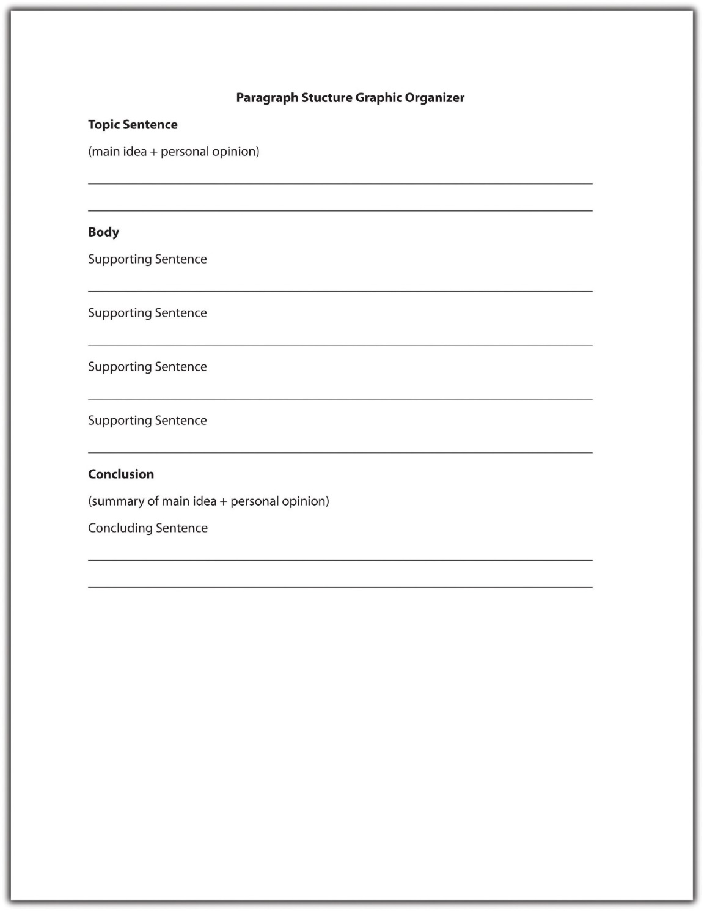
Read the following paragraph. The topic sentence is underlined for you.
After reading the new TV guide this week I had just one thought—why are we still being bombarded with reality shows? This season, the plague of reality television continues to darken our airwaves. Along with the return of viewer favorites, we are to be cursed with yet another mindless creation. Prisoner follows the daily lives of eight suburban housewives who have chosen to be put in jail for the purposes of this fake psychological experiment. A preview for the first episode shows the usual tears and tantrums associated with reality television. I dread to think what producers will come up with next season, but if any of them are reading this blog—stop it! We’ve had enough reality television to last us a lifetime!
The first sentence of this paragraph is the topic sentence. It tells the reader that the paragraph will be about reality television shows, and it expresses the writer’s distaste for these shows through the use of the word bombarded.
Each of the following sentences in the paragraph supports the topic sentence by providing further information about a specific reality television show. The final sentence is the concluding sentence. It reiterates the main point that viewers are bored with reality television shows by using different words from the topic sentence.
Paragraphs that begin with the topic sentence move from the general to the specific. They open with a general statement about a subject (reality shows) and then discuss specific examples (the reality show Prisoner). Most academic essays contain the topic sentence at the beginning of the first paragraph.
Now take a look at the following paragraph. The topic sentence is underlined for you.
Last year, a cat traveled 130 miles to reach its family, who had moved to another state and had left their pet behind. Even though it had never been to their new home, the cat was able to track down its former owners. A dog in my neighborhood can predict when its master is about to have a seizure. It makes sure that he does not hurt himself during an epileptic fit. Compared to many animals, our own senses are almost dull.
The last sentence of this paragraph is the topic sentence. It draws on specific examples (a cat that tracked down its owners and a dog that can predict seizures) and then makes a general statement that draws a conclusion from these examples (animals’ senses are better than humans’). In this case, the supporting sentences are placed before the topic sentence and the concluding sentence is the same as the topic sentence.
This technique is frequently used in persuasive writing. The writer produces detailed examples as evidence to back up his or her point, preparing the reader to accept the concluding topic sentence as the truth.
Sometimes, the topic sentence appears in the middle of a paragraph. Read the following example. The topic sentence is underlined for you.
For many years, I suffered from severe anxiety every time I took an exam. Hours before the exam, my heart would begin pounding, my legs would shake, and sometimes I would become physically unable to move. Last year, I was referred to a specialist and finally found a way to control my anxiety—breathing exercises. It seems so simple, but by doing just a few breathing exercises a couple of hours before an exam, I gradually got my anxiety under control. The exercises help slow my heart rate and make me feel less anxious. Better yet, they require no pills, no equipment, and very little time. It’s amazing how just breathing correctly has helped me learn to manage my anxiety symptoms.
In this paragraph, the underlined sentence is the topic sentence. It expresses the main idea—that breathing exercises can help control anxiety. The preceding sentences enable the writer to build up to his main point (breathing exercises can help control anxiety) by using a personal anecdote (how he used to suffer from anxiety). The supporting sentences then expand on how breathing exercises help the writer by providing additional information. The last sentence is the concluding sentence and restates how breathing can help manage anxiety.
Placing a topic sentence in the middle of a paragraph is often used in creative writing. If you notice that you have used a topic sentence in the middle of a paragraph in an academic essay, read through the paragraph carefully to make sure that it contains only one major topic. To read more about topic sentences and where they appear in paragraphs, see Chapter 8 "The Writing Process: How Do I Begin?".

Implied Topic Sentences
Some well-organized paragraphs do not contain a topic sentence at all. Instead of being directly stated, the main idea is implied in the content of the paragraph. Read the following example:
Heaving herself up the stairs, Luella had to pause for breath several times. She let out a wheeze as she sat down heavily in the wooden rocking chair. Tao approached her cautiously, as if she might crumble at the slightest touch. He studied her face, like parchment; stretched across the bones so finely he could almost see right through the skin to the decaying muscle underneath. Luella smiled a toothless grin.
Although no single sentence in this paragraph states the main idea, the entire paragraph focuses on one concept—that Luella is extremely old. The topic sentence is thus implied rather than stated. This technique is often used in descriptive or narrative writing. Implied topic sentences work well if the writer has a firm idea of what he or she intends to say in the paragraph and sticks to it. However, a paragraph loses its effectiveness if an implied topic sentence is too subtle or the writer loses focus.

Tip
Avoid using implied topic sentences in an informational document. Readers often lose patience if they are unable to quickly grasp what the writer is trying to say. The clearest and most efficient way to communicate in an informational document is to position the topic sentence at the beginning of the paragraph.

EXERCISE 4
Identify the topic sentence, supporting sentences, and concluding sentence in the following paragraph.
The desert provides a harsh environment in which few mammals are able to adapt. Of these hardy creatures, the kangaroo rat is possibly the most fascinating. Able to live in some of the most arid parts of the southwest, the kangaroo rat neither sweats nor pants to keep cool. Its specialized kidneys enable it to survive on a miniscule amount of water. Unlike other desert creatures, the kangaroo rat does not store water in its body but instead is able to convert the dry seeds it eats into moisture. Its ability to adapt to such a hostile environment makes the kangaroo rat a truly amazing creature.
Collaboration
Please share with a classmate and compare your answers.

Supporting Sentences
If you think of a paragraph as a hamburger, the supporting sentences are the meat inside the bun. They make up the body of the paragraph by explaining, proving, or enhancing the controlling idea in the topic sentence. Most paragraphs contain three to six supporting sentences depending on the audience and purpose for writing. A supporting sentence usually offers one of the following:
- Reason
Sentence: The refusal of the baby boom generation to retire is contributing to the current lack of available jobs.
- Fact
Sentence: Many families now rely on older relatives to support them financially.
- Statistic
Sentence: Nearly 10 percent of adults are currently unemployed in the United States.
- Quotation
Sentence: “We will not allow this situation to continue,” stated Senator Johns.
- Example
Sentence: Last year, Bill was asked to retire at the age of fifty-five.
The type of supporting sentence you choose will depend on what you are writing and why you are writing. For example, if you are attempting to persuade your audience to take a particular position you should rely on facts, statistics, and concrete examples, rather than personal opinions. Read the following example:
There are numerous advantages to owning a hybrid car. (Topic sentence)
First, they get 20 percent to 35 percent more miles to the gallon than a fuel-efficient gas-powered vehicle. (Supporting sentence 1: statistic)
Second, they produce very few emissions during low speed city driving. (Supporting sentence 2: fact)
Because they do not require gas, hybrid cars reduce dependency on fossil fuels, which helps lower prices at the pump. (Supporting sentence 3: reason)
Alex bought a hybrid car two years ago and has been extremely impressed with its performance. (Supporting sentence 4: example)
“It’s the cheapest car I’ve ever had,” she said. “The running costs are far lower than previous gas powered vehicles I’ve owned.” (Supporting sentence 5: quotation)
Given the low running costs and environmental benefits of owning a hybrid car, it is likely that many more people will follow Alex’s example in the near future. (Concluding sentence)
To find information for your supporting sentences, you might consider using one of the following sources:
- Reference book
- Encyclopedia
- Website
- Biography/autobiography
- Map
- Dictionary
- Newspaper/magazine
- Interview
- Previous experience
- Personal research
To read more about sources and research, see Chapter 11 "Writing from Research: What Will I Learn?".

Tip
When searching for information on the Internet, remember that some websites are more reliable than others. websites ending in .gov or .edu are generally more reliable than websites ending in .com or .org. Wikis and blogs are not reliable sources of information because they are subject to inaccuracies.

Concluding Sentences
An effective concluding sentence draws together all the ideas you have raised in your paragraph. It reminds readers of the main point—the topic sentence—without restating it in exactly the same words. Using the hamburger example, the top bun (the topic sentence) and the bottom bun (the concluding sentence) are very similar. They frame the “meat” or body of the paragraph. Compare the topic sentence and concluding sentence from the previous example:
Topic sentence: There are numerous advantages to owning a hybrid car.
Concluding sentence: Given the low running costs and environmental benefits of owning a hybrid car, it is likely that many more people will follow Alex’s example in the near future.
Notice the use of the synonyms advantages and benefits. The concluding sentence reiterates the idea that owning a hybrid is advantageous without using the exact same words. It also summarizes two examples of the advantages covered in the supporting sentences: low running costs and environmental benefits.
You should avoid introducing any new ideas into your concluding sentence. A conclusion is intended to provide the reader with a sense of completion. Introducing a subject that is not covered in the paragraph will confuse the reader and weaken your writing.
A concluding sentence may do any of the following:
- Restate the main idea.
Example: Childhood obesity is a growing problem in the United States.
- Summarize the key points in the paragraph.
Example: A lack of healthy choices, poor parenting, and an addiction to video games are among the many factors contributing to childhood obesity.
- Draw a conclusion based on the information in the paragraph.
Example: These statistics indicate that unless we take action, childhood obesity rates will continue to rise.
- Make a prediction, suggestion, or recommendation about the information in the paragraph.
Example: Based on this research, more than 60 percent of children in the United States will be morbidly obese by the year 2030 unless we take evasive action.
- Offer an additional observation about the controlling idea.
Example: Childhood obesity is an entirely preventable tragedy.

EXERCISE 5
On your own paper, write one example of each type of concluding sentence based on a topic of your choice.

Transitions
A strong paragraph moves seamlessly from the topic sentence into the supporting sentences and on to the concluding sentence. To help organize a paragraph and ensure that ideas logically connect to one another, writers use transitional words and phrases. A transition is a connecting word that describes a relationship between ideas. Take another look at the earlier example:
There are numerous advantages to owning a hybrid car. First, they get 20 percent to 35 percent more miles to the gallon than a fuel-efficient gas-powered vehicle. Second, they produce very few emissions during low speed city driving. Because they do not require gas, hybrid cars reduce dependency on fossil fuels, which helps lower prices at the pump. Alex bought a hybrid car two years ago and has been extremely impressed with its performance. “It’s the cheapest car I’ve ever had,” she said. “The running costs are far lower than previous gas-powered vehicles I’ve owned.” Given the low running costs and environmental benefits of owning a hybrid car, it is likely that many more people will follow Alex’s example in the near future.
Each of the underlined words is a transition word. Words such as first and second are transition words that show sequence or clarify order. They help organize the writer’s ideas by showing that he or she has another point to make in support of the topic sentence. Other transition words that show order include third, also, and furthermore.
The transition word because is a transition word of consequence that continues a line of thought. It indicates that the writer will provide an explanation of a result. In this sentence, the writer explains why hybrid cars will reduce dependency on fossil fuels (because they do not require gas). Other transition words of consequence include as a result, so that, since, or for this reason.
To include a summarizing transition in her concluding sentence, the writer could rewrite the final sentence as follows:
In conclusion, given the low running costs and environmental benefits of owning a hybrid car, it is likely that many more people will follow Alex’s example in the near future.
The following chart provides some useful transition words to connect supporting sentences and concluding sentences. See Chapter 8 "The Writing Process: How Do I Begin?" for a more comprehensive look at transitional words and phrases.
Table 6.1 Useful Transitional Words and Phrases
For Supporting Sentences
above all | but | for instance | in particular | moreover | subsequently
also | conversely | furthermore | later on | nevertheless | therefore
aside from | correspondingly | however | likewise | on one hand | to begin with
at the same time | for example | in addition | meanwhile | on the contrary
For Concluding Sentences
after all | all things considered | in brief | in summary | on the whole | to sum up
all in all | finally | in conclusion | on balance | thus

EXERCISE 6
Using your own paper, write a paragraph on a topic of your choice. Be sure to include a topic sentence, supporting sentences, and a concluding sentence and to use transitional words and phrases to link your ideas together.
Collaboration
Please share with a classmate and compare your answers.

Writing at Work
Transitional words and phrases are useful tools to incorporate into workplace documents. They guide the reader through the document, clarifying relationships between sentences and paragraphs so that the reader understands why they have been written in that particular order.
For example, when writing an instructional memo, it may be helpful to consider the following transitional words and phrases: before you begin, first, next, then, finally, after you have completed. Using these transitions as a template to write your memo will provide readers with clear, logical instructions about a particular process and the order in which steps are supposed to be completed.

KEY TAKEAWAYS
- A good paragraph contains three distinct components: a topic sentence, body, and concluding sentence.
- The topic sentence expresses the main idea of the paragraph combined with the writer’s attitude or opinion about the topic.
- Good topic sentences contain both a main idea and a controlling idea, are clear and easy to follow, use engaging vocabulary, and provide an accurate indication of what will follow in the rest of the paragraph.
- Topic sentences may be placed at the beginning, middle, or end of a paragraph. In most academic essays, the topic sentence is placed at the beginning of a paragraph.
- Supporting sentences help explain, prove, or enhance the topic sentence by offering facts, reasons, statistics, quotations, or examples.
- Concluding sentences summarize the key points in a paragraph and reiterate the main idea without repeating it word for word.
- Transitional words and phrases help organize ideas in a paragraph and show how these ideas relate to one another.

4.2.2: Develop Arguments around Your Thesis Writing for Success: "Chapter 9, Section 2: Writing Body Paragraphs"

LEARNING OBJECTIVES
- Select primary support related to your thesis.
- Support your topic sentences.
If your thesis gives the reader a roadmap to your essay, then body paragraphs should closely follow that map. The reader should be able to predict what follows your introductory paragraph by simply reading the thesis statement.
The body paragraphs present the evidence you have gathered to confirm your thesis. Before you begin to support your thesis in the body, you must find information from a variety of sources that support and give credit to what you are trying to prove.

Select Primary Support for Your Thesis
Without primary support, your argument is not likely to be convincing. Primary support can be described as the major points you choose to expand on your thesis. It is the most important information you select to argue for your point of view. Each point you choose will be incorporated into the topic sentence for each body paragraph you write. Your primary supporting points are further supported by supporting details within the paragraphs.

Tip
Remember that a worthy argument is backed by examples. In order to construct a valid argument, good writers conduct lots of background research and take careful notes. They also talk to people knowledgeable about a topic in order to understand its implications before writing about it.

Identify the Characteristics of Good Primary Support
In order to fulfill the requirements of good primary support, the information you choose must meet the following standards:
- Be specific. The main points you make about your thesis and the examples you use to expand on those points need to be specific. Use specific examples to provide the evidence and to build upon your general ideas. These types of examples give your reader something narrow to focus on, and if used properly, they leave little doubt about your claim. General examples, while they convey the necessary information, are not nearly as compelling or useful in writing because they are too obvious and typical.
- Be relevant to the thesis. Primary support is considered strong when it relates directly to the thesis. Primary support should show, explain, or prove your main argument without delving into irrelevant details. When faced with lots of information that could be used to prove your thesis, you may think you need to include it all in your body paragraphs. But effective writers resist the temptation to lose focus. Choose your examples wisely by making sure they directly connect to your thesis.
- Be detailed. Remember that your thesis, while specific, should not be very detailed. The body paragraphs are where you develop the discussion that a thorough essay requires. Using detailed support shows readers that you have considered all the facts and chosen only the most precise details to enhance your point of view.

Prewrite to Identify Primary Supporting Points for a Thesis Statement
Recall that when you prewrite you essentially make a list of examples or reasons why you support your stance. Stemming from each point, you further provide details to support those reasons. After prewriting, you are then able to look back at the information and choose the most compelling pieces you will use in your body paragraphs.

EXERCISE 1
Choose one of the following working thesis statements. On a separate sheet of paper, write for at least five minutes using one of the prewriting techniques you learned in Chapter 8 "The Writing Process: How Do I Begin?".
- Unleashed dogs on city streets are a dangerous nuisance.
- Students cheat for many different reasons.
- Drug use among teens and young adults is a problem.
- The most important change that should occur at my college or university is ____________________________________________.

Select the Most Effective Primary Supporting Points for a Thesis Statement
After you have prewritten about your working thesis statement, you may have generated a lot of information, which may be edited out later. Remember that your primary support must be relevant to your thesis. Remind yourself of your main argument, and delete any ideas that do not directly relate to it. Omitting unrelated ideas ensures that you will use only the most convincing information in your body paragraphs. Choose at least three of only the most compelling points. These will serve as the topic sentences for your body paragraphs.

EXERCISE 2
Refer to the previous exercise and select three of your most compelling reasons to support the thesis statement. Remember that the points you choose must be specific and relevant to the thesis. The statements you choose will be your primary support points, and you will later incorporate them into the topic sentences for the body paragraphs.
Collaboration
Please share with a classmate and compare your answers.
When you support your thesis, you are revealing evidence. Evidence includes anything that can help support your stance. The following are the kinds of evidence you will encounter as you conduct your research:
- Facts. Facts are the best kind of evidence to use because they often cannot be disputed. They can support your stance by providing background information on or a solid foundation for your point of view. However, some facts may still need explanation. For example, the sentence “The most populated state in the United States is California” is a pure fact, but it may require some explanation to make it relevant to your specific argument.
- Judgments. Judgments are conclusions drawn from the given facts. Judgments are more credible than opinions because they are founded upon careful reasoning and examination of a topic.
- Testimony. Testimony consists of direct quotations from either an eyewitness or an expert witness. An eyewitness is someone who has direct experience with a subject; he adds authenticity to an argument based on facts. An expert witness is a person who has extensive experience with a topic. This person studies the facts and provides commentary based on either facts or judgments, or both. An expert witness adds authority and credibility to an argument.
- Personal observation. Personal observation is similar to testimony, but personal observation consists of your testimony. It reflects what you know to be true because you have experiences and have formed either opinions or judgments about them. For instance, if you are one of five children and your thesis states that being part of a large family is beneficial to a child’s social development, you could use your own experience to support your thesis.

Writing at Work
In any job where you devise a plan, you will need to support the steps that you lay out. This is an area in which you would incorporate primary support into your writing. Choosing only the most specific and relevant information to expand upon the steps will ensure that your plan appears well-thought-out and precise.

Tip
You can consult a vast pool of resources to gather support for your stance. Citing relevant information from reliable sources ensures that your reader will take you seriously and consider your assertions. Use any of the following sources for your essay: newspapers or news organization websites, magazines, encyclopedias, and scholarly journals, which are periodicals that address topics in a specialized field.

Choose Supporting Topic Sentences
Each body paragraph contains a topic sentence that states one aspect of your thesis and then expands upon it. Like the thesis statement, each topic sentence should be specific and supported by concrete details, facts, or explanations.
Each body paragraph should comprise the following elements.
topic sentence + supporting details (examples, reasons, or arguments)
As you read in Chapter 8 "The Writing Process: How Do I Begin?", topic sentences indicate the location and main points of the basic arguments of your essay. These sentences are vital to writing your body paragraphs because they always refer back to and support your thesis statement. Topic sentences are linked to the ideas you have introduced in your thesis, thus reminding readers what your essay is about. A paragraph without a clearly identified topic sentence may be unclear and scattered, just like an essay without a thesis statement.

Tip
Unless your teacher instructs otherwise, you should include at least three body paragraphs in your essay. A five-paragraph essay, including the introduction and conclusion, is commonly the standard for exams and essay assignments.
Consider the following the thesis statement:
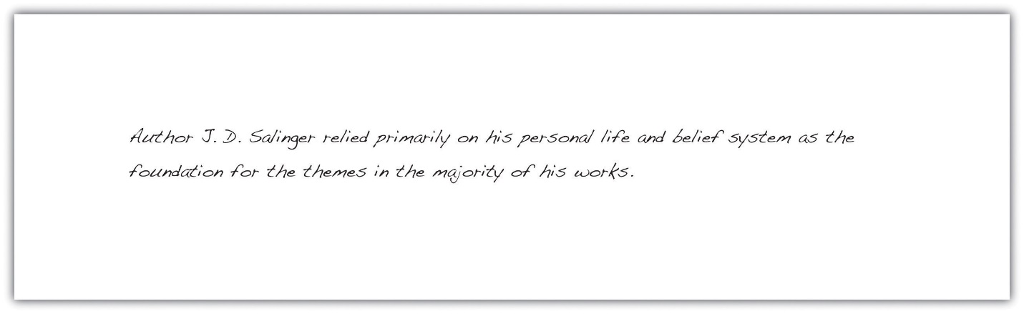
The following topic sentence is a primary support point for the thesis. The topic sentence states exactly what the controlling idea of the paragraph is. Later, you will see the writer immediately provide support for the sentence.
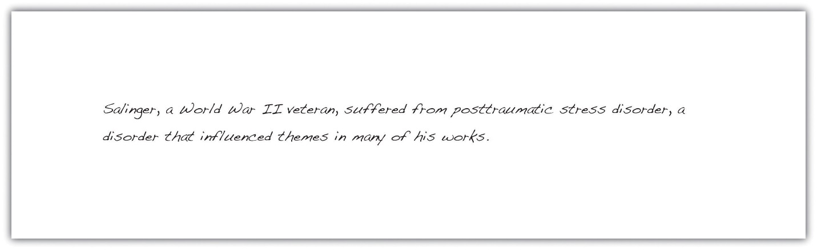

EXERCISE 3
In Note 9.19 "Exercise 2", you chose three of your most convincing points to support the thesis statement you selected from the list. Take each point and incorporate it into a topic sentence for each body paragraph.
Supporting point 1: ____________________________________________
Topic sentence: ____________________________________________
Supporting point 2: ____________________________________________
Topic sentence: ____________________________________________
Supporting point 3: ____________________________________________
Topic sentence: ____________________________________________
Collaboration
Please share with a classmate and compare your answers.

Draft Supporting Detail Sentences for Each Primary Support Sentence
After deciding which primary support points you will use as your topic sentences, you must add details to clarify and demonstrate each of those points. These supporting details provide examples, facts, or evidence that support the topic sentence.
The writer drafts possible supporting detail sentences for each primary support sentence based on the thesis statement:
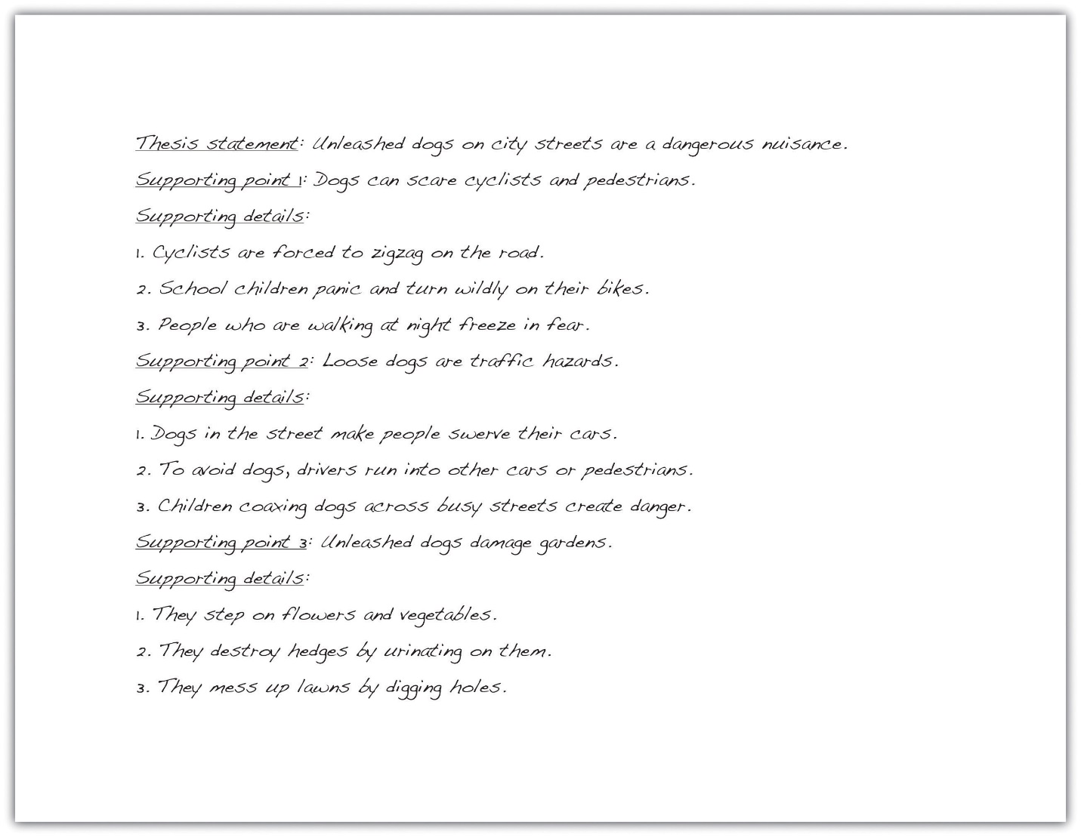
The following paragraph contains supporting detail sentences for the primary support sentence (the topic sentence), which is underlined.
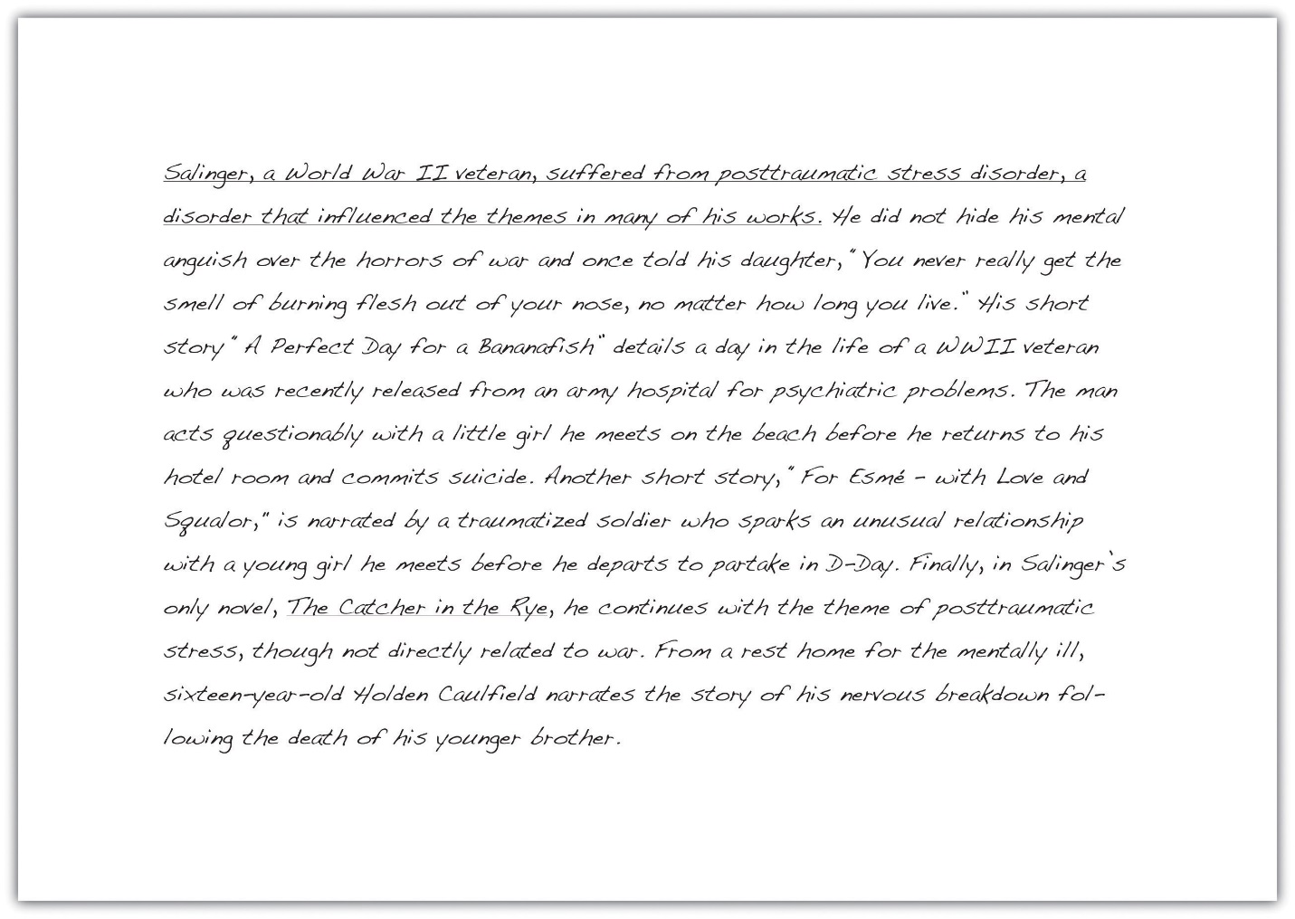

EXERCISE 4
Using the three topic sentences you composed for the thesis statement in Note 9.18 "Exercise 1", draft at least three supporting details for each point.
Thesis statement: ____________________________________________
Primary supporting point 1: ____________________________________________
Supporting details: ____________________________________________
Primary supporting point 2: ____________________________________________
Supporting details: ____________________________________________
Primary supporting point 3: ____________________________________________
Supporting details: ____________________________________________

Tip
You have the option of writing your topic sentences in one of three ways. You can state it at the beginning of the body paragraph, or at the end of the paragraph, or you do not have to write it at all. This is called an implied topic sentence. An implied topic sentence lets readers form the main idea for themselves. For beginning writers, it is best to not use implied topic sentences because it makes it harder to focus your writing. Your instructor may also want to clearly identify the sentences that support your thesis. For more information on the placement of thesis statements and implied topic statements, see Chapter 8 "The Writing Process: How Do I Begin?".

Tip
Print out the first draft of your essay and use a highlighter to mark your topic sentences in the body paragraphs. Make sure they are clearly stated and accurately present your paragraphs, as well as accurately reflect your thesis. If your topic sentence contains information that does not exist in the rest of the paragraph, rewrite it to more accurately match the rest of the paragraph.

KEY TAKEAWAYS
- Your body paragraphs should closely follow the path set forth by your thesis statement.
- Strong body paragraphs contain evidence that supports your thesis.
- Primary support comprises the most important points you use to support your thesis.
- Strong primary support is specific, detailed, and relevant to the thesis.
- Prewriting helps you determine your most compelling primary support.
- Evidence includes facts, judgments, testimony, and personal observation.
- Reliable sources may include newspapers, magazines, academic journals, books, encyclopedias, and firsthand testimony.
- A topic sentence presents one point of your thesis statement while the information in the rest of the paragraph supports that point.
- A body paragraph comprises a topic sentence plus supporting details.

4.2.4: Toulmins Schema Utah State University: "Intermediate Writing: Toulmin's Schema"
Stephen Edelston Toulmin (born March 25, 1922) is a British philosopher, author, and educator. Influenced by the Austrian philosopher Ludwig Wittgenstein, Toulmin devoted his works to the analysis of moral reasoning. Throughout his writings, he seeks to develop practical arguments which can be used effectively in evaluating the ethics behind moral issues. The Toulmin Model of Argumentation, a diagram containing six interrelated components used for analyzing arguments, was considered his most influential work, particularly in the field of rhetoric and communication, and in computer science.
Stephen Toulmin is a British philosopher and educator who devoted to analyzing moral reasoning. Throughout his writings, he seeks to develop practical arguments which can be used effectively in evaluating the ethics behind moral issues. His most famous work was his Model of Argumentation(sometimes called "Toulmin's Schema," which is a method of analyzing an argument by breaking it down into six parts. Once an argument is broken down and examined, weaknesses in the argument can be found and addressed.

Toulmin's Schema:
- Claim: conclusions whose merit must be established. For example, if a person tries to convince a listener that he is a British citizen, the claim would be "I am a British citizen."
- Data: the facts appealed to as a foundation for the claim. For example, the person introduced in 1 can support his claim with the supporting data "I was born in Bermuda."
- Warrant: the statement authorizing the movement from the data to the claim. In order to move from the data established in 2, "I was born in Bermuda," to the claim in 1, "I am a British citizen," the person must supply a warrant to bridge the gap between 1 & 2 with the statement "A man born in Bermuda will legally be a British Citizen." Toulmin stated that an argument is only as strong as its weakest warrant and if a warrant isn't valid, then the whole argument collapses. Therefore, it is important to have strong, valid warrants.
- Backing: facts that give credibility to the statement expressed in the warrant; backing must be introduced when the warrant itself is not convincing enough to the readers or the listeners. For example, if the listener does not deem the warrant as credible, the speaker would supply legal documents as backing statement to show that it is true that "A man born in Bermuda will legally be a British Citizen."
- Rebuttal: statements recognizing the restrictions to which the claim may legitimately be applied. The rebuttal is exemplified as follows, "A man born in Bermuda will legally be a British citizen, unless he has betrayed Britain and become a spy of another country."
- Qualifier: words or phrases expressing how certain the author/speaker is concerning the claim. Such words or phrases include "possible," "probably," "impossible," "certainly," "presumably," "as far as the evidence goes," or "necessarily." The claim "I am definitely a British citizen" has a greater degree of force than the claim "I am a British citizen, presumably."
- The first three elements "claim," "data," and "warrant" are considered as the essential components of practical arguments, while the 4-6 "Qualifier," "Backing," and "Rebuttal" may not be needed in some arguments. When first proposed, this layout of argumentation is based on legal arguments and intended to be used to analyze arguments typically found in the courtroom; in fact, Toulmin did not realize that this layout would be applicable to the field of rhetoric and communication until later. ¹
Here are a few more examples of Toulmin's Schema:
Suppose you see a one of those commercials for a product that promises to give you whiter teeth. Here are the basic parts of the argument behind the commercial:
- Claim: You should buy our tooth-whitening product.
- Data: Studies show that teeth are 50% whiter after using the product for a specified time.
- Warrant: People want whiter teeth.
- Backing: Celebrities want whiter teeth.
- Rebuttal: Commercial says "unless you don't want to attract guys."
- Qualifier: Fine print says "product must be used six weeks for results."
Notice that those commercials don't usually bother trying to convince you that you want whiter teeth; instead, they assume that you have bought into the value our culture places on whiter teeth. When an assumption--a warrant in Toulmin's terms--is unstated, it's called an implicit warrant. Sometimes, however, the warrant may need to be stated because it is a powerful part of the argument. When the warrant is stated, it's called an explicit warrant. ²
Another example:
- Claim: People should probably own a gun.
- Data: Studies show that people who own a gun are less likely to be mugged.
- Warrant: People want to be safe.
- Backing: May not be necessary. In this case, it is common sense that people want to be safe.
- Rebuttal: Not everyone should own a gun. Children and those will mental disorders/problems should not own a gun.
- Qualifier: The word "probably" in the claim.
- Claim: Flag burning should be unconstitutional in most cases.
- Data: A national poll says that 60% of Americans want flag burning unconstitutional
- Warrant: People want to respect the flag.
- Backing: Official government procedures for the disposal of flags.
- Rebuttal: Not everyone in the U.S. respects the flag.
- Qualifier: The phrase "in most cases"
Toulmin says that the weakest part of any argument is its weakest warrant. Remember that the warrant is the link between the data and the claim. If the warrant isn't valid, the argument collapses. ²

Sources
- Stephen Toulmin
- Toulmin's Analysis
Last modified: Wednesday, October 21, 2015, 12:02 PM

4.3.1: Look for Assumptions and Generalizations Utah State University: "Intermediate Writing: Detecting Assumptions and Generalizations"
Large assumptions and overgeneralizations are logical fallacies, which will be covered in Week 8. For the moment, focus on your introduction and conclusion. Are you making too many assumptions or an assumption that doesn't have strong evidence? An example might be "all college students hate general education requirements." An unfounded assumption might be assuming the reader agrees with you on a debatable subject or that they are aware of subject they might know little about. For example, if you assume that readers are against the death penalty, people in favor of the death penalty are less likely to agree with you. Or, if you assume the reader knows about golf or Russian history, then people who don't know about those subjects will be lost in parts of the paper or could possibly misunderstand your entire argument.

Fixing assumptions
If you are discussing a subject which might be unfamiliar to parts of your audience, give a brief explanation of the concept/history/event and then explain its significance to your argument. If you are assuming they agree with you on a debatable or controversial subject, you may have to explain why they should agree with you on that subject, or restructure your argument so that it doesn't use that assumption.

Fixing generalizations
One possibility is to be flexible in the number:
- Some college students hate general education requirements.
- Many college students hate general education requirements.
Another possibility is to limit by geography or other factors:
- Many Utah State University students hate general education requirements.
- Half the students in my geography class hate general education requirements.
Finally, you can also find statistics that confirm your belief.
I surveyed twenty people at random and fifteen said they hated general education requirements. A national survey found that 43% of college students felt that general education requirements were "a waste of time."

Sources
- Introductions
Last modified: Wednesday, October 21, 2015, 12:04 PM
4.3.2: Using Direct Quotations to Support Your Arguments Boundless: "Differentiating your Argument from Others"
There are several ways to properly incorporate and give credit to the sources you cite within your paper.

LEARNING OBJECTIVE
- Explain the different methods for using quotations or citations to differentiate your thoughts from the ideas of your sources.

KEY POINTS
  - There are three methods for referencing a source in the text of your paper: quoting, summarizing, and paraphrasing.
  - Direct quotations are words and phrases that are taken directly from another source, and then used word-for-word in your paper.
  - A summary is typically a short description that outlines the most important points and general position of the source.
  - A paraphrase is when you put another source or part of a source (such as a chapter, paragraph, or page) into your own words.
  - You should follow quotes with a description, in your own terms, of what the quote says and why it is relevant to the purpose of your paper.
  - Follow a the chosen style guide of your audience to properly format and cite your quotations and borrowed information.

TERMS
- summary
A short description that outlines the most important points and general position of the source.
- paraphrase
A rewording of something written or spoken by someone else.
- quotation
A fragment of a human expression that is being referred to by somebody else.

How to Use Your Sources in Your Paper
Within the pages of your paper, it is important to properly reference and cite your sources to avoid plagiarism and to give credit for original ideas. Depending on your audience and its chosen style guide (e.g.: APA, MLA), you will follow different methods to format your text to refer to others' work.
There are three methods for referencing a source in the text of your paper: quoting, summarizing, and paraphrasing.

Quoting
Direct quotations are words and phrases that are taken directly from another source, and then used word-for-word in your paper. If you incorporate a direct quotation from another author's text, you must put that quotation or phrase in quotation marks to indicate that it is not your language. When writing direct quotations, you can use the source author's name in the same sentence as the quotation to introduce the quoted text and to indicate the source in which you found the text. You should then include the page number or other relevant information in parentheses at the end of the phrase depending on the formatting style of your essay.

Summarizing
Summarizing a source involves distilling the main idea of a source into a much shorter overview. A summary outlines a source's most important points and general position. When summarizing a source, it is still necessary to use a citation to give credit to the original author. You must reference the author or source in the appropriate parenthetical citation at the end of the summary.

Paraphrasing
When paraphrasing a source, you may put any part of another source (such as a phrase, sentence, paragraph, or chapter) into your own words. You may find that the original source uses language that is more clear, concise, or specific than your own language, in which case you should use a direct quotation, putting quotation marks around those unique words or phrases you don't change. It is common to use a mixture of paraphrased text and quoted words or phrases as long as the direct quotations are inside of quotation marks.

Providing Context for Your Sources
Whether you use a direct quotation, summary, or paraphrased text, it is important to distinguish the original source from your ideas, and to explain how the cited source fits into your argument. While the use of quotation marks or parenthetical citations tells your reader that these are not your own words or ideas, you should follow the quote with a description, in your own terms, of what the quote says and why it is relevant to the purpose of your paper. You should not let quoted or paraphrased text stand alone in your paper, but rather, should integrate the sources into your argument by providing context and explanations about how each source supports your argument.

The Writing Process
Signaling who is saying what is an important part of the writing process.
Source: Boundless. “Incorporating Your Sources Into Your Paper.” Boundless Writing. Boundless, 08 Oct. 2015. Retrieved 21 Oct. 2015 from https://www.boundless.com/writing/textbooks/boundless-writing-textbook/the-research-process-2/using-your-sources-11/incorporating-your-sources-into-your-paper-96-10295/
Last modified: Tuesday, May 7, 2019, 2:17 PM

4.3.2: Using Direct Quotations to Support Your Arguments The University of North Carolina at Chapel Hill Writing Center: "Quotations"

WHAT THIS HANDOUT IS ABOUT
Used effectively, quotations can provide important pieces of evidence and lend fresh voices and perspectives to your narrative. Used ineffectively, however, quotations can clutter your text and interrupt the flow of your argument. This handout will help you decide when and how to quote like a pro.

WHEN SHOULD I QUOTE?
Use quotations at strategically selected moments. You have probably been told by teachers to provide as much evidence as possible in support of your thesis. But packing your paper with quotations will not necessarily strengthen your argument. The majority of your paper should still be your original ideas in your own words (after all, it’s your paper). And quotations are only one type of evidence: well-balanced papers may also make use of paraphrases, data, and statistics. The types of evidence you use will depend in part on the conventions of the discipline or audience for which you are writing. For example, papers analyzing literature may rely heavily on direct quotations of the text, while papers in the social sciences may have more paraphrasing, data, and statistics than quotations.
Sometimes, in order to have a clear, accurate discussion of the ideas of others, you need to quote those ideas word for word. Suppose you want to challenge the following statement made by John Doe, a well-known historian:
“At the beginning of World War Two, almost all Americans assumed the war would end quickly.”
If it is especially important that you formulate a counterargument to this claim, then you might wish to quote the part of the statement that you find questionable and establish a dialogue between yourself and John Doe:
Historian John Doe has argued that in 1941 “almost all Americans assumed the war would end quickly” (Doe 223). Yet during the first six months of U.S. involvement, the wives and mothers of soldiers often noted in their diaries their fear that the war would drag on for years.

Giving added emphasis to a particularly authoritative source on your topic.
There will be times when you want to highlight the words of a particularly important and authoritative source on your topic. For example, suppose you were writing an essay about the differences between the lives of male and female slaves in the U.S. South. One of your most provocative sources is a narrative written by a former slave, Harriet Jacobs. It would then be appropriate to quote some of Jacobs’s words:
Harriet Jacobs, a former slave from North Carolina, published an autobiographical slave narrative in 1861. She exposed the hardships of both male and female slaves but ultimately concluded that “slavery is terrible for men; but it is far more terrible for women.”
In this particular example, Jacobs is providing a crucial first-hand perspective on slavery. Thus, her words deserve more exposure than a paraphrase could provide.
Jacobs is quoted in Harriet A. Jacobs, Incidents in the Life of a Slave Girl, ed. Jean Fagan Yellin (Cambridge: Harvard University Press, 1987).

Analyzing how others use language.
This scenario is probably most common in literature and linguistics courses, but you might also find yourself writing about the use of language in history and social science classes. If the use of language is your primary topic, then you will obviously need to quote users of that language.
Examples of topics that might require the frequent use of quotations include:
Southern colloquial expressions in William Faulkner’s Light in August
Ms.
and the creation of a language of female empowerment
A comparison of three British poets and their use of rhyme

Spicing up your prose.
In order to lend variety to your prose, you may wish to quote a source with particularly vivid language. All quotations, however, must closely relate to your topic and arguments. Do not insert a quotation solely for its literary merits.
One example of a quotation that adds flair:
President Calvin Coolidge’s tendency to fall asleep became legendary. As H. L. Mencken commented in the American Mercury in 1933, “Nero fiddled, but Coolidge only snored.”

HOW DO I SET UP AND FOLLOW UP A QUOTATION?
Once you’ve carefully selected the quotations that you want to use, your next job is to weave those quotations into your text. The words that precede and follow a quotation are just as important as the quotation itself. You can think of each quote as the filling in a sandwich: it may be tasty on its own, but it’s messy to eat without some bread on either side of it. Your words can serve as the “bread” that helps readers digest each quote easily. Below are four guidelines for setting up and following up quotations.
In illustrating these four steps, we’ll use as our example, Franklin Roosevelt’s famous quotation, “The only thing we have to fear is fear itself.”

1. Provide context for each quotation.
Do not rely on quotations to tell your story for you. It is your responsibility to provide your reader with context for the quotation. The context should set the basic scene for when, possibly where, and under what circumstances the quotation was spoken or written. So, in providing context for our above example, you might write:
When Franklin Roosevelt gave his inaugural speech on March 4, 1933, he addressed a nation weakened and demoralized by economic depression.

2. Attribute each quotation to its source.
Tell your reader who is speaking. Here is a good test: try reading your text aloud. Could your reader determine without looking at your paper where your quotations begin? If not, you need to attribute the quote more noticeably.
Avoid getting into the “he/she said” attribution rut! There are many other ways to attribute quotes besides this construction. Here are a few alternative verbs, usually followed by “that”:
add | remark | exclaim
announce | reply | state
comment | respond | estimate
write | point out | predict
argue | suggest | propose
declare | criticize | proclaim
note | complain | opine
observe | think | note
Different reporting verbs are preferred by different disciplines, so pay special attention to these in your disciplinary reading. If you’re unfamiliar with the meanings of any of these words or others you find in your reading, consult a dictionary before using them.

3. Explain the significance of the quotation.
Once you’ve inserted your quotation, along with its context and attribution, don’t stop! Your reader still needs your assessment of why the quotation holds significance for your paper. Using our Roosevelt example, if you were writing a paper on the first one-hundred days of FDR’s administration, you might follow the quotation by linking it to that topic:
With that message of hope and confidence, the new president set the stage for his next one-hundred days in office and helped restore the faith of the American people in their government.

4. Provide a citation for the quotation.
All quotations, just like all paraphrases, require a formal citation. For more details about particular citation formats, see the UNC Librariescitation tutorial. In general, you should remember one rule of thumb: Place the parenthetical reference or footnote/endnote number after—not within—the closed quotation mark.
Roosevelt declared, “The only thing we have to fear is fear itself” (Roosevelt,
Public Papers, 11).
Roosevelt declared, “The only thing we have to fear is fear itself.”¹

HOW DO I EMBED A QUOTATION INTO A SENTENCE?
In general, avoid leaving quotes as sentences unto themselves. Even if you have provided some context for the quote, a quote standing alone can disrupt your flow. Take a look at this example:
Hamlet denies Rosencrantz’s claim that thwarted ambition caused his depression. “I could be bounded in a nutshell and count myself a king of infinite space” (Hamlet 2.2).
Standing by itself, the quote’s connection to the preceding sentence is unclear. There are several ways to incorporate a quote more smoothly:

Lead into the quote with a colon.
Hamlet denies Rosencrantz’s claim that thwarted ambition caused his depression: “I could be bounded in a nutshell and count myself a king of infinite space” (Hamlet 2.2).
The colon announces that a quote will follow to provide evidence for the sentence’s claim.

Introduce or conclude the quote by attributing it to the speaker. If your attribution precedes the quote, you will need to use a comma after the verb.
Hamlet denies Rosencrantz’s claim that thwarted ambition caused his depression. He states, “I could be bounded in a nutshell and count myself a king of infinite space” (Hamlet 2.2).
When faced with a twelve-foot mountain troll, Ron gathers his courage, shouting, “Wingardium Leviosa!” (Rowling, p. 176).
The Pirate King sees an element of regality in their impoverished and dishonest life. “It is, it is a glorious thing/To be a pirate king,” he declares (Pirates of Penzance, 1983).

Interrupt the quote with an attribution to the speaker. Again, you will need to use a comma after the verb, as well as a comma leading into the attribution.
“There is nothing either good or bad,” Hamlet argues, “but thinking makes it so” (Hamlet 2.2).
“And death shall be no more,” Donne writes, “Death thou shalt die” (“Death, Be Not Proud,” l. 14).
Dividing the quote may highlight a particular nuance of the quote’s meaning. In the first example, the division calls attention to the two parts of Hamlet’s claim. The first phrase states that nothing is inherently good or bad; the second phrase suggests that our perspective causes things to become good or bad. In the second example, the isolation of “Death thou shalt die” at the end of the sentence draws a reader’s attention to that phrase in particular. As you decide whether or not you want to break up a quote, you should consider the shift in emphasis that the division might create.

Use the words of the quote grammatically within your own sentence.
When Hamlet tells Rosencrantz that he “could be bounded in a nutshell and count [him]self a king of infinite space” (Hamlet2.2), he implies that thwarted ambition did not cause his depression.
Ultimately, death holds no power over Donne since in the afterlife, “death shall be no more” (“Death, Be Not Proud,” l. 14).
Note that when you use “that” after the verb that introduces the quote, you no longer need a comma.
The Pirate King argues that “it is, it is a glorious thing/to be a pirate king” (Pirates of Penzance, 1983).

HOW MUCH SHOULD I QUOTE?
As few words as possible. Remember, your paper should primarily contain your own words, so quote only the most pithy and memorable parts of sources. Here are guidelines for selecting quoted material judiciously:

Excerpt fragments.
Sometimes, you should quote short fragments, rather than whole sentences. Suppose you interviewed Jane Doe about her reaction to John F. Kennedy’s assassination. She commented:
“I couldn’t believe it. It was just unreal and so sad. It was just unbelievable. I had never experienced such denial. I don’t know why I felt so strongly. Perhaps it was because JFK was more to me than a president. He represented the hopes of young people everywhere.”
You could quote all of Jane’s comments, but her first three sentences are fairly redundant. You might instead want to quote Jane when she arrives at the ultimate reason for her strong emotions:
Jane Doe grappled with grief and disbelief. She had viewed JFK, not just as a national figurehead, but as someone who “represented the hopes of young people everywhere.”

Excerpt those fragments carefully!
Quoting the words of others carries a big responsibility. Misquoting misrepresents the ideas of others. Here’s a classic example of a misquote:
John Adams has often been quoted as having said: “This would be the best of all possible worlds if there were no religion in it.”
John Adams did, in fact, write the above words. But if you see those words in context, the meaning changes entirely. Here’s the rest of the quotation:
Twenty times, in the course of my late reading, have I been on the point of breaking out, ‘this would be the best of all possible worlds, if there were no religion in it!!!!’ But in this exclamation, I should have been as fanatical as Bryant or Cleverly. Without religion, this world would be something not fit to be mentioned in public company—I mean hell.
As you can see from this example, context matters!
This example is from Paul F. Boller, Jr. and John George, They Never Said It: A Book of Fake Quotes, Misquotes, and Misleading Attributions(Oxford University Press, 1989).

Use block quotations sparingly.
There may be times when you need to quote long passages. However, you should use block quotations only when you fear that omitting any words will destroy the integrity of the passage. If that passage exceeds four lines (some sources say five), then set it off as a block quotation.
Be sure you are handling block quotes correctly in papers for different academic disciplines–check the index of the citation style guide you are using. Here are a few general tips for setting off your block quotations:
    - Set up a block quotation with your own words followed by a colon.
    - Indent. You normally indent 4-5 spaces for the start of a paragraph. When setting up a block quotation, indent the entire paragraph once from the left-hand margin.
    - Single space or double space within the block quotation, depending on the style guidelines of your discipline (MLA, CSE, APA, Chicago, etc.).
    - Do not use quotation marks at the beginning or end of the block quote—the indentation is what indicates that it’s a quote.
    - Place parenthetical citation according to your style guide (usually after the period following the last sentence of the quote).
    - Follow up a block quotation with your own words.
So, using the above example from John Adams, here’s how you might include a block quotation:
After reading several doctrinally rigid tracts, John Adams recalled the zealous ranting of his former teacher, Joseph Cleverly, and minister, Lemuel Bryant. He expressed his ambivalence toward religion in an 1817 letter to Thomas Jefferson:
Twenty times, in the course of my late reading, have I been on the point of breaking out, ‘this would be the best of all possible worlds, if there were no religion in it!!!!’ But in this exclamation, I should have been as fanatical as Bryant or Cleverly. Without religion, this world would be something not fit to be mentioned in public company—I mean hell.
Adams clearly appreciated religion, even if he often questioned its promotion.

HOW DO I COMBINE QUOTATION MARKS WITH OTHER PUNCTUATION MARKS?
It can be confusing when you start combining quotation marks with other punctuation marks. You should consult a style manual for complicated situations, but the following two rules apply to most cases:

Keep periods and commas within quotation marks.
So, for example:
According to Professor Jones, Lincoln “feared the spread of slavery,” but many of his aides advised him to “watch and wait.”
In the above example, both the comma and period were enclosed in the quotation marks. The main exception to this rule involves the use of internal citations, which always precede the last period of the sentence. For example:
According to Professor Jones, Lincoln “feared the spread of slavery,” but many of his aides advised him to “watch and wait” (Jones 143).

Note, however, that the period remains inside the quotation marks when your citation style involved superscript footnotes or endnotes. For example:
According to Professor Jones, Lincoln “feared the spread of slavery,” but many of his aides advised him to “watch and wait.”²

Place all other punctuation marks (colons, semicolons, exclamation marks, question marks) outside the quotation marks, except when they were part of the original quotation.
Take a look at the following examples:
The student wrote that the U. S. Civil War “finally ended around 1900″!
The coach yelled, “Run!”
In the first example, the author placed the exclamation point outside the quotation mark because she added it herself to emphasize the absurdity of the student’s comment. The student’s original comment had not included an exclamation mark. In the second example, the exclamation mark remains within the quotation mark because it is indicating the excited tone in which the coach yelled the command. Thus, the exclamation mark is considered to be part of the original quotation.

HOW DO I INDICATE QUOTATIONS WITHIN QUOTATIONS?
If you are quoting a passage that contains a quotation, then you use single quotation marks for the internal quotation. Quite rarely, you quote a passage that has a quotation within a quotation. In that rare instance, you would use double quotation marks for the second internal quotation.
Here’s an example of a quotation within a quotation:
In “The Emperor’s New Clothes,” Hans Christian Andersen wrote, “‘But the Emperor has nothing on at all!’ cried a little child.”
Remember to consult your style guide to determine how to properly cite a quote within a quote.

WHEN DO I USE THOSE THREE DOTS ( . . . )?
Whenever you want to leave out material from within a quotation, you need to use an ellipsis, which is a series of three periods, each of which should be preceded and followed by a space. So, an ellipsis in this sentence would look like . . . this. There are a few rules to follow when using ellipses:

Be sure that you don’t fundamentally change the meaning of the quotation by omitting material.
Take a look at the following example:
“The Writing Center is located on the UNC campus and serves the entire UNC community.”
“The Writing Center . . . serves the entire UNC community.”
The reader’s understanding of the Writing Center’s mission to serve the UNC community is not affected by omitting the information about its location.

Do not use ellipses at the beginning or ending of quotations, unless it’s important for the reader to know that the quotation was truncated.
For example, using the above example, you would NOT need an ellipsis in either of these situations:
“The Writing Center is located on the UNC campus . . .”
The Writing Center ” . . . serves the entire UNC community.”

Use punctuation marks in combination with ellipses when removing material from the end of sentences or clauses.
For example, if you take material from the end of a sentence, keep the period in as usual.
“The boys ran to school, forgetting their lunches and books. Even though they were out of breath, they made it on time.”
“The boys ran to school. . . . Even though they were out of breath, they made it on time.”
Likewise, if you excerpt material at the end of clause that ends in a comma, retain the comma.
“The red car came to a screeching halt that was heard by nearby pedestrians, but no one was hurt.”
“The red car came to a screeching halt . . . , but no one was hurt.”

IS IT EVER OKAY TO INSERT MY OWN WORDS OR CHANGE WORDS IN A QUOTATION?
Sometimes it is necessary for clarity and flow to alter a word or words within a quotation. You should make such changes rarely. In order to alert your reader to the changes you’ve made, you should always bracket the altered words. Here are a few examples of situations when you might need brackets:

Changing verb tense or pronouns in order to be consistent with the rest of the sentence.
Suppose you were quoting a woman who, when asked about her experiences immigrating to the United States, commented “nobody understood me.” You might write:
Esther Hansen felt that when she came to the United States “nobody understood [her].”
In the above example, you’ve changed “me” to “her” in order to keep the entire passage in third person. However, you could avoid the need for this change by simply rephrasing:
“Nobody understood me,” recalled Danish immigrant Esther Hansen.

Including supplemental information that your reader needs in order to understand the quotation.
For example, if you were quoting someone’s nickname, you might want to let your reader know the full name of that person in brackets.
“The principal of the school told Billy [William Smith] that his contract would be terminated.”
Similarly, if a quotation referenced an event with which the reader might be unfamiliar, you could identify that event in brackets.
“We completely revised our political strategies after the strike [of 1934].”

Indicating the use of nonstandard grammar or spelling.
In rare situations, you may quote from a text that has nonstandard grammar, spelling, or word choice. In such cases, you may want to insert [sic], which means “thus” or “so” in Latin. Using [sic] alerts your reader to the fact that this nonstandard language is not the result of a typo on your part. Always italicize “sic” and enclose it in brackets. There is no need to put a period at the end. Here’s an example of when you might use [sic]:
Twelve-year-old Betsy Smith wrote in her diary, “Father is afraid that he will be guilty of beach [sic] of contract.”
Here [sic] indicates that the original author wrote “beach of contract,” not breach of contract, which is the accepted terminology.

Do not overuse brackets!
For example, it is not necessary to bracket capitalization changes that you make at the beginning of sentences. For example, suppose you were going to use part of this quotation:
“We never looked back, but the memory of our army days remained with us the rest of our lives.”
If you wanted to begin a sentence with an excerpt from the middle of this quotation, there would be no need to bracket your capitalization changes.
“The memory of our army days remained with us the rest of our lives,” commented Joe Brown, a World War II veteran.
Not
“[T]he memory of our army days remained with us the rest of our lives,” commented Joe Brown, a World War II veteran.

WORKS CONSULTED
We consulted these works while writing the original version of this handout. This is not a comprehensive list of resources on the handout’s topic, and we encourage you to do your own research to find the latest publications on this topic. Please do not use this list as a model for the format of your own reference list, as it may not match the citation style you are using. For guidance on formatting citations, please see the UNC Libraries citation tutorial.
Barzun, Jacques, and Henry F. Graff. The Modern Researcher. 6th ed. Belmont, CA: Thomson/Wadsworth, 2004.
Booth, Wayne C., Gregory G. Colomb, and Joseph M. Williams. The Craft of Research. 2nd ed. Chicago: University of Chicago Press, 2003.
MLA Handbook for Writers of Research Papers. 6th ed. New York: The Modern Language Association of America, 2003.
Turabian, Kate L. A Manual for Writers of Research Papers, Theses, and Dissertations. 6th ed. Chicago: University of Chicago Press, 1996.
Last modified: Wednesday, October 21, 2015, 12:12 PM
4.3.3: Addressing Counterargument The University of North Carolina at Chapel Hill Writing Center: "Argument"

WHAT THIS HANDOUT IS ABOUT
This handout will define what an argument is and explain why you need one in most of your academic essays.

ARGUMENTS ARE EVERYWHERE
You may be surprised to hear that the word “argument” does not have to be written anywhere in your assignment for it to be an important part of your task. In fact, making an argument—expressing a point of view on a subject and supporting it with evidence—is often the aim of academic writing. Your instructors may assume that you know this and thus may not explain the importance of arguments in class.
Most material you learn in college is or has been debated by someone, somewhere, at some time. Even when the material you read or hear is presented as simple “fact,” it may actually be one person’s interpretation of a set of information. Instructors may call on you to examine that interpretation and defend it, refute it, or offer some new view of your own. In writing assignments, you will almost always need to do more than just summarize information that you have gathered or regurgitate facts that have been discussed in class. You will need to develop a point of view on or interpretation of that material and provide evidence for your position.
If you think that “fact,” not argument, rules intelligent thinking, consider an example. For nearly 2000 years, educated people in many Western cultures believed that bloodletting—deliberately causing a sick person to lose blood—was the most effective treatment for a variety of illnesses. The “fact” that bloodletting is beneficial to human health was not widely questioned until the 1800’s, and some physicians continued to recommend bloodletting as late as the 1920’s. We have come to accept a different set of “facts” now because some people began to doubt the effectiveness of bloodletting; these people argued against it and provided convincing evidence. Human knowledge grows out of such differences of opinion, and scholars like your instructors spend their lives engaged in debate over what may be counted as “true,” “real,” or “right” in their fields. In their courses, they want you to engage in similar kinds of critical thinking and debate.
Argumentation is not just what your instructors do. We all use argumentation on a daily basis, and you probably already have some skill at crafting an argument. The more you improve your skills in this area, the better you will be at thinking critically, reasoning, making choices, and weighing evidence.

MAKING A CLAIM
What is an argument? In academic writing, an argument is usually a main idea, often called a “claim” or “thesis statement,” backed up with evidence that supports the idea. In the majority of college papers, you will need to make some sort of claim and use evidence to support it, and your ability to do this well will separate your papers from those of students who see assignments as mere accumulations of fact and detail. In other words, gone are the happy days of being given a “topic” about which you can write anything. It is time to stake out a position and prove why it is a good position for a thinking person to hold. See our handout on thesis statements.
Claims can be as simple as “Protons are positively charged and electrons are negatively charged,” with evidence such as, “In this experiment, protons and electrons acted in such and such a way.” Claims can also be as complex as “The end of the South African system of apartheid was inevitable,” using reasoning and evidence such as, “Every successful revolution in the modern era has come about after the government in power has given and then removed small concessions to the uprising group.” In either case, the rest of your paper will detail the reasoning and evidence that have led you to believe that your position is best.
When beginning to write a paper, ask yourself, “What is my point?” For example, the point of this handout is to help you become a better writer, and we are arguing that an important step in the process of writing effective arguments is understanding the concept of argumentation. If your papers do not have a main point, they cannot be arguing for anything. Asking yourself what your point is can help you avoid a mere “information dump.” Consider this: your instructors probably know a lot more than you do about your subject matter. Why, then, would you want to provide them with material they already know? Instructors are usually looking for two things:
- Proof that you understand the material, AND
- A demonstration of your ability to use or apply the material in ways that go beyond what you have read or heard.
This second part can be done in many ways: you can critique the material, apply it to something else, or even just explain it in a different way. In order to succeed at this second step, though, you must have a particular point to argue.
Arguments in academic writing are usually complex and take time to develop. Your argument will need to be more than a simple or obvious statement such as “Frank Lloyd Wright was a great architect.” Such a statement might capture your initial impressions of Wright as you have studied him in class; however, you need to look deeper and express specifically what caused that “greatness.” Your instructor will probably expect something more complicated, such as “Frank Lloyd Wright’s architecture combines elements of European modernism, Asian aesthetic form, and locally found materials to create a unique new style,” or “There are many strong similarities between Wright’s building designs and those of his mother, which suggests that he may have borrowed some of her ideas.” To develop your argument, you would then define your terms and prove your claim with evidence from Wright’s drawings and buildings and those of the other architects you mentioned.

EVIDENCE
Do not stop with having a point. You have to back up your point with evidence. The strength of your evidence, and your use of it, can make or break your argument. See our handout on evidence. You already have the natural inclination for this type of thinking, if not in an academic setting. Think about how you talked your parents into letting you borrow the family car. Did you present them with lots of instances of your past trustworthiness? Did you make them feel guilty because your friends’ parents all let them drive? Did you whine until they just wanted you to shut up? Did you look up statistics on teen driving and use them to show how you didn’t fit the dangerous-driver profile? These are all types of argumentation, and they exist in academia in similar forms.
Every field has slightly different requirements for acceptable evidence, so familiarize yourself with some arguments from within that field instead of just applying whatever evidence you like best. Pay attention to your textbooks and your instructor’s lectures. What types of argument and evidence are they using? The type of evidence that sways an English instructor may not work to convince a sociology instructor. Find out what counts as proof that something is true in that field. Is it statistics, a logical development of points, something from the object being discussed (art work, text, culture, or atom), the way something works, or some combination of more than one of these things?
Be consistent with your evidence. Unlike negotiating for the use of your parents’ car, a college paper is not the place for an all-out blitz of every type of argument. You can often use more than one type of evidence within a paper, but make sure that within each section you are providing the reader with evidence appropriate to each claim. So, if you start a paragraph or section with a statement like “Putting the student seating area closer to the basketball court will raise player performance,” do not follow with your evidence on how much more money the university could raise by letting more students go to games for free. Information about how fan support raises player morale, which then results in better play, would be a better follow-up. Your next section could offer clear reasons why undergraduates have as much or more right to attend an undergraduate event as wealthy alumni—but this information would not go in the same section as the fan support stuff. You cannot convince a confused person, so keep things tidy and ordered.

COUNTERARGUMENT
One way to strengthen your argument and show that you have a deep understanding of the issue you are discussing is to anticipate and address counterarguments or objections. By considering what someone who disagrees with your position might have to say about your argument, you show that you have thought things through, and you dispose of some of the reasons your audience might have for not accepting your argument. Recall our discussion of student seating in the Dean Dome. To make the most effective argument possible, you should consider not only what students would say about seating but also what alumni who have paid a lot to get good seats might say.
You can generate counterarguments by asking yourself how someone who disagrees with you might respond to each of the points you’ve made or your position as a whole. If you can’t immediately imagine another position, here are some strategies to try:
- Do some research. It may seem to you that no one could possibly disagree with the position you are arguing, but someone probably has. For example, some people argue that the American Civil War never ended. If you are making an argument concerning, for example, the outcomes of the Civil War, you might wish to see what some of these people have to say.
- Talk with a friend or with your teacher. Another person may be able to imagine counterarguments that haven’t occurred to you.
- Consider your conclusion or claim and the premises of your argument and imagine someone who denies each of them. For example, if you argued, “Cats make the best pets. This is because they are clean and independent,” you might imagine someone saying, “Cats do not make the best pets. They are dirty and needy.”
Once you have thought up some counterarguments, consider how you will respond to them—will you concede that your opponent has a point but explain why your audience should nonetheless accept your argument? Will you reject the counterargument and explain why it is mistaken? Either way, you will want to leave your reader with a sense that your argument is stronger than opposing arguments.
When you are summarizing opposing arguments, be charitable. Present each argument fairly and objectively, rather than trying to make it look foolish. You want to show that you have seriously considered the many sides of the issue and that you are not simply attacking or caricaturing your opponents.
It is usually better to consider one or two serious counterarguments in some depth, rather than to give a long but superficial list of many different counterarguments and replies.
Be sure that your reply is consistent with your original argument. If considering a counterargument changes your position, you will need to go back and revise your original argument accordingly.

AUDIENCE
Audience is a very important consideration in argument. Take a look at our handout on audience. A lifetime of dealing with your family members has helped you figure out which arguments work best to persuade each of them. Maybe whining works with one parent, but the other will only accept cold, hard statistics. Your kid brother may listen only to the sound of money in his palm. It’s usually wise to think of your audience in an academic setting as someone who is perfectly smart but who doesn’t necessarily agree with you. You are not just expressing your opinion in an argument (“It’s true because I said so”), and in most cases your audience will know something about the subject at hand—so you will need sturdy proof. At the same time, do not think of your audience as clairvoyant. You have to come out and state both your claim and your evidence clearly. Do not assume that because the instructor knows the material, he or she understands what part of it you are using, what you think about it, and why you have taken the position you’ve chosen.

CRITICAL READING
Critical reading is a big part of understanding argument. Although some of the material you read will be very persuasive, do not fall under the spell of the printed word as authority. Very few of your instructors think of the texts they assign as the last word on the subject. Remember that the author of every text has an agenda, something that he or she wants you to believe. This is OK—everything is written from someone’s perspective—but it’s a good thing to be aware of. For more information on objectivity and bias and on reading sources carefully, read our handouts on evaluating print sources and reading to write.
Take notes either in the margins of your source (if you are using a photocopy or your own book) or on a separate sheet as you read. Put away that highlighter! Simply highlighting a text is good for memorizing the main ideas in that text—it does not encourage critical reading. Part of your goal as a reader should be to put the author’s ideas in your own words. Then you can stop thinking of these ideas as facts and start thinking of them as arguments.
When you read, ask yourself questions like “What is the author trying to prove?” and “What is the author assuming I will agree with?” Do you agree with the author? Does the author adequately defend her argument? What kind of proof does she use? Is there something she leaves out that you would put in? Does putting it in hurt her argument? As you get used to reading critically, you will start to see the sometimes hidden agendas of other writers, and you can use this skill to improve your own ability to craft effective arguments.

WORKS CONSULTED
We consulted these works while writing the original version of this handout. This is not a comprehensive list of resources on the handout’s topic, and we encourage you to do your own research to find the latest publications on this topic. Please do not use this list as a model for the format of your own reference list, as it may not match the citation style you are using. For guidance on formatting citations, please see the UNC Libraries citation tutorial.
Anson, Chris M., and Robert A. Schwegler. The Longman Handbook for Writers and Readers. 6th ed. New York: Longman, 2010.
Booth, Wayne C., Gregory G. Colomb, and Joseph M. Williams. The Craft of Research. 3rd ed. Chicago: University of Chicago Press, 2008.
Ede, Lisa. Work in Progress. New York: St. Martin’s Press, 1989.
Gage, John T. The Shape of Reason: Argumentative Writing in College. 4th ed. New York: Longman, 2005.
Lunsford, Andrea, and John Ruszkiewicz. Everything’s an Argument. 6th ed. Boston: Bedford/St. Martin’s, 2012.
Rosen, Leonard J., and Laurence Behrens. The Allyn & Bacon Handbook. 5th ed. New York: Longman, 2003.
Last modified: Wednesday, October 21, 2015, 12:15 PM

4.4.1: Write an Abstract of Your Work The University of North Carolina at Chapel Hill Writing Center: "Abstracts"

WHAT THIS HANDOUT IS ABOUT
This handout provides definitions and examples of the two main types of abstracts: descriptive and informative. It also provides guidelines for constructing an abstract and general tips for you to keep in mind when drafting. Finally, it includes a few examples of abstracts broken down into their component parts.

WHAT IS AN ABSTRACT?
An abstract is a self-contained, short, and powerful statement that describes a larger work. Components vary according to discipline. An abstract of a social science or scientific work may contain the scope, purpose, results, and contents of the work. An abstract of a humanities work may contain the thesis, background, and conclusion of the larger work. An abstract is not a review, nor does it evaluate the work being abstracted. While it contains key words found in the larger work, the abstract is an original document rather than an excerpted passage.

WHY WRITE AN ABSTRACT?
You may write an abstract for various reasons. The two most important are selection and indexing. Abstracts allow readers who may be interested in a longer work to quickly decide whether it is worth their time to read it. Also, many online databases use abstracts to index larger works. Therefore, abstracts should contain keywords and phrases that allow for easy searching.

Selection
Say you are beginning a research project on how Brazilian newspapers helped Brazil’s ultra-liberal president Luiz Ignácio da Silva wrest power from the traditional, conservative power base. A good first place to start your research is to search Dissertation Abstracts International for all dissertations that deal with the interaction between newspapers and politics. “Newspapers and politics” returned 569 hits. A more selective search of “newspapers and Brazil” returned 22 hits. That is still a fair number of dissertations. Titles can sometimes help winnow the field, but many titles are not very descriptive. For example, one dissertation is titled “Rhetoric and Riot in Rio de Janeiro.” It is unclear from the title what this dissertation has to do with newspapers in Brazil. One option would be to download or order the entire dissertation on the chance that it might speak specifically to the topic. A better option is to read the abstract. In this case, the abstract reveals the main focus of the dissertation:
This dissertation examines the role of newspaper editors in the political turmoil and strife that characterized late First Empire Rio de Janeiro (1827-1831). Newspaper editors and their journals helped change the political culture of late First Empire Rio de Janeiro by involving the people in the discussion of state. This change in political culture is apparent in Emperor Pedro I’s gradual loss of control over the mechanisms of power. As the newspapers became more numerous and powerful, the Emperor lost his legitimacy in the eyes of the people. To explore the role of the newspapers in the political events of the late First Empire, this dissertation analyzes all available newspapers published in Rio de Janeiro from 1827 to 1831. Newspapers and their editors were leading forces in the effort to remove power from the hands of the ruling elite and place it under the control of the people. In the process, newspapers helped change how politics operated in the constitutional monarchy of Brazil.
From this abstract you now know that although the dissertation has nothing to do with modern Brazilian politics, it does cover the role of newspapers in changing traditional mechanisms of power. After reading the abstract, you can make an informed judgment about whether the dissertation would be worthwhile to read.

Indexing
Besides selection, the other main purpose of the abstract is for indexing. Most article databases in the online catalog of the library enable you to search abstracts. This allows for quick retrieval by users and limits the extraneous items recalled by a “full-text” search. However, for an abstract to be useful in an online retrieval system, it must incorporate the key terms that a potential researcher would use to search. For example, if you search Dissertation Abstracts International using the keywords “France” “revolution” and “politics,” the search engine would search through all the abstracts in the database that included those three words. Without an abstract, the search engine would be forced to search titles, which, as we have seen, may not be fruitful, or else search the full text. It’s likely that a lot more than 60 dissertations have been written with those three words somewhere in the body of the entire work. By incorporating keywords into the abstract, the author emphasizes the central topics of the work and gives prospective readers enough information to make an informed judgment about the applicability of the work.

WHEN DO PEOPLE WRITE ABSTRACTS?
- when submitting articles to journals, especially online journals
- when applying for research grants
- when writing a book proposal
- when completing the Ph.D. dissertation or M.A. thesis
- when writing a proposal for a conference paper
- when writing a proposal for a book chapter
Most often, the author of the entire work (or prospective work) writes the abstract. However, there are professional abstracting services that hire writers to draft abstracts of other people’s work. In a work with multiple authors, the first author usually writes the abstract. Undergraduates are sometimes asked to draft abstracts of books/articles for classmates who have not read the larger work.

TYPES OF ABSTRACTS
There are two types of abstracts: descriptive and informative. They have different aims, so as a consequence they have different components and styles. There is also a third type called critical, but it is rarely used. If you want to find out more about writing a critique or a review of a work, see the UNC Writing Center handout on writing a literature review. If you are unsure which type of abstract you should write, ask your instructor (if the abstract is for a class) or read other abstracts in your field or in the journal where you are submitting your article.

Descriptive abstracts
A descriptive abstract indicates the type of information found in the work. It makes no judgments about the work, nor does it provide results or conclusions of the research. It does incorporate key words found in the text and may include the purpose, methods, and scope of the research. Essentially, the descriptive abstract describes the work being abstracted. Some people consider it an outline of the work, rather than a summary. Descriptive abstracts are usually very short—100 words or less.

Informative abstracts
The majority of abstracts are informative. While they still do not critique or evaluate a work, they do more than describe it. A good informative abstract acts as a surrogate for the work itself. That is, the writer presents and explains all the main arguments and the important results and evidence in the complete article/paper/book. An informative abstract includes the information that can be found in a descriptive abstract (purpose, methods, scope) but also includes the results and conclusions of the research and the recommendations of the author. The length varies according to discipline, but an informative abstract is rarely more than 10% of the length of the entire work. In the case of a longer work, it may be much less.
Here are examples of a descriptive and an informative abstract of this handout:
“Abstracts,” UNC-CH Writing Center, <http://writingcenter.unc.edu/handouts/abstracts/
>.
Descriptive abstract:
The two most common abstract types—descriptive and informative—are described and examples of each are provided.
Informative abstract:
Abstracts present the essential elements of a longer work in a short and powerful statement. The purpose of an abstract is to provide prospective readers the opportunity to judge the relevance of the longer work to their projects. Abstracts also include the key terms found in the longer work and the purpose and methods of the research. Authors abstract various longer works, including book proposals, dissertations, and online journal articles. There are two main types of abstracts: descriptive and informative. A descriptive abstract briefly describes the longer work, while an informative abstract presents all the main arguments and important results. This handout provides examples of various types of abstracts and instructions on how to construct one.

Which type should I use?
Your best bet in this case is to ask your instructor or refer to the instructions provided by the publisher. You can also make a guess based on the length allowed; i.e., 100-120 words = descriptive; 250+ words = informative.

HOW DO I WRITE AN ABSTRACT?
The format of your abstract will depend on the work being abstracted. An abstract of a scientific research paper will contain elements not found in an abstract of a literature article, and vice versa. However, all abstracts share several mandatory components, and there are also some optional parts that you can decide to include or not. When preparing to draft your abstract, keep the following key process elements in mind:
- Reason for writing:
What is the importance of the research? Why would a reader be interested in the larger work?
- Problem:
What problem does this work attempt to solve? What is the scope of the project? What is the main argument/thesis/claim?
- Methodology:
An abstract of a scientific work may include specific models or approaches used in the larger study. Other abstracts may describe the types of evidence used in the research.
- Results:
Again, an abstract of a scientific work may include specific data that indicates the results of the project. Other abstracts may discuss the findings in a more general way.
- Implications:
What changes should be implemented as a result of the findings of the work? How does this work add to the body of knowledge on the topic?
(This list of elements is adapted with permission from Philip Koopman, “How to Write an Abstract.”)

All abstracts include:
- A full citation of the source, preceding the abstract.
- The most important information first.
- The same type and style of language found in the original, including technical language.
- Key words and phrases that quickly identify the content and focus of the work.
- Clear, concise, and powerful language.

Abstracts may include:
- The thesis of the work, usually in the first sentence.
- Background information that places the work in the larger body of literature.
- The same chronological structure as the original work.

How not to write an abstract:
- Do not refer extensively to other works.
- Do not add information not contained in the original work.
- Do not define terms.

If you are abstracting your own writing
When abstracting your own work, it may be difficult to condense a piece of writing that you have agonized over for weeks (or months, or even years) into a 250-word statement. There are some tricks that you could use to make it easier, however.
Reverse outlining:
This technique is commonly used when you are having trouble organizing your own writing. The process involves writing down the main idea of each paragraph on a separate piece of paper–see our short video. For the purposes of writing an abstract, try grouping the main ideas of each section of the paper into a single sentence. Practice grouping ideas using webbing or color coding.
For a scientific paper, you may have sections titled Purpose, Methods, Results, and Discussion. Each one of these sections will be longer than one paragraph, but each is grouped around a central idea. Use reverse outlining to discover the central idea in each section and then distill these ideas into one statement.
Cut and paste:
To create a first draft of an abstract of your own work, you can read through the entire paper and cut and paste sentences that capture key passages. This technique is useful for social science research with findings that cannot be encapsulated by neat numbers or concrete results. A well-written humanities draft will have a clear and direct thesis statement and informative topic sentences for paragraphs or sections. Isolate these sentences in a separate document and work on revising them into a unified paragraph.

If you are abstracting someone else’s writing
When abstracting something you have not written, you cannot summarize key ideas just by cutting and pasting. Instead, you must determine what a prospective reader would want to know about the work. There are a few techniques that will help you in this process:
Identify key terms:
Search through the entire document for key terms that identify the purpose, scope, and methods of the work. Pay close attention to the Introduction (or Purpose) and the Conclusion (or Discussion). These sections should contain all the main ideas and key terms in the paper. When writing the abstract, be sure to incorporate the key terms.
Highlight key phrases and sentences:
Instead of cutting and pasting the actual words, try highlighting sentences or phrases that appear to be central to the work. Then, in a separate document, rewrite the sentences and phrases in your own words.
Don’t look back:
After reading the entire work, put it aside and write a paragraph about the work without referring to it. In the first draft, you may not remember all the key terms or the results, but you will remember what the main point of the work was. Remember not to include any information you did not get from the work being abstracted.

REVISE, REVISE, REVISE
No matter what type of abstract you are writing, or whether you are abstracting your own work or someone else’s, the most important step in writing an abstract is to revise early and often. When revising, delete all extraneous words and incorporate meaningful and powerful words. The idea is to be as clear and complete as possible in the shortest possible amount of space. The Word Count feature of Microsoft Word can help you keep track of how long your abstract is and help you hit your target length.

EXAMPLE 1: HUMANITIES ABSTRACT
Kenneth Tait Andrews, “‘Freedom is a constant struggle': The dynamics and consequences of the Mississippi Civil Rights Movement, 1960-1984″ Ph.D. State University of New York at Stony Brook, 1997 DAI-A 59/02, p. 620, Aug 1998
This dissertation examines the impacts of social movements through a multi-layered study of the Mississippi Civil Rights Movement from its peak in the early 1960s through the early 1980s. By examining this historically important case, I clarify the process by which movements transform social structures and the constraints movements face when they try to do so. The time period studied includes the expansion of voting rights and gains in black political power, the desegregation of public schools and the emergence of white-flight academies, and the rise and fall of federal anti-poverty programs. I use two major research strategies: (1) a quantitative analysis of county-level data and (2) three case studies. Data have been collected from archives, interviews, newspapers, and published reports. This dissertation challenges the argument that movements are inconsequential. Some view federal agencies, courts, political parties, or economic elites as the agents driving institutional change, but typically these groups acted in response to the leverage brought to bear by the civil rights movement. The Mississippi movement attempted to forge independent structures for sustaining challenges to local inequities and injustices. By propelling change in an array of local institutions, movement infrastructures had an enduring legacy in Mississippi.
Now let’s break down this abstract into its component parts to see how the author has distilled his entire dissertation into a ~200 word abstract.

What the dissertation does
This dissertation examines the impacts of social movements through a multi-layered study of the Mississippi Civil Rights Movement from its peak in the early 1960s through the early 1980s. By examining this historically important case, I clarify the process by which movements transform social structures and the constraints movements face when they try to do so.

How the dissertation does it
The time period studied in this dissertation includes the expansion of voting rights and gains in black political power, the desegregation of public schools and the emergence of white-flight academies, and the rise and fall of federal anti-poverty programs. I use two major research strategies: (1) a quantitative analysis of county-level data and (2) three case studies.

What materials are used
Data have been collected from archives, interviews, newspapers, and published reports.

Conclusion
This dissertation challenges the argument that movements are inconsequential. Some view federal agencies, courts, political parties, or economic elites as the agents driving institutional change, but typically these groups acted in response to movement demands and the leverage brought to bear by the civil rights movement. The Mississippi movement attempted to forge independent structures for sustaining challenges to local inequities and injustices. By propelling change in an array of local institutions, movement infrastructures had an enduring legacy in Mississippi.

Keywords
social movements
Civil Rights Movement
Mississippi
voting rights
desegregation

EXAMPLE 2: SCIENCE ABSTRACT
Luis Lehner, “Gravitational radiation from black hole spacetimes” Ph.D. University of Pittsburgh, 1998 DAI-B 59/06, p. 2797, Dec 1998
The problem of detecting gravitational radiation is receiving considerable attention with the construction of new detectors in the United States, Europe, and Japan. The theoretical modeling of the wave forms that would be produced in particular systems will expedite the search for and analysis of detected signals. The characteristic formulation of GR is implemented to obtain an algorithm capable of evolving black holes in 3D asymptotically flat spacetimes. Using compactification techniques, future null infinity is included in the evolved region, which enables the unambiguous calculation of the radiation produced by some compact source. A module to calculate the waveforms is constructed and included in the evolution algorithm. This code is shown to be second-order convergent and to handle highly non-linear spacetimes. In particular, we have shown that the code can handle spacetimes whose radiation is equivalent to a galaxy converting its whole mass into gravitational radiation in one second. We further use the characteristic formulation to treat the region close to the singularity in black hole spacetimes. The code carefully excises a region surrounding the singularity and accurately evolves generic black hole spacetimes with apparently unlimited stability.
This science abstract covers much of the same ground as the humanities one, but it asks slightly different questions.

Why do this study
The problem of detecting gravitational radiation is receiving considerable attention with the construction of new detectors in the United States, Europe, and Japan. The theoretical modeling of the wave forms that would be produced in particular systems will expedite the search and analysis of the detected signals.

What the study does
The characteristic formulation of GR is implemented to obtain an algorithm capable of evolving black holes in 3D asymptotically flat spacetimes. Using compactification techniques, future null infinity is included in the evolved region, which enables the unambiguous calculation of the radiation produced by some compact source. A module to calculate the waveforms is constructed and included in the evolution algorithm.

Results
This code is shown to be second-order convergent and to handle highly non-linear spacetimes. In particular, we have shown that the code can handle spacetimes whose radiation is equivalent to a galaxy converting its whole mass into gravitational radiation in one second. We further use the characteristic formulation to treat the region close to the singularity in black hole spacetimes. The code carefully excises a region surrounding the singularity and accurately evolves generic black hole spacetimes with apparently unlimited stability.

Keywords
gravitational radiation (GR)
spacetimes
black holes

WORKS CONSULTED
We consulted these works while writing the original version of this handout. This is not a comprehensive list of resources on the handout’s topic, and we encourage you to do your own research to find the latest publications on this topic. Please do not use this list as a model for the format of your own reference list, as it may not match the citation style you are using. For guidance on formatting citations, please see the UNC Libraries citation tutorial.
Koopman, Philip. “How to Write an Abstract.”
Lancaster, F.W. Indexing and Abstracting in Theory and Practice, 3rd edition. (London: Facet, 2003), 95.
Rensselaer Polytechnic Institute. “Abstracts.”
St. Cloud University, LEO, “Writing Abstracts.”
Last modified: Wednesday, October 21, 2015, 12:14 PM

4.4.2: Revising Your Outline Activity
Return to your outline and flesh out as much detail as possible. Your thesis should be clear and focused, and all of your logic and evidence should clearly support that controlling idea. Using your annotated bibliography, make note of the sources you will use to support your arguments. You may identify points that could use additional clarification and notice a few small holes in your research, though your information-gathering should be almost complete at this point. If needed, conduct some more research to fill these gaps.

UNIT FIVE: Writing the Research Paper and Acknowledging Your Sources
5.1.1: Drafting Process Writing for Success: "Chapter 12, Section 1: Creating a Rough Draft for a Research Paper"

LEARNING OBJECTIVES
- Apply strategies for drafting an effective introduction and conclusion.
- Identify when and how to summarize, paraphrase, and directly quote information from research sources.
- Apply guidelines for citing sources within the body of the paper and the bibliography.
- Use primary and secondary research to support ideas.
- Identify the purposes for which writers use each type of research.
At last, you are ready to begin writing the rough draft of your research paper. Putting your thinking and research into words is exciting. It can also be challenging. In this section, you will learn strategies for handling the more challenging aspects of writing a research paper, such as integrating material from your sources, citing information correctly, and avoiding any misuse of your sources.

The Structure of a Research Paper
Research papers generally follow the same basic structure: an introduction that presents the writer’s thesis, a body section that develops the thesis with supporting points and evidence, and a conclusion that revisits the thesis and provides additional insights or suggestions for further research.
Your writing voice will come across most strongly in your introduction and conclusion, as you work to attract your readers’ interest and establish your thesis. These sections usually do not cite sources at length. They focus on the big picture, not specific details. In contrast, the body of your paper will cite sources extensively. As you present your ideas, you will support your points with details from your research.

Writing Your Introduction
There are several approaches to writing an introduction, each of which fulfills the same goals. The introduction should get readers’ attention, provide background information, and present the writer’s thesis. Many writers like to begin with one of the following catchy openers:
- A surprising fact
- A thought-provoking question
- An attention-getting quote
- A brief anecdote that illustrates a larger concept
- A connection between your topic and your readers’ experiences
The next few sentences place the opening in context by presenting background information. From there, the writer builds toward a thesis, which is traditionally placed at the end of the introduction. Think of your thesis as a signpost that lets readers know in what direction the paper is headed.
Jorge decided to begin his research paper by connecting his topic to readers’ daily experiences. Read the first draft of his introduction. The thesis is underlined. Note how Jorge progresses from the opening sentences to background information to his thesis.

Beyond the Hype: Evaluating Low-Carb Diets
I. Introduction
Over the past decade, increasing numbers of Americans have jumped on the low-carb bandwagon. Some studies estimate that approximately 40 million Americans, or about 20 percent of the population, are attempting to restrict their intake of food high in carbohydrates (Sanders and Katz, 2004; Hirsch, 2004). Proponents of low-carb diets say they are not only the most effective way to lose weight, but they also yield health benefits such as lower blood pressure and improved cholesterol levels. Meanwhile, some doctors claim that low-carb diets are overrated and caution that their long-term effects are unknown. Although following a low-carbohydrate diet can benefit some people, these diets are not necessarily the best option for everyone who wants to lose weight or improve their health.

EXERCISE 1
Write the introductory paragraph of your research paper. Try using one of the techniques listed in this section to write an engaging introduction. Be sure to include background information about the topic that leads to your thesis.

Tip
Writers often work out of sequence when writing a research paper. If you find yourself struggling to write an engaging introduction, you may wish to write the body of your paper first. Writing the body sections first will help you clarify your main points. Writing the introduction should then be easier. You may have a better sense of how to introduce the paper after you have drafted some or all of the body.

Writing Your Conclusion
In your introduction, you tell readers where they are headed. In your conclusion, you recap where they have been. For this reason, some writers prefer to write their conclusions soon after they have written their introduction. However, this method may not work for all writers. Other writers prefer to write their conclusion at the end of the paper, after writing the body paragraphs. No process is absolutely right or absolutely wrong; find the one that best suits you.
No matter when you compose the conclusion, it should sum up your main ideas and revisit your thesis. The conclusion should not simply echo the introduction or rely on bland summary statements, such as “In this paper, I have demonstrated that.…” In fact, avoid repeating your thesis verbatim from the introduction. Restate it in different words that reflect the new perspective gained through your research. That helps keep your ideas fresh for your readers. An effective writer might conclude a paper by asking a new question the research inspired, revisiting an anecdote presented earlier, or reminding readers of how the topic relates to their lives.

Writing at Work
If your job involves writing or reading scientific papers, it helps to understand how professional researchers use the structure described in this section. A scientific paper begins with an abstract that briefly summarizes the entire paper. The introduction explains the purpose of the research, briefly summarizes previous research, and presents the researchers’ hypothesis. The body provides details about the study, such as who participated in it, what the researchers measured, and what results they recorded. The conclusion presents the researchers’ interpretation of the data, or what they learned.

Using Source Material in Your Paper
One of the challenges of writing a research paper is successfully integrating your ideas with material from your sources. Your paper must explain what you think, or it will read like a disconnected string of facts and quotations. However, you also need to support your ideas with research, or they will seem insubstantial. How do you strike the right balance?
You have already taken a step in the right direction by writing your introduction. The introduction and conclusion function like the frame around a picture. They define and limit your topic and place your research in context.
In the body paragraphs of your paper, you will need to integrate ideas carefully at the paragraph level and at the sentence level. You will use topic sentences in your paragraphs to make sure readers understand the significance of any facts, details, or quotations you cite. You will also include sentences that transition between ideas from your research, either within a paragraph or between paragraphs. At the sentence level, you will need to think carefully about how you introduce paraphrased and quoted material.
Earlier you learned about summarizing, paraphrasing, and quoting when taking notes. In the next few sections, you will learn how to use these techniques in the body of your paper to weave in source material to support your ideas.

Summarizing Sources
When you summarize material from a source, you zero in on the main points and restate them concisely in your own words. This technique is appropriate when only the major ideas are relevant to your paper or when you need to simplify complex information into a few key points for your readers.
Be sure to review the source material as you summarize it. Identify the main idea and restate it as concisely as you can—preferably in one sentence. Depending on your purpose, you may also add another sentence or two condensing any important details or examples. Check your summary to make sure it is accurate and complete.
In his draft, Jorge summarized research materials that presented scientists’ findings about low-carbohydrate diets. Read the following passage from a trade magazine article and Jorge’s summary of the article.

Assessing the Efficacy of Low-Carbohydrate Diets
Adrienne Howell, Ph.D.
Over the past few years, a number of clinical studies have explored whether high-protein, low-carbohydrate diets are more effective for weight loss than other frequently recommended diet plans, such as diets that drastically curtail fat intake (Pritikin) or that emphasize consuming lean meats, grains, vegetables, and a moderate amount of unsaturated fats (the Mediterranean diet). A 2009 study found that obese teenagers who followed a low-carbohydrate diet lost an average of 15.6 kilograms over a six-month period, whereas teenagers following a low-fat diet or a Mediterranean diet lost an average of 11.1 kilograms and 9.3 kilograms respectively. Two 2010 studies that measured weight loss for obese adults following these same three diet plans found similar results. Over three months, subjects on the low-carbohydrate diet plan lost anywhere from four to six kilograms more than subjects who followed other diet plans.

Summary
In three recent studies, researchers compared outcomes for obese subjects who followed either a low-carbohydrate diet, a low-fat diet, or a Mediterranean diet and found that subjects following a low-carbohydrate diet lost more weight in the same time (Howell, 2010).

Tip
A summary restates ideas in your own words—but for specialized or clinical terms, you may need to use terms that appear in the original source. For instance, Jorge used the term obese in his summary because related words such as heavy or overweight have a different clinical meaning.

EXERCISE 2
On a separate sheet of paper, practice summarizing by writing a one-sentence summary of the same passage that Jorge already summarized.

Paraphrasing Sources
When you paraphrase material from a source, restate the information from an entire sentence or passage in your own words, using your own original sentence structure. A paraphrased source differs from a summarized source in that you focus on restating the ideas, not condensing them.
Again, it is important to check your paraphrase against the source material to make sure it is both accurate and original. Inexperienced writers sometimes use the thesaurus method of paraphrasing—that is, they simply rewrite the source material, replacing most of the words with synonyms. This constitutes a misuse of sources. A true paraphrase restates ideas using the writer’s own language and style.
In his draft, Jorge frequently paraphrased details from sources. At times, he needed to rewrite a sentence more than once to ensure he was paraphrasing ideas correctly. Read the passage from a website. Then read Jorge’s initial attempt at paraphrasing it, followed by the final version of his paraphrase.

Source
Dieters nearly always get great results soon after they begin following a low-carbohydrate diet, but these results tend to taper off after the first few months, particularly because many dieters find it difficult to follow a low-carbohydrate diet plan consistently.

Summary
People usually see encouraging outcomes shortly after they go on a low-carbohydrate diet, but their progress slows down after a short while, especially because most discover that it is a challenge to adhere to the diet strictly (Heinz, 2009).
After reviewing the paraphrased sentence, Jorge realized he was following the original source too closely. He did not want to quote the full passage verbatim, so he again attempted to restate the idea in his own style.

Summary
Because it is hard for dieters to stick to a low-carbohydrate eating plan, the initial success of these diets is short-lived (Heinz, 2009).

EXERCISE 3
On a separate sheet of paper, follow these steps to practice paraphrasing.
- Choose an important idea or detail from your notes.
- Without looking at the original source, restate the idea in your own words.
- Check your paraphrase against the original text in the source. Make sure both your language and your sentence structure are original.
- Revise your paraphrase if necessary.

Quoting Sources Directly
Most of the time, you will summarize or paraphrase source material instead of quoting directly. Doing so shows that you understand your research well enough to write about it confidently in your own words. However, direct quotes can be powerful when used sparingly and with purpose.
Quoting directly can sometimes help you make a point in a colorful way. If an author’s words are especially vivid, memorable, or well phrased, quoting them may help hold your reader’s interest. Direct quotations from an interviewee or an eyewitness may help you personalize an issue for readers. And when you analyze primary sources, such as a historical speech or a work of literature, quoting extensively is often necessary to illustrate your points. These are valid reasons to use quotations.
Less experienced writers, however, sometimes overuse direct quotations in a research paper because it seems easier than paraphrasing. At best, this reduces the effectiveness of the quotations. At worst, it results in a paper that seems haphazardly pasted together from outside sources. Use quotations sparingly for greater impact.
When you do choose to quote directly from a source, follow these guidelines:
- Make sure you have transcribed the original statement accurately.
- Represent the author’s ideas honestly. Quote enough of the original text to reflect the author’s point accurately.
- Never use a stand-alone quotation. Always integrate the quoted material into your own sentence.
- Use ellipses (…) if you need to omit a word or phrase. Use brackets [ ] if you need to replace a word or phrase.
- Make sure any omissions or changed words do not alter the meaning of the original text. Omit or replace words only when absolutely necessary to shorten the text or to make it grammatically correct within your sentence.
- Remember to include correctly formatted citations that follow the assigned style guide.
Jorge interviewed a dietician as part of his research, and he decided to quote her words in his paper. Read an excerpt from the interview and Jorge’s use of it, which follows.

Source
Personally, I don’t really buy into all of the hype about low-carbohydrate miracle diets like Atkins and so on. Sure, for some people, they are great, but for most, any sensible eating and exercise plan would work just as well.

Summary
Registered dietician Dana Kwon (2010) admits, “Personally, I don’t really buy into all of the hype.…Sure, for some people, [low-carbohydrate diets] are great, but for most, any sensible eating and exercise plan would work just as well.”
Notice how Jorge smoothly integrated the quoted material by starting the sentence with an introductory phrase. His use of ellipses and brackets did not change the source’s meaning.

Documenting Source Material
Throughout the writing process, be scrupulous about documenting information taken from sources. The purpose of doing so is twofold:
- To give credit to other writers or researchers for their ideas
- To allow your reader to follow up and learn more about the topic if desired
You will cite sources within the body of your paper and at the end of the paper in your bibliography. For this assignment, you will use the citation format used by the American Psychological Association (also known as APA style). For information on the format used by the Modern Language Association (MLA style), see Chapter 13 "APA and MLA Documentation and Formatting".

Citing Sources in the Body of Your Paper
In-text citations document your sources within the body of your paper. These include two vital pieces of information: the author’s name and the year the source material was published. When quoting a print source, also include in the citation the page number where the quoted material originally appears. The page number will follow the year in the in-text citation. Page numbers are necessary only when content has been directly quoted, not when it has been summarized or paraphrased.
Within a paragraph, this information may appear as part of your introduction to the material or as a parenthetical citation at the end of a sentence. Read the examples that follow. For more information about in-text citations for other source types, see Chapter 13 "APA and MLA Documentation and Formatting".

Summary
Leibowitz (2008) found that low-carbohydrate diets often helped subjects with Type II diabetes maintain a healthy weight and control blood-sugar levels.
The introduction to the source material includes the author’s name followed by the year of publication in parentheses.

Summary
Low-carbohydrate diets often help subjects with Type II diabetes maintain a healthy weight and control blood-sugar levels (Leibowitz, 2008).
The parenthetical citation at the end of the sentence includes the author’s name, a comma, and the year the source was published. The period at the end of the sentence comes after the parentheses.

Creating a List of References
Each of the sources you cite in the body text will appear in a references list at the end of your paper. While in-text citations provide the most basic information about the source, your references section will include additional publication details. In general, you will include the following information:
- The author’s last name followed by his or her first (and sometimes middle) initial
- The year the source was published
- The source title
- For articles in periodicals, the full name of the periodical, along with the volume and issue number and the pages where the article appeared
Additional information may be included for different types of sources, such as online sources. For a detailed guide to APA or MLA citations, see Chapter 13 "APA and MLA Documentation and Formatting". A sample reference list is provided with the final draft of Jorge’s paper later in this chapter.

Using Primary and Secondary Research
As you write your draft, be mindful of how you are using primary and secondary source material to support your points. Recall that primary sources present firsthand information. Secondary sources are one step removed from primary sources. They present a writer’s analysis or interpretation of primary source materials. How you balance primary and secondary source material in your paper will depend on the topic and assignment.

Using Primary Sources Effectively
Some types of research papers must use primary sources extensively to achieve their purpose. Any paper that analyzes a primary text or presents the writer’s own experimental research falls in this category. Here are a few examples:
- A paper for a literature course analyzing several poems by Emily Dickinson
- A paper for a political science course comparing televised speeches delivered by two presidential candidates
- A paper for a communications course discussing gender biases in television commercials
- A paper for a business administration course that discusses the results of a survey the writer conducted with local businesses to gather information about their work-from-home and flextime policies
- A paper for an elementary education course that discusses the results of an experiment the writer conducted to compare the effectiveness of two different methods of mathematics instruction
For these types of papers, primary research is the main focus. If you are writing about a work (including nonprint works, such as a movie or a painting), it is crucial to gather information and ideas from the original work, rather than relying solely on others’ interpretations. And, of course, if you take the time to design and conduct your own field research, such as a survey, a series of interviews, or an experiment, you will want to discuss it in detail. For example, the interviews may provide interesting responses that you want to share with your reader.

Using Secondary Sources Effectively
For some assignments, it makes sense to rely more on secondary sources than primary sources. If you are not analyzing a text or conducting your own field research, you will need to use secondary sources extensively.
As much as possible, use secondary sources that are closely linked to primary research, such as a journal article presenting the results of the authors’ scientific study or a book that cites interviews and case studies. These sources are more reliable and add more value to your paper than sources that are further removed from primary research. For instance, a popular magazine article on junk-food addiction might be several steps removed from the original scientific study on which it is loosely based. As a result, the article may distort, sensationalize, or misinterpret the scientists’ findings.
Even if your paper is largely based on primary sources, you may use secondary sources to develop your ideas. For instance, an analysis of Alfred Hitchcock’s films would focus on the films themselves as a primary source, but might also cite commentary from critics. A paper that presents an original experiment would include some discussion of similar prior research in the field.
Jorge knew he did not have the time, resources, or experience needed to conduct original experimental research for his paper. Because he was relying on secondary sources to support his ideas, he made a point of citing sources that were not far removed from primary research.

Tip
Some sources could be considered primary or secondary sources, depending on the writer’s purpose for using them. For instance, if a writer’s purpose is to inform readers about how the No Child Left Behind legislation has affected elementary education, a Time magazine article on the subject would be a secondary source. However, suppose the writer’s purpose is to analyze how the news media has portrayed the effects of the No Child Left Behind legislation. In that case, articles about the legislation in news magazines like Time, Newsweek, and US News & World Reportwould be primary sources. They provide firsthand examples of the media coverage the writer is analyzing.

Avoiding Plagiarism
Your research paper presents your thinking about a topic, supported and developed by other people’s ideas and information. It is crucial to always distinguish between the two—as you conduct research, as you plan your paper, and as you write. Failure to do so can lead to plagiarism.

Intentional and Accidental Plagiarism
Plagiarism is the act of misrepresenting someone else’s work as your own. Sometimes a writer plagiarizes work on purpose—for instance, by purchasing an essay from a website and submitting it as original course work. In other cases, a writer may commit accidental plagiarism due to carelessness, haste, or misunderstanding. To avoid unintentional plagiarism, follow these guidelines:
- Understand what types of information must be cited.
- Understand what constitutes fair use of a source.
- Keep source materials and notes carefully organized.
- Follow guidelines for summarizing, paraphrasing, and quoting sources.

When to Cite
Any idea or fact taken from an outside source must be cited, in both the body of your paper and the references list. The only exceptions are facts or general statements that are common knowledge. Common-knowledge facts or general statements are commonly supported by and found in multiple sources. For example, a writer would not need to cite the statement that most breads, pastas, and cereals are high in carbohydrates; this is well known and well documented. However, if a writer explained in detail the differences among the chemical structures of carbohydrates, proteins, and fats, a citation would be necessary. When in doubt, cite.

Fair Use
In recent years, issues related to the fair use of sources have been prevalent in popular culture. Recording artists, for example, may disagree about the extent to which one has the right to sample another’s music. For academic purposes, however, the guidelines for fair use are reasonably straightforward.
Writers may quote from or paraphrase material from previously published works without formally obtaining the copyright holder’s permission. Fair use means that the writer legitimately uses brief excerpts from source material to support and develop his or her own ideas. For instance, a columnist may excerpt a few sentences from a novel when writing a book review. However, quoting or paraphrasing another’s work at excessive length, to the extent that large sections of the writing are unoriginal, is not fair use.
As he worked on his draft, Jorge was careful to cite his sources correctly and not to rely excessively on any one source. Occasionally, however, he caught himself quoting a source at great length. In those instances, he highlighted the paragraph in question so that he could go back to it later and revise. Read the example, along with Jorge’s revision.

Summary
Heinz (2009) found that “subjects in the low-carbohydrate group (30% carbohydrates; 40% protein, 30% fat) had a mean weight loss of 10 kg (22 lbs) over a 4-month period.” These results were “noticeably better than results for subjects on a low-fat diet (45% carbohydrates, 35% protein, 20% fat)” whose average weight loss was only “7 kg (15.4 lbs) in the same period.” From this, it can be concluded that “low-carbohydrate diets obtain more rapid results.” Other researchers agree that “at least in the short term, patients following low-carbohydrate diets enjoy greater success” than those who follow alternative plans (Johnson & Crowe, 2010).
After reviewing the paragraph, Jorge realized that he had drifted into unoriginal writing. Most of the paragraph was taken verbatim from a single article. Although Jorge had enclosed the material in quotation marks, he knew it was not an appropriate way to use the research in his paper.

Summary
Low-carbohydrate diets may indeed be superior to other diet plans for short-term weight loss. In a study comparing low-carbohydrate diets and low-fat diets, Heinz (2009) found that subjects who followed a low-carbohydrate plan (30% of total calories) for 4 months lost, on average, about 3 kilograms more than subjects who followed a low-fat diet for the same time. Heinz concluded that these plans yield quick results, an idea supported by a similar study conducted by Johnson and Crowe (2010). What remains to be seen, however, is whether this initial success can be sustained for longer periods.
As Jorge revised the paragraph, he realized he did not need to quote these sources directly. Instead, he paraphrased their most important findings. He also made sure to include a topic sentence stating the main idea of the paragraph and a concluding sentence that transitioned to the next major topic in his essay.

Working with Sources Carefully
Disorganization and carelessness sometimes lead to plagiarism. For instance, a writer may be unable to provide a complete, accurate citation if he didn’t record bibliographical information. A writer may cut and paste a passage from a website into her paper and later forget where the material came from. A writer who procrastinates may rush through a draft, which easily leads to sloppy paraphrasing and inaccurate quotations. Any of these actions can create the appearance of plagiarism and lead to negative consequences.
Carefully organizing your time and notes is the best guard against these forms of plagiarism. Maintain a detailed working bibliography and thorough notes throughout the research process. Check original sources again to clear up any uncertainties. Allow plenty of time for writing your draft so there is no temptation to cut corners.

Writing at Work
Citing other people’s work appropriately is just as important in the workplace as it is in school. If you need to consult outside sources to research a document you are creating, follow the general guidelines already discussed, as well as any industry-specific citation guidelines. For more extensive use of others’ work—for instance, requesting permission to link to another company’s website on your own corporate website—always follow your employer’s established procedures.

Academic Integrity
The concepts and strategies discussed in this section of Chapter 12 "Writing a Research Paper"connect to a larger issue—academic integrity. You maintain your integrity as a member of an academic community by representing your work and others’ work honestly and by using other people’s work only in legitimately accepted ways. It is a point of honor taken seriously in every academic discipline and career field.
Academic integrity violations have serious educational and professional consequences. Even when cheating and plagiarism go undetected, they still result in a student’s failure to learn necessary research and writing skills. Students who are found guilty of academic integrity violations face consequences ranging from a failing grade to expulsion from the university. Employees may be fired for plagiarism and do irreparable damage to their professional reputation. In short, it is never worth the risk.

KEY TAKEAWAYS
- An effective research paper focuses on the writer’s ideas. The introduction and conclusion present and revisit the writer’s thesis. The body of the paper develops the thesis and related points with information from research.
- Ideas and information taken from outside sources must be cited in the body of the paper and in the references section.
- Material taken from sources should be used to develop the writer’s ideas. Summarizing and paraphrasing are usually most effective for this purpose.
- A summary concisely restates the main ideas of a source in the writer’s own words.
- A paraphrase restates ideas from a source using the writer’s own words and sentence structures.
- Direct quotations should be used sparingly. Ellipses and brackets must be used to indicate words that were omitted or changed for conciseness or grammatical correctness.
- Always represent material from outside sources accurately.
- Plagiarism has serious academic and professional consequences. To avoid accidental plagiarism, keep research materials organized, understand guidelines for fair use and appropriate citation of sources, and review the paper to make sure these guidelines are followed.

5.1.2: Overcoming Writer's Block The University of North Carolina at Chapel Hill Writing Center: "Writing Anxiety"

WHAT THIS HANDOUT IS ABOUT
This handout discusses the situational nature of writer’s block and other writing anxiety and suggests things you can try to feel more confident and optimistic about yourself as a writer.

WHAT ARE WRITING ANXIETY AND WRITER’S BLOCK?
“Writing anxiety” and “writer’s block” are informal terms for a wide variety of apprehensive and pessimistic feelings about writing. These feelings may not be pervasive in a person’s writing life. For example, you might feel perfectly fine writing a biology lab report but apprehensive about writing a paper on a novel. You may confidently tackle a paper about the sociology of gender but delete and start over twenty times when composing an email to a cute classmate to suggest a coffee date. In other words, writing anxiety and writers’ block aresituational (Hjortshoj 7). These terms do NOT describe psychological attributes. People aren’t born anxious writers; rather, they become anxious or blocked through negative or difficult experiences with writing.

WHEN DO THESE NEGATIVE FEELINGS ARISE?
Although there is a great deal of variation among individuals, there are also some common experiences that writers in general find stressful.
For example, you may struggle when you are:
- adjusting to a new form of writing—for example, first year college writing, papers in a new field of study, or longer forms than you are used to (a long research paper, a senior thesis, a master’s thesis, a dissertation) (Hjortshoj 56-76).
- writing for a reader or readers who have been overly critical or demanding in the past.
- remembering negative criticism received in the past—even if the reader who criticized your work won’t be reading your writing this time.
- working with limited time or with a lot of unstructured time.
- responding to an assignment that seems unrelated to academic or life goals.
- dealing with troubling events outside of school.

WHAT ARE SOME STRATEGIES FOR HANDLING THESE FEELINGS?

Get support
Choose a writing buddy, someone you trust to encourage you in your writing life. Your writing buddy might be a friend or family member, a classmate, a teacher, a colleague, or a Writing Center tutor. Talk to your writing buddy about your ideas, your writing process, your worries, and your successes. Share pieces of your writing. Make checking in with your writing buddy a regular part of your schedule. When you share pieces of writing with your buddy, use our handout on asking for feedback.
In his book Understanding Writing Blocks, Keith Hjortshoj describes how isolation can harm writers, particularly students who are working on long projects not connected with coursework (134-135). He suggests that in addition to connecting with supportive individuals, such students can benefit from forming or joining a writing group, which functions in much the same way as a writing buddy. A group can provide readers, deadlines, support, praise, and constructive criticism. For help starting one, see our handout about writing groups.

Identify your strengths
Often, writers who are experiencing block or anxiety have a worse opinion of their own writing than anyone else! Make a list of the things you do well. You might ask a friend or colleague to help you generate such a list. Here are some possibilities to get you started:
- I explain things well to people.
- I get people’s interest.
- I have strong opinions.
- I listen well.
- I am critical of what I read.
- I see connections.
Choose at least one strength as your starting point. Instead of saying “I can’t write,” say “I am a writer who can …”

Recognize that writing is a complex process
Writing is an attempt to fix meaning on the page, but you know, and your readers know, that there is always more to be said on a topic. The best writers can do is to contribute what they know and feel about a topic at a particular point in time.
Writers often seek “flow,” which usually entails some sort of breakthrough followed by a beautifully coherent outpouring of knowledge. Flow is both a possibility—most people experience it at some point in their writing lives—and a myth. Inevitably, if you write over a long period of time and for many different situations, you will encounter obstacles. As Hjortshoj explains, obstacles are particularly common during times of transition—transitions to new writing roles or to new kinds of writing.

Think of yourself as an apprentice.
If block or apprehension is new for you, take time to understand the situations you are writing in. In particular, try to figure out what has changed in your writing life. Here are some possibilities:
- You are writing in a new format.
- You are writing longer papers than before.
- You are writing for new audiences.
- You are writing about new subject matter.
- You are turning in writing from different stages of the writing process—for example, planning stages or early drafts.
It makes sense to have trouble when dealing with a situation for the first time. It’s also likely that when you confront these new situations, you will learn and grow. Writing in new situations can be rewarding. Not every format or audience will be right for you, but you won’t know which ones might be right until you try them. Think of new writing situations as apprenticeships. When you’re doing a new kind of writing, learn as much as you can about it, gain as many skills in that area as you can, and when you finish the apprenticeship, decide which of the skills you learned will serve you well later on. You might be surprised.
Below are some suggestions for how to learn about new kinds of writing:
- Ask a lot of questions of people who are more experienced with this kind of writing. Here are some of the questions you might ask: What’s the purpose of this kind of writing? Who’s the audience? What are the most important elements to include? What’s not as important? How do you get started? How do you know when what you’ve written is good enough? How did you learn to write this way?
- Ask a lot of questions of the person who assigned you a piece of writing. If you have a paper, the best place to start is with the written assignment itself. For help with this, see our handout on understanding assignments.
- Look for examples of this kind of writing. (You can ask your instructor for a recommended example). Look, especially, for variation. There are often many different ways to write within a particular form. Look for ways that feel familiar to you, approaches that you like. You might want to look for published models or, if this seems too intimidating, look at your classmates’ writing. In either case, ask yourself questions about what these writers are doing, and take notes. How does the writer begin and end? In what order does the writer tell things? How and when does the writer convey her or his main point? How does the writer bring in other people’s ideas? What is the writer’s purpose? How does is that purpose achieved?
- Read our handouts about how to write in specific fields or how to handle specific writing assignments.
- Listen critically to your readers. Before you dismiss or wholeheartedly accept what they say, try to understand them. If a reader has given you written comments, ask yourself questions to figure out the reader’s experience of your paper: What is this reader looking for? What am I doing that satisfies this reader? In what ways is this reader still unsatisfied? If you can’t answer these questions from the reader’s comments, then talk to the reader, or ask someone else to help you interpret the comments.
- Most importantly, don’t try to do everything at once. Start with reasonable expectations. You can’t write like an expert your first time out. Nobody does! Use the criticism you get.
Once you understand what readers want, you are in a better position to decide what to do with their criticisms. There are two extreme possibilities—dismissing the criticisms and accepting them all—but there is also a lot of middle ground. Figure out which criticisms are consistent with your own purposes, and do the hard work of engaging with them. Again, don’t expect an overnight turn-around; recognize that changing writing habits is a process and that papers are steps in the process.
Chances are that at some point in your writing life you will encounter readers who seem to dislike, disagree with, or miss the point of your work. Figuring out what to do with criticism from such readers is an important part of a writer’s growth.

Try new tactics when you get stuck
Often, writing blocks occur at particular stages of the writing process. The writing process is cyclical and variable. For different writers, the process may include reading, brainstorming, drafting, getting feedback, revising, and editing. These stages do not always happen in this order, and once a writer has been through a particular stage, chances are she or he hasn’t seen the last of that stage. For example, brainstorming may occur all along the way.
Figure out what your writing process looks like and whether there’s a particular stage where you tend to get stuck. Perhaps you love researching and taking notes on what you read, and you have a hard time moving from that work to getting started on your own first draft. Or once you have a draft, it seems set in stone and even though readers are asking you questions and making suggestions, you don’t know how to go back in and change it. Or just the opposite may be true; you revise and revise and don’t want to let the paper go.
Wherever you have trouble, take a longer look at what you do and what you might try. Sometimes what you do is working for you; it’s just a slow and difficult process. Other times, what you do may not be working; these are the times when you can look around for other approaches to try:
- Talk to your writing buddy and to other colleagues about what they do at the particular stage that gets you stuck.
- Read about possible new approaches in our handouts on brainstorming and revising.
- Try thinking of yourself as an apprentice to a stage of the writing process and give different strategies a shot.
- Cut your paper into pieces and tape them to the wall, use eight different colors of highlighters, draw a picture of your paper, read your paper out loud in the voice of your favorite movie star….
Okay, we’re kind of kidding with some of those last few suggestions, but there is no limit to what you can try (for some fun writing strategies, check out our online animated demos). When it comes to conquering a block, give yourself permission to fall flat on your face. Trying and failing will you help you arrive at the thing that works for you.

Celebrate your successes
Start storing up positive experiences with writing. Whatever obstacles you’ve faced, celebrate the occasions when you overcome them. This could be something as simple as getting started, sharing your work with someone besides a teacher, revising a paper for the first time, trying out a new brainstorming strategy, or turning in a paper that has been particularly challenging for you. You define what a success is for you. Keep a log or journal of your writing successes and breakthroughs, how you did it, how you felt. This log can serve as a boost later in your writing life when you face new challenges.

Get support
Wait a minute, didn’t we already say that? Yes. It’s worth repeating. Most people find relief for various kinds of anxieties by getting support from others. Sometimes the best person to help you through a spell of worry is someone who’s done that for you before—a family member, a friend, a mentor. Maybe you don’t even need to talk with this person about writing; maybe you just need to be reminded to believe in yourself, that you can do it.
If you don’t know anyone on campus yet whom you have this kind of relationship with, reach out to someone who seems like they could be a good listener and supportive. There are a number of professional resources for you on campus, people you can talk through your ideas or your worries with. A great place to start is the UNC Writing Center. If you know you have a problem with writing anxiety, make an appointment well before the paper is due. You can come to the Writing Center with a draft or even before you’ve started writing. You can also approach your instructor with questions about your writing assignment. If you’re an undergraduate, your academic advisor and your residence hall advisor are other possible resources. Counselors at Counseling and Wellness Services are also available to talk with you about anxieties and concerns that extend beyond writing.

CONCLUSION
Apprehension about writing is a common condition on college campuses. Because writing is the most common means of sharing our knowledge, we put a lot of pressure on ourselves when we write. This handout has given some suggestions for how to relieve that pressure. Talk with others; realize we’re all learning; take an occasional risk; turn to the people who believe in you. Counter negative experiences by actively creating positive ones.
Even after you have tried all of these strategies and read every Writing Center handout, invariably you will still have negative experiences in your writing life. When you get a paper back with a bad grade on it or when you get a rejection letter from a journal, fend off the negative aspects of that experience. Try not to let them sink in; try not to let your disappointment fester. Instead, jump right back in to some area of the writing process: choose one suggestion the evaluator has made and work on it, or read and discuss the paper with a friend or colleague, or do some writing or revising—on this or any paper—as quickly as possible.
Failures of various kinds are an inevitable part of the writing process. Without them, it would be difficult if not impossible to grow as a writer. Learning often occurs in the wake of a startling event, something that stirs you up, something that makes you wonder. Use your failures to keep moving.

WORKS CONSULTED
We consulted these works while writing the original version of this handout. This is not a comprehensive list of resources on the handout’s topic, and we encourage you to do your own research to find the latest publications on this topic. Please do not use this list as a model for the format of your own reference list, as it may not match the citation style you are using. For guidance on formatting citations, please see the UNC Libraries citation tutorial.
Hjortshoj, Keith. 2001. Understanding Writing Blocks. Oxford: Oxford University Press.
This is a particularly excellent resource for advanced undergraduates and graduate students. Hjortshoj writes about his experiences working with university students experiencing block. He explains the transitional nature of most writing blocks and the importance of finding support from others when working on long projects.
Rose, Mike, ed. 1985. When a Writer Can’t Write: Studies in Writer’s Block and Other Composing-Process Problems. New York and London: The Guilford Press.
This collection of empirical studies is written primarily for writing teachers, researchers and tutors. Studies focus on writers of various ages, including young children, high school students, and college students.
Last modified: Wednesday, October 21, 2015, 12:40 PM
5.2.1: Writing an Introduction The University of North Carolina at Chapel Hill Writing Center: "Introductions"

WHAT THIS HANDOUT IS ABOUT
This handout will explain the functions of introductions, offer strategies for writing and revising effective introductions, and provide some examples of less effective introductions to avoid.

THE ROLE OF INTRODUCTIONS
Introductions and conclusions can be the most difficult parts of papers to write. Usually when you sit down to respond to an assignment, you have at least some sense of what you want to say in the body of your paper. You might have chosen a few examples you want to use or have an idea that will help you answer the main question of your assignment; these sections, therefore, are not as hard to write. But these middle parts of the paper can’t just come out of thin air; they need to be introduced and concluded in a way that makes sense to your reader.
Your introduction and conclusion act as bridges that transport your readers from their own lives into the “place” of your analysis. If your readers pick up your paper about education in the autobiography of Frederick Douglass, for example, they need a transition to help them leave behind the world of Chapel Hill, television, e-mail, and The Daily Tar Heel and to help them temporarily enter the world of nineteenth-century American slavery. By providing an introduction that helps your readers make a transition between their own world and the issues you will be writing about, you give your readers the tools they need to get into your topic and care about what you are saying. Similarly, once you’ve hooked your reader with the introduction and offered evidence to prove your thesis, your conclusion can provide a bridge to help your readers make the transition back to their daily lives. (See our handout on conclusions.)

WHY BOTHER WRITING A GOOD INTRODUCTION?
You never get a second chance to make a first impression. The opening paragraph of your paper will provide your readers with their initial impressions of your argument, your writing style, and the overall quality of your work. A vague, disorganized, error-filled, off-the-wall, or boring introduction will probably create a negative impression. On the other hand, a concise, engaging, and well-written introduction will start your readers off thinking highly of you, your analytical skills, your writing, and your paper. This impression is especially important when the audience you are trying to reach (your instructor) will be grading your work.
Your introduction is an important road map for the rest of your paper. Your introduction conveys a lot of information to your readers. You can let them know what your topic is, why it is important, and how you plan to proceed with your discussion. In most academic disciplines, your introduction should contain a thesis that will assert your main argument. It should also, ideally, give the reader a sense of the kinds of information you will use to make that argument and the general organization of the paragraphs and pages that will follow. After reading your introduction, your readers should not have any major surprises in store when they read the main body of your paper.
Ideally, your introduction will make your readers want to read your paper. The introduction should capture your readers’ interest, making them want to read the rest of your paper. Opening with a compelling story, a fascinating quotation, an interesting question, or a stirring example can get your readers to see why this topic matters and serve as an invitation for them to join you for an interesting intellectual conversation.

STRATEGIES FOR WRITING AN EFFECTIVE INTRODUCTION
Start by thinking about the question (or questions) you are trying to answer. Your entire essay will be a response to this question, and your introduction is the first step toward that end. Your direct answer to the assigned question will be your thesis, and your thesis will be included in your introduction, so it is a good idea to use the question as a jumping off point. Imagine that you are assigned the following question:
Education has long been considered a major force for American social change, righting the wrongs of our society. Drawing on theNarrative of the Life of Frederick Douglass, discuss the relationship between education and slavery in 19th-century America. Consider the following: How did white control of education reinforce slavery? How did Douglass and other enslaved African Americans view education while they endured slavery? And what role did education play in the acquisition of freedom? Most importantly, consider the degree to which education was or was not a major force for social change with regard to slavery.
You will probably refer back to your assignment extensively as you prepare your complete essay, and the prompt itself can also give you some clues about how to approach the introduction. Notice that it starts with a broad statement, that education has been considered a major force for social change, and then narrows to focus on specific questions from the book. One strategy might be to use a similar model in your own introduction—start off with a big picture sentence or two about the power of education as a force for change as a way of getting your reader interested and then focus in on the details of your argument about Douglass. Of course, a different approach could also be very successful, but looking at the way the professor set up the question can sometimes give you some ideas for how you might answer it. (See our handout on understanding assignments for additional information on the hidden clues in assignments.)
Decide how general or broad your opening should be. Keep in mind that even a “big picture” opening needs to be clearly related to your topic; an opening sentence that said “Human beings, more than any other creatures on earth, are capable of learning” would be too broad for our sample assignment about slavery and education. If you have ever used Google Maps or similar programs, that experience can provide a helpful way of thinking about how broad your opening should be. Imagine that you’re researching Chapel Hill. If what you want to find out is whether Chapel Hill is at roughly the same latitude as Rome, it might make sense to hit that little “minus” sign on the online map until it has zoomed all the way out and you can see the whole globe. If you’re trying to figure out how to get from Chapel Hill to Wrightsville Beach, it might make more sense to zoom in to the level where you can see most of North Carolina (but not the rest of the world, or even the rest of the United States). And if you are looking for the intersection of Ridge Road and Manning Drive so that you can find the Writing Center’s main office, you may need to zoom all the way in. The question you are asking determines how “broad” your view should be. In the sample assignment above, the questions are probably at the “state” or “city” level of generality. But the introductory sentence about human beings is mismatched—it’s definitely at the “global” level. When writing, you need to place your ideas in context—but that context doesn’t generally have to be as big as the whole galaxy!
Try writing your introduction last. You may think that you have to write your introduction first, but that isn’t necessarily true, and it isn’t always the most effective way to craft a good introduction. You may find that you don’t know what you are going to argue at the beginning of the writing process, and only through the experience of writing your paper do you discover your main argument. It is perfectly fine to start out thinking that you want to argue a particular point, but wind up arguing something slightly or even dramatically different by the time you’ve written most of the paper. The writing process can be an important way to organize your ideas, think through complicated issues, refine your thoughts, and develop a sophisticated argument. However, an introduction written at the beginning of that discovery process will not necessarily reflect what you wind up with at the end. You will need to revise your paper to make sure that the introduction, all of the evidence, and the conclusion reflect the argument you intend. Sometimes it’s easiest to just write up all of your evidence first and then write the introduction last—that way you can be sure that the introduction will match the body of the paper.
Don’t be afraid to write a tentative introduction first and then change it later. Some people find that they need to write some kind of introduction in order to get the writing process started. That’s fine, but if you are one of those people, be sure to return to your initial introduction later and rewrite if necessary.
Open with an attention grabber. Sometimes, especially if the topic of your paper is somewhat dry or technical, opening with something catchy can help. Consider these options:
- an intriguing example—for example, Douglass writes about a mistress who initially teaches him but then ceases her instruction as she learns more about slavery.
- a provocative quotation—for example, Douglass writes that “education and slavery were incompatible with each other.”
- a puzzling scenario—for example, Frederick Douglass says of slaves that “[N]othing has been left undone to cripple their intellects, darken their minds, debase their moral nature, obliterate all traces of their relationship to mankind; and yet how wonderfully they have sustained the mighty load of a most frightful bondage, under which they have been groaning for centuries!” Douglass clearly asserts that slave owners went to great lengths to destroy the mental capacities of slaves, yet his own life story proves that these efforts could be unsuccessful.
- a vivid and perhaps unexpected anecdote—for example, “Learning about slavery in the American history course at Frederick Douglass High School, students studied the work slaves did, the impact of slavery on their families, and the rules that governed their lives. We didn’t discuss education, however, until one student, Mary, raised her hand and asked, ‘But when did they go to school?’ That modern high school students could not conceive of an American childhood devoid of formal education speaks volumes about the centrality of education to American youth today and also suggests the significance of the deprivation of education in past generations.”
- a thought-provoking question—for example, given all of the freedoms that were denied enslaved individuals in the American South, why does Frederick Douglass focus his attentions so squarely on education and literacy?
Pay special attention to your first sentence. Start off on the right foot with your readers by making sure that the first sentence actually says something useful and that it does so in an interesting and polished way.
Be straightforward and confident. Avoid statements like “In this paper, I will argue that Frederick Douglass valued education.” While this sentence points toward your main argument, it isn’t especially interesting. It might be more effective to say what you mean in a declarative sentence. It is much more convincing to tell us that “Frederick Douglass valued education” than to tell us that you are going to say that he did. Assert your main argument confidently. After all, you can’t expect your reader to believe it if it doesn’t sound like you believe it!

HOW TO EVALUATE YOUR INTRODUCTION DRAFT
Ask a friend to read it and then tell you what he or she expects the paper will discuss, what kinds of evidence the paper will use, and what the tone of the paper will be. If your friend is able to predict the rest of your paper accurately, you probably have a good introduction.

FIVE KINDS OF LESS EFFECTIVE INTRODUCTIONS
1. The place holder introduction. When you don’t have much to say on a given topic, it is easy to create this kind of introduction. Essentially, this kind of weaker introduction contains several sentences that are vague and don’t really say much. They exist just to take up the “introduction space” in your paper. If you had something more effective to say, you would probably say it, but in the meantime this paragraph is just a place holder.
Example: Slavery was one of the greatest tragedies in American history. There were many different aspects of slavery. Each created different kinds of problems for enslaved people.
2. The restated question introduction. Restating the question can sometimes be an effective strategy, but it can be easy to stop at JUST restating the question instead of offering a more specific, interesting introduction to your paper. The professor or teaching assistant wrote your questions and will be reading ten to seventy essays in response to them—he or she does not need to read a whole paragraph that simply restates the question.
Example: Indeed, education has long been considered a major force for American social change, righting the wrongs of our society. The Narrative of the Life of Frederick Douglass discusses the relationship between education and slavery in 19th century America, showing how white control of education reinforced slavery and how Douglass and other enslaved African Americans viewed education while they endured. Moreover, the book discusses the role that education played in the acquisition of freedom. Education was a major force for social change with regard to slavery.
3. The Webster’s Dictionary introduction. This introduction begins by giving the dictionary definition of one or more of the words in the assigned question. This introduction strategy is on the right track—if you write one of these, you may be trying to establish the important terms of the discussion, and this move builds a bridge to the reader by offering a common, agreed-upon definition for a key idea. You may also be looking for an authority that will lend credibility to your paper. However, anyone can look a word up in the dictionary and copy down what Webster says—it may be far more interesting for you (and your reader) if you develop your own definition of the term in the specific context of your class and assignment, or if you use a definition from one of the sources you’ve been reading for class. Also recognize that the dictionary is also not a particularly authoritative work—it doesn’t take into account the context of your course and doesn’t offer particularly detailed information. If you feel that you must seek out an authority, try to find one that is very relevant and specific. Perhaps a quotation from a source reading might prove better? Dictionary introductions are also ineffective simply because they are so overused. Many graders will see twenty or more papers that begin in this way, greatly decreasing the dramatic impact that any one of those papers will have.
Example: Webster’s dictionary defines slavery as “the state of being a slave,” as “the practice of owning slaves,” and as “a condition of hard work and subjection.”
4. The “dawn of man” introduction. This kind of introduction generally makes broad, sweeping statements about the relevance of this topic since the beginning of time. It is usually very general (similar to the place holder introduction) and fails to connect to the thesis. You may write this kind of introduction when you don’t have much to say—which is precisely why it is ineffective.
Example: Since the dawn of man, slavery has been a problem in human history.
5. The book report introduction. This introduction is what you had to do for your elementary school book reports. It gives the name and author of the book you are writing about, tells what the book is about, and offers other basic facts about the book. You might resort to this sort of introduction when you are trying to fill space because it’s a familiar, comfortable format. It is ineffective because it offers details that your reader already knows and that are irrelevant to the thesis.
Example: Frederick Douglass wrote his autobiography, Narrative of the Life of Frederick Douglass, An American Slave, in the 1840s. It was published in 1986 by Penguin Books. In it, he tells the story of his life.

WORKS CONSULTED
We consulted these works while writing the original version of this handout. This is not a comprehensive list of resources on the handout’s topic, and we encourage you to do your own research to find the latest publications on this topic. Please do not use this list as a model for the format of your own reference list, as it may not match the citation style you are using. For guidance on formatting citations, please see the UNC Libraries citation tutorial.
All quotations are from Frederick Douglass, Narrative of the Life of Frederick Douglass, An American Slave, edited and with introduction by Houston A. Baker, Jr., New York: Penguin Books, 1986.
Last modified: Wednesday, October 21, 2015, 12:39 PM

5.2.2: Paragraph Development The University of North Carolina at Chapel Hill Writing Center: "Paragraphs"

WHAT THIS HANDOUT IS ABOUT
This handout will help you understand how paragraphs are formed, how to develop stronger paragraphs, and how to completely and clearly express your ideas.

WHAT IS A PARAGRAPH?
Paragraphs are the building blocks of papers. Many students define paragraphs in terms of length: a paragraph is a group of at least five sentences, a paragraph is half a page long, etc. In reality, though, the unity and coherence of ideas among sentences is what constitutes a paragraph. A paragraph is defined as “a group of sentences or a single sentence that forms a unit” (Lunsford and Connors 116). Length and appearance do not determine whether a section in a paper is a paragraph. For instance, in some styles of writing, particularly journalistic styles, a paragraph can be just one sentence long. Ultimately, a paragraph is a sentence or group of sentences that support one main idea. In this handout, we will refer to this as the “controlling idea,” because it controls what happens in the rest of the paragraph.

HOW DO I DECIDE WHAT TO PUT IN A PARAGRAPH?
Before you can begin to determine what the composition of a particular paragraph will be, you must first decide on an argument and a working thesis statement for your paper. What is the most important idea that you are trying to convey to your reader? The information in each paragraph must be related to that idea. In other words, your paragraphs should remind your reader that there is a recurrent relationship between your thesis and the information in each paragraph. A working thesis functions like a seed from which your paper, and your ideas, will grow. The whole process is an organic one—a natural progression from a seed to a full-blown paper where there are direct, familial relationships between all of the ideas in the paper.
The decision about what to put into your paragraphs begins with the germination of a seed of ideas; this “germination process” is better known as brainstorming. There are many techniques for brainstorming; whichever one you choose, this stage of paragraph development cannot be skipped. Building paragraphs can be like building a skyscraper: there must be a well-planned foundation that supports what you are building. Any cracks, inconsistencies, or other corruptions of the foundation can cause your whole paper to crumble.
So, let’s suppose that you have done some brainstorming to develop your thesis. What else should you keep in mind as you begin to create paragraphs?
Every paragraph in a paper should be:
- Unified: All of the sentences in a single paragraph should be related to a single controlling idea (often expressed in the topic sentence of the paragraph).
- Clearly related to the thesis: The sentences should all refer to the central idea, or thesis, of the paper (Rosen and Behrens 119).
- Coherent: The sentences should be arranged in a logical manner and should follow a definite plan for development (Rosen and Behrens 119).
- Well-developed: Every idea discussed in the paragraph should be adequately explained and supported through evidence and details that work together to explain the paragraph’s controlling idea (Rosen and Behrens 119).

HOW DO I ORGANIZE A PARAGRAPH?
There are many different ways to organize a paragraph. The organization you choose will depend on the controlling idea of the paragraph.
Below are a few possibilities for organization, with links to brief examples:
- Narration: Tell a story. Go chronologically, from start to finish. (See an example.)
- Description: Provide specific details about what something looks, smells, tastes, sounds, or feels like. Organize spatially, in order of appearance, or by topic. (See an example.)
- Process: Explain how something works, step by step. Perhaps follow a sequence—first, second, third. (See an example.)
- Classification: Separate into groups or explain the various parts of a topic. (See an example.)
- Illustration: Give examples and explain how those examples prove your point. (See the detailed example in the next section of this handout.)

5-STEP PROCESS TO PARAGRAPH DEVELOPMENT
Let’s walk through a 5-step process for building a paragraph. For each step there is an explanation and example. Our example paragraph will be about slave spirituals, the original songs that African Americans created during slavery. The model paragraph uses illustration (giving examples) to prove its point.

Step 1. Decide on a controlling idea and create a topic sentence
Paragraph development begins with the formulation of the controlling idea. This idea directs the paragraph’s development. Often, the controlling idea of a paragraph will appear in the form of a topic sentence. In some cases, you may need more than one sentence to express a paragraph’s controlling idea. Here is the controlling idea for our “model paragraph,” expressed in a topic sentence:
Model controlling idea and topic sentence
—
Slave spirituals often had hidden double meanings.

Step 2. Explain the controlling idea
Paragraph development continues with an expression of the rationale or the explanation that the writer gives for how the reader should interpret the information presented in the idea statement or topic sentence of the paragraph. The writer explains his/her thinking about the main topic, idea, or focus of the paragraph. Here’s the sentence that would follow the controlling idea about slave spirituals:
Model explanation
—
On one level, spirituals referenced heaven, Jesus, and the soul; but on another level, the songs spoke about slave resistance.

Step 3. Give an example (or multiple examples)
Paragraph development progresses with the expression of some type of support or evidence for the idea and the explanation that came before it. The example serves as a sign or representation of the relationship established in the idea and explanation portions of the paragraph. Here are two examples that we could use to illustrate the double meanings in slave spirituals
Model example A
—
For example, according to Frederick Douglass, the song “O Canaan, Sweet Canaan” spoke of slaves’ longing for heaven, but it also expressed their desire to escape to the North. Careful listeners heard this second meaning in the following lyrics: “I don’t expect to stay / Much longer here. / Run to Jesus, shun the danger. / I don’t expect to stay.”
Model example B
—
Slaves even used songs like “Steal Away to Jesus (at midnight)” to announce to other slaves the time and place of secret, forbidden meetings.

Step 4. Explain the example(s)
The next movement in paragraph development is an explanation of each example and its relevance to the topic sentence and rationale that were stated at the beginning of the paragraph. This explanation shows readers why you chose to use this/or these particular examples as evidence to support the major claim, or focus, in your paragraph.
Continue the pattern of giving examples and explaining them until all points/examples that the writer deems necessary have been made and explained. NONE of your examples should be left unexplained. You might be able to explain the relationship between the example and the topic sentence in the same sentence which introduced the example. More often, however, you will need to explain that relationship in a separate sentence. Look at these explanations for the two examples in the slave spirituals paragraph:
Model explanation for example A
—
When slaves sang this song, they could have been speaking of their departure from this life and their arrival in heaven; however, they also could have been describing their plans to leave the South and run, not to Jesus, but to the North.
Model explanation for example B
—
[The relationship between example B and the main idea of the paragraph’s controlling idea is clear enough without adding another sentence to explain it.]

Step 5. Complete the paragraph’s idea or transition into the next paragraph
The final movement in paragraph development involves tying up the loose ends of the paragraph and reminding the reader of the relevance of the information in this paragraph to the main or controlling idea of the paper. At this point, you can remind your reader about the relevance of the information that you just discussed in the paragraph. You might feel more comfortable, however, simply transitioning your reader to the next development in the next paragraph. Here’s an example of a sentence that completes the slave spirituals paragraph:
Model sentence for completing a paragraph
—
What whites heard as merely spiritual songs, slaves discerned as detailed messages. The hidden meanings in spirituals allowed slaves to sing what they could not say.
Notice that the example and explanation steps of this 5-step process (steps 3 and 4) can be repeated as needed. The idea is that you continue to use this pattern until you have completely developed the main idea of the paragraph.

Here is a look at the completed “model” paragraph:
Slave spirituals often had hidden double meanings. On one level, spirituals referenced heaven, Jesus, and the soul, but on another level, the songs spoke about slave resistance. For example, according to Frederick Douglass, the song “O Canaan, Sweet Canaan” spoke of slaves’ longing for heaven, but it also expressed their desire to escape to the North. Careful listeners heard this second meaning in the following lyrics: “I don’t expect to stay / Much longer here. / Run to Jesus, shun the danger. / I don’t expect to stay.” When slaves sang this song, they could have been speaking of their departure from this life and their arrival in heaven; however, they also could have been describing their plans to leave the South and run, not to Jesus, but to the North. Slaves even used songs like “Steal Away to Jesus (at midnight)” to announce to other slaves the time and place of secret, forbidden meetings. What whites heard as merely spiritual songs, slaves discerned as detailed messages. The hidden meanings in spirituals allowed slaves to sing what they could not say.

TROUBLESHOOTING PARAGRAPHS

Problem: the paragraph has no topic sentence.
Imagine each paragraph as a sandwich. The real content of the sandwich—the meat or other filling—is in the middle. It includes all the evidence you need to make the point. But it gets kind of messy to eat a sandwich without any bread. Your readers don’t know what to do with all the evidence you’ve given them. So, the top slice of bread (the first sentence of the paragraph) explains the topic (or controlling idea) of the paragraph. And, the bottom slice (the last sentence of the paragraph) tells the reader how the paragraph relates to the broader argument. In the original and revised paragraphs below, notice how a topic sentence expressing the controlling idea tells the reader the point of all the evidence.
Original paragraph
Piranhas rarely feed on large animals; they eat smaller fish and aquatic plants. When confronted with humans, piranhas’ first instinct is to flee, not attack. Their fear of humans makes sense. Far more piranhas are eaten by people than people are eaten by piranhas. If the fish are well-fed, they won’t bite humans.
Revised paragraph
Although most people consider piranhas to be quite dangerous, they are, for the most part, entirely harmless. Piranhas rarely feed on large animals; they eat smaller fish and aquatic plants. When confronted with humans, piranhas’ first instinct is to flee, not attack. Their fear of humans makes sense. Far more piranhas are eaten by people than people are eaten by piranhas. If the fish are well-fed, they won’t bite humans.
Once you have mastered the use of topic sentences, you may decide that the topic sentence for a particular paragraph really shouldn’t be the first sentence of the paragraph. This is fine—the topic sentence can actually go at the beginning, middle, or end of a paragraph; what’s important is that it is in there somewhere so that readers know what the main idea of the paragraph is and how it relates back to the thesis of your paper. Suppose that we wanted to start the piranha paragraph with a transition sentence—something that reminds the reader of what happened in the previous paragraph—rather than with the topic sentence. Let’s suppose that the previous paragraph was about all kinds of animals that people are afraid of, like sharks, snakes, and spiders. Our paragraph might look like this (the topic sentence is underlined):
Like sharks, snakes, and spiders, pirahnas are widely feared. Although most people consider piranhas to be quite dangerous, they are, for the most part, entirely harmless. Piranhas rarely feed on large animals; they eat smaller fish and aquatic plants. When confronted with humans, piranhas’ first instinct is to flee, not attack. Their fear of humans makes sense. Far more piranhas are eaten by people than people are eaten by piranhas. If the fish are well-fed, they won’t bite humans.

Problem: the paragraph has more than one controlling idea.
If a paragraph has more than one main idea, consider eliminating sentences that relate to the second idea, or split the paragraph into two or more paragraphs, each with only one main idea. Watch our short video on reverse outlining to learn a quick way to test whether your paragraphs are unified. In the following paragraph, the final two sentences branch off into a different topic; so, the revised paragraph eliminates them and concludes with a sentence that reminds the reader of the paragraph’s main idea.
Original paragraph
Although most people consider piranhas to be quite dangerous, they are, for the most part, entirely harmless. Piranhas rarely feed on large animals; they eat smaller fish and aquatic plants. When confronted with humans, piranhas’ first instinct is to flee, not attack. Their fear of humans makes sense. Far more piranhas are eaten by people than people are eaten by piranhas. *A number of South Americans eat piranhas. They fry or grill the fish and then serve them with coconut milk or tucupi, a sauce made from fermented manioc juices….
Revised paragraph
Although most people consider piranhas to be quite dangerous, they are, for the most part, entirely harmless. Piranhas rarely feed on large animals; they eat smaller fish and aquatic plants. When confronted with humans, piranhas’ first instinct is to flee, not attack. Their fear of humans makes sense. Far more piranhas are eaten by people than people are eaten by piranhas. If the fish are well-fed, they won’t bite humans.

Problem: transitions are needed within the paragraph.
You are probably familiar with the idea that transitions may be needed between paragraphs or sections in a paper (see our handout on transitions). Sometimes they are also helpful within the body of a single paragraph. Within a paragraph, transitions are often single words or short phrases that help to establish relationships between ideas and to create a logical progression of those ideas in a paragraph. This is especially likely to be true within paragraphs that discuss multiple examples. Let’s take a look at a version of our piranha paragraph that uses transitions to orient the reader:
Although most people consider piranhas to be quite dangerous, they are, except in two main situations, entirely harmless. Piranhas rarely feed on large animals; they eat smaller fish and aquatic plants. When confronted with humans, piranhas’ instinct is to flee, not attack. But there are two situations in which a piranha bite is likely. The first is when a frightened piranha is lifted out of the water—for example, if it has been caught in a fishing net. The second is when the water level in pools where piranhas are living falls too low. A large number of fish may be trapped in a single pool, and if they are hungry, they may attack anything that enters the water.
In this example, you can see how the phrases “the first” and “the second” help the reader follow the organization of the ideas in the paragraph.

WORKS CONSULTED
We consulted these works while writing the original version of this handout. This is not a comprehensive list of resources on the handout’s topic, and we encourage you to do your own research to find the latest publications on this topic. Please do not use this list as a model for the format of your own reference list, as it may not match the citation style you are using. For guidance on formatting citations, please see the UNC Libraries citation tutorial.
Lunsford, Andrea and Robert Collins. The St. Martin’s Handbook, Annotated Instructor’s Edition. 5th Ed. New York: St. Martin’s, 2003.
Rosen, Leonard and Laurence Behrens. The Allyn and Bacon Handbook, Annotated Instructor’s Edition. 4th Ed. Boston: Allyn and Bacon, 2000.
Last modified: Wednesday, October 21, 2015, 12:45 PM
5.2.3: Writing a Conclusion Writing for Success: "Chapter 9, Section 4: Writing Introductory and Concluding Paragraphs"

LEARNING OBJECTIVES
- Recognize the importance of strong introductory and concluding paragraphs.
- Learn to engage the reader immediately with the introductory paragraph.
- Practice concluding your essays in a more memorable way.
Picture your introduction as a storefront window: You have a certain amount of space to attract your customers (readers) to your goods (subject) and bring them inside your store (discussion). Once you have enticed them with something intriguing, you then point them in a specific direction and try to make the sale (convince them to accept your thesis).
Your introduction is an invitation to your readers to consider what you have to say and then to follow your train of thought as you expand upon your thesis statement.
An introduction serves the following purposes:
- Establishes your voice and tone, or your attitude, toward the subject
- Introduces the general topic of the essay
- States the thesis that will be supported in the body paragraphs
First impressions are crucial and can leave lasting effects in your reader’s mind, which is why the introduction is so important to your essay. If your introductory paragraph is dull or disjointed, your reader probably will not have much interest in continuing with the essay.

Attracting Interest in Your Introductory Paragraph
Your introduction should begin with an engaging statement devised to provoke your readers’ interest. In the next few sentences, introduce them to your topic by stating general facts or ideas about the subject. As you move deeper into your introduction, you gradually narrow the focus, moving closer to your thesis. Moving smoothly and logically from your introductory remarks to your thesis statement can be achieved using a funnel technique, as illustrated in the diagram in Figure 9.1 "Funnel Technique".
Figure 9.1 Funnel Technique
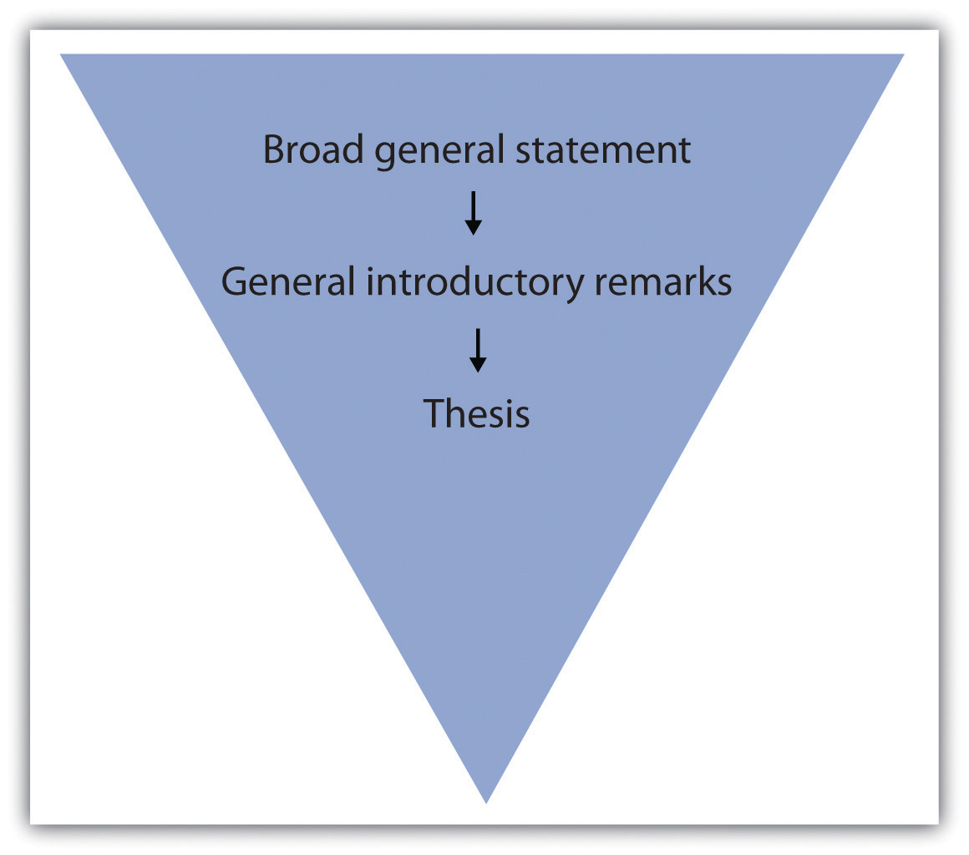

EXERCISE 1
On a separate sheet of paper, jot down a few general remarks that you can make about the topic for which you formed a thesis in Section 9.1 "Developing a Strong, Clear Thesis Statement".
Immediately capturing your readers’ interest increases the chances of having them read what you are about to discuss. You can garner curiosity for your essay in a number of ways. Try to get your readers personally involved by doing any of the following:
- Appealing to their emotions
- Using logic
- Beginning with a provocative question or opinion
- Opening with a startling statistic or surprising fact
- Raising a question or series of questions
- Presenting an explanation or rationalization for your essay
- Opening with a relevant quotation or incident
- Opening with a striking image
- Including a personal anecdote

Tip
Remember that your diction, or word choice, while always important, is most crucial in your introductory paragraph. Boring diction could extinguish any desire a person might have to read through your discussion. Choose words that create images or express action. For more information on diction, see Chapter 4 "Working with Words: Which Word Is Right?".
In Chapter 8 "The Writing Process: How Do I Begin?", you followed Mariah as she moved through the writing process. In this chapter, Mariah writes her introduction and conclusion for the same essay. Mariah incorporates some of the introductory elements into her introductory paragraph, which she previously outlined in Chapter 8 "The Writing Process: How Do I Begin?". Her thesis statement is underlined.
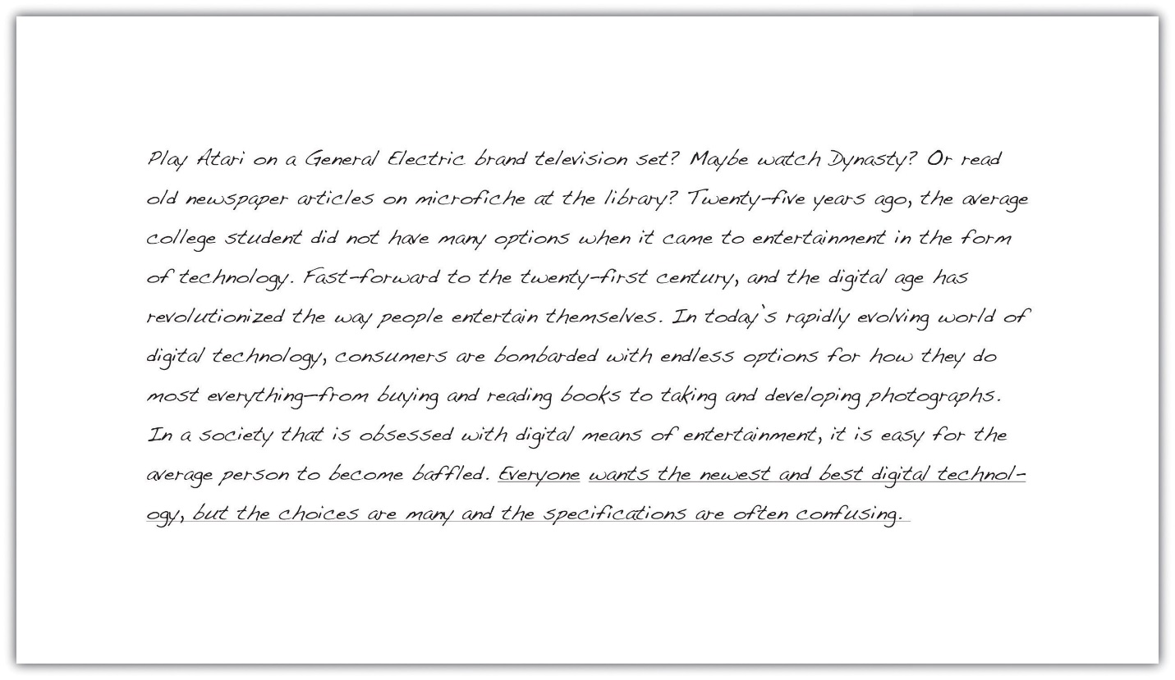

Tip
If you have trouble coming up with a provocative statement for your opening, it is a good idea to use a relevant, attention-grabbing quote about your topic. Use a search engine to find statements made by historical or significant figures about your subject.

Writing at Work
In your job field, you may be required to write a speech for an event, such as an awards banquet or a dedication ceremony. The introduction of a speech is similar to an essay because you have a limited amount of space to attract your audience’s attention. Using the same techniques, such as a provocative quote or an interesting statistic, is an effective way to engage your listeners. Using the funnel approach also introduces your audience to your topic and then presents your main idea in a logical manner.

EXERCISE 2
Reread each sentence in Mariah’s introductory paragraph. Indicate which techniques she used and comment on how each sentence is designed to attract her readers’ interest.

Writing a Conclusion
It is not unusual to want to rush when you approach your conclusion, and even experienced writers may fade. But what good writers remember is that it is vital to put just as much attention into the conclusion as in the rest of the essay. After all, a hasty ending can undermine an otherwise strong essay.
A conclusion that does not correspond to the rest of your essay, has loose ends, or is unorganized can unsettle your readers and raise doubts about the entire essay. However, if you have worked hard to write the introduction and body, your conclusion can often be the most logical part to compose.

The Anatomy of a Strong Conclusion
Keep in mind that the ideas in your conclusion must conform to the rest of your essay. In order to tie these components together, restate your thesis at the beginning of your conclusion. This helps you assemble, in an orderly fashion, all the information you have explained in the body. Repeating your thesis reminds your readers of the major arguments you have been trying to prove and also indicates that your essay is drawing to a close. A strong conclusion also reviews your main points and emphasizes the importance of the topic.
The construction of the conclusion is similar to the introduction, in which you make general introductory statements and then present your thesis. The difference is that in the conclusion you first paraphrase, or state in different words, your thesis and then follow up with general concluding remarks. These sentences should progressively broaden the focus of your thesis and maneuver your readers out of the essay.
Many writers like to end their essays with a final emphatic statement. This strong closing statement will cause your readers to continue thinking about the implications of your essay; it will make your conclusion, and thus your essay, more memorable. Another powerful technique is to challenge your readers to make a change in either their thoughts or their actions. Challenging your readers to see the subject through new eyes is a powerful way to ease yourself and your readers out of the essay.

Tip
When closing your essay, do not expressly state that you are drawing to a close. Relying on statements such as in conclusion, it is clear that, as you can see, or in summation is unnecessary and can be considered trite.

Tip
It is wise to avoid doing any of the following in your conclusion:
- Introducing new material
- Contradicting your thesis
- Changing your thesis
- Using apologies or disclaimers
Introducing new material in your conclusion has an unsettling effect on your reader. When you raise new points, you make your reader want more information, which you could not possibly provide in the limited space of your final paragraph.
Contradicting or changing your thesis statement causes your readers to think that you do not actually have a conviction about your topic. After all, you have spent several paragraphs adhering to a singular point of view. When you change sides or open up your point of view in the conclusion, your reader becomes less inclined to believe your original argument.
By apologizing for your opinion or stating that you know it is tough to digest, you are in fact admitting that even you know what you have discussed is irrelevant or unconvincing. You do not want your readers to feel this way. Effective writers stand by their thesis statement and do not stray from it.

EXERCISE 3
On a separate sheet of a paper, restate your thesis from Note 9.52 "Exercise 2" of this section and then make some general concluding remarks. Next, compose a final emphatic statement. Finally, incorporate what you have written into a strong conclusion paragraph for your essay.
Collaboration
Please share with a classmate and compare your answers
Mariah incorporates some of these pointers into her conclusion. She has paraphrased her thesis statement in the first sentence.
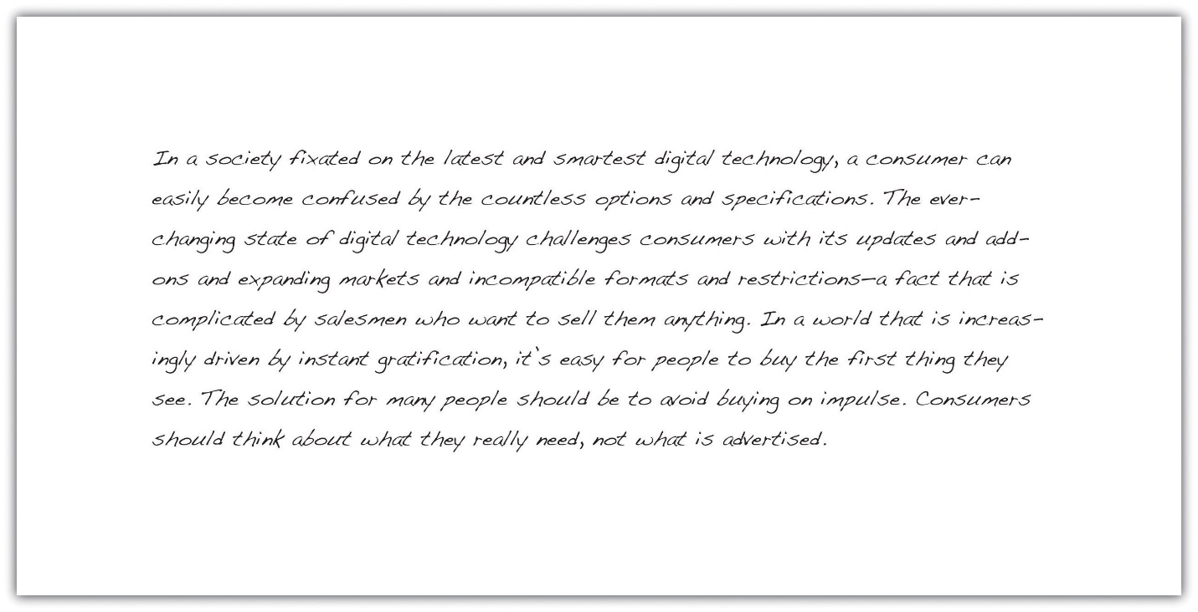

Tip
Make sure your essay is balanced by not having an excessively long or short introduction or conclusion. Check that they match each other in length as closely as possible, and try to mirror the formula you used in each. Parallelism strengthens the message of your essay.

Writing at Work
On the job you will sometimes give oral presentations based on research you have conducted. A concluding statement to an oral report contains the same elements as a written conclusion. You should wrap up your presentation by restating the purpose of the presentation, reviewing its main points, and emphasizing the importance of the material you presented. A strong conclusion will leave a lasting impression on your audience.

KEY TAKEAWAYS
- A strong opening captures your readers’ interest and introduces them to your topic before you present your thesis statement.
- An introduction should restate your thesis, review your main points, and emphasize the importance of the topic.
- The funnel technique to writing the introduction begins with generalities and gradually narrows your focus until you present your thesis.
- A good introduction engages people’s emotions or logic, questions or explains the subject, or provides a striking image or quotation.
- Carefully chosen diction in both the introduction and conclusion prevents any confusing or boring ideas.
- A conclusion that does not connect to the rest of the essay can diminish the effect of your paper.
- The conclusion should remain true to your thesis statement. It is best to avoid changing your tone or your main idea and avoid introducing any new material.
- Closing with a final emphatic statement provides closure for your readers and makes your essay more memorable.
5.3.1: Why You Must Acknowledge Sources Dr. Pavel Zemliansky's "Methods of Discovery: A Guide to Research Writing - Chapter 5: Acknowledging Sources and Avoiding Plagiarism"

Acknowledgment of Sources is a Rhetorical Act
To an inexperienced writer, citing and documenting sources may seem like busywork. Yet, when you cite your external sources in the text of your paper and when you document them at the end of your piece in a list of works cited or a bibliography, you are performing a rhetorical act. Complete and accurate citing and documenting of all external sources help writers achieve three very important goals:
- It enhances your credibility as a writer. By carefully and accurately citing your external sources in the text and by documenting them at the end of your paper you show your readers that you are serious about your subject, your research, and the argument which you are making in your paper. You demonstrate that you have studied your subject in sufficient depth, and by reading credible and authoritative sources.
- It helps you to avoid plagiarism. Plagiarism is trying to pass someone else’s ideas or writing as your own. It is a serious offense that can damage the reputation of a writer forever and lead to very serious consequences if committed in an academic or professional setting. Later on in the chapter, we will discuss plagiarism and ways to avoid it in detail.
- The presence of complete citations of sources in your paper will help you demonstrate to your readers that you are an active participant in the community of readers, writers, researchers, and learners. It shows that you are aware of the conversations that are going on among writers and researchers in your field and that you are willing to enter those conversations by researching and writing about the subjects that interest you. By providing enough information about the sources which you used in you own research and writing, you give other interested readers the opportunity to find out more about your subject and, thus, to enter in a conversation with you.

The Logic and Structure of a Source Citation
Every time writers cite and document their sources, they do it in two places in the paper—in the text itself and at the end of the paper, in a list of works cited or bibliography. A citation is incomplete and, by and large, useless to the readers, if either of the parts is missing. Consider the following example, in which I cite an academic journal article using the Modern Language Association citation system. Please note that I give this example at this point in the chapter only to demonstrate the two parts of a citation. Later on, we will discuss how to cite and document different kinds of sources using different documentation systems, in full detail.

In-text citations
In-text citations are also known as parenthetical citations or parenthetical references because, at the end of the citation, parentheses are used.
In her essay “If Winston Weather Would Just Write to Me on E-mail,” published in the journal College Composition and Communication, writer and teacher Wendy Bishop shares her thoughts on the nature of writing: “[I see…writing as a mixture of mess and self-discipline, of self-history [and] cultural history.” (101).
The Citation in the List of Works Cited
Bishop, Wendy. “If Winston Weather Would Just Write to Me on E-mail.” College Composition and Communication. 46.1 (1995): 97-103.
The reasons why each citation, regardless of the type of source and the documentation system being used has two parts are simple. Writers acknowledge and document external sources for several reasons. One of these reasons is to give their readers enough information and enable them, if necessary, to find the same source which the paper mentions. Therefore, if we look at the kinds of information provided in the citation (page numbers, titles, authors, publishers, and publication dates), it becomes clear that this information is sufficient to locate the source in the library, bookstore, or online.
When to Cite and Document Sources
The brief answer to this question is “always.” Every time you use someone else’s ideas, arguments, opinions, or data, you need to carefully acknowledge their author and source. Keep in mind that you are not just borrowing others’ words when you use sources in your writing. You are borrowing ideas. Therefore, even if you are not directly citing the source, but paraphrase or summarize it, you still need to cite it both in the text and at the end of the paper in a list of works cited or in a list of references.
The only exception is when you are dealing with what is known as “common knowledge.” Common knowledge consists of facts that are so widely known that they do not require a source reference. For instance, if you say in your writing that the Earth rotates around the Sun or that Ronald Reagan was a US President, you do not need to cite the sources of this common knowledge formally.
Avoiding Plagiarism
Plagiarism is a problem that exists not only on college, university, and high school campuses. In recent years, several high profile cases, some involving famous writers and journalists have surfaced, in which the these writers were accused of either presenting someone else work as their own or fabricating works based on fictitious or unreliable research.
With the advent of the Internet, it has become relatively easy to download complete papers. Various people and organizations, sometimes masquerading as “writing consultants” promise students that they would write a paper on any subject and of any level of complexity for a hefty fee. Clearly, the use of such services by student writers is dishonest and dishonorable. If your college or university is like mine, it probably has adopted strict policies for dealing with plagiarizing writers. Punishments for intentional plagiarism are severe and may include not only a failing grade for the class but even an expulsion from the university.
In addition to intentional plagiarism, there is also the unintentional kind. Experience shows that beginning writers’ work sometimes include passages which could be called plagiarized because such writers often do not know how to cite and document external sources properly or do not understand that importance of following proper citation practices.
Observing the following practices will help you avoid plagiarism:
As you research, keep careful notes of your sources. As you take notes for your research project, keep track of what materials in those notes comes from external sources and what material is yours. Keep track of all your sources, including interviews and surveys, photographs and drawings, personal e-mails and conversations. Be sure to record the following information:
- Author
- Title
- Date of publication
- Publisher
Remember that when you use external sources, you are borrowing not the words of another writer, but his or her ideas, theories, and opinions. Therefore, even if you summarize or paraphrase a source, be sure to give it full credit. Writers used to have to record this information on separate note cards. However, with the proliferation of online and other electronic tools which allow us to keep track of our research, the task of recording and reflecting on source-related information has become easier.

Anti-Plagiarism Activity
Read the following four paragraphs. They are from a research source, an article in The New Yorker magazine. The other three are from student papers which attempt to use the article as an external source. As you read consider the following questions:
- Would you call the student’s passage or its parts plagiarized from the original? Why or why not?
- If any parts of the student’s passages are plagiarized what needs to be changed in order to avoid plagiarism? Keep in mind that you may need to rewrite the whole Paragraph and not just make changes in separate sentences.
- Which of the student passages will require more significant rewriting than others and why?
Source Paragraph (from the article “Personality Plus,” by Malcolm Cladwell. New Yorker, Sept 20, 2004).
One of the most popular personality tests in the world is the Myers-Briggs Type Indicator (MBTI), a psychological-assessment system based on Carl Jung’s notion that people make sense of the world through a series or psychological frames. Some people are extraverts, some are introverts. Some process information through logical thought. Some are directed by their feelings. Some make sense of the world through intuitive leaps. Others collect data through their senses.
Student Paragraph 1
The Myers-Briggs Test is a very popular way to assess someone’s personality type. Philosopher Carl Jung believed that people make sense of the world in different ways. Some are extraverts and some and introverts. According to this idea, people process information either by logical reasoning or through intuition or feelings.
Student Paragraph 2
According to writer Malcolm Cladwell, One of the most popular personality tests in the world is the Myers-Briggs Type Indicator (MBTI), a psychological-assessment system based on Carl Jung’s notion that people make sense of the world through a series or psychological frames. Cladwell states that the test is based on the idea by Carl Jung that people make sense of the world through a series of psychological frames. According to Jung, some people are extroverts and some are introverts. Some process information through logical input, and some through feelings. Some make sense of the world through intuitive leaps. Others collect data through their senses.
Student Paragraph 3
One of the most popular personality tests in the world is the Myers-Briggs Type Indicator (MBTI), a psychological-assessment system based on Carl Jung’s notion that people make sense of the world through a series or psychological frames (Cladwell 43). The test is based on Jung’s theory that people understand the world differently. This is why we have extroverts and introverts and people who act either based on reasoning or feelings (Cladwell).

Major Citation Systems
In this part of the chapter, I will explain the major citation and documentation systems which you are likely to encounter in your writing for college classes and beyond. The information in this section is not meant to be memorized. Instead, I encourage you to use this material as a reference source, when you are writing a paper and need to cite and document sources correctly, using one of the systems described below, refer to this chapter.
Please note that the following sections include only the basic information about each of the citation styles. There are plenty of excellent sources explaining and illustrating the differences between citation systems. I recommend the cite of the Online Writing Center at Purdue University.
Conclusion
Avoiding plagiarism and acknowledging your external sources completely and accurately are vital parts of the writing process. Your credibility as a writer and the reception that you work will receive from readers may depend on how well you acknowledge your sources. By following the guidelines presented in this chapter and by seeking out more knowledge about the rules of citing and documenting from the publications listed in this chapter, you will become a more competent, more professional, and more credible writer. This chapter covers only the basics of source citing and documenting. For more resources this topic and the various styles of documentation, see the Appendix to this book.
Last modified: Wednesday, October 21, 2015, 1:03 PM

5.3.2: Acknowledging and Integrating Sources Writing for Success: "Chapter 13, Section 2: Citing and Referencing Techniques"

LEARNING OBJECTIVE
- Apply American Psychological Association (APA) style formatting guidelines for citations.
This section covers the nitty-gritty details of in-text citations. You will learn how to format citations for different types of source materials, whether you are citing brief quotations, paraphrasing ideas, or quoting longer passages. You will also learn techniques you can use to introduce quoted and paraphrased material effectively. Keep this section handy as a reference to consult while writing the body of your paper.

Formatting Cited Material: The Basics
As noted in previous sections of this book, in-text citations usually provide the name of the author(s) and the year the source was published. For direct quotations, the page number must also be included. Use past-tense verbs when introducing a quote—“Smith found…” and not “Smith finds.…”

Formatting Brief Quotations
For brief quotations—fewer than forty words—use quotation marks to indicate where the quoted material begins and ends, and cite the name of the author(s), the year of publication, and the page number where the quotation appears in your source. Remember to include commas to separate elements within the parenthetical citation. Also, avoid redundancy. If you name the author(s) in your sentence, do not repeat the name(s) in your parenthetical citation. Review following the examples of different ways to cite direct quotations.
Chang (2008) emphasized that “engaging in weight-bearing exercise consistently is one of the single best things women can do to maintain good health” (p. 49).
The author’s name can be included in the body of the sentence or in the parenthetical citation. Note that when a parenthetical citation appears at the end of the sentence, it comes after the closing quotation marks and before the period. The elements within parentheses are separated by commas.
Weight Training for Women (Chang, 2008) claimed that “engaging in weight-bearing exercise consistently is one of the single best things women can do to maintain good health” (p. 49).
Weight Training for Women claimed that “engaging in weight-bearing exercise consistently is one of the single best things women can do to maintain good health” (Chang, 2008, p. 49).
Including the title of a source is optional.
In Chang’s 2008 text Weight Training for Women, she asserts, “Engaging in weight-bearing exercise is one of the single best things women can do to maintain good health” (p. 49).
The author’s name, the date, and the title may appear in the body of the text. Include the page number in the parenthetical citation. Also, notice the use of the verb asserts to introduce the direct quotation.
“Engaging in weight-bearing exercise,” Chang asserts, “is one of the single best things women can do to maintain good health” (2008, p. 49).
You may begin a sentence with the direct quotation and add the author’s name and a strong verb before continuing the quotation.

Formatting Paraphrased and Summarized Material
When you paraphrase or summarize ideas from a source, you follow the same guidelines previously provided, except that you are not required to provide the page number where the ideas are located. If you are summing up the main findings of a research article, simply providing the author’s name and publication year may suffice, but if you are paraphrasing a more specific idea, consider including the page number.
Read the following examples.
Chang (2008) pointed out that weight-bearing exercise has many potential benefits for women.
Here, the writer is summarizing a major idea that recurs throughout the source material. No page reference is needed.
Chang (2008) found that weight-bearing exercise could help women maintain or even increase bone density through middle age and beyond, reducing the likelihood that they will develop osteoporosis in later life (p. 86).
Although the writer is not directly quoting the source, this passage paraphrases a specific detail, so the writer chose to include the page number where the information is located.

Tip
Although APA style guidelines do not require writers to provide page numbers for material that is not directly quoted, your instructor may wish you to do so when possible.
Check with your instructor about his or her preferences.

Formatting Longer Quotations
When you quote a longer passage from a source—forty words or more—use a different format to set off the quoted material. Instead of using quotation marks, create a block quotation by starting the quotation on a new line and indented five spaces from the margin. Note that in this case, the parenthetical citation comes after the period that ends the sentence. Here is an example:
In recent years, many writers within the fitness industry have emphasized the ways in which women can benefit from weight-bearing exercise, such as weightlifting, karate, dancing, stair climbing, hiking, and jogging. Chang (2008) found that engaging in weight-bearing exercise regularly significantly reduces women’s risk of developing osteoporosis. Additionally, these exercises help women maintain muscle mass and overall strength, and many common forms of weight-bearing exercise, such as brisk walking or stair climbing, also provide noticeable cardiovascular benefits. (p. 93)

EXERCISE 1
Review the places in your paper where you cited, quoted, and paraphrased material from a source with a single author. Edit your citations to ensure that
- each citation includes the author’s name, the date of publication, and, where appropriate, a page reference;
- parenthetical citations are correctly formatted;
- longer quotations use the block-quotation format.
If you are quoting a passage that continues into a second paragraph, indent five spaces again in the first line of the second paragraph. Here is an example:
In recent years, many writers within the fitness industry have emphasized the ways in which women can benefit from weight-bearing exercise, such as weightlifting, karate, dancing, stair climbing, hiking, and jogging. Chang (2008) found that engaging in weight-bearing exercise regularly significantly reduces women’s risk of developing osteoporosis. Additionally, these exercises help women maintain muscle mass and overall strength, and many common forms of weight-bearing exercise, such as brisk walking or stair climbing, also provide noticeable cardiovascular benefits.
It is important to note that swimming cannot be considered a weight-bearing exercise, since the water supports and cushions the swimmer. That doesn’t mean swimming isn’t great exercise, but it should be considered one part of an integrated fitness program. (p. 93)

Tip
Be wary of quoting from sources at length. Remember, your ideas should drive the paper, and quotations should be used to support and enhance your points. Make sure any lengthy quotations that you include serve a clear purpose. Generally, no more than 10–15 percent of a paper should consist of quoted material.

Introducing Cited Material Effectively
Including an introductory phrase in your text, such as “Jackson wrote” or “Copeland found,” often helps you integrate source material smoothly. This citation technique also helps convey that you are actively engaged with your source material. Unfortunately, during the process of writing your research paper, it is easy to fall into a rut and use the same few dull verbs repeatedly, such as “Jones said,” “Smith stated,” and so on.
Punch up your writing by using strong verbs that help your reader understand how the source material presents ideas. There is a world of difference between an author who “suggests” and one who “claims,” one who “questions” and one who “criticizes.” You do not need to consult your thesaurus every time you cite a source, but do think about which verbs will accurately represent the ideas and make your writing more engaging. The following chart shows some possibilities.
Strong Verbs for Introducing Cited Material
ask | suggest | question
explain | assert | claim
recommend | compare | contrast
propose | hypothesize | believe
insist | argue | find
determine | measure | assess
evaluate | conclude | study
warn | point out | sum up

EXERCISE 2
Review the citations in your paper once again. This time, look for places where you introduced source material using a signal phrase in your sentence.
- Highlight the verbs used in your signal phrases, and make note of any that seem to be overused throughout the paper.
- Identify at least three places where a stronger verb could be used.
- Make the edits to your draft.

Writing at Work
It is important to accurately represent a colleague’s ideas or communications in the workplace. When writing professional or academic papers, be mindful of how the words you use to describe someone’s tone or ideas carry certain connotations. Do not say a source argues a particular point unless an argument is, in fact, presented. Use lively language, but avoid language that is emotionally charged. Doing so will ensure you have represented your colleague’s words in an authentic and accurate way.

Formatting In-Text Citations for Other Source Types
These sections discuss the correct format for various types of in-text citations. Read them through quickly to get a sense of what is covered, and then refer to them again as needed.

Print Sources
This section covers books, articles, and other print sources with one or more authors.

A Work by One Author
For a print work with one author, follow the guidelines provided in Chapter 13 "APA and MLA Documentation and Formatting", Section 13.1 "Formatting a Research Paper". Always include the author’s name and year of publication. Include a page reference whenever you quote a source directly. (See also the guidelines presented earlier in this chapter about when to include a page reference for paraphrased material.)
Chang (2008) emphasized that “engaging in weight-bearing exercise consistently is one of the single best things women can do to maintain good health” (p. 49).
Chang (2008) pointed out that weight-bearing exercise has many potential benefits for women.

Two or More Works by the Same Author
At times, your research may include multiple works by the same author. If the works were published in different years, a standard in-text citation will serve to distinguish them. If you are citing multiple works by the same author published in the same year, include a lowercase letter immediately after the year. Rank the sources in the order they appear in your references section. The source listed first includes an a after the year, the source listed second includes a b, and so on.
Rodriguez (2009a) criticized the nutrition-supplement industry for making unsubstantiated and sometimes misleading claims about the benefits of taking supplements. Additionally, he warned that consumers frequently do not realize the potential harmful effects of some popular supplements (Rodriguez, 2009b).

Tip
If you have not yet created your references section, you may not be sure which source will appear first. See Chapter 13 "APA and MLA Documentation and Formatting", Section 13.3 "Creating a References Section" for guidelines—or assign each source a temporary code and highlight the in-text citations so you remember to double-check them later on.

Works by Authors with the Same Last Name
If you are citing works by different authors with the same last name, include each author’s initials in your citation, whether you mention them in the text or in parentheses. Do so even if the publication years are different.
J. S. Williams (2007) believes nutritional supplements can be a useful part of some diet and fitness regimens. C. D. Williams (2008), however, believes these supplements are overrated.
According to two leading researchers, the rate of childhood obesity exceeds the rate of adult obesity (K. Connelley, 2010; O. Connelley, 2010).
Studies from both A. Wright (2007) and C. A. Wright (2008) confirm the benefits of diet and exercise on weight loss.

A Work by Two Authors
When two authors are listed for a given work, include both authors’ names each time you cite the work. If you are citing their names in parentheses, use an ampersand (&) between them. (Use the word and, however, if the names appear in your sentence.)
As Garrison and Gould (2010) pointed out, “It is never too late to quit smoking. The health risks associated with this habit begin to decrease soon after a smoker quits” (p. 101).
As doctors continue to point out, “It is never too late to quit smoking. The health risks associated with this habit begin to decrease soon after a smoker quits” (Garrison & Gould, 2010, p. 101).

A Work by Three to Five Authors
If the work you are citing has three to five authors, list all the authors’ names the first time you cite the source. In subsequent citations, use the first author’s name followed by the abbreviation et al. (Et al. is short for et alia, the Latin phrase for “and others.”)
Henderson, Davidian, and Degler (2010) surveyed 350 smokers aged 18 to 30.
One survey, conducted among 350 smokers aged 18 to 30, included a detailed questionnaire about participants’ motivations for smoking (Henderson, Davidian, & Degler, 2010).
Note that these examples follow the same ampersand conventions as sources with two authors. Again, use the ampersand only when listing authors’ names in parentheses.
As Henderson et al. (2010) found, some young people, particularly young women, use smoking as a means of appetite suppression.
Disturbingly, some young women use smoking as a means of appetite suppression (Henderson et al., 2010).
Note how the phrase et al. is punctuated. No period comes after et, but al. gets a period because it is an abbreviation for a longer Latin word. In parenthetical references, include a comma after et al. but not before. Remember this rule by mentally translating the citation to English: “Henderson and others, 2010.”

A Work by Six or More Authors
If the work you are citing has six or more authors, list only the first author’s name, followed by et al., in your in-text citations. The other authors’ names will be listed in your references section.
Researchers have found that outreach work with young people has helped reduce tobacco use in some communities (Costello et al., 2007).

A Work Authored by an Organization
When citing a work that has no individual author(s) but is published by an organization, use the organization’s name in place of the author’s name. Lengthy organization names with well-known abbreviations can be abbreviated. In your first citation, use the full name, followed by the abbreviation in square brackets. Subsequent citations may use the abbreviation only.
It is possible for a patient to have a small stroke without even realizing it (American Heart Association [AHA], 2010).
Another cause for concern is that even if patients realize that they have had a stroke and need medical attention, they may not know which nearby facilities are best equipped to treat them (AHA, 2010).

EXERCISE 3
- Review the places in your paper where you cited material from a source with multiple authors or with an organization as the author. Edit your citations to ensure that each citation follows APA guidelines for the inclusion of the authors’ names, the use of ampersands and et al., the date of publication, and, where appropriate, a page reference.
- Mark any additional citations within your paper that you are not sure how to format based on the guidelines provided so far. You will revisit these citations after reading the next few sections.

A Work with No Listed Author
If no author is listed and the source cannot be attributed to an organization, use the title in place of the author’s name. You may use the full title in your sentence or use the first few words—enough to convey the key ideas—in a parenthetical reference. Follow standard conventions for using italics or quotations marks with titles:
- Use italics for titles of books or reports.
- Use quotation marks for titles of articles or chapters.
“Living With Diabetes: Managing Your Health” (2009) recommends regular exercise for patients with diabetes.
Regular exercise can benefit patients with diabetes (“Living with Diabetes,” 2009).
Rosenhan (1973) had mentally healthy study participants claim to be experiencing hallucinations so they would be admitted to psychiatric hospitals.

A Work Cited within Another Work
To cite a source that is referred to within another secondary source, name the first source in your sentence. Then, in parentheses, use the phrase as cited in and the name of the second source author.
Rosenhan’s study “On Being Sane in Insane Places” (as cited in Spitzer, 1975) found that psychiatrists diagnosed schizophrenia in people who claimed to be experiencing hallucinations and sought treatment—even though these patients were, in fact, imposters.

Two or More Works Cited in One Reference
At times, you may provide more than one citation in a parenthetical reference, such as when you are discussing related works or studies with similar results. List the citations in the same order they appear in your references section, and separate the citations with a semicolon.
Some researchers have found serious flaws in the way Rosenhan’s study was conducted (Dawes, 2001; Spitzer, 1975).
Both of these researchers authored works that support the point being made in this sentence, so it makes sense to include both in the same citation.

A Famous Text Published in Multiple Editions
In some cases, you may need to cite an extremely well-known work that has been repeatedly republished or translated. Many works of literature and sacred texts, as well as some classic nonfiction texts, fall into this category. For these works, the original date of publication may be unavailable. If so, include the year of publication or translation for your edition. Refer to specific parts or chapters if you need to cite a specific section. Discuss with your instructor whether he or she would like you to cite page numbers in this particular instance.
In New Introductory Lectures on Psycho-Analysis, Freud explains that the “manifest content” of a dream—what literally takes place—is separate from its “latent content,” or hidden meaning (trans. 1965, lecture XXIX).
Here, the student is citing a classic work of psychology, originally written in German and later translated to English. Since the book is a collection of Freud’s lectures, the student cites the lecture number rather than a page number.

An Introduction, Foreword, Preface, or Afterword
To cite an introduction, foreword, preface, or afterword, cite the author of the material and the year, following the same format used for other print materials.

Electronic Sources
Whenever possible, cite electronic sources as you would print sources, using the author, the date, and where appropriate, a page number. For some types of electronic sources—for instance, many online articles—this information is easily available. Other times, however, you will need to vary the format to reflect the differences in online media.

Online Sources without Page Numbers
If an online source has no page numbers but you want to refer to a specific portion of the source, try to locate other information you can use to direct your reader to the information cited. Some websites number paragraphs within published articles; if so, include the paragraph number in your citation. Precede the paragraph number with the abbreviation for the word paragraph and the number of the paragraph (e.g., para. 4).
As researchers have explained, “Incorporating fresh fruits and vegetables into one’s diet can be a challenge for residents of areas where there are few or no easily accessible supermarkets” (Smith & Jones, 2006, para. 4).
Even if a source does not have numbered paragraphs, it is likely to have headings that organize the content. In your citation, name the section where your cited information appears, followed by a paragraph number.
The American Lung Association (2010) noted, “After smoking, radon exposure is the second most common cause of lung cancer” (What Causes Lung Cancer? section, para. 2).
This student cited the appropriate section heading within the website and then counted to find the specific paragraph where the cited information was located.
If an online source has no listed author and no date, use the source title and the abbreviation n.d. in your parenthetical reference.
It has been suggested that electromagnetic radiation from cellular telephones may pose a risk for developing certain cancers (“Cell Phones and Cancer,” n.d.).

Personal Communication
For personal communications, such as interviews, letters, and e-mails, cite the name of the person involved, clarify that the material is from a personal communication, and provide the specific date the communication took place. Note that while in-text citations correspond to entries in the references section, personal communications are an exception to this rule. They are cited only in the body text of your paper.
J. H. Yardley, M.D., believes that available information on the relationship between cell phone use and cancer is inconclusive (personal communication, May 1, 2009).

Writing at Work
At work, you may sometimes share information resources with your colleagues by photocopying an interesting article or forwarding the URL of a useful website. Your goal in these situations and in formal research citations is the same. The goal is to provide enough information to help your professional peers locate and follow up on potentially useful information. Provide as much specific information as possible to achieve that goal, and consult with your professor as to what specific style he or she may prefer.

EXERCISE 4
Revisit the problem citations you identified in Note 13.55 "Exercise 3"—for instance, sources with no listed author or other oddities. Review the guidelines provided in this section and edit your citations for these kinds of sources according to APA guidelines.

KEY TAKEAWAYS
- In APA papers, in-text citations include the name of the author(s) and the year of publication whenever possible.
- Page numbers are always included when citing quotations. It is optional to include page numbers when citing paraphrased material; however, this should be done when citing a specific portion of a work.
- When citing online sources, provide the same information used for print sources if it is available.
- When a source does not provide information that usually appears in a citation, in-text citations should provide readers with alternative information that would help them locate the source material. This may include the title of the source, section headings and paragraph numbers for websites, and so forth.
- When writing a paper, discuss with your professor what particular standards he or she would like you to follow.
5.3.3: Avoiding Plagiarism Pennsylvania State University: Joe Schaal's "How Plagiarism Occurs"
To discuss professionalism and writing, we should begin with the most obvious problem: plagiarism. Outright plagiarism is always a serious offense, and, when professors forgive it, it is usually because they see it as a terribly dumb and desperate act. In a composition class that I taught, I once had a foolish student plagiarize from someone in the same section (then he was surprised that I noticed—duh), and in the hallways I have heard students talk about “getting away with” blatant plagiarism on papers. Further, there are ample websites (I will not supply their URLs here, natch) where lazy students can download ready-made papers and turn them in for their classes. (Savvy professors can track down these papers readily, of course, perhaps by submitting a suspicious paper to http://turnitin.com/, [1] a website devoted to helping teachers check submitted papers for originality.)
However, as a writing tutor for 20 years I discussed this issue almost daily with students, and I am convinced that many students plagiarize “accidentally”—that is, they fail to cite information they took from a source because they quickly, if tentatively, assess that the information they chose resides in a “gray area,” and thus it might not need to be cited. They reason, “Why bother if I’m unsure?”, or “Why risk doing it poorly?” Further, students frequently oversimplify this issue by rationalizing that the information appeared in an encyclopedia or in several books and therefore it need not be cited. In one case, I had a student say to me, “If it’s on the internet, by definition, it’s common knowledge, and therefore I don’t have to cite it.” Such thinking causes me pain.
What such writers must realize is that one’s use and citation of sources has to be both reflective and discerning. The quality and context of your sources matter just as much as their content, and you are obliged always to assess that quality and consider whether and how best to establish that context. Your readers—especially your professors—will naturally be assessing quality and context in the act of reading, and they will expect you to have done the same. When using web-based sources, the responsibility to cite your material conscientiously remains, and in fact your responsibility to assess the credibility of the information increases simply because the material did in fact appear on the web. Further, if you see in-text citation of sources as a final, merely trivial step to writing rather than as an integral part, you are bound to slip up somewhere in your citation practice or lose track of the relationship between your own ideas and those of your sources. I am always surprised at the number of students who sit down with me to review a “complete” paper draft, yet with no sources cited. “Oh, I do that last,” they say, then during our tutorials we invariably encounter problems that can only be reconciled by a better handling of source material. Stated simply, using sources well in your paper is not a matter of mere mechanics; it is the art of blending source material within the context of a focused argument as you write.
Unfortunately, the norm for many students is that they spend hours unreflectively surfing the web with an overly broad research focus, or they quickly Xerox anything that looks relevant in the library, then, 24 or 12 hours before the deadline, they sit down and start tapping madly into the word processor, sometimes simply lifting whole paragraphs from their sources and hoping that it looks like their own work, loudly assuring themselves and their friends that they “work best under pressure.” If this is your technique, you will find that it fails you miserably when it comes to writing a thesis or working on a lengthy writing project on the job. Writing a long research paper in a day is a bit like pulling an all-nighter on Christmas Eve to crochet a quilt—the end product looks hurried and flimsy, and you can be sure that you have left many loose ends and produced a lousy Christmas gift.
Last modified: Wednesday, October 21, 2015, 1:10 PM
5.3.3.1: Documenting to Avoid Plagiarism Pennsylvania State University: Joe Schall's "Anatomy of a Well-Cited Paragraph"
Writing a paragraph with the sources properly cited can seem a tricky task at first, but the process is straightforward enough, especially when we analyze an example. Writing a sound paragraph is really just a matter of thinking clearly about a topic you have researched and transferring that thinking to the page. To illustrate, a tidy sample paragraph follows, with the sources properly documented in the author-year system. Next, the genesis of the paragraph is analyzed.
The millions of species of plants and animals on the earth have a phenomenal influence on the human species. Not only do they provide a substantial amount of our food, they are of great value in medicine and science. Over 60 percent of the purchases we make at the pharmacy contain substances that are derived from wild organisms (Myers 2008). Studies of plants and animals have led to discoveries in virtually all of the sciences, from biology and chemistry to psychology and astronomy (Wilson 2001). Furthermore, plants and animals are vital to the maintenance of our ecosystem. Their diversity and balance directly control food webs, nutrient diversity, supplies of fresh water, climate consistency, and waste disposal (Eberly 1988). Finally, many species act as barometers of our environment. The salmon, for example, is extremely sensitive to changes in the condition of the water in which it lives. Any abnormality in population or behavior of fish usually indicates some type of chemical imbalance in the water. The same is true of butterflies and their responses to the environment within prominent agricultural areas. Clearly, the millions of species of plants and animals in the world are vital to the continued thriving of the human population.
Now let’s walk through the paragraph and its use of sources. The first two sentences assert the author’s personal view about the value of the world’s species (a view shaped by his research, no doubt), which he is about to back up by using three recent sources. Next, the author cites a journal article (Myers) from which he extracted a statistic (“over 60 percent of the purchases we make at the pharmacy”). Without this source cited, the reader might believe that the author estimated loosely or simply relied on his memory for the statistic. The next source (Wilson) is cited because the paper author borrowed a general claim from a textbook by Wilson. The author was at first not sure whether to cite the source, but he wisely decided that he should because he realized that he had in fact had Wilson’s book open to a particular page and referred to it as he wrote the sentence. The next source (Eberly) is cited because the author had browsed through a whole chapter of Eberly’s book in order to compose the list in the sentence, usually using Eberly’s exact section headings from the chapter as the list members. The final examples of the salmon and the butterfly were based directly on the author’s personal experience of working at a fish hatchery for a summer, so documenting sources was not an issue. The fact that the author finds a way to tie this experiential knowledge in with his research is testimony to the fact that he is thinking as he writes the paragraph. He blends his sources, but he does not allow them to do the thinking for him. More evidence of the author’s control over his material resides in his transparent mid-paragraph transition sentence (beginning with “Furthermore”), his labeling of species as “barometers” of the environment a few sentences later, and his closing sentence, which wraps up the paragraph’s ideas neatly by making an affirmative and confident statement that backs up his topic sentence and examples.
Not every paragraph should look exactly like this, of course, but every paragraph should be written with the same kind of conscientiousness about how, when, and why the sources are cited.
Last modified: Wednesday, October 21, 2015, 1:25 PM

5.3.3.2: When Sources Must Be Cited Pennsylvania State University: Joe Schall's "When Sources Must Be Cited"
Information that always must be cited—whether web-based or print-based—includes:
- Quotations, opinions, and predictions, whether directly quoted or paraphrased.
- Statistics derived by the original author.
- Visuals in the original.
- Another author’s theories.
- Case studies.
- Another author’s direct experimental methods or results.
- Another author’s specialized research procedures or findings.
If you use specific information of the type just mentioned, document it; otherwise you could be plagiarizing. Better safe than lazy. By citing the source of your information you point to an authority rather than ask your reader to trust your memory or what might appear to be your own idea. Even though you can recall a statistic or a description of a process, for example, citation of such information—if it came directly from a source—gives more credibility to your writing and underscores the accuracy, timeliness, and even the potential bias of your information. In short, be honest, smart, and safe.
Last modified: Wednesday, October 21, 2015, 1:24 PM

5.3.4: Frequently Asked Questions about Citing Sources Pennsylvania State University: Joe Schall's "FAQs about Citing Sources"
Q: Suppose I can’t determine the author of a source, should I just cite “Anonymous”?
A: This is an outmoded practice. If no author is listed but an affiliated organization is given, consider the name of that organization to be the source, both in-text and on the references page.
Q: What if I can’t find either author or year? May I cite the source in-text just by its title?
A: Typically, yes. Supply the title (or a shortened form of it) in-text in quotation marks, then give fuller bibliographic information on the references page.
Q: When citing web sources, should I give the URL within the text itself?
A: No—this is non-standard and, frankly, comes off as pretty lame. Provide the URL on the references page, but handle the in-text citation as you would any other, providing author-year or source number. Unless the nature of the source as being web-based is highly relevant to context, the reader in the act of reading should be virtually unaware (no pun intended) that you are using a web source. Never attempt an in-text citation with something as informal and downright silly as “According to the internet . . .”
Q: Suppose a web page has nothing but a title on it, and I have no idea who authored it?
A: Then you would provide only that information available, in particular the URL and the date accessed, on your references page. As always, be sure to carefully assess the page’s quality and credibility too.
Q: What about information obtained verbally from a credible source?
A: In-text, handle the citation as you normally would, giving author-year or source number; on the references page, follow the person’s name with his or her title or affiliation (you could even supply the party’s mailing address), then the words “personal communication.”
Q: What if I’m citing e-mail, or a newsgroup, or a gopher site, or a CD-ROM? How do I handle this on the references page?
A: For such specialized concerns, you need to consult a more specific style guide. Online, I can recommend online! a reference guide to using internet sources. [1]
Q: I’m trying to return to a page I visited last week, and I get error messages. How do I find it?
A: After rechecking your typing, try truncating a portion of the URL. Cutting off the end of the address frequently takes you back to the page’s author and you can try relocating from there. Of course, the page might indeed be gone, entirely eliminated from cyberspace.
Q: How important is a small detail such as punctuation on my references page?
A: Consistency within your document is what matters. Professors rarely deduct points over such small issues, but they do expect you to pay close attention to them and be consistent in your practices.
Q: Suppose I’m citing an author who cited someone else? Do I cite the original author or just the one I read?
A: You should only formally cite the author that you actually read, although a narrative mention of the other source within an in-text sentence is often appropriate. For example: “Kunkle (2001) reports that a 1998 study by Edmund Eberly revealed . . .” Of course, if time permits and the circumstances suggest you should, you might try to track down the original source and interpret it for yourself.
Q: Are footnotes “in” or “out”?
A: They’re definitely “out.” Try to avoid them. Journals rarely use them, preferring an endnotes page with explanatory notes at the end of the text. Even this practice is rare except in scholarly works, where the author chooses to offer explanatory side discussions.
Q: What’s the difference between a references page and a bibliography?
A: A references page contains only those references that were directly cited in the text. A bibliography page is more of a reading list—it contains references referred to in the text plus the chief publications that you consulted in a general way. Some people—even some professors—use the two terms loosely and interchangeably, but journals tend to follow the distinction I just provided.
Q: What if I can’t find a source in the library, but the computer tells me it’s on the shelves?
A: Ask a librarian (this answer applies to questions I haven’t listed here as well). My experience is that most librarians are terribly helpful and kind to serious, respectful students.
Q: I’m old-fashioned and I still believe in books, so can you recommend some print resources to answer specific questions about citing web sources?
A: Good for you. I highly recommend Electronic Style: A Guide to Citing Electronic Information [2], by Xia Li and Nancy B. Crane. Also, the most modern library editions of major style guides (The MLA Style Manual and Guide to Scholarly Publishing [3]; The Chicago Manual of Style [4]) have thorough information and discussion on citing web sources.
Last modified: Wednesday, October 21, 2015, 3:24 PM

UNIT SIX: Polishing Your Research Paper
6.1: Review, Revise, and Finalize Research Paper Writing for Success: "Chapter 8, Section 4: Revising and Editing"

LEARNING OBJECTIVES
- Identify major areas of concern in the draft essay during revising and editing.
- Use peer reviews and editing checklists to assist revising and editing.
- Revise and edit the first draft of your essay and produce a final draft.
Revising and editing are the two tasks you undertake to significantly improve your essay. Both are very important elements of the writing process. You may think that a completed first draft means little improvement is needed. However, even experienced writers need to improve their drafts and rely on peers during revising and editing. You may know that athletes miss catches, fumble balls, or overshoot goals. Dancers forget steps, turn too slowly, or miss beats. For both athletes and dancers, the more they practice, the stronger their performance will become. Web designers seek better images, a more clever design, or a more appealing background for their web pages. Writing has the same capacity to profit from improvement and revision.

Understanding the Purpose of Revising and Editing
Revising and editing allow you to examine two important aspects of your writing separately, so that you can give each task your undivided attention.
- When you revise, you take a second look at your ideas. You might add, cut, move, or change information in order to make your ideas clearer, more accurate, more interesting, or more convincing.
- When you edit, you take a second look at how you expressed your ideas. You add or change words. You fix any problems in grammar, punctuation, and sentence structure. You improve your writing style. You make your essay into a polished, mature piece of writing, the end product of your best efforts.

Tip
How do you get the best out of your revisions and editing? Here are some strategies that writers have developed to look at their first drafts from a fresh perspective. Try them over the course of this semester; then keep using the ones that bring results.
- Take a break. You are proud of what you wrote, but you might be too close to it to make changes. Set aside your writing for a few hours or even a day until you can look at it objectively.
- Ask someone you trust for feedback and constructive criticism.
- Pretend you are one of your readers. Are you satisfied or dissatisfied? Why?
- Use the resources that your college provides. Find out where your school’s writing lab is located and ask about the assistance they provide online and in person.
Many people hear the words critic, critical, and criticism and pick up only negative vibes that provoke feelings that make them blush, grumble, or shout. However, as a writer and a thinker, you need to learn to be critical of yourself in a positive way and have high expectations for your work. You also need to train your eye and trust your ability to fix what needs fixing. For this, you need to teach yourself where to look.

Creating Unity and Coherence
Following your outline closely offers you a reasonable guarantee that your writing will stay on purpose and not drift away from the controlling idea. However, when writers are rushed, are tired, or cannot find the right words, their writing may become less than they want it to be. Their writing may no longer be clear and concise, and they may be adding information that is not needed to develop the main idea.
When a piece of writing has unity, all the ideas in each paragraph and in the entire essay clearly belong and are arranged in an order that makes logical sense. When the writing has coherence, the ideas flow smoothly. The wording clearly indicates how one idea leads to another within a paragraph and from paragraph to paragraph.

Tip
Reading your writing aloud will often help you find problems with unity and coherence. Listen for the clarity and flow of your ideas. Identify places where you find yourself confused, and write a note to yourself about possible fixes.

Creating Unity
Sometimes writers get caught up in the moment and cannot resist a good digression. Even though you might enjoy such detours when you chat with friends, unplanned digressions usually harm a piece of writing.
Mariah stayed close to her outline when she drafted the three body paragraphs of her essay she tentatively titled “Digital Technology: The Newest and the Best at What Price?” But a recent shopping trip for an HDTV upset her enough that she digressed from the main topic of her third paragraph and included comments about the sales staff at the electronics store she visited. When she revised her essay, she deleted the off-topic sentences that affected the unity of the paragraph.
Read the following paragraph twice, the first time without Mariah’s changes, and the second time with them.
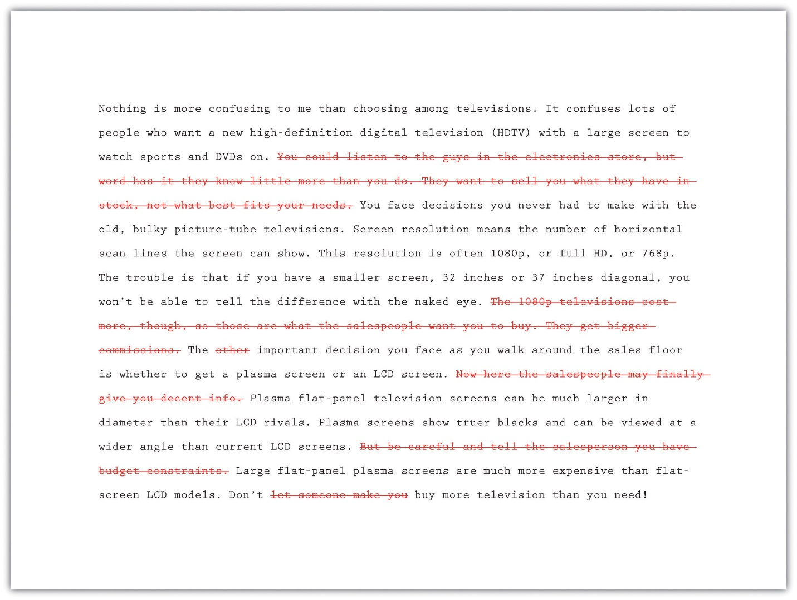

EXERCISE 1
- Answer the following two questions about Mariah’s paragraph:
  - Do you agree with Mariah’s decision to make the deletions she made? Did she cut too much, too little, or just enough? Explain.
  - Is the explanation of what screen resolution means a digression? Or is it audience friendly and essential to understanding the paragraph? Explain.
Collaboration
Please share with a classmate and compare your answers.
- Now start to revise the first draft of the essay you wrote in Section 8 "Writing Your Own First Draft". Reread it to find any statements that affect the unity of your writing. Decide how best to revise.

Tip
When you reread your writing to find revisions to make, look for each type of problem in a separate sweep. Read it straight through once to locate any problems with unity. Read it straight through a second time to find problems with coherence. You may follow this same practice during many stages of the writing process.

Writing at Work
Many companies hire copyeditors and proofreaders to help them produce the cleanest possible final drafts of large writing projects. Copyeditors are responsible for suggesting revisions and style changes; proofreaders check documents for any errors in capitalization, spelling, and punctuation that have crept in. Many times, these tasks are done on a freelance basis, with one freelancer working for a variety of clients.

Creating Coherence
Careful writers use transitions to clarify how the ideas in their sentences and paragraphs are related. These words and phrases help the writing flow smoothly. Adding transitions is not the only way to improve coherence, but they are often useful and give a mature feel to your essays. Table 8.3 "Common Transitional Words and Phrases" groups many common transitions according to their purpose.
Table 8.3 Common Transitional Words and Phrases
Transitions That Show Sequence or Time
after | before | later
afterward | before long | meanwhile
as soon as | finally | next
at first | first, second, third | soon
at last | in the first place | then
Transitions That Show Position
above | across | at the bottom
at the top | behind | below
beside | beyond | inside
near | next to | opposite
to the left, to the right, to the side | under | where
Transitions That Show a Conclusion
indeed | hence | in conclusion
in the final analysis | therefore | thus
Transitions That Continue a Line of Thought
consequently | furthermore | additionally
because | besides the fact | following this idea further
in addition | in the same way | moreover
looking further | considering…, it is clear that
Transitions That Change a Line of Thought
but | yet | however
nevertheless | on the contrary | on the other hand
Transitions That Show Importance
above all | best | especially
in fact | more important | most important
most | worst
Transitions That Introduce the Final Thoughts in a Paragraph or Essay
finally | last | in conclusion
most of all | least of all | last of all
All-Purpose Transitions to Open Paragraphs or to Connect Ideas Inside Paragraphs
admittedly | at this point | certainly
granted | it is true | generally speaking
in general | in this situation | no doubt
no one denies | obviously | of course
to be sure | undoubtedly | unquestionably
Transitions that Introduce Examples
for instance | for example
Transitions That Clarify the Order of Events or Steps
first, second, third | generally, furthermore, finally | in the first place, also, last
in the first place, furthermore, finally | in the first place, likewise, lastly
After Maria revised for unity, she next examined her paragraph about televisions to check for coherence. She looked for places where she needed to add a transition or perhaps reword the text to make the flow of ideas clear. In the version that follows, she has already deleted the sentences that were off topic.

Tip
Many writers make their revisions on a printed copy and then transfer them to the version on-screen. They conventionally use a small arrow called a caret (^) to show where to insert an addition or correction.
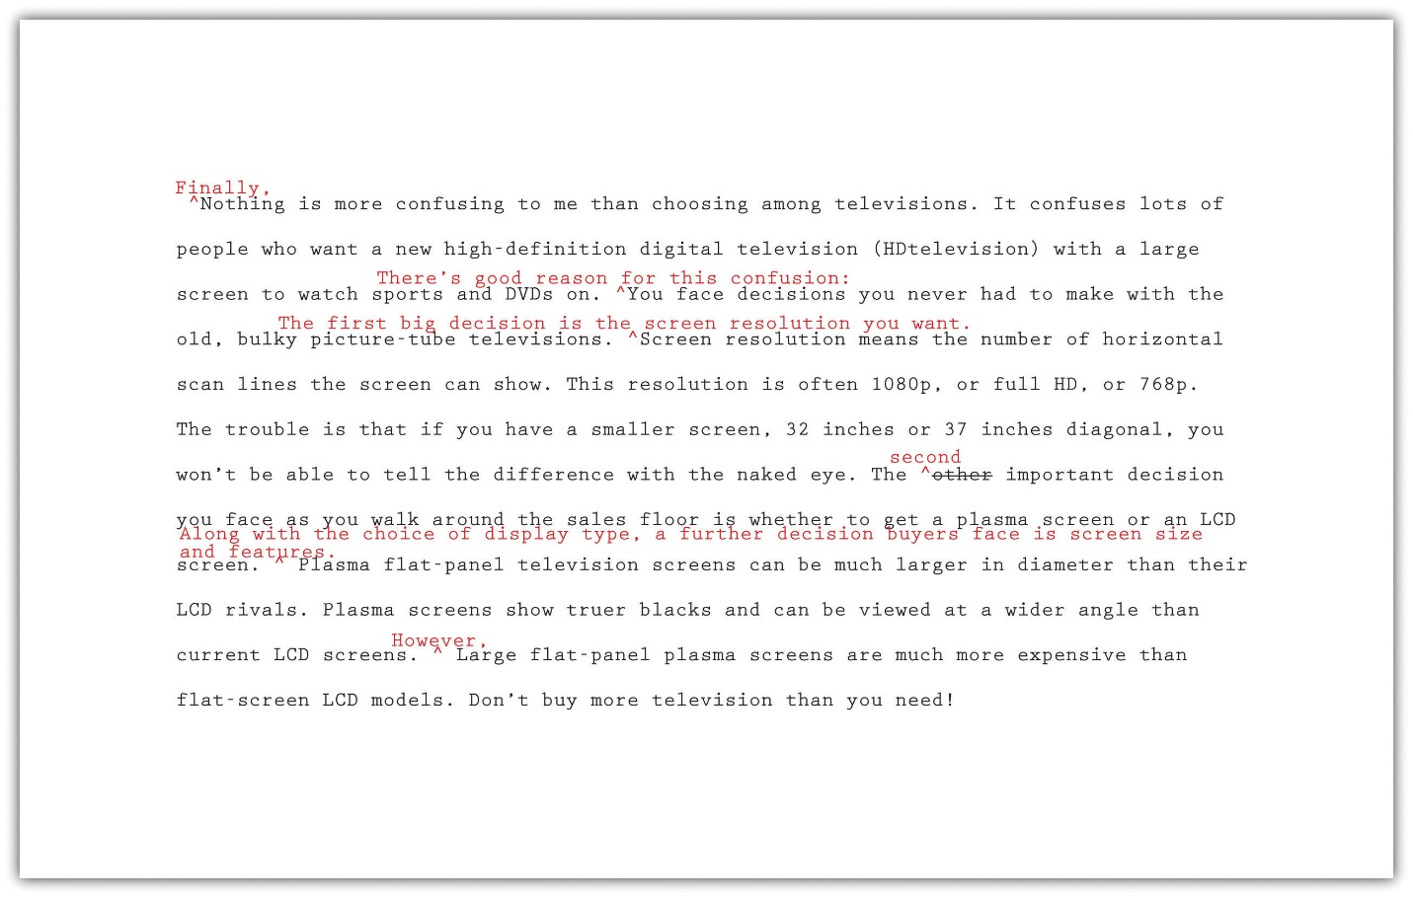

EXERCISE 2
- Answer the following questions about Mariah’s revised paragraph.
  - Do you agree with the transitions and other changes that Mariah made to her paragraph? Which would you keep and which were unnecessary? Explain.
  - What transition words or phrases did Mariah add to her paragraph? Why did she choose each one?
  - What effect does adding additional sentences have on the coherence of the paragraph? Explain. When you read both versions aloud, which version has a more logical flow of ideas? Explain.
- Now return to the first draft of the essay you wrote in Section 8 "Writing Your Own First Draft" and revise it for coherence. Add transition words and phrases where they are needed, and make any other changes that are needed to improve the flow and connection between ideas.

Being Clear and Concise
Some writers are very methodical and painstaking when they write a first draft. Other writers unleash a lot of words in order to get out all that they feel they need to say. Do either of these composing styles match your style? Or is your composing style somewhere in between? No matter which description best fits you, the first draft of almost every piece of writing, no matter its author, can be made clearer and more concise.
If you have a tendency to write too much, you will need to look for unnecessary words. If you have a tendency to be vague or imprecise in your wording, you will need to find specific words to replace any overly general language.

Identifying Wordiness
Sometimes writers use too many words when fewer words will appeal more to their audience and better fit their purpose. Here are some common examples of wordiness to look for in your draft. Eliminating wordiness helps all readers, because it makes your ideas clear, direct, and straightforward.
- Sentences that begin with There is or There are.
Wordy: There are two major experiments that the Biology Department sponsors.
Revised: The Biology Department sponsors two major experiments.
- Sentences with unnecessary modifiers.
Wordy: Two extremely famous and well-known consumer advocates spoke eloquently in favor of the proposed important legislation.
Revised: Two well-known consumer advocates spoke in favor of the proposed legislation.
- Sentences with deadwood phrases that add little to the meaning. Be judicious when you use phrases such as in terms of, with a mind to, on the subject of, as to whether or not, more or less, as far as…is concerned, and similar expressions. You can usually find a more straightforward way to state your point.
Wordy: As a world leader in the field of green technology, the company plans to focus its efforts in the area of geothermal energy.
A report as to whether or not to use geysers as an energy source is in the process of preparation.
Revised: As a world leader in green technology, the company plans to focus on geothermal energy.
A report about using geysers as an energy source is in preparation.
- Sentences in the passive voice or with forms of the verb to be. Sentences with passive-voice verbs often create confusion, because the subject of the sentence does not perform an action. Sentences are clearer when the subject of the sentence performs the action and is followed by a strong verb. Use strong active-voice verbs in place of forms of to be, which can lead to wordiness. Avoid passive voice when you can.
Wordy: It might perhaps be said that using a GPS device is something that is a benefit to drivers who have a poor sense of direction.
Revised: Using a GPS device benefits drivers who have a poor sense of direction.
- Sentences with constructions that can be shortened.
Wordy: The e-book reader, which is a recent invention, may become as commonplace as the cell phone.
My over-sixty uncle bought an e-book reader, and his wife bought an e-book reader, too.
Revised: The e-book reader, a recent invention, may become as commonplace as the cell phone.
My over-sixty uncle and his wife both bought e-book readers.

EXERCISE 3
Now return once more to the first draft of the essay you have been revising. Check it for unnecessary words. Try making your sentences as concise as they can be.

Choosing Specific, Appropriate Words
Most college essays should be written in formal English suitable for an academic situation. Follow these principles to be sure that your word choice is appropriate. For more information about word choice, see Chapter 4 "Working with Words: Which Word Is Right?".
- Avoid slang. Find alternatives to bummer, kewl, and rad.
- Avoid language that is overly casual. Write about “men and women” rather than “girls and guys” unless you are trying to create a specific effect. A formal tone calls for formal language.
- Avoid contractions. Use do not in place of don’t, I am in place of I’m, have not in place of haven’t, and so on. Contractions are considered casual speech.
- Avoid clichés. Overused expressions such as green with envy, face the music, better late than never, and similar expressions are empty of meaning and may not appeal to your audience.
- Be careful when you use words that sound alike but have different meanings. Some examples are allusion/illusion, complement/compliment, council/counsel, concurrent/consecutive, founder/flounder, and historic/historical. When in doubt, check a dictionary.
- Choose words with the connotations you want. Choosing a word for its connotations is as important in formal essay writing as it is in all kinds of writing. Compare the positive connotations of the word proud and the negative connotations of arrogant and conceited.
- Use specific words rather than overly general words. Find synonyms for thing, people, nice, good, bad, interesting, and other vague words. Or use specific details to make your exact meaning clear.
Now read the revisions Mariah made to make her third paragraph clearer and more concise. She has already incorporated the changes she made to improve unity and coherence.
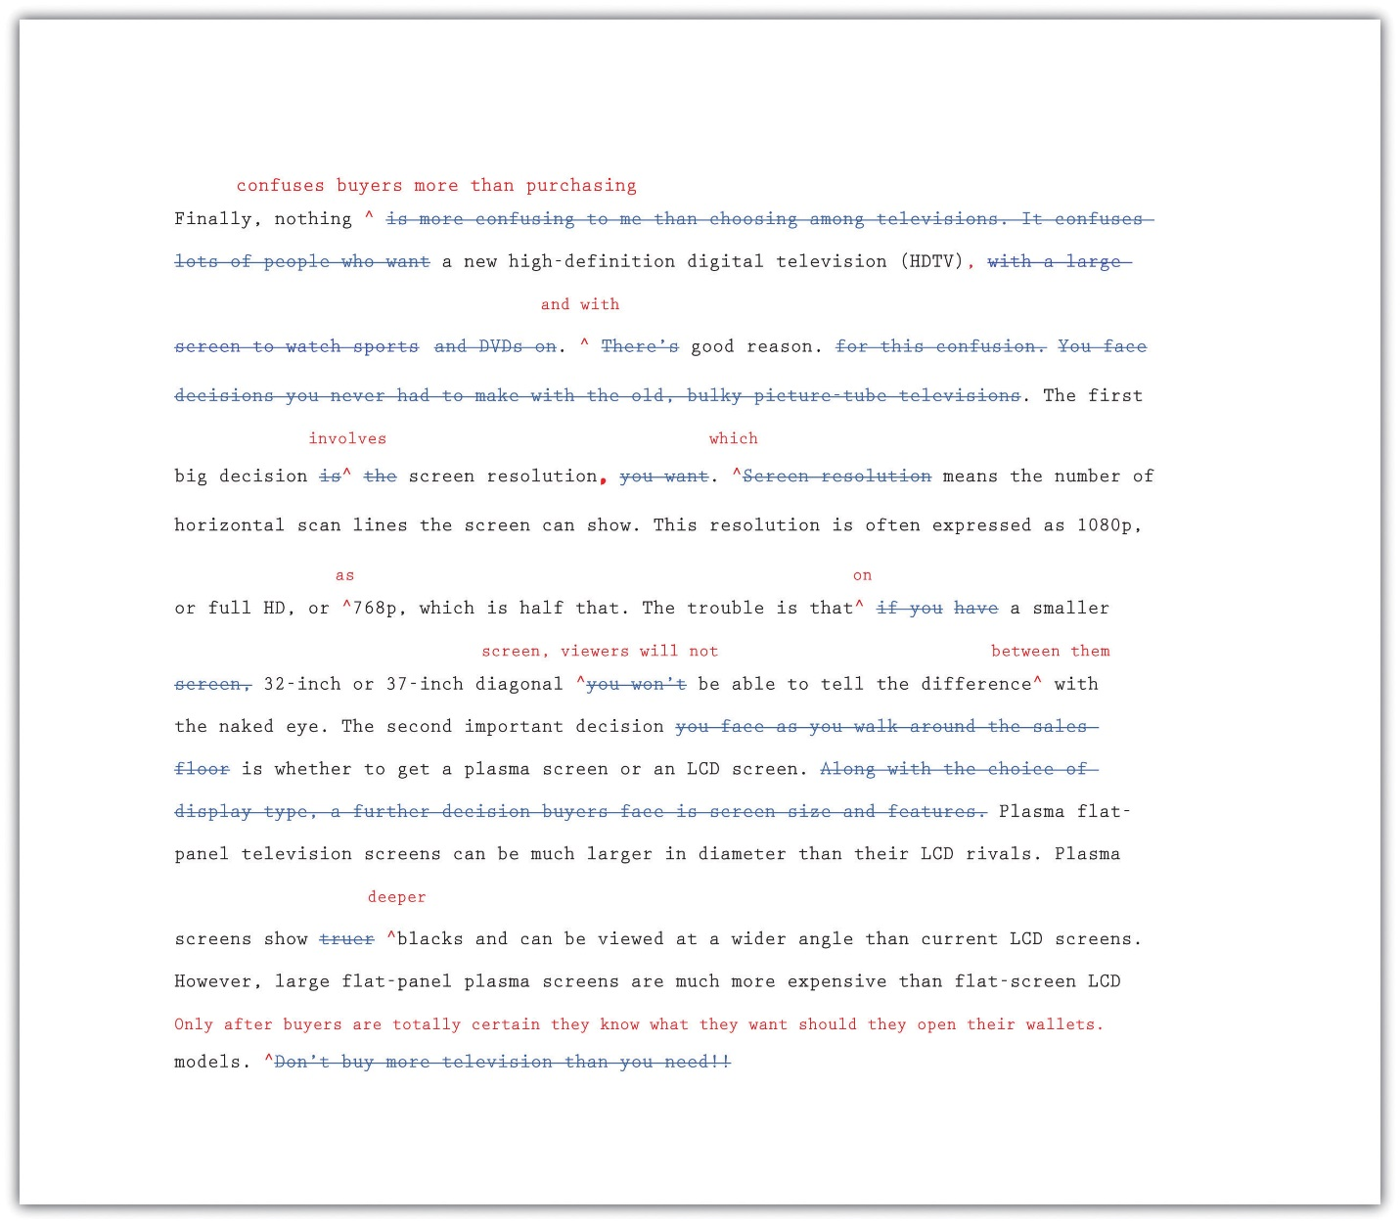

EXERCISE 4
- Answer the following questions about Mariah’s revised paragraph:
  - Read the unrevised and the revised paragraphs aloud. Explain in your own words how changes in word choice have affected Mariah’s writing.
  - Do you agree with the changes that Mariah made to her paragraph? Which changes would you keep and which were unnecessary? Explain. What other changes would you have made?
  - What effect does removing contractions and the pronoun you have on the tone of the paragraph? How would you characterize the tone now? Why?
- Now return once more to your essay in progress. Read carefully for problems with word choice. Be sure that your draft is written in formal language and that your word choice is specific and appropriate.

Completing a Peer Review
After working so closely with a piece of writing, writers often need to step back and ask for a more objective reader. What writers most need is feedback from readers who can respond only to the words on the page. When they are ready, writers show their drafts to someone they respect and who can give an honest response about its strengths and weaknesses.
You, too, can ask a peer to read your draft when it is ready. After evaluating the feedback and assessing what is most helpful, the reader’s feedback will help you when you revise your draft. This process is called peer review.
You can work with a partner in your class and identify specific ways to strengthen each other’s essays. Although you may be uncomfortable sharing your writing at first, remember that each writer is working toward the same goal: a final draft that fits the audience and the purpose. Maintaining a positive attitude when providing feedback will put you and your partner at ease. The box that follows provides a useful framework for the peer review session.

Questions for Peer Review
Title of essay: ____________________________________________
Date: ____________________________________________
Writer’s name: ____________________________________________
Peer reviewer’s name: _________________________________________
- This essay is about____________________________________________.
- Your main points in this essay are____________________________________________.
- What I most liked about this essay is____________________________________________.
- These three points struck me as your strongest:
  - Point: ____________________________________________
Why: ____________________________________________
  - Point: ____________________________________________
Why: ____________________________________________
  - Point: ____________________________________________
Why: ____________________________________________
- These places in your essay are not clear to me:
  - Where: ____________________________________________
Needs improvement because__________________________________________
  - Where: ____________________________________________
Needs improvement because ____________________________________________
  - Where: ____________________________________________
Needs improvement because ____________________________________________
- The one additional change you could make that would improve this essay significantly is ____________________________________________.

Writing at Work
One of the reasons why word-processing programs build in a reviewing feature is that workgroups have become a common feature in many businesses. Writing is often collaborative, and the members of a workgroup and their supervisors often critique group members’ work and offer feedback that will lead to a better final product.

EXERCISE 5
Exchange essays with a classmate and complete a peer review of each other’s draft in progress. Remember to give positive feedback and to be courteous and polite in your responses. Focus on providing one positive comment and one question for more information to the author.

Using Feedback Objectively
The purpose of peer feedback is to receive constructive criticism of your essay. Your peer reviewer is your first real audience, and you have the opportunity to learn what confuses and delights a reader so that you can improve your work before sharing the final draft with a wider audience (or your intended audience).
It may not be necessary to incorporate every recommendation your peer reviewer makes. However, if you start to observe a pattern in the responses you receive from peer reviewers, you might want to take that feedback into consideration in future assignments. For example, if you read consistent comments about a need for more research, then you may want to consider including more research in future assignments.

Using Feedback from Multiple Sources
You might get feedback from more than one reader as you share different stages of your revised draft. In this situation, you may receive feedback from readers who do not understand the assignment or who lack your involvement with and enthusiasm for it.
You need to evaluate the responses you receive according to two important criteria:
- Determine if the feedback supports the purpose of the assignment.
- Determine if the suggested revisions are appropriate to the audience.
Then, using these standards, accept or reject revision feedback.

EXERCISE 6
Work with two partners. Go back to Note 8.81 "Exercise 4" in this lesson and compare your responses to Activity A, about Mariah’s paragraph, with your partners’. Recall Mariah’s purpose for writing and her audience. Then, working individually, list where you agree and where you disagree about revision needs.

Editing Your Draft
If you have been incorporating each set of revisions as Mariah has, you have produced multiple drafts of your writing. So far, all your changes have been content changes. Perhaps with the help of peer feedback, you have made sure that you sufficiently supported your ideas. You have checked for problems with unity and coherence. You have examined your essay for word choice, revising to cut unnecessary words and to replace weak wording with specific and appropriate wording.
The next step after revising the content is editing. When you edit, you examine the surface features of your text. You examine your spelling, grammar, usage, and punctuation. You also make sure you use the proper format when creating your finished assignment.

Tip
Editing often takes time. Budgeting time into the writing process allows you to complete additional edits after revising. Editing and proofreading your writing helps you create a finished work that represents your best efforts. Here are a few more tips to remember about your readers:
- Readers do not notice correct spelling, but they do notice misspellings.
- Readers look past your sentences to get to your ideas—unless the sentences are awkward, poorly constructed, and frustrating to read.
- Readers notice when every sentence has the same rhythm as every other sentence, with no variety.
- Readers do not cheer when you use there, their, and they’re correctly, but they notice when you do not.
- Readers will notice the care with which you handled your assignment and your attention to detail in the delivery of an error-free document..
The first section of this book offers a useful review of grammar, mechanics, and usage. Use it to help you eliminate major errors in your writing and refine your understanding of the conventions of language. Do not hesitate to ask for help, too, from peer tutors in your academic department or in the college’s writing lab. In the meantime, use the checklist to help you edit your writing.

Checklist
Editing Your Writing
Grammar
- Are some sentences actually sentence fragments?
- Are some sentences run-on sentences? How can I correct them?
- Do some sentences need conjunctions between independent clauses?
- Does every verb agree with its subject?
- Is every verb in the correct tense?
- Are tense forms, especially for irregular verbs, written correctly?
- Have I used subject, object, and possessive personal pronouns correctly?
- Have I used who and whom correctly?
- Is the antecedent of every pronoun clear?
- Do all personal pronouns agree with their antecedents?
- Have I used the correct comparative and superlative forms of adjectives and adverbs?
- Is it clear which word a participial phrase modifies, or is it a dangling modifier?
Sentence Structure
- Are all my sentences simple sentences, or do I vary my sentence structure?
- Have I chosen the best coordinating or subordinating conjunctions to join clauses?
- Have I created long, overpacked sentences that should be shortened for clarity?
- Do I see any mistakes in parallel structure?
Punctuation
- Does every sentence end with the correct end punctuation?
- Can I justify the use of every exclamation point?
- Have I used apostrophes correctly to write all singular and plural possessive forms?
- Have I used quotation marks correctly?
Mechanics and Usage
- Can I find any spelling errors? How can I correct them?
- Have I used capital letters where they are needed?
- Have I written abbreviations, where allowed, correctly?
- Can I find any errors in the use of commonly confused words, such as to/too/two?

Tip
Be careful about relying too much on spelling checkers and grammar checkers. A spelling checker cannot recognize that you meant to write principle but wrote principal instead. A grammar checker often queries constructions that are perfectly correct. The program does not understand your meaning; it makes its check against a general set of formulas that might not apply in each instance. If you use a grammar checker, accept the suggestions that make sense, but consider why the suggestions came up.

Tip
Proofreading requires patience; it is very easy to read past a mistake. Set your paper aside for at least a few hours, if not a day or more, so your mind will rest. Some professional proofreaders read a text backward so they can concentrate on spelling and punctuation. Another helpful technique is to slowly read a paper aloud, paying attention to every word, letter, and punctuation mark.
If you need additional proofreading help, ask a reliable friend, a classmate, or a peer tutor to make a final pass on your paper to look for anything you missed.

Formatting
Remember to use proper format when creating your finished assignment. Sometimes an instructor, a department, or a college will require students to follow specific instructions on titles, margins, page numbers, or the location of the writer’s name. These requirements may be more detailed and rigid for research projects and term papers, which often observe the American Psychological Association (APA) or Modern Language Association (MLA) style guides, especially when citations of sources are included.
To ensure the format is correct and follows any specific instructions, make a final check before you submit an assignment.

EXERCISE 7
With the help of the checklist, edit and proofread your essay.

KEY TAKEAWAYS
- Revising and editing are the stages of the writing process in which you improve your work before producing a final draft.
- During revising, you add, cut, move, or change information in order to improve content.
- During editing, you take a second look at the words and sentences you used to express your ideas and fix any problems in grammar, punctuation, and sentence structure.
- Unity in writing means that all the ideas in each paragraph and in the entire essay clearly belong together and are arranged in an order that makes logical sense.
- Coherence in writing means that the writer’s wording clearly indicates how one idea leads to another within a paragraph and between paragraphs.
- Transitional words and phrases effectively make writing more coherent.
- Writing should be clear and concise, with no unnecessary words.
- Effective formal writing uses specific, appropriate words and avoids slang, contractions, clichés, and overly general words.
- Peer reviews, done properly, can give writers objective feedback about their writing. It is the writer’s responsibility to evaluate the results of peer reviews and incorporate only useful feedback.
- Remember to budget time for careful editing and proofreading. Use all available resources, including editing checklists, peer editing, and your institution’s writing lab, to improve your editing skills.

6.2: Completing Your Research Paper Writing for Success: "Chapter 12, Section 2: Developing a Final Draft of a Research Paper"

LEARNING OBJECTIVES
- Revise your paper to improve organization and cohesion.
- Determine an appropriate style and tone for your paper.
- Revise to ensure that your tone is consistent.
- Edit your paper to ensure that language, citations, and formatting are correct.
Given all the time and effort you have put into your research project, you will want to make sure that your final draft represents your best work. This requires taking the time to revise and edit your paper carefully.
You may feel like you need a break from your paper before you revise and edit it. That is understandable—but leave yourself with enough time to complete this important stage of the writing process. In this section, you will learn the following specific strategies that are useful for revising and editing a research paper:
- How to evaluate and improve the overall organization and cohesion
- How to maintain an appropriate style and tone
- How to use checklists to identify and correct any errors in language, citations, and formatting

Revising Your Paper: Organization and Cohesion
When writing a research paper, it is easy to become overly focused on editorial details, such as the proper format for bibliographical entries. These details do matter. However, before you begin to address them, it is important to spend time reviewing and revising the content of the paper.
A good research paper is both organized and cohesive. Organization means that your argument flows logically from one point to the next. Cohesion means that the elements of your paper work together smoothly and naturally. In a cohesive research paper, information from research is seamlessly integrated with the writer’s ideas.

Revise to Improve Organization
When you revise to improve organization, you look at the flow of ideas throughout the essay as a whole and within individual paragraphs. You check to see that your essay moves logically from the introduction to the body paragraphs to the conclusion, and that each section reinforces your thesis. Use Checklist 12.1 to help you.

Checklist 12.1
Revision: Organization
At the essay level
- Does my introduction proceed clearly from the opening to the thesis?
- Does each body paragraph have a clear main idea that relates to the thesis?
- Do the main ideas in the body paragraphs flow in a logical order? Is each paragraph connected to the one before it?
- Do I need to add or revise topic sentences or transitions to make the overall flow of ideas clearer?
- Does my conclusion summarize my main ideas and revisit my thesis?
At the paragraph level
- Does the topic sentence clearly state the main idea?
- Do the details in the paragraph relate to the main idea?
- Do I need to recast any sentences or add transitions to improve the flow of sentences?
Jorge reread his draft paragraph by paragraph. As he read, he highlighted the main idea of each paragraph so he could see whether his ideas proceeded in a logical order. For the most part, the flow of ideas was clear. However, he did notice that one paragraph did not have a clear main idea. It interrupted the flow of the writing. During revision, Jorge added a topic sentence that clearly connected the paragraph to the one that had preceded it. He also added transitions to improve the flow of ideas from sentence to sentence.
Read the following paragraphs twice, the first time without Jorge’s changes, and the second time with them.
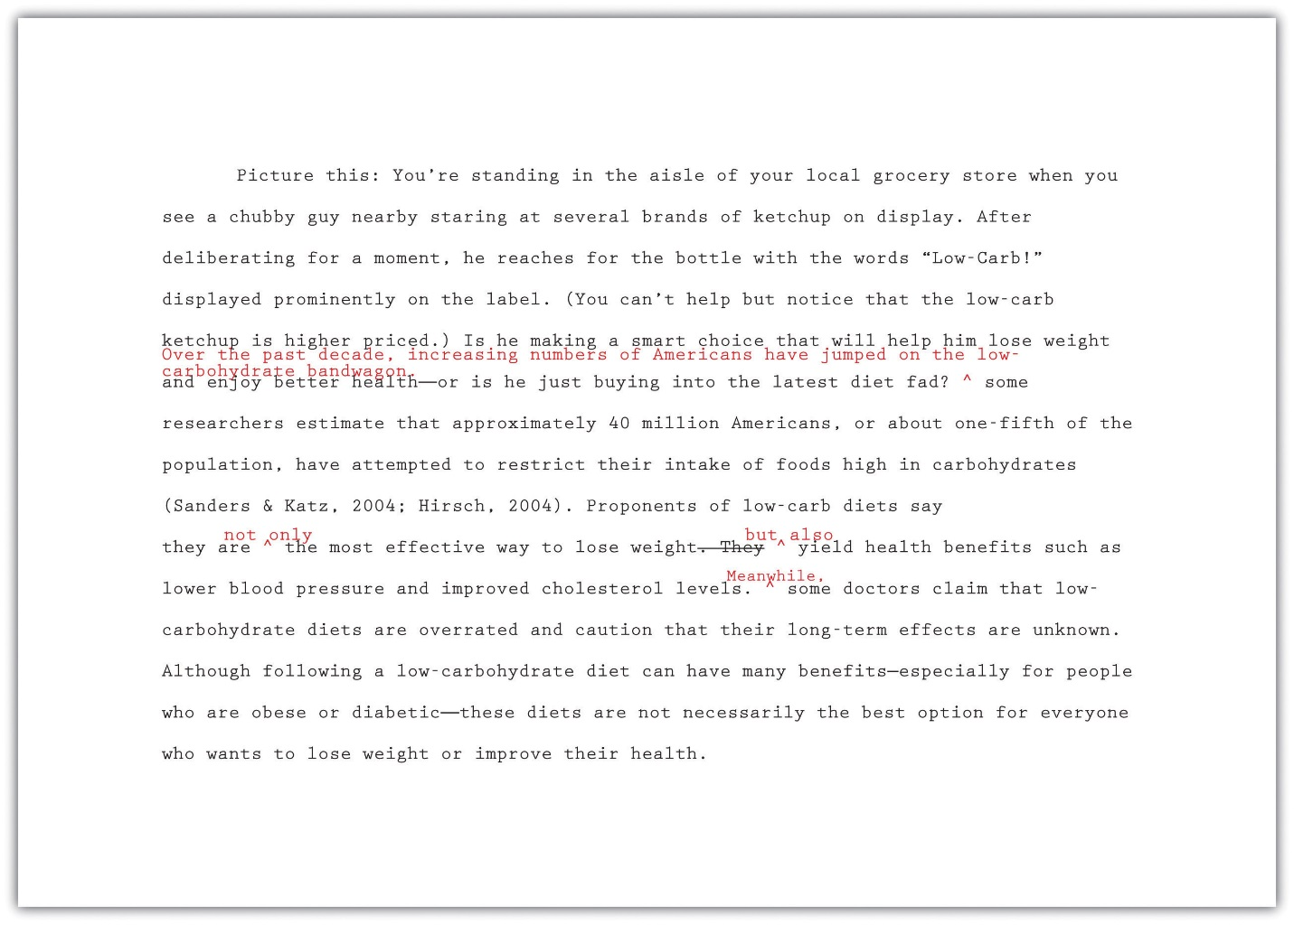

EXERCISE 1
Follow these steps to begin revising your paper’s overall organization.
- Print out a hard copy of your paper.
- Read your paper paragraph by paragraph. Highlight your thesis and the topic sentence of each paragraph.
- Using the thesis and topic sentences as starting points, outline the ideas you presented—just as you would do if you were outlining a chapter in a textbook. Do not look at the outline you created during prewriting. You may write in the margins of your draft or create a formal outline on a separate sheet of paper.
- Next, reread your paper more slowly, looking for how ideas flow from sentence to sentence. Identify places where adding a transition or recasting a sentence would make the ideas flow more logically.
- Review the topics on your outline. Is there a logical flow of ideas? Identify any places where you may need to reorganize ideas.
- Begin to revise your paper to improve organization. Start with any major issues, such as needing to move an entire paragraph. Then proceed to minor revisions, such as adding a transitional phrase or tweaking a topic sentence so it connects ideas more clearly.
Collaboration
Please share your paper with a classmate. Repeat the six steps and take notes on a separate piece of paper. Share and compare notes.

Tip
Writers choose transitions carefully to show the relationships between ideas—for instance, to make a comparison or elaborate on a point with examples. Make sure your transitions suit your purpose and avoid overusing the same ones. For an extensive list of transitions, see Chapter 8 "The Writing Process: How Do I Begin?", Section 8.4 "Revising and Editing".

Revise to Improve Cohesion
When you revise to improve cohesion, you analyze how the parts of your paper work together. You look for anything that seems awkward or out of place. Revision may involve deleting unnecessary material or rewriting parts of the paper so that the out-of-place material fits in smoothly.
In a research paper, problems with cohesion usually occur when a writer has trouble integrating source material. If facts or quotations have been awkwardly dropped into a paragraph, they distract or confuse the reader instead of working to support the writer’s point. Overusing paraphrased and quoted material has the same effect. Use Checklist 12.2 to review your essay for cohesion.

Checklist 12.2
Revision: Cohesion
- Does the opening of the paper clearly connect to the broader topic and thesis? Make sure entertaining quotes or anecdotes serve a purpose.
- Have I included support from research for each main point in the body of my paper?
- Have I included introductory material before any quotations? Quotations should never stand alone in a paragraph.
- Does paraphrased and quoted material clearly serve to develop my own points?
- Do I need to add to or revise parts of the paper to help the reader understand how certain information from a source is relevant?
- Are there any places where I have overused material from sources?
- Does my conclusion make sense based on the rest of the paper? Make sure any new questions or suggestions in the conclusion are clearly linked to earlier material.
As Jorge reread his draft, he looked to see how the different pieces fit together to prove his thesis. He realized that some of his supporting information needed to be integrated more carefully and decided to omit some details entirely. Read the following paragraph, first without Jorge’s revisions and then with them.
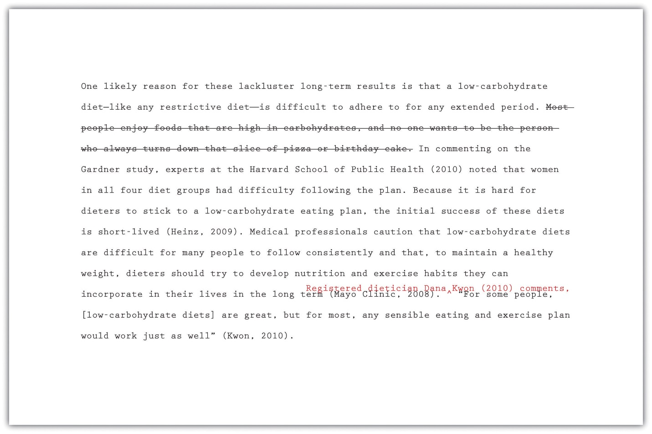
Jorge decided that his comment about pizza and birthday cake came across as subjective and was not necessary to make his point, so he deleted it. He also realized that the quotation at the end of the paragraph was awkward and ineffective. How would his readers know who Kwon was or why her opinion should be taken seriously? Adding an introductory phrase helped Jorge integrate this quotation smoothly and establish the credibility of his source.

EXERCISE 2
Follow these steps to begin revising your paper to improve cohesion.
- Print out a hard copy of your paper, or work with your printout from Note 12.33 "Exercise 1".
- Read the body paragraphs of your paper first. Each time you come to a place that cites information from sources, ask yourself what purpose this information serves. Check that it helps support a point and that it is clearly related to the other sentences in the paragraph.
- Identify unnecessary information from sources that you can delete.
- Identify places where you need to revise your writing so that readers understand the significance of the details cited from sources.
- Skim the body paragraphs once more, looking for any paragraphs that seem packed with citations. Review these paragraphs carefully for cohesion.
- Review your introduction and conclusion. Make sure the information presented works with ideas in the body of the paper.
- Revise the places you identified in your paper to improve cohesion.
Collaboration
Please exchange papers with a classmate. Complete step four. On a separate piece of paper, note any areas that would benefit from clarification. Return and compare notes.

Writing at Work
Understanding cohesion can also benefit you in the workplace, especially when you have to write and deliver a presentation. Speakers sometimes rely on cute graphics or funny quotations to hold their audience’s attention. If you choose to use these elements, make sure they work well with the substantive content of your presentation. For example, if you are asked to give a financial presentation, and the financial report shows that the company lost money, funny illustrations would not be relevant or appropriate for the presentation.

Using a Consistent Style and Tone
Once you are certain that the content of your paper fulfills your purpose, you can begin revising to improve style and tone. Together, your style and tone create the voice of your paper, or how you come across to readers. Style refers to the way you use language as a writer—the sentence structures you use and the word choices you make. Tone is the attitude toward your subject and audience that you convey through your word choice.

Determining an Appropriate Style and Tone
Although accepted writing styles will vary within different disciplines, the underlying goal is the same—to come across to your readers as a knowledgeable, authoritative guide. Writing about research is like being a tour guide who walks readers through a topic. A stuffy, overly formal tour guide can make readers feel put off or intimidated. Too much informality or humor can make readers wonder whether the tour guide really knows what he or she is talking about. Extreme or emotionally charged language comes across as unbalanced.
To help prevent being overly formal or informal, determine an appropriate style and tone at the beginning of the research process. Consider your topic and audience because these can help dictate style and tone. For example, a paper on new breakthroughs in cancer research should be more formal than a paper on ways to get a good night’s sleep.
A strong research paper comes across as straightforward, appropriately academic, and serious. It is generally best to avoid writing in the first person, as this can make your paper seem overly subjective and opinion based. Use Checklist 12.3 on style to review your paper for other issues that affect style and tone. You can check for consistency at the end of the writing process. Checking for consistency is discussed later in this section.

Checklist 12.3
Style
- My paper avoids excessive wordiness.
- My sentences are varied in length and structure.
- I have avoided using first-person pronouns such as I and we.
- I have used the active voice whenever possible.
- I have defined specialized terms that might be unfamiliar to readers.
- I have used clear, straightforward language whenever possible and avoided unnecessary jargon.
- My paper states my point of view using a balanced tone—neither too indecisive nor too forceful.

Word Choice
Note that word choice is an especially important aspect of style. In addition to checking the points noted on Checklist 12.3, review your paper to make sure your language is precise, conveys no unintended connotations, and is free of biases. Here are some of the points to check for:
- Vague or imprecise terms
- Slang
- Repetition of the same phrases (“Smith states…, Jones states…”) to introduce quoted and paraphrased material (For a full list of strong verbs to use with in-text citations, see Chapter 13 "APA and MLA Documentation and Formatting".)
- Exclusive use of masculine pronouns or awkward use of he or she
- Use of language with negative connotations, such as haughty or ridiculous
- Use of outdated or offensive terms to refer to specific ethnic, racial, or religious groups

Tip
Using plural nouns and pronouns or recasting a sentence can help you keep your language gender neutral while avoiding awkwardness. Consider the following examples.
- Gender-biased: When a writer cites a source in the body of his paper, he must list it on his references page.
- Awkward: When a writer cites a source in the body of his or her paper, he or she must list it on his or her references page.
- Improved: Writers must list any sources cited in the body of a paper on the references page.

Keeping Your Style Consistent
As you revise your paper, make sure your style is consistent throughout. Look for instances where a word, phrase, or sentence just does not seem to fit with the rest of the writing. It is best to reread for style after you have completed the other revisions so that you are not distracted by any larger content issues. Revising strategies you can use include the following:
- Read your paper aloud. Sometimes your ears catch inconsistencies that your eyes miss.
- Share your paper with another reader whom you trust to give you honest feedback.It is often difficult to evaluate one’s own style objectively—especially in the final phase of a challenging writing project. Another reader may be more likely to notice instances of wordiness, confusing language, or other issues that affect style and tone.
- Line-edit your paper slowly, sentence by sentence. You may even wish to use a sheet of paper to cover everything on the page except the paragraph you are editing—that forces you to read slowly and carefully. Mark any areas where you notice problems in style or tone, and then take time to rework those sections.
On reviewing his paper, Jorge found that he had generally used an appropriately academic style and tone. However, he noticed one glaring exception—his first paragraph. He realized there were places where his overly informal writing could come across as unserious or, worse, disparaging. Revising his word choice and omitting a humorous aside helped Jorge maintain a consistent tone. Read his revisions.
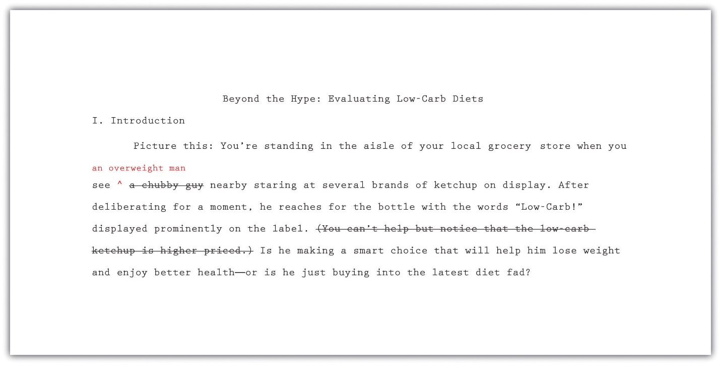

EXERCISE 3
Using Checklist 12.3, line-edit your paper. You may use either of these techniques:
- Print out a hard copy of your paper, or work with your printout from Note 12.33 "Exercise 1". Read it line by line. Check for the issues noted on Checklist 12.3, as well as any other aspects of your writing style you have previously identified as areas for improvement. Mark any areas where you notice problems in style or tone, and then take time to rework those sections.
- If you prefer to work with an electronic document, use the menu options in your word-processing program to enlarge the text to 150 or 200 percent of the original size. Make sure the type is large enough that you can focus on only one paragraph at a time. Read the paper line by line as described in step 1. Highlight any areas where you notice problems in style or tone, and then take time to rework those sections.
Collaboration
Please exchange papers with a classmate. On a separate piece of paper, note places where the essay does not seem to flow or you have questions about what was written. Return the essay and compare notes.

Editing Your Paper
After revising your paper to address problems in content or style, you will complete one final editorial review. Perhaps you already have caught and corrected minor mistakes during previous revisions. Nevertheless, give your draft a final edit to make sure it is error-free. Your final edit should focus on two broad areas:
- Errors in grammar, mechanics, usage, and spelling
- Errors in citing and formatting sources
For in-depth information on these two topics, see Chapter 2 "Writing Basics: What Makes a Good Sentence?" and Chapter 13 "APA and MLA Documentation and Formatting".

Correcting Errors
Given how much work you have put into your research paper, you will want to check for any errors that could distract or confuse your readers. Using the spell-checking feature in your word-processing program can be helpful—but this should not replace a full, careful review of your document. Be sure to check for any errors that may have come up frequently for you in the past. Use Checklist 12.4 to help you as you edit:

Checklist 12.4
Grammar, Mechanics, Punctuation, Usage, and Spelling
- My paper is free of grammatical errors, such as errors in subject-verb agreement and sentence fragments. (For additional guidance on grammar, see Chapter 2 "Writing Basics: What Makes a Good Sentence?".)
- My paper is free of errors in punctuation and mechanics, such as misplaced commas or incorrectly formatted source titles. (For additional guidance on punctuation and mechanics, see Chapter 3 "Punctuation".)
- My paper is free of common usage errors, such as alot and alright. (For additional guidance on correct usage, see Chapter 4 "Working with Words: Which Word Is Right?".)
- My paper is free of spelling errors. I have proofread my paper for spelling in addition to using the spell-checking feature in my word-processing program.
- I have checked my paper for any editing errors that I know I tend to make frequently.

Checking Citations and Formatting
When editing a research paper, it is also important to check that you have cited sources properly and formatted your document according to the specified guidelines. There are two reasons for this. First and foremost, citing sources correctly ensures that you have given proper credit to other people for ideas and information that helped you in your work. Second, using correct formatting establishes your paper as one student’s contribution to the work developed by and for a larger academic community. Increasingly, American Psychological Association (APA) style guidelines are the standard for many academic fields. Modern Language Association (MLA) is also a standard style in many fields. Use Checklist 12.5 to help you check citations and formatting.

Checklist 12.5
Citations and Formatting
- Within the body of my paper, each fact or idea taken from a source is credited to the correct source.
- Each in-text citation includes the source author’s name (or, where applicable, the organization name or source title) and year of publication. I have used the correct format of in-text and parenthetical citations.
- Each source cited in the body of my paper has a corresponding entry in the references section of my paper.
- My references section includes a heading and double-spaced, alphabetized entries.
- Each entry in my references section is indented on the second line and all subsequent lines.
- Each entry in my references section includes all the necessary information for that source type, in the correct sequence and format.
- My paper includes a title page.
- My paper includes a running head.
- The margins of my paper are set at one inch. Text is double spaced and set in a standard 12-point font.
For detailed guidelines on APA and MLA citation and formatting, see Chapter 13 "APA and MLA Documentation and Formatting".

Writing at Work
Following APA or MLA citation and formatting guidelines may require time and effort. However, it is good practice for learning how to follow accepted conventions in any professional field. Many large corporations create a style manual with guidelines for editing and formatting documents produced by that corporation. Employees follow the style manual when creating internal documents and documents for publication.
During the process of revising and editing, Jorge made changes in the content and style of his paper. He also gave the paper a final review to check for overall correctness and, particularly, correct APA or MLA citations and formatting. Read the final draft of his paper.
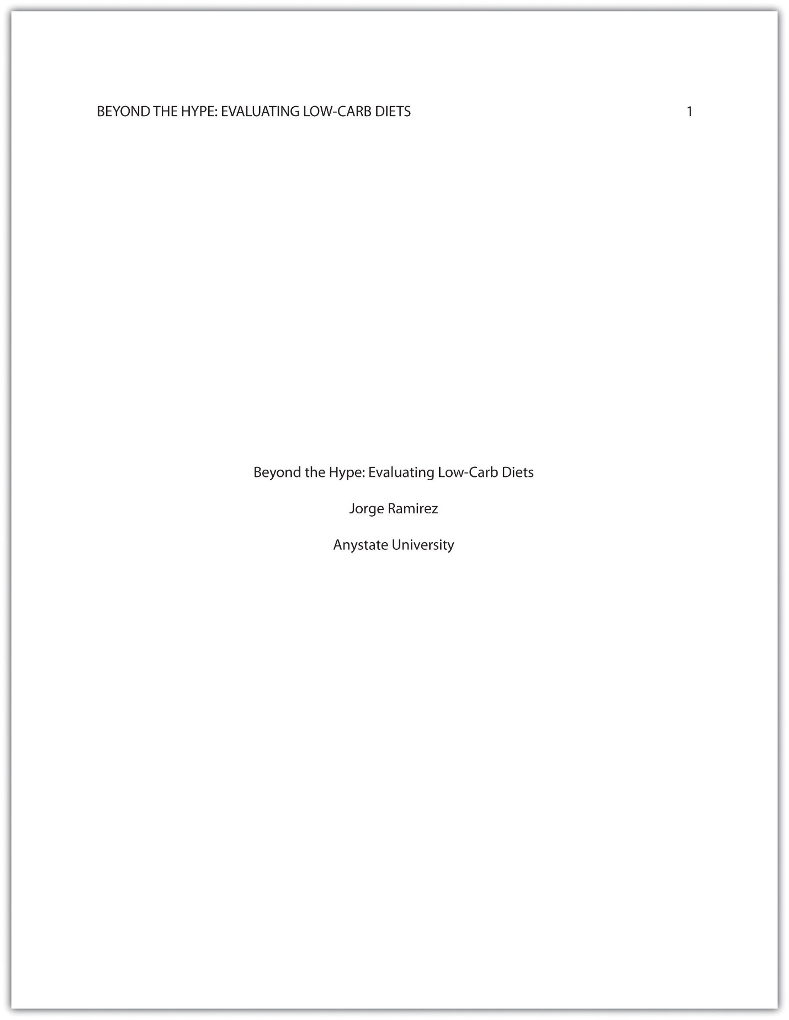
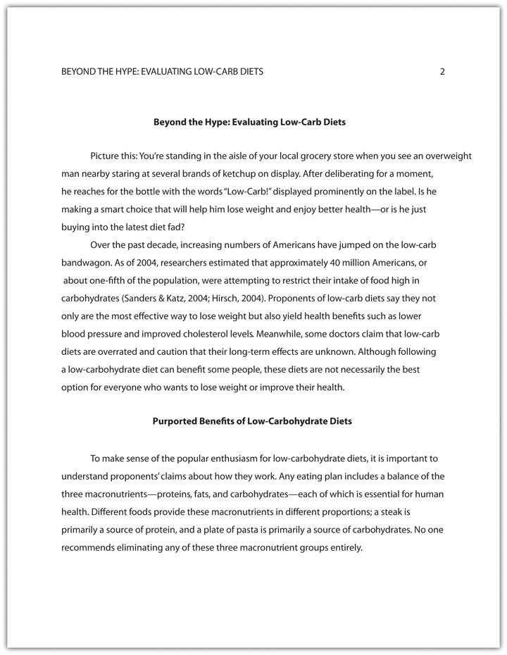
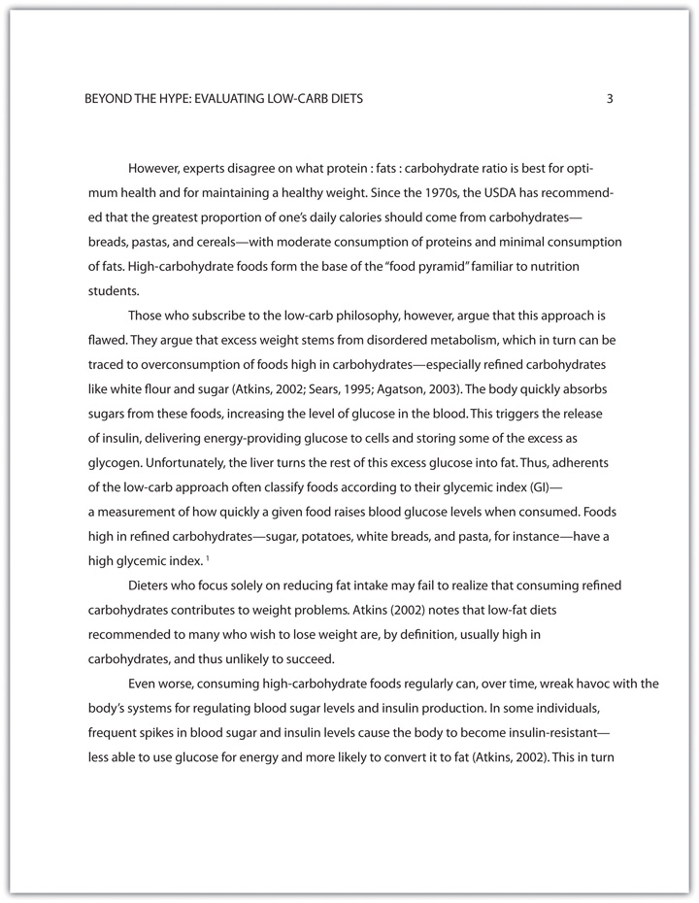
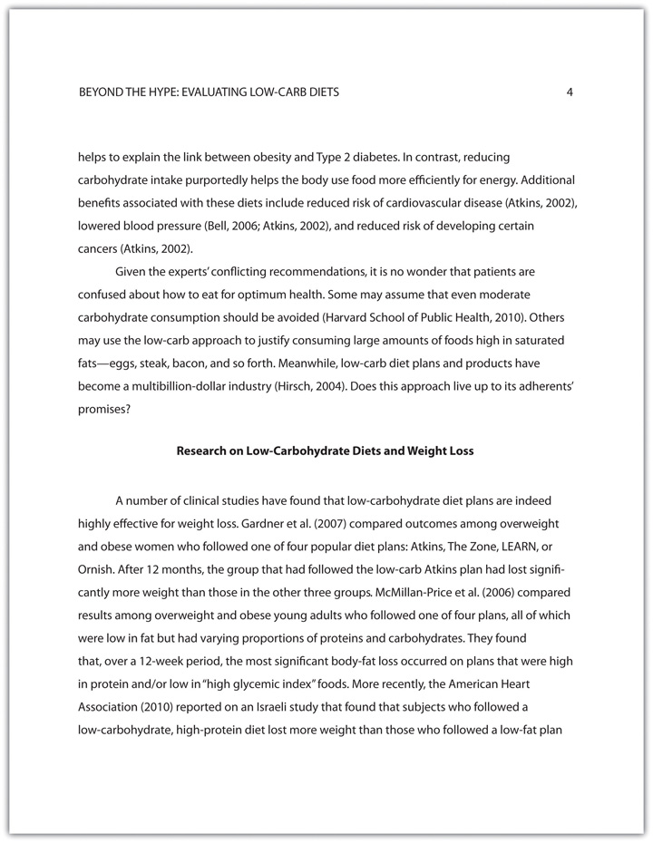
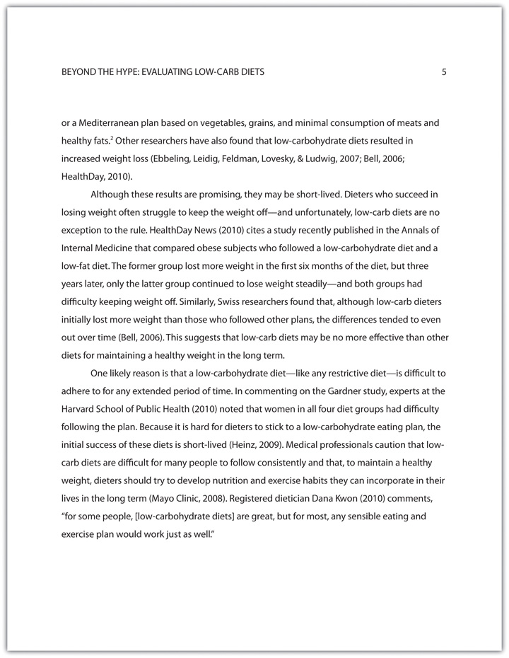
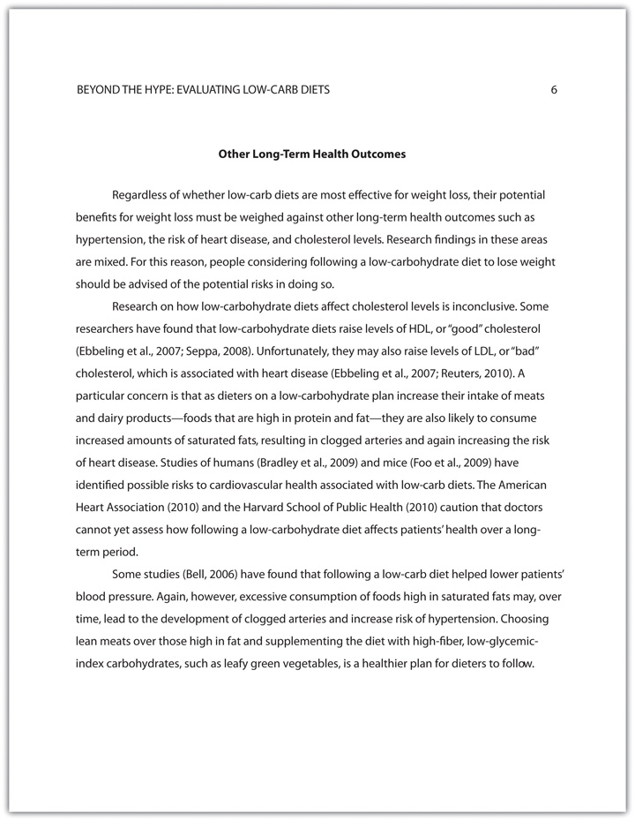
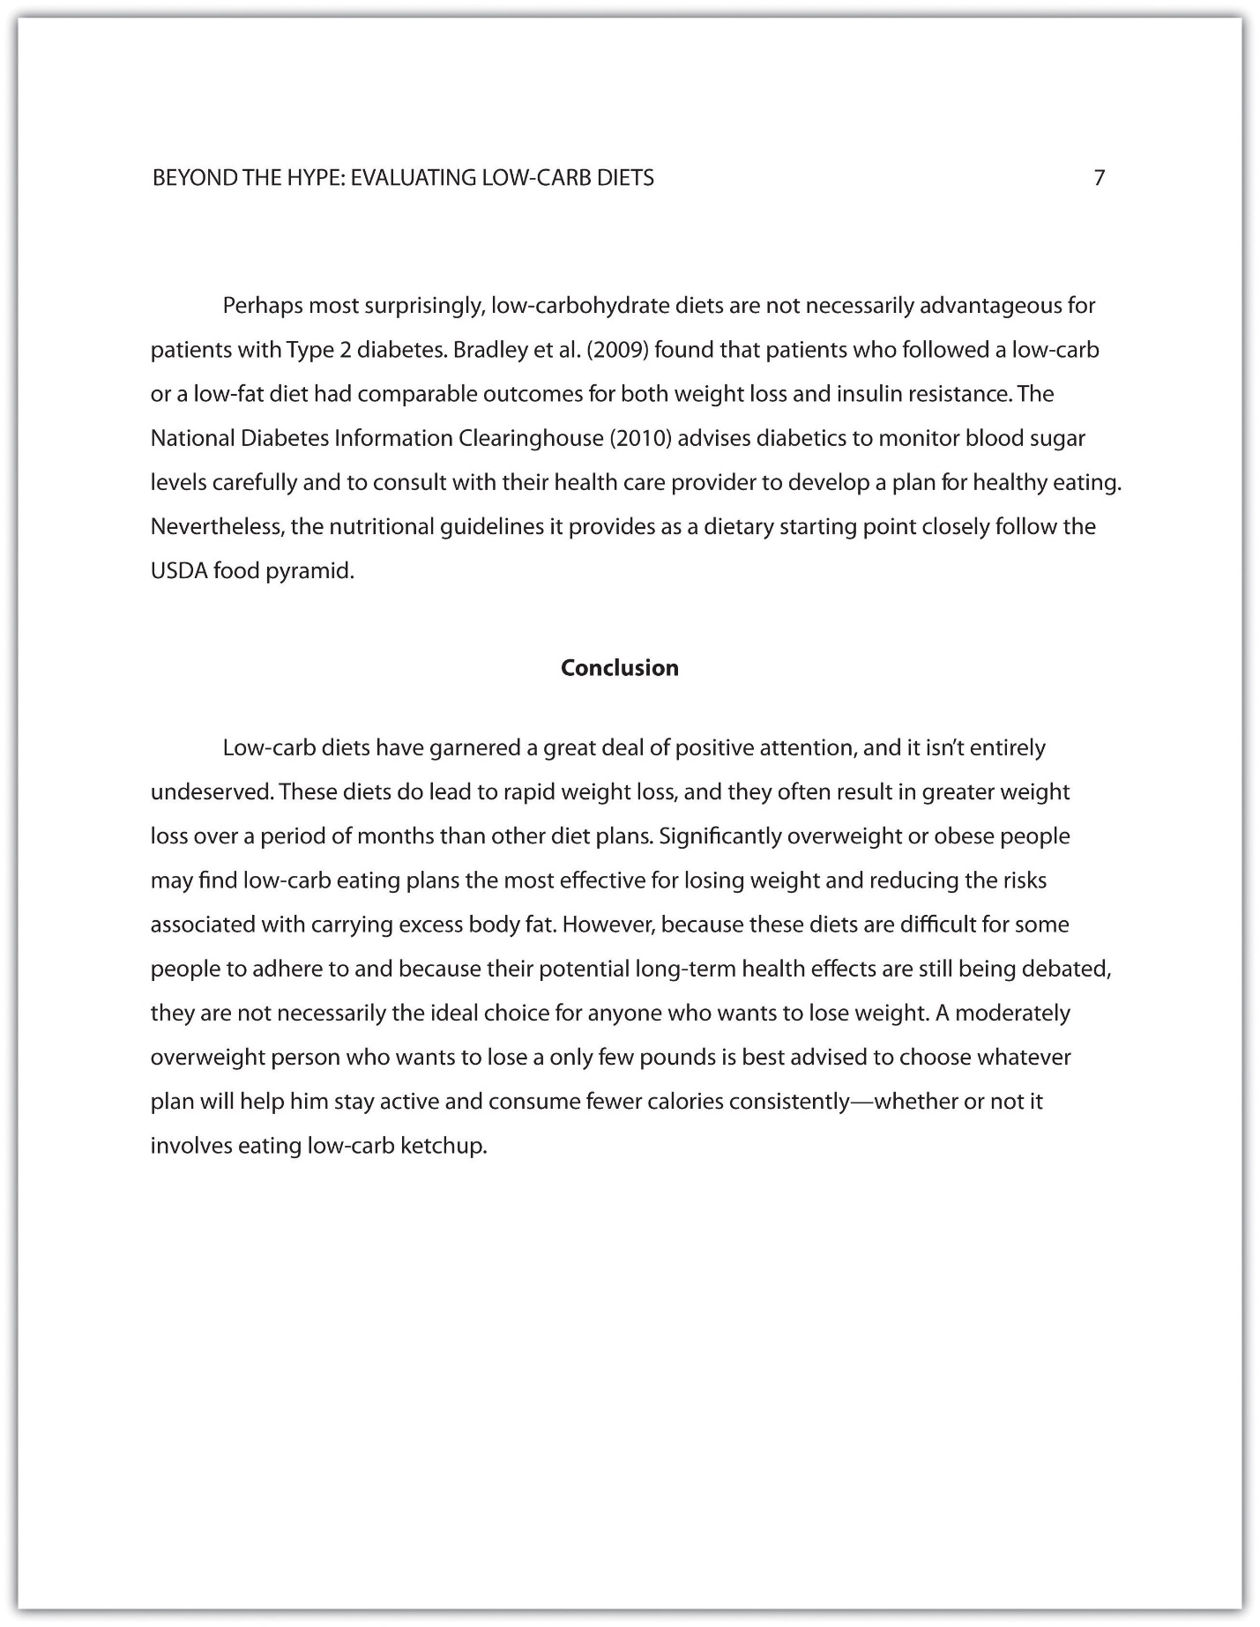
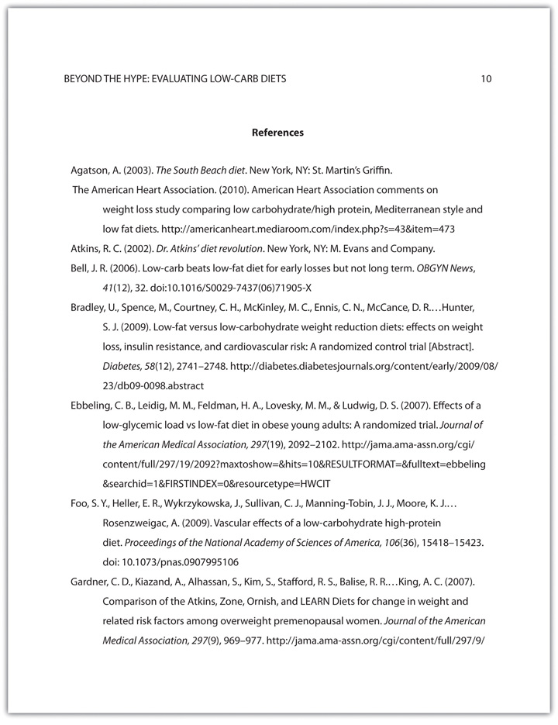
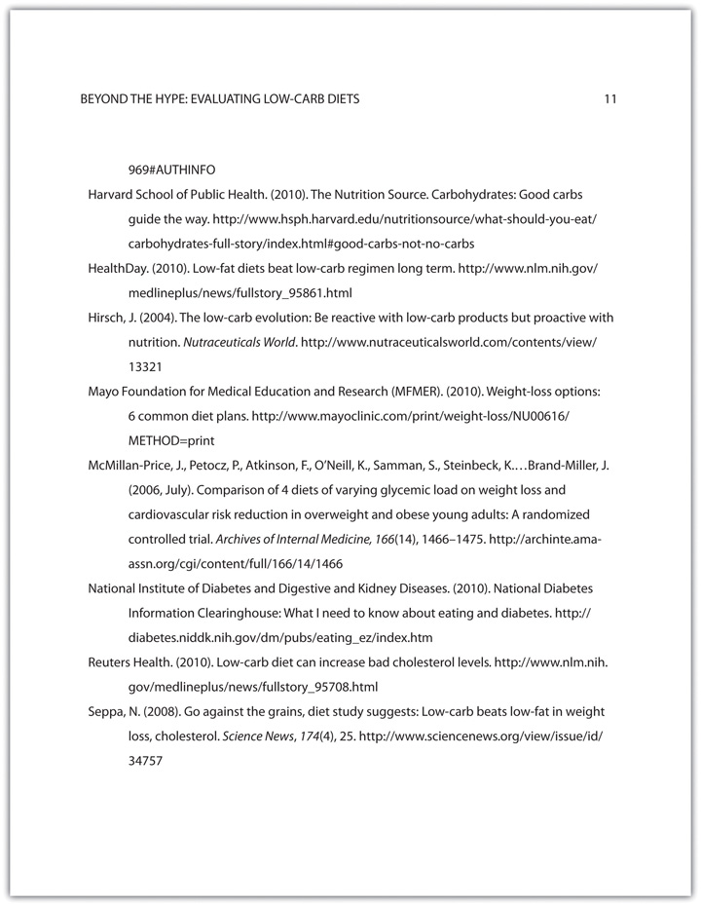

KEY TAKEAWAYS
- Organization in a research paper means that the argument proceeds logically from the introduction to the body to the conclusion. It flows logically from one point to the next. When revising a research paper, evaluate the organization of the paper as a whole and the organization of individual paragraphs.
- In a cohesive research paper, the elements of the paper work together smoothly and naturally. When revising a research paper, evaluate its cohesion. In particular, check that information from research is smoothly integrated with your ideas.
- An effective research paper uses a style and tone that are appropriately academic and serious. When revising a research paper, check that the style and tone are consistent throughout.
- Editing a research paper involves checking for errors in grammar, mechanics, punctuation, usage, spelling, citations, and formatting.

