CG
Professor Ramser
ENGL 350
14 April 2019
Vivid Arguments
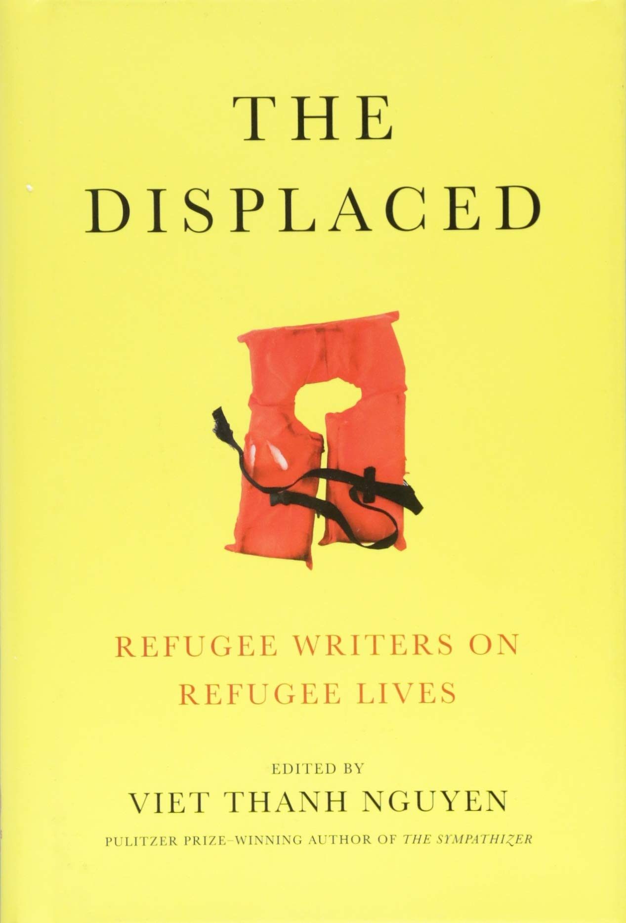

Table of Contents

Cover Page…………………………………………………………………….1
Table of Contents……………………………………………………………...2
Introduction……………………………………………………………………3
Last, Middle, First……………………………………………………………..4
Common Story………………………………………………………………...5
The Parent Who Stays…………………………………………………………7
Conclusion……………………………………………………………………..8

The Displaced by Viet Thanh Nguyen is a collection of experiences from refugees who have shared their personal experience based on fleeing their home country due to dangerous living conditions. Specifically, three stories from this book examine crucial arguments in which individuals who take advantage of their freedom should care for. In addition, the stories Last, Middle, First by Joseph Azam, Common Story by David Bezmozgis, and The Parent Who Stays by Reyna Grande present a strong argument pertaining to the dehumanizing experiences of the refugees pertaining to these stories. Each story presents a case on what the experience was like and how each family or individual overcame that specific situation. Evidently, the stories arguments speak to the individuals who take advantage of their freedom and citizenship by committing things like crimes.



(“Social Security Cards.” Mount Holyoke College, 23 Jan. 2018)

The following picture represents a social security card that represents an identity to a specific individual. The picture of the social security card is symbolic of Azams conflict in the story. Essentially, Azam is dealing with an issue of having a lost identity as he goes through many name changes.

In the story Last, Middle, First by Joseph Azam the author presents a vivid argument pertaining to the lost identity a refugee has upon fleeing their home country and entering a new one. The argument is exploited by describing how once a refugee leaves their home country, then they are faced with an issue relating to their identity because like Azam many refugees change their name to become more Americanized or more like the people living in the region. Furthermore, the importance of having an identity crisis can be a stressful experience as the author mentions how the name change brought “…discomfort and waves of guilt at home” (Azam 17) implying that identity is one of the only things that refugees own and abandoning the name diminishes everything in their past. In addition, the argument examined also reveals the power of the difficulties of being a refugee, which causes an issue pertaining to identity. Shelter, jobs, money, and residence are some key aspects of having an identity. Consequently, many refugees who leave their home country and enter a new one face these similar issues of not having shelter or not having a job, which effects their sense of having an identity. Essentially, the audience who this issue speaks to is individuals who have an identity; but ruin it by committing crimes.
The issue of having a lost identity upon fleeing their home country speaks to individuals who live in a secure region and abandon their freedom by committing crimes and losing their identity. Individuals who commit crimes go from being a citizen to being a criminal, which is a transition of their identity by choice. In contrast, refugees at most times have to abandon their identity by leaving everything behind in their home country, while if they were given the opportunity to have freedom with the addition of citizenship the chances of them committing violent crimes may be minimal.



(Kumok, Zina. “What To Do If Your Partner Has A Spending Problem.” Money Under 30, Money Under 30, 22 Mar. 2018)

The following picture consisting of a broken dollar sign represents the issue that Bezmozgis and his family was going through. The family left their home country due to the economic issues that the family was facing.

In the harsh reality of “Common Story”, Bezmozgis issues the argument relating to the economic issues the family faced in order to fight for survival. Rather than facing issues relating to war, violence, or even political issues; the family escaped the Soviet Union’s economic issues and its condition of anti-Semitism. Bezmozgis parents left everything back home including jobs, home, and possessions in hoping for a higher quality of life due to the opportunity that was provided to the family. This included having to live in Vienna for a couple of months and living on the outskirts of Rome. Sadly, the family was broken apart as Bezmozgis father had a sister who emigrated to Los Angeles, but the family was unwanted by the husband. In addition, the family ended up in Toronto. Mentioning the harsh political history, Bezmozgis mentions how the other people who also fled their country wasn’t “…their first experience of exile. Most Soviet Jews of my parents’ or grandparents’ generation survived WWII because they managed to flee Hitler’s army” (Bezmozgis 20) pointing out other significant reasons of fleeing one’s home country. Soon after, the mother would suffer a nervous breakdown and become significantly ill. However, Bezmozgis grandmother would then meet up with the family to take care of the family and get them back to reality.
The audience in whom “Common Story” applies to, relates to individuals who take advantage of their citizenship by not improving as citizens to provide a better life for themselves and or their family. There are many citizens throughout the world who complain about making ends meet, but do not take initiative to help solve their complaints. In the harsh reality of Bezmozgis his family had to escapes a harsh economic reality in order to improve the life of the family. In the reality of some citizens, some individuals lack initiative to improve their life without having to face economic issues in their region.



(Limited, Alamy. “Stock Photo - Family Problem, Issues Concept. Father Leaving His Child and Wife.” Alamy)

This following picture illustrates a father being separated from his family. The image intertwines with Grande’s story because her father left the family in order to provide a better life for them.

In “The Parent Who Stays” by Reyna Grande, the argument that is presented consist of the effect of having a parent figure abandon the family. Consequently, due to having no jobs in Mexico due to the national debt crisis and peso devaluation; the author states “…my father left his wife and children behind and became part of the largest wave of migration from Mexico ever, a wave that has only recently ended” (Grande 41). The argument also exposes the conflict of immigration as families have to be separated, but when families rejoin each other the emotional and psychological attachment is destroyed. The author presents her argument by providing her harsh reality in what she had to go through emotionally, psychologically, being othered in school, and the trauma of losing both parents due to immigration. The issue of having family bonds being broken apart due to immigration speaks to citizens who abandon their family due to stress or the feeling of being overwhelmed.
The audience in which this story speaks to pertains to the citizens who abandon their family due to being overwhelmed or too stressed. There are many single parent households across the world in which are caused by a parent figure leaving due to being stressed or too tired. To further validate, according to Amato’s study in “Single parenthood has become increasingly common in most western societies” (Amato 30). In the “Parent Who Stays” the parents left their family in order to pursue a stronger lifestyle for their children. In contrast, many citizens today take advantage of their freedom and blessings by leaving their family due to high amounts of pressure, when in actuality if immigrants had the opportunity to be living in a country where many jobs are provided the odds of that parent leaving their family would be minimal.
In closing, the three stories all present an argument that consist of trials and tribulations that the family has to overcome in order to fight for survival. Each story connects to a specific type of audience consisting of citizens who take advantage of their freedom and citizenship. For instance, in the story by Joseph Azam; he faces an issue relating to losing his identity after experiencing harsh reality in many countries. Citizens take advantage of their freedom and identity by committing crimes, which causes a shift in identity like being a citizen to now being a criminal. Essentially, citizens who take advantage of their freedom and living in a country with low life-threatening issues should evaluate their life and make positive changes because many immigrants and refugees are going through a more significant conflict.

Works Cited
Amato, Paul R. “Single-Parent Households as Settings for Children’s Development, Well-Being, and Attainment: A Social Network/Resources Perspective.” Sociological Studies of Children, vol. 7, Jan. 1995, pp. 19–47

Azam, Joseph. “Last, Middle, First.” The Displaced: Refugee Writers on Refugee Lives. Edited by Viet Thanh Nguyen, Abrams, 2018

Bezmozgis, David. “Common Story.” The Displaced: Refugee Writers on Refugee Lives. Edited by Viet Thanh Nguyen, Abrams, 2018.

Grande, Reyna. “The Parent Who Stays.” The Displaced: Refugee Writers on Refugee Lives. Edited by Viet Thanh Nguyen, Abrams, 2018.

(Limited, Alamy. “Stock Photo - Family Problem, Issues Concept. Father Leaving His Child and Wife.” Alamy)

(Kumok, Zina. “What To Do If Your Partner Has A Spending Problem.” Money Under 30, Money Under 30, 22 Mar. 2018)

(“Social Security Cards.” Mount Holyoke College, 23 Jan. 2018)

.

