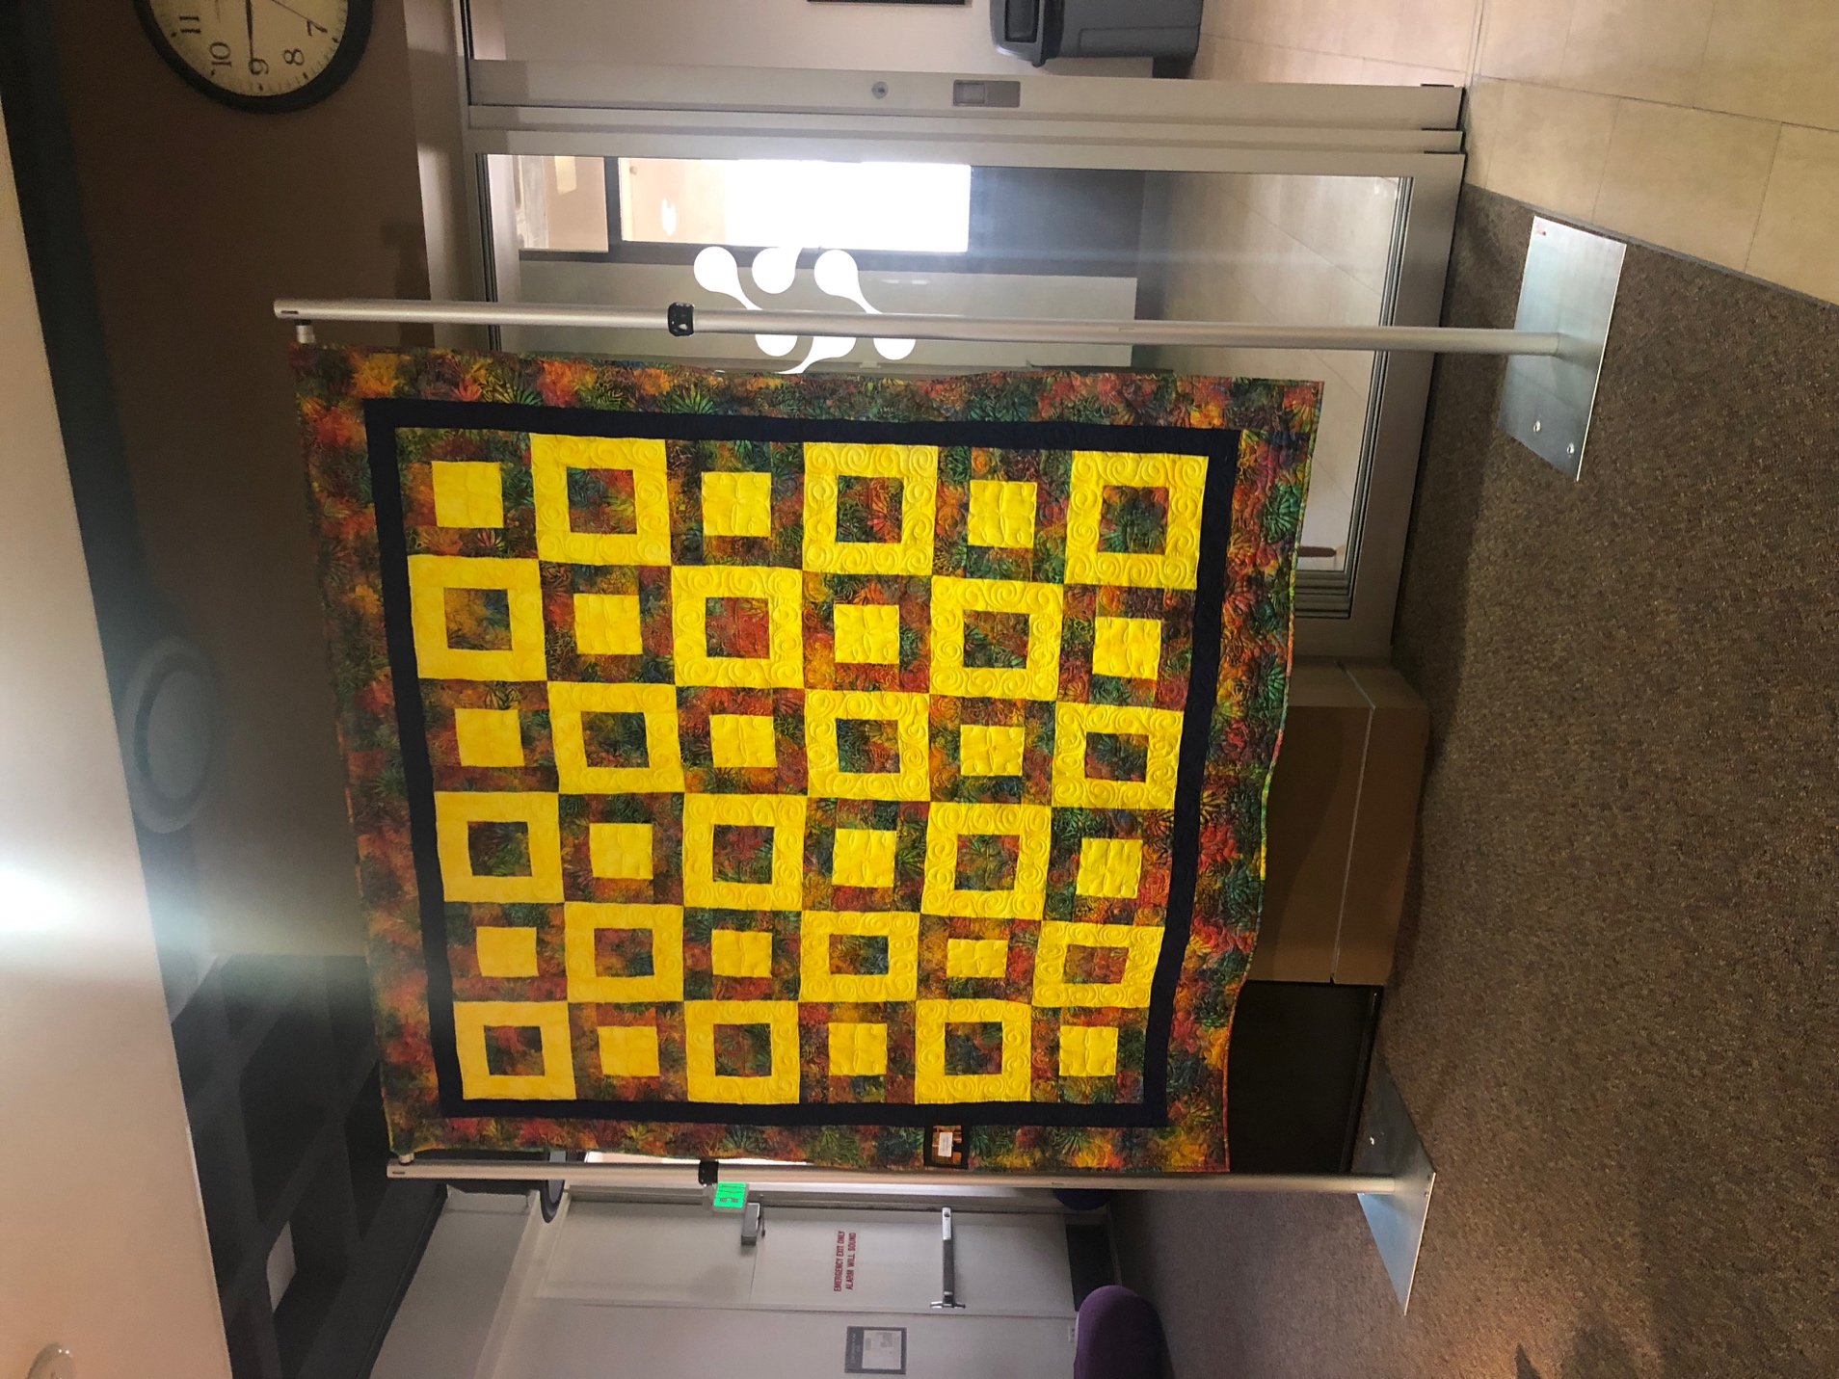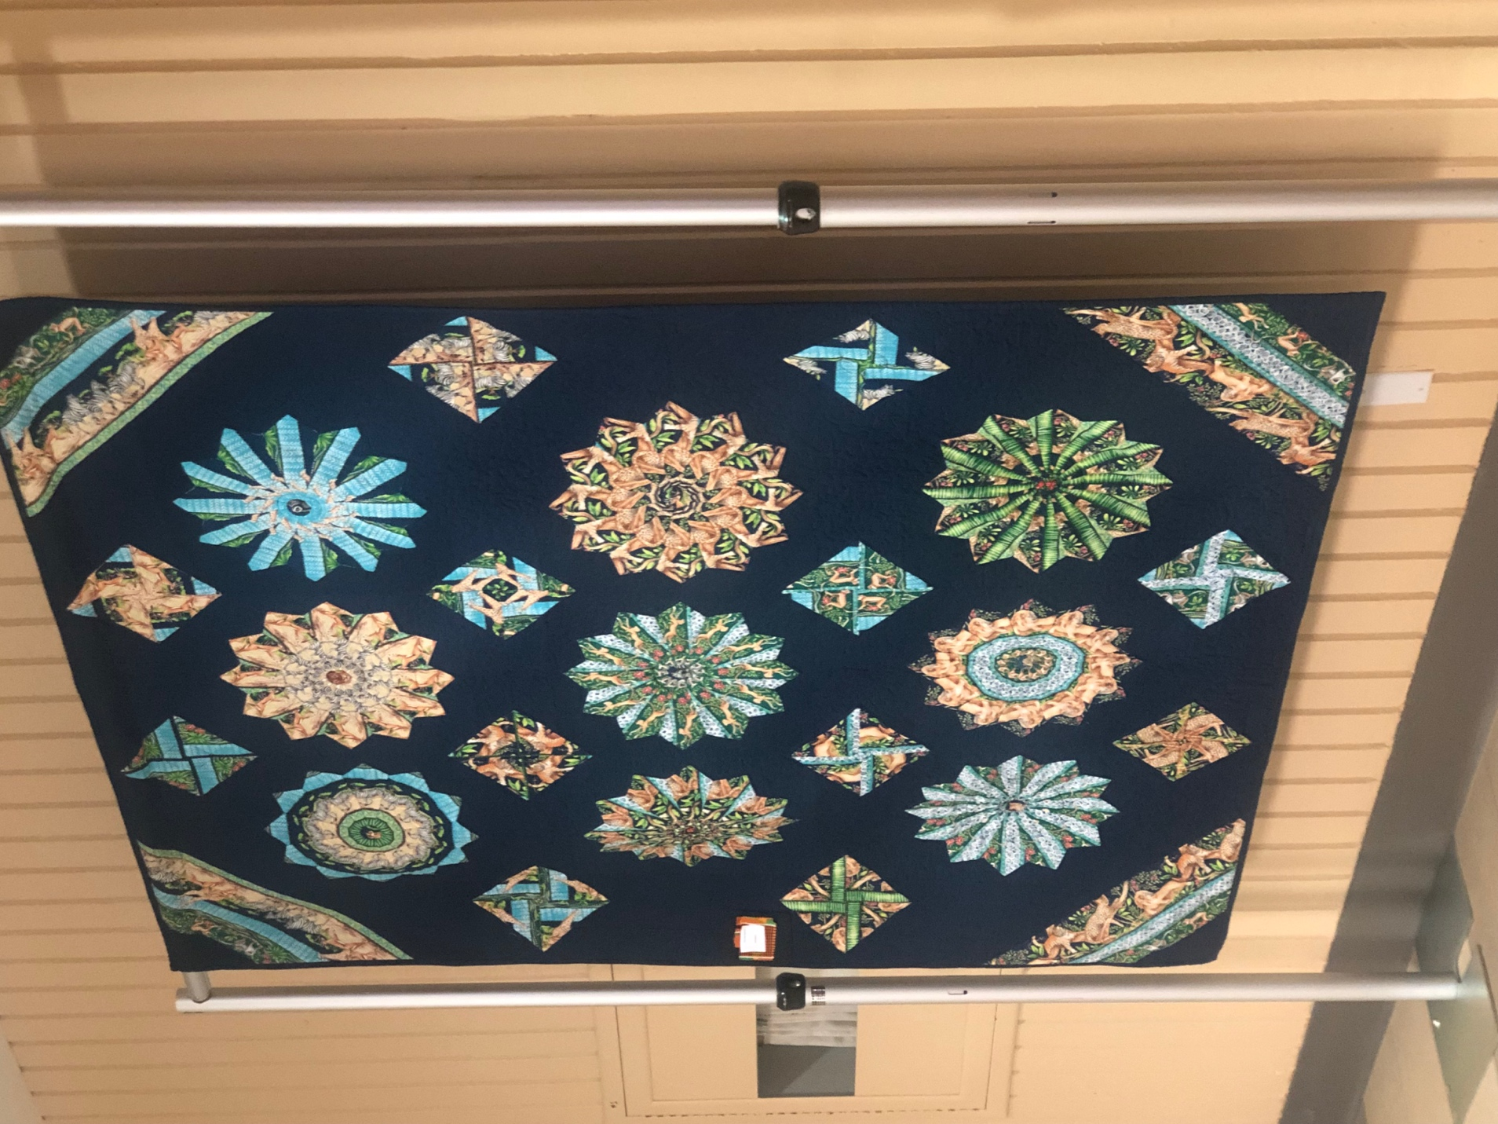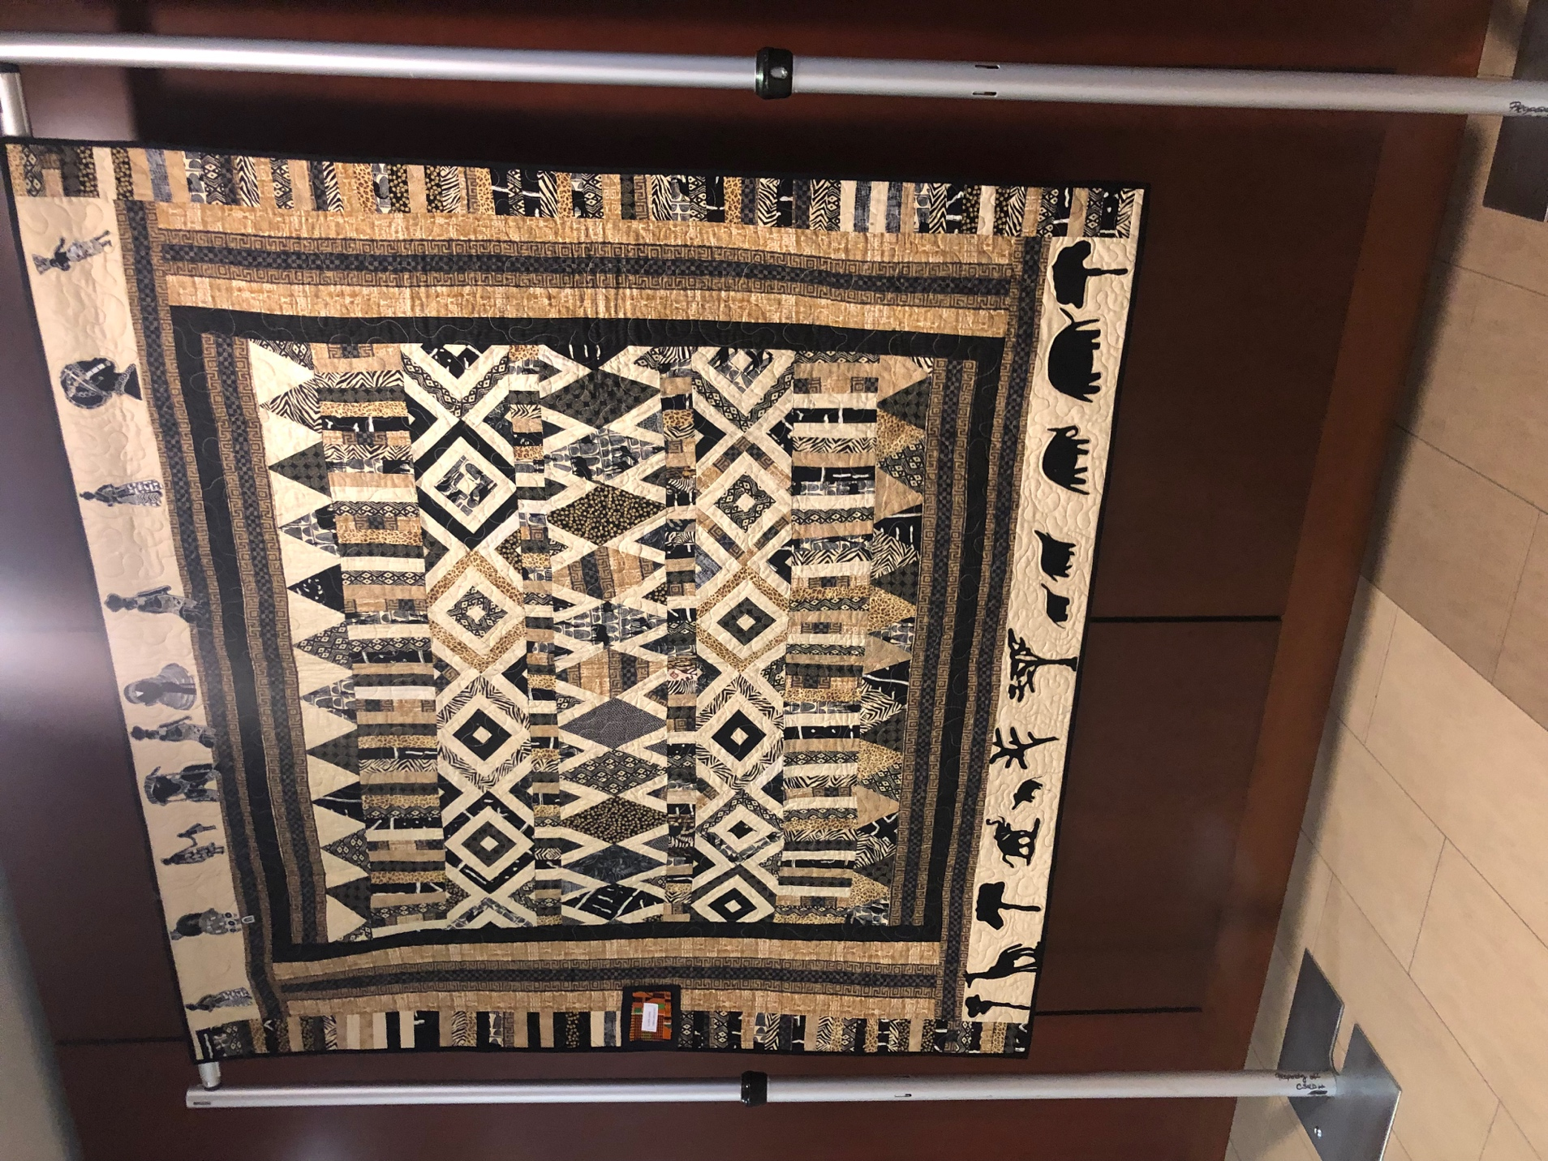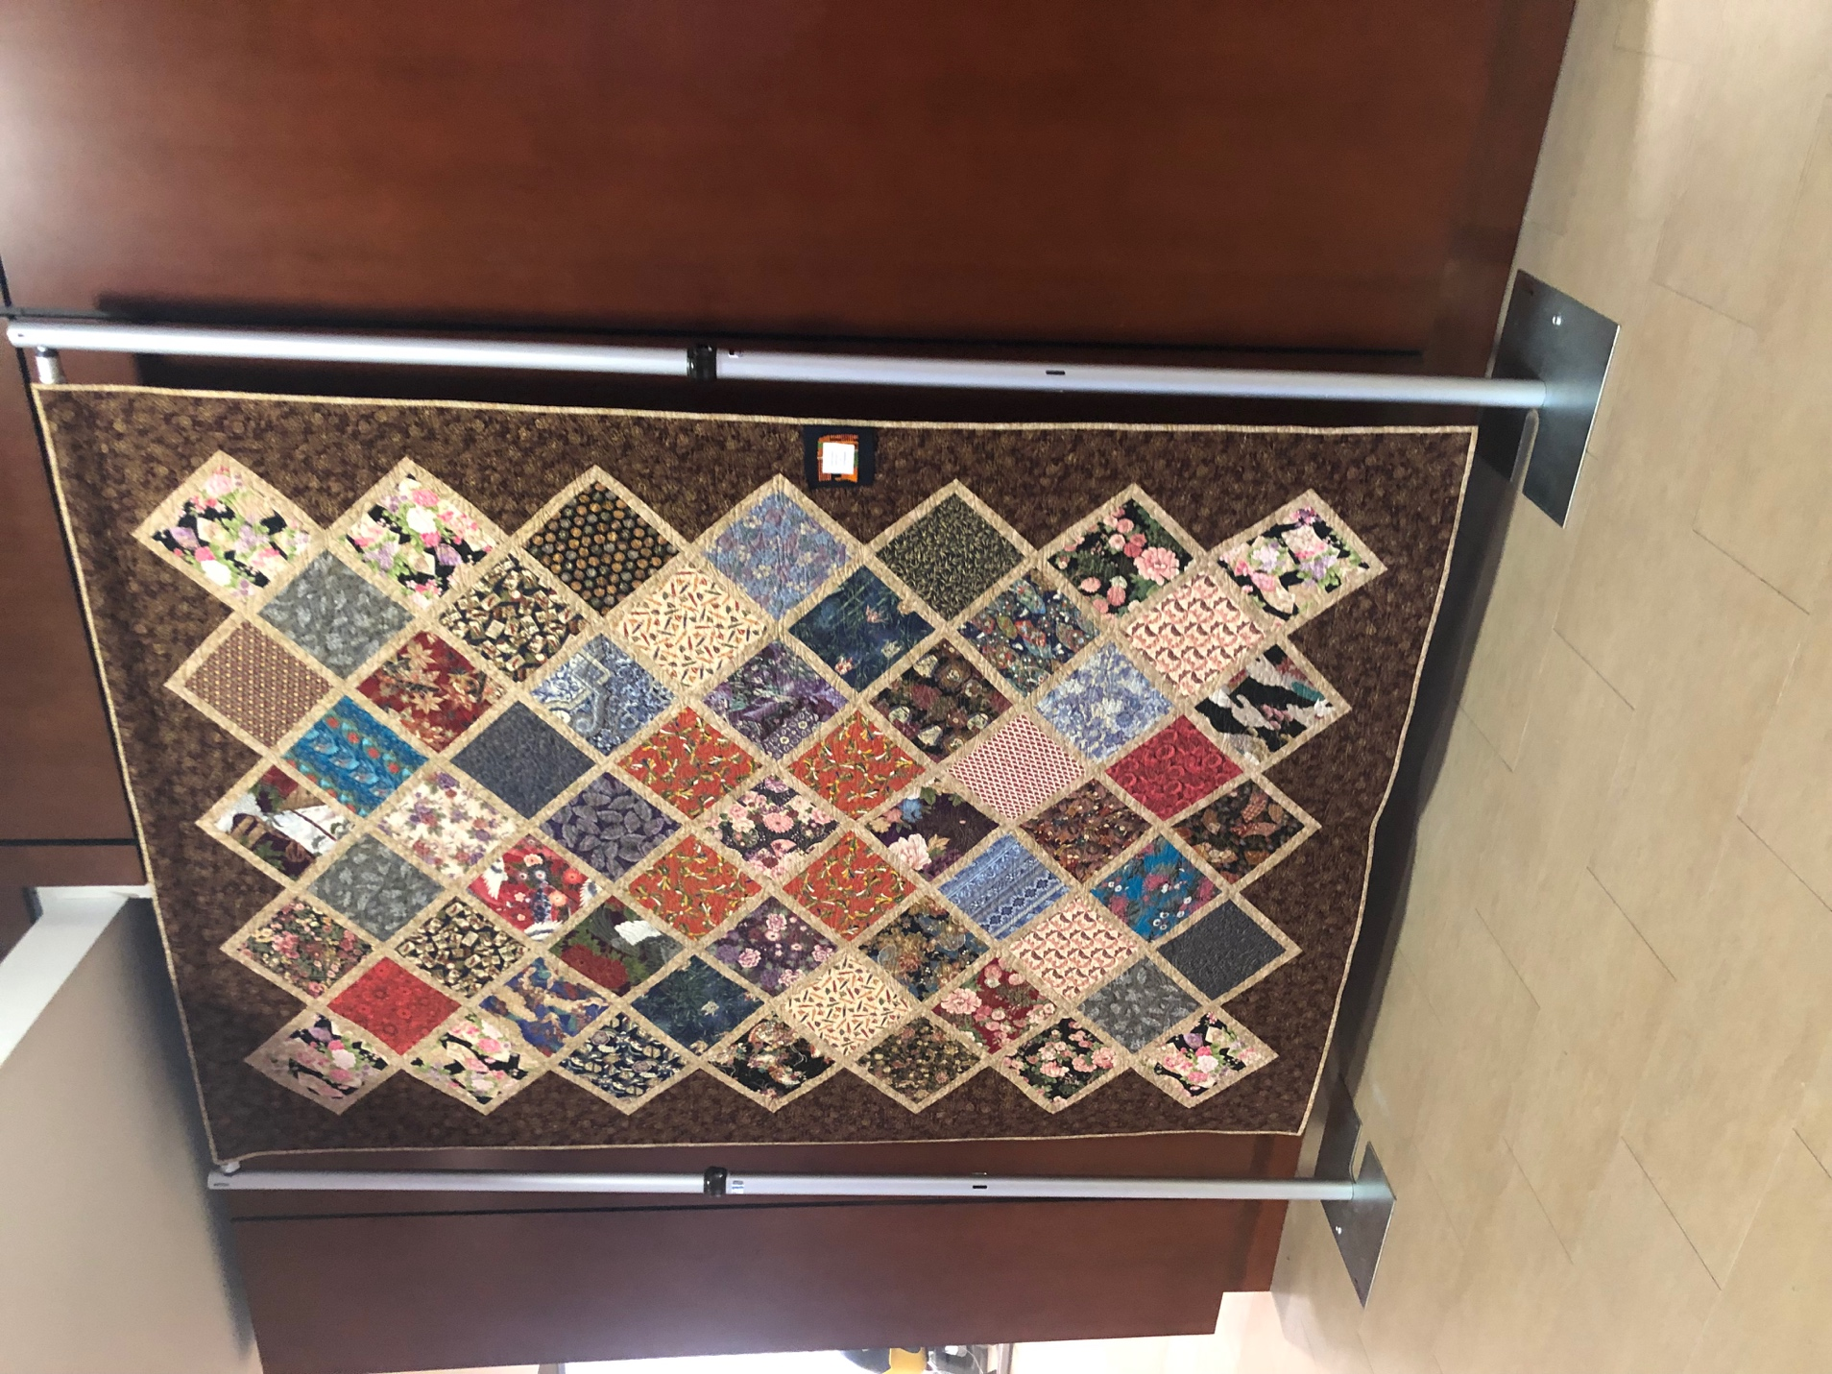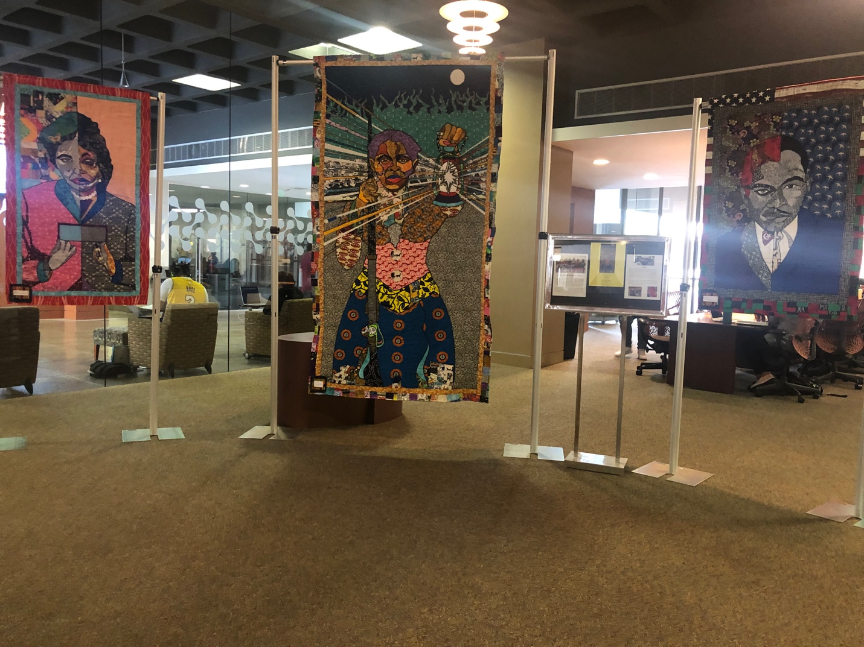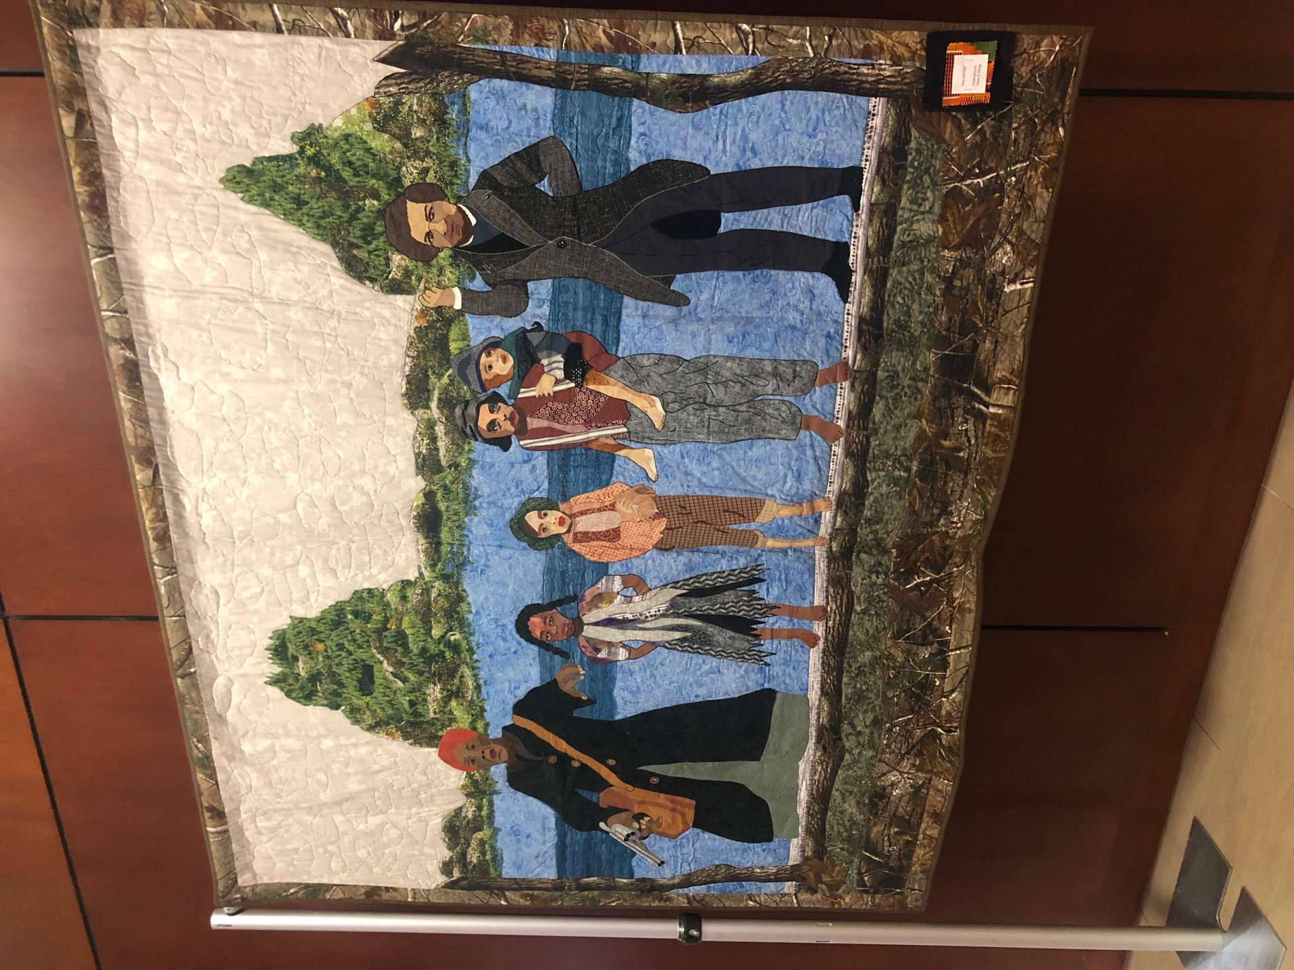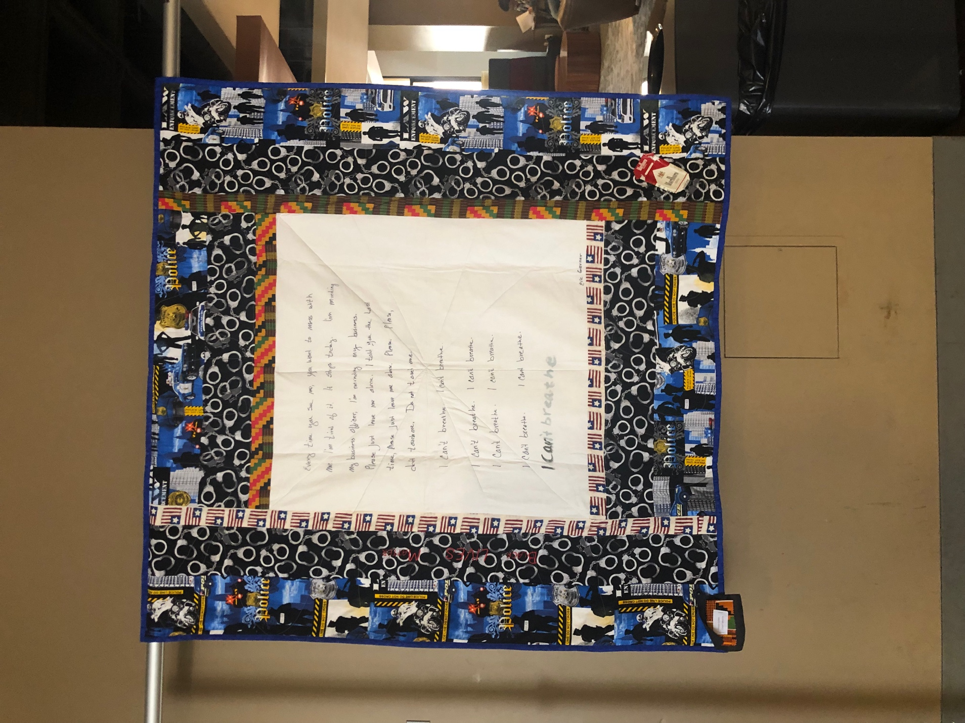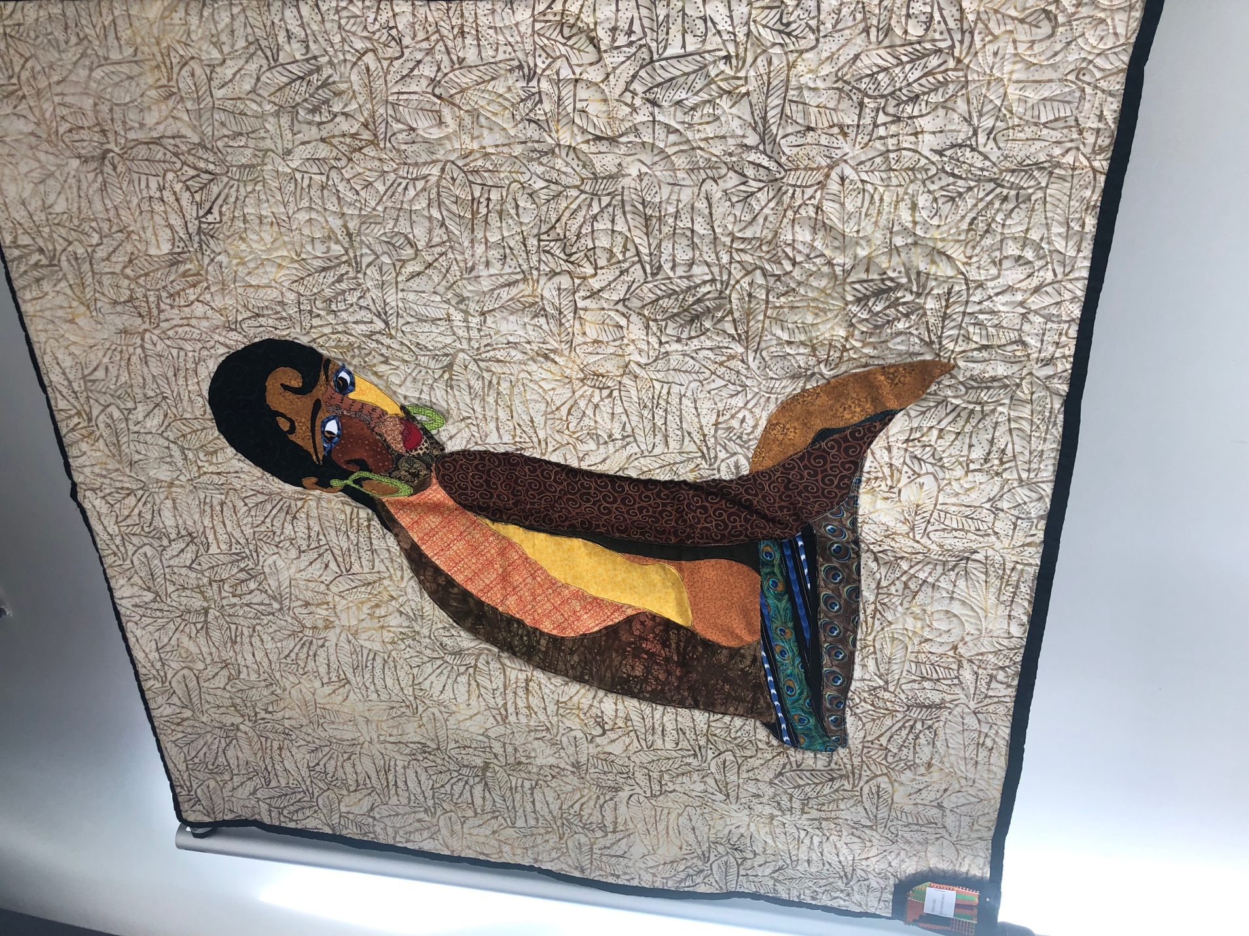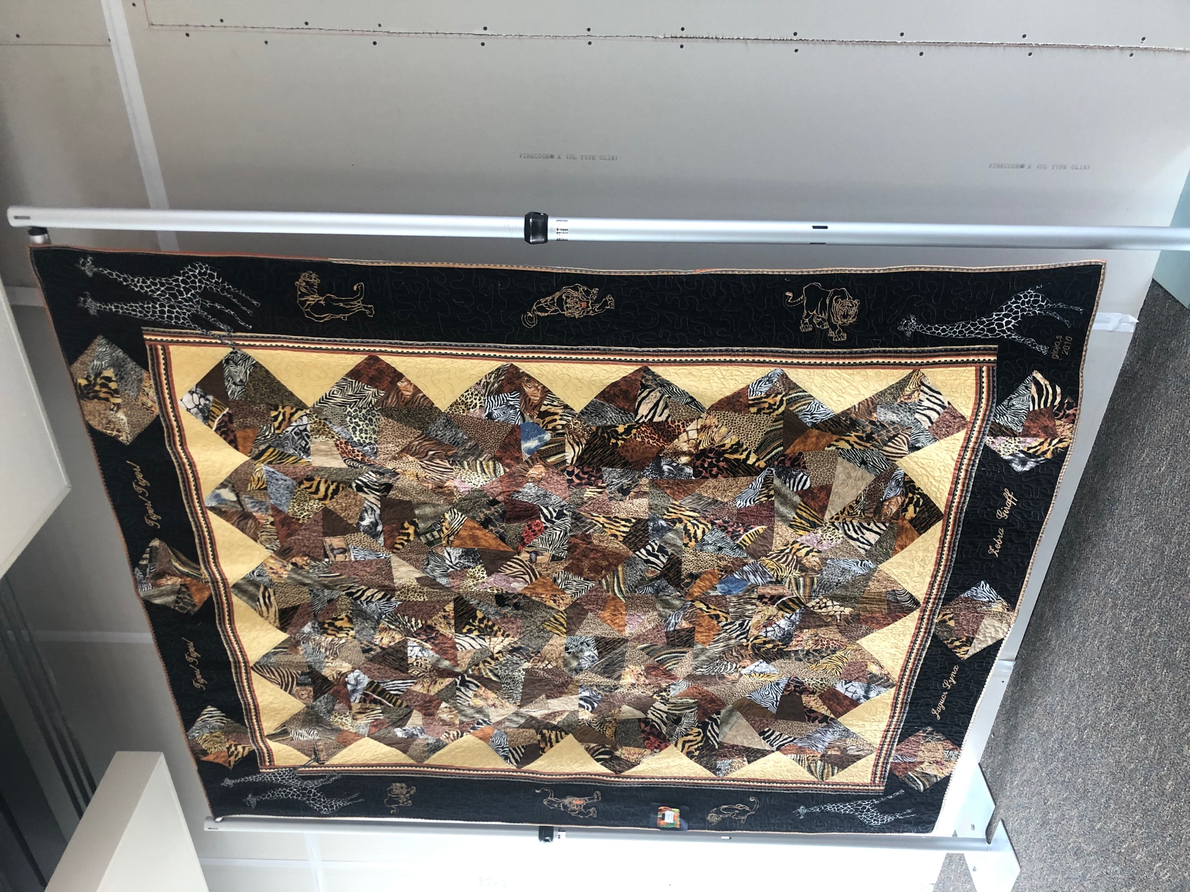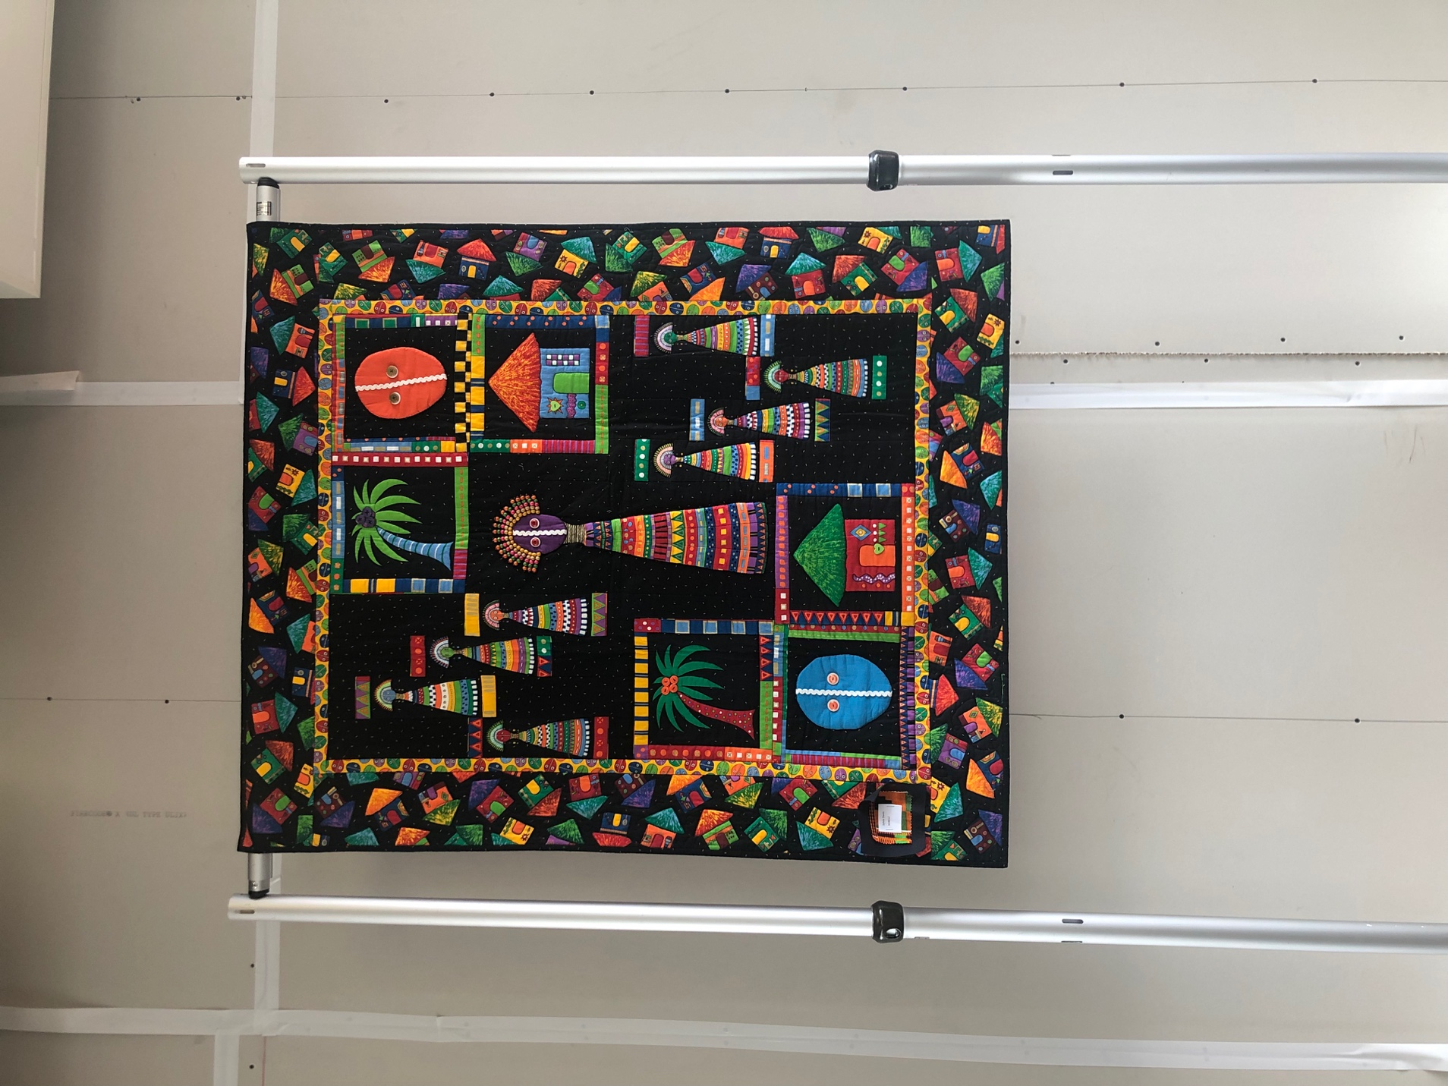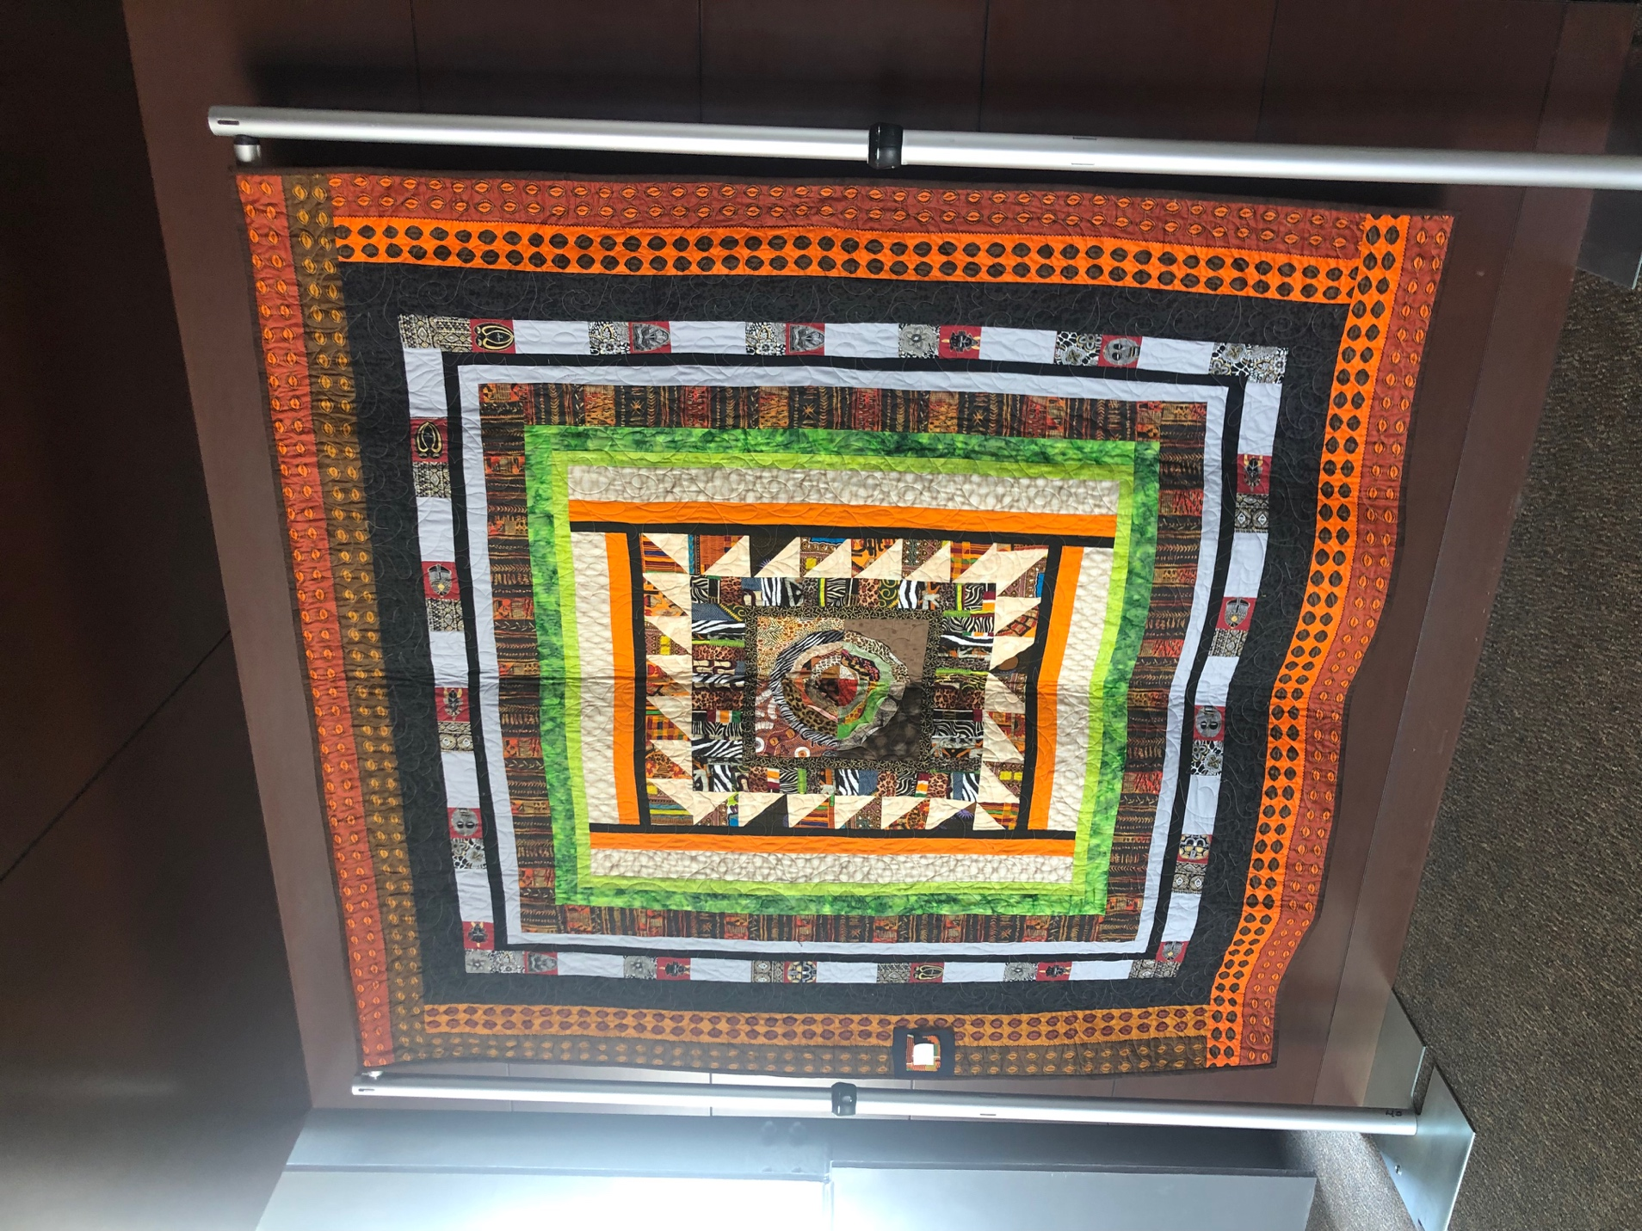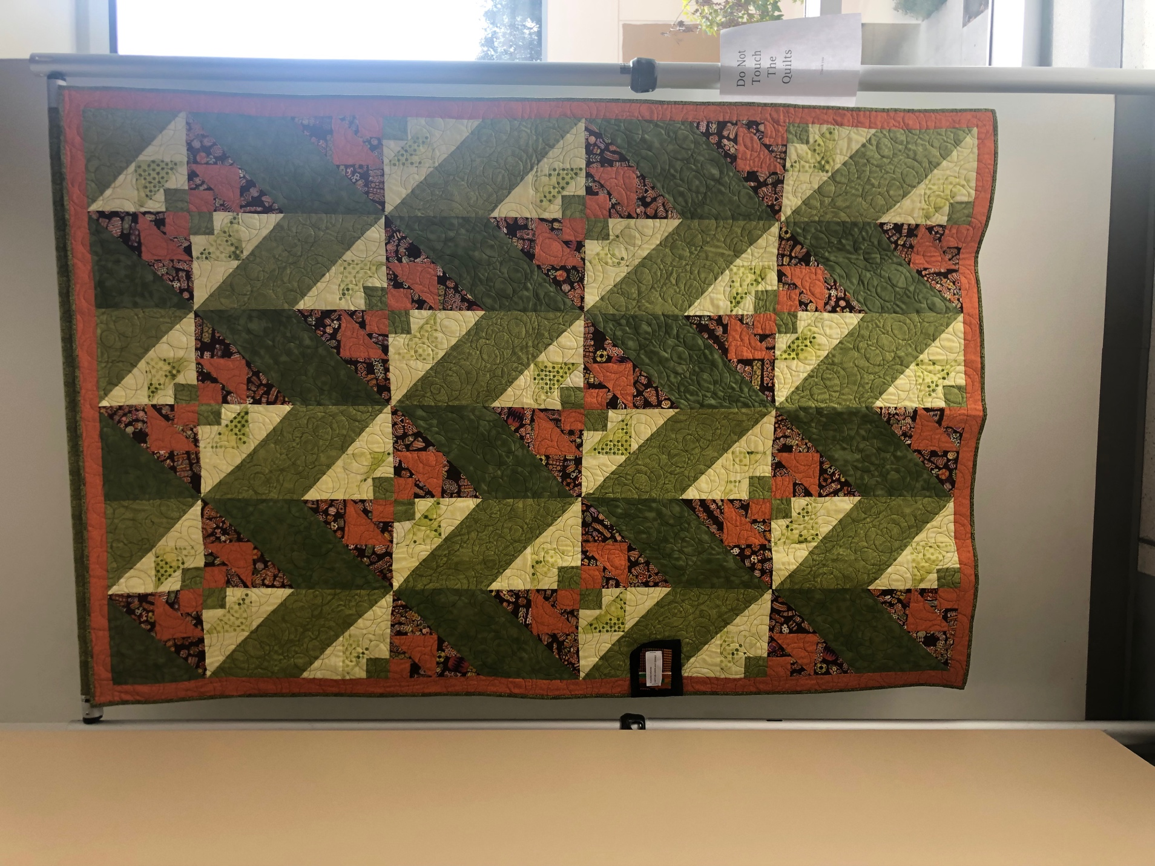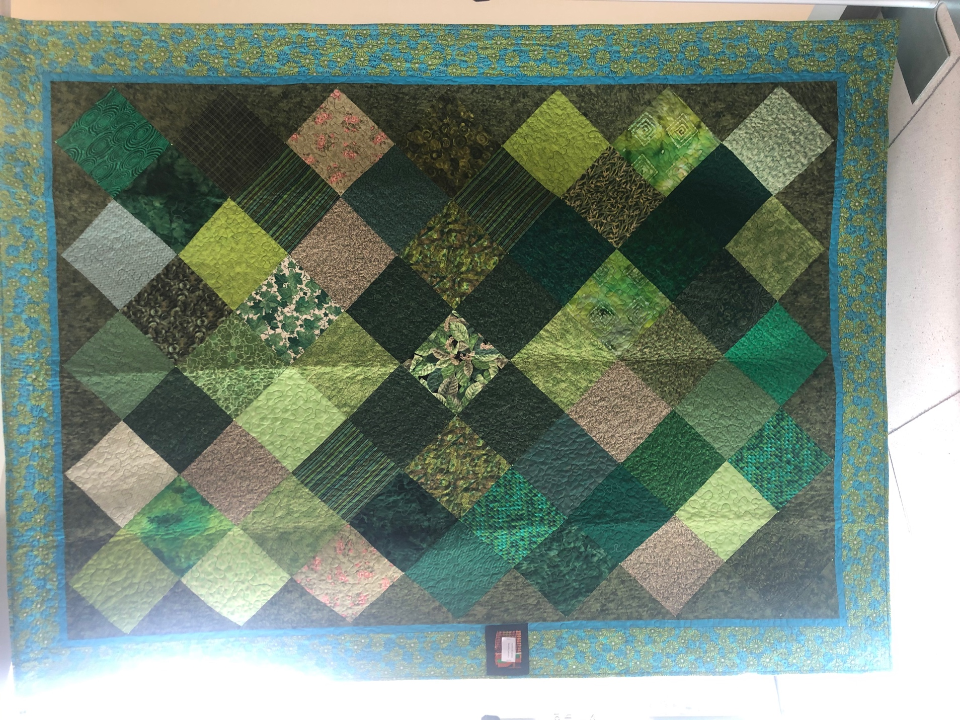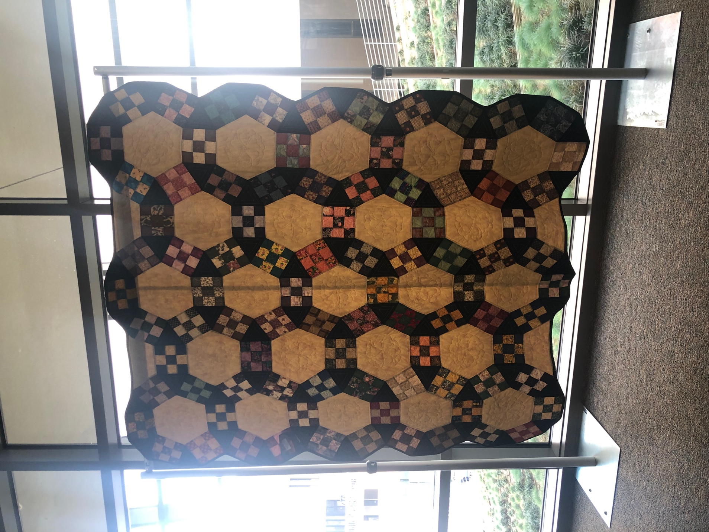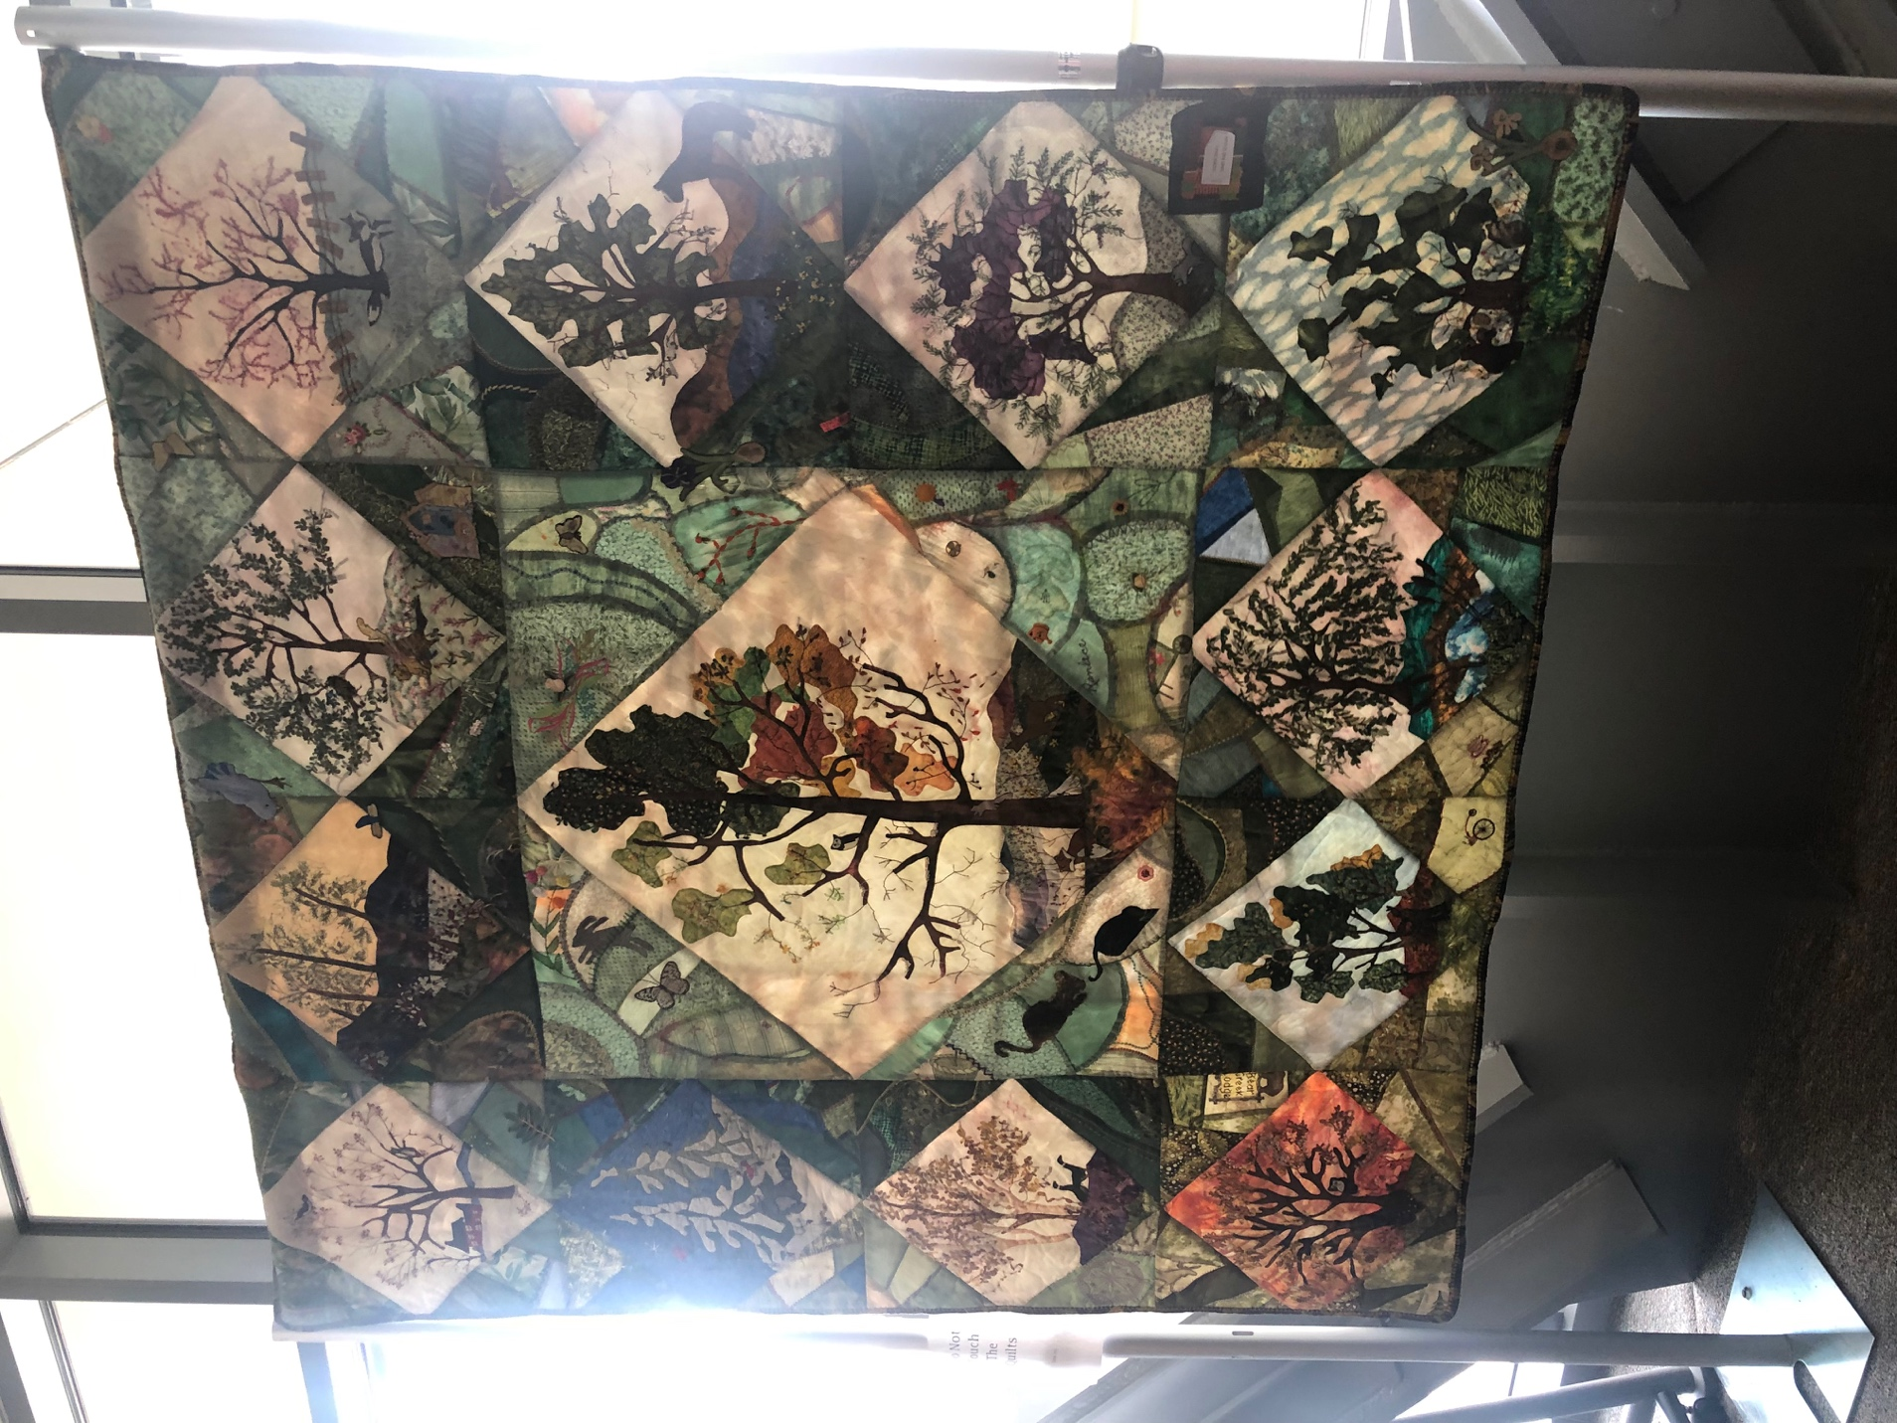

What do you think of when you hear the word quilt? I think of a big blanket sown together by different patterned patches. When the extra credit was assigned, I thought I was going to walk into the library and see “boring” quilts, like the ones we tend to see on televisions, or the ones our grandmas use to put together when we were younger. What I actually saw as I walked in the library actually took me by surprise, not only were quilts full of color just like I thought they would be, but many of them were portraying a story. Since I am not a quilter myself, I did not know that such thing could be done, but it can and it was.
I had the perception that going into the library I would just walk in, take the pictures of each of the quilts as our assignment required and leave right away. I caught myself spending about 5 minutes with each quilt, trying to figure out the story behind each of them. Black history month is the theme I perceived after taking a look at all of the quilts, for example one of the quilts had Dr. Martin Luther King, some of them had Harriet Tubman, one had an African woman, and others had colorful patches all around the quilt. The one that really caught my eye was the “I can’t breathe” quilt, before reading the name on the bottom Eric Garner, I already knew it was about him just by reading the phrase “I can’t breathe”. Eric Garner was an African male, killed by police a New York City police officer who put him on a headlock or chokehold for about 15 seconds while other officers were arresting him. He yelled out I can’t breathe a couple of times, unfortunately the officer did not stop until it was too late. If you pay close attention to the details on this quilt, you will notice a pack of Marlboro’s on the bottom right, which is what Eric Garner was selling outside the store. Garners death triggered many protests around the country, people would chant “I can’t breathe”.
Another quilt that happened to catch my attention is the one right above this page, the one full of trees. The reason it caught my attention was because it was different from all of the other ones I saw. Each patch had a tree, every tree looked like it was in a different season, for example there is a tree covered in snow, there is a tree left with no leaf’s, some tree’s leaves are green and some are yellow. If you pay close attention to the small detail you will see animals such as, fox’s, butterflies, bunnies and a rat. You can tell the artist put quite a lot of time into his or her piece, each patch must have taken time to cut out, figure out the exact placement and then bring his or her vision alive.
After analyzing each quilt, I found myself wondering “ Can quilts be considered a piece of art?”. I came to the conclusion that yes, yes they can, not only does the quilter pay close attention to the design of the quilt, they also choose their color scheme with great detail. If you take a look at all of the images of the quilts, every color incorporated into the quilt is in sync with the whole quilt all together. Each quilt tells a different story, what story that is depends on the audience, we all have different opinions and interpretations of what each quilt is saying.

