RS
Professor
ENGL 350
10 September 2018
Children Health in Danger
BACKGROUND INFORMATION
Childhood obesity affects an enormous number of families, but the vast majority of these cases are preventable. With support, encouragement, and positive role modeling, we can help children reach and maintain a healthy weight. Children tend to take in more calories than they burn throughout the day. Physical education occurs only one time a week at Reche Canyon Elementary School. Children are eating too much and exercising too little. I have noticed that children spend less time actively playing outside, and more time watching TV, playing video games, and on the cell phone. In my community, “Four out of ten students in San Bernardino County schools are considered overweight or obese.

OBSERVATION
I gathered what Alan (age 5) and Aaron (age 10) ate and drank on Sunday and Monday.

9 September 2018 (8:25 p.m.-8:33 p.m.); For breakfast Alan ate a donut. For lunch he ate Mongolian food at a restaurant. After lunch Alan had ice cream and for dinner he ate the rest of his Mongolian food.
9 September 2018 (8:36 p.m.-8:41 p.m.); Aaron ate French toast with chocolate milk. For lunch he ate chicken tenders with French fries with lemonade. After lunch he had ice cream. For dinner he ate Mongolian leftovers.

10 September 2018 (7:00 p.m.-7:10 p.m.); At school Alan was served pizza and milk for breakfast. For lunch, he ate a peanut butter sandwich, a banana, and he had chocolate milk. After school Alan had gummies and a string cheese. For dinner he ate rice with shrimps with water.

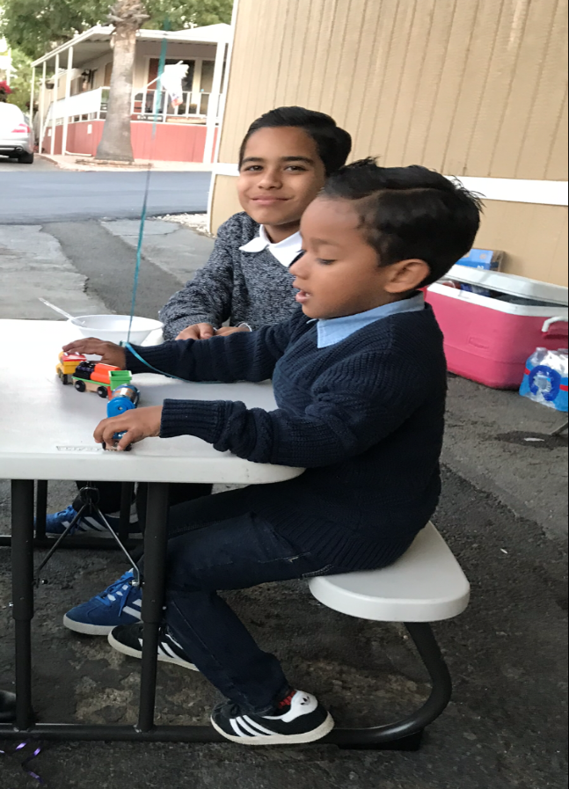
10 September 2018 (7:12 p.m.-7:20 p.m.); At home Aaron ate pancakes a had a glass of milk for breakfast. Then at school he ate waffles and chicken with apples and had regular milk for lunch. After school Aaron had gummies and a string cheese. During dinner he ate white rice with shrimps with water.

“Overweight and Obesity.” San Bernardino County, California Health Interview Survey, n.d. 10 September 2018.

