ME
Professor Ramser
ENG 110
1 October 2018
Transients vs. Tourists
An Ethnography of Subculture
PREFACE
Through this assignment, I am forced to become more observant and interactive within my local community. Being an already observant person, I did not find this as a challenge; I just had to put what I saw into words, and perhaps become more noticeable of specificities.

BACKGROUND INFORMATION
The Starbucks coffee shop I work at is on Del Amo and Avalon. It is about five minutes away from the StubHub center, a sports venue in Carson, California.

OBSERVATIONAL DATA AND ANALYSIS
28 September 2018 (3 PM – 10 PM)
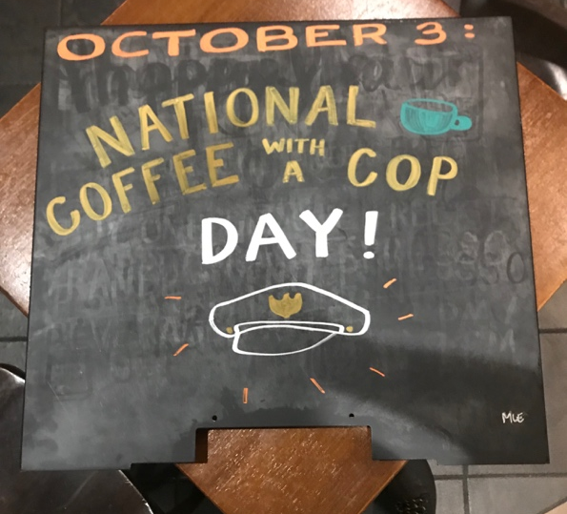
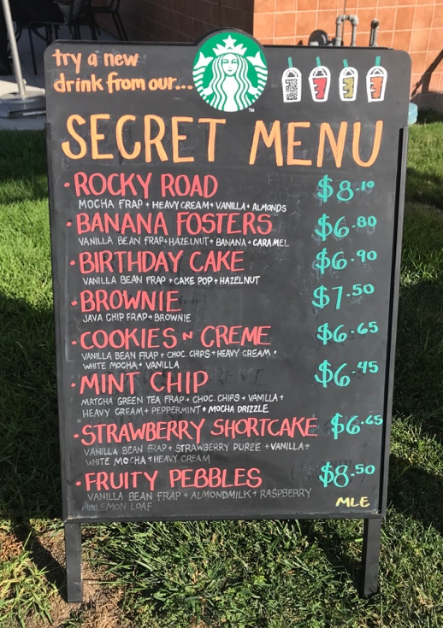
Right now it is 8:05 PM and I am on my lunch break. I am eating a grilled cheese sandwich and an Iced White Chocolate Mocha with almond milk. There are four people besides me in the lobby right now; two of them are on their laptops and the other two are waiting for their drinks. When I first came in the store, there was a person outside. I am not sure if it is a man or a woman, but I have seen them before. This person appears to be a woman, but they have a beard. They also wear their glasses upside-down, I am not sure why. One of my coworkers told me that they came in before, peed in a cup, and threw it at the wall. I don’t think this person is homeless, because they do not appear to be dirty. I said hello to them when I first walked in, but they did not acknowledge me. Today is a good day – I say it this way because sometimes I have bad days at work. Sometimes I make mistakes and feel embarrassed because of this, other times I feel like my coworkers are being passive aggressive towards me. I find comfort in knowing that I wont feel as bad about something so trivial in about a week’s time. There have been two new hires; one girl named Val and a boy named Luciano. I like Val because she talks to me like she already knows me. Today, I wrote her nametag for her as well as one of my shift supervisors, Marco. Everyone likes my handwriting, I make all the handwritten signs at work on a chalkboard with markers. Today I was told to make a sign that says “National Coffee with a Cop Day,” an event on October third. It seemed odd to me. Why is there a day designated to this, and did we have a certain promotion for it? Nobody else knew either, and Marco thought it meant “bring your own cup.”

30 September 2018 (12:20 PM – 5PM)
Today I worked a short shift. I wrote a new Secret Menu board today; consisting of new drinks made with ingredients that we already had. There was a football game today at the StubHub Center, which is very close to our store. We started to get a rush of people in red jerseys just as my shift was ending.

